

**Contributions to the thematic report to the UN General Assembly by the Special Rapporteur on adequate housing as a component of the right to an adequate standard of living, and on the right to non-discrimination in this context, Ms. Leilani Farha – June 2016**

Namibia wishes to submit the following information in response to the request by the Special Rapporteur (SR) dated 11 May 2016:

Namibia became a member of the core group sponsoring the Right to Housing as an adequate standard of living in the Human Rights Council (HRC) in March 2016. We take note of the focus of the report by the SR on the intimate link between the right to life and the right to adequate housing.

It is our submission that Economic, Social and Cultural (ESC) rights continue to remain secondary thus we call for a greater balance to be struck between these rights and Civil and Political (CP) rights. The rights as set out in the Universal Declaration of Human Rights (UDHR) are indivisible and inter-dependant and should enjoy equal status.

We further take note of the three distinct questions posted by the SR in her questionnaire, but would like to point out that we do not have the statistics and data in all the categories of desegregation as requested. The information we share is based on the information obtained mainly from the National Statistics Agency as reflected in the National Housing and Population Census of 2011.

Reply to the questions posed by the Special Rapporteur in her correspondence:

Although we have no detailed information on the health, mortality and morbidity consequences of inadequate housing and homelessness in Namibia, we would like to share the information as set out below.

***1. DISABILITY AND HOUSING CHARACTERISTICS***

Housing plays a very important role in one’s life, for the poor it simply fulfills a basic need for shelter. It should be noted that, housing was one of the priority areas of development identified by government, which led to the formulation of the first National Housing Policy in 1991, reviewed in July 2009. This information focuses on characteristics of housing units, which are occupied by households with persons with disabilities. The information presents information specifically on type of tenure, type of housing unit, material used for construction, source of energy for cooking and lighting, water supply and sanitation.

***1.1 Tenure Status***

According to the Namibia 2011 Population and Housing census, tenure refers to the conditions, which govern the rights of individuals to occupying dwelling units. The common form of tenancy is rent whereby rent is paid to the landlord. The landlord can be a private individual, non-profit organization or a government body, which provides housing to the public (Namibia Census, 2011).

Statistics indicate that 69.9 percent of households with persons with disabilities owned housing units that they occupied without mortgage. This situation was more common in rural areas with 80.4 percent of households, while in urban areas 46.3 percent own housing units without mortgage. This was due to the fact that most dwelling units in rural areas are traditional houses and have no title deeds and cannot be mortgaged. In terms of rent (employer and individual), about 19 percent of households with persons with disabilities in urban areas lives in rented housing units i.e. rented employer and individual.

***1.2 Type of housing***

The 2011 Namibia Population and Housing census collected information on the type of housing unit. The types of housing units used were: detached house; semi-detached/townhouse; apartment/flat; guest flat; part commercial/ industrial; mobile home (caravan, tent); single quarters; traditional dwelling and improvised housing unit (shack).

Statistics show that traditional dwellings were occupied by 58.8 percent of households. This phenomenon is predominant in rural areas where 81.1 percent of households with people with disabilities lived in traditional dwellings. Improvised housing units (shacks) were more common in urban areas with 23.2 percent of households, while only 3.4 percent of households in rural areas live in improvised housing units.

The percent distribution of persons with disabilities having difficulties in engaging in any learning and/or economic activities by type of housing unit and area shows that traditional dwelling (66.6%) was the most common type of housing unit with persons with disabilities having difficulties engaging in any learning and or economic activities.

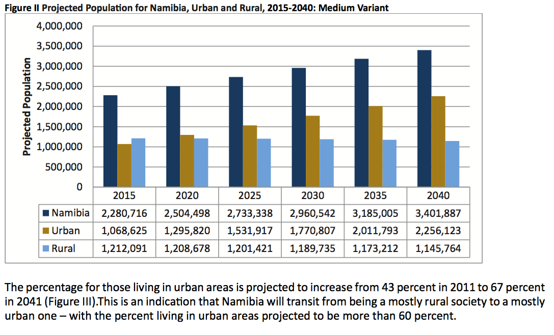

***2. HOUSING INITIATIVES IN NAMIBIA:***

Some micro lending for housing purposes is on the increase through organisations such as the Shack Dwellers Federation of Namibia (SDFN), a community organisation that aims to improve living conditions of poor Namibians by providing its members with building loans ranging from N$20 000 (US$1 467) to N$ 35 000 (US$2 568). The loans are repayable within a period of 11 years at an interest rate of 0.5 percent per month. The government’s Financial Sector Strategy also includes improved consumer literacy and protection, and local ownership in commercial banks. Pension-based lending for housing is allowed, although concerns have been raised that part of the money is diverted for consumer rather than long-term housing spending. Better enforcement for correct use is needed.

The Mass Housing Development Programme (MHDP) was launched and implemented by the Government of the Republic of Namibia in 2013 aimed at increasing investment in the affordable housing sector to increase the production of the housing stock and significantly increase the supply towards meeting the demand for housing in the country. The increase in the housing supply will result in the reduction of the prices for houses in the long run as the economic principle of supply and demand dictates.

***3. AFFORDABILITY OF HOUSING IN NAMIBIA:***

According to the March 2015 First National Bank (FNB) Housing Index, a median housing unit costs N$842 000 (about US$65 154), up from N$774 000 (US$59 923) by a private developer in June 2014, while a small-sized property costs N$280 000 (US$18 563) by a public developer (NHE). In terms of affordability at the current interest rate, households need to earn N$10 500 (US$70 743) to afford a small house and N$38 700 (US$2 989) for a medium house. The average price of a house financed by FNB costs NS$720 000 (about US$65 498). As 93 percent of the population earn less that N$7 000 (US$51 362) a month, the majority of the population cannot afford mortgaged housing in urban centers across the country.

***4. POLICIES AND REGULATION OF THE HOUSING INDUSTRY IN NAMIBIA:***

According to the Presidency (2015) the Vision of the Namibian Government is to eradicate poverty in its entirety by, among others, providing affordable housing to all Namibians in line with Vision 2030 through increased investment in the housing portfolio and in the process eliminate all shacks that are prevalent in various regions and local authority areas in Namibia.

Within the context of the 4th National Development Plan (NDP4), Government undertakes to have a “robust and effective housing delivery programme where affordability is the key feature of the programme”, a concept that has seen the initiation of the MHDP as well as the MLSP. If these programmes are implemented effectively, Government may attain its objective of housing 60 percent of its population by the end of NDP4 (2016/17). It is likely that extension on deadlines may be sanctioned given unexpected delays experienced especially in the implementation of the MHDP.

In 2013, a National Housing Technical Committee was also established to develop a mass housing development strategy.

A N$2.9 billion (US$212 million) budget was earmarked for allocation to the Ministry of Regional, Local Government, Housing and Rural Development to cater for the servicing of land and improved sanitary standards in urban, peri-urban and rural areas. The programme has been characterised by funding challenges, which Government is addressing by assessing local and foreign markets for potential institutions to provide affordable funding to the programme.

***5. THE RIGHT TO LIFE AND THE RIGHT TO HOUSING:***

The Namibian Constitution in Article 6 provides for the Protection of Life. However, this does not directly apply to circumstances where homelessness or inadequate housing place health, security or life at risk. The right to housing is encompassed in the Namibian Constitution under Article 95, which contains the provisions for “Promotion of the Welfare of the People”.

***6. DISPROPORTIONATE EFFECT OF HOMELESSNESS ON PARTICULAR GROUPS:***

Currently we are not in possession of verified information on the disproportionate effect of homelessness on particular groups, but have endeavored to highlight the impact as set out above. There is no jurisprudence yet on the disproportionate effect of homelessness and inadequate housing on particular groups as an issue of discrimination.

**Sources:**

Bank of Namibia (2014). Annual Report.

Economist (2014). EBH employees to get affordable housing, 22 August 2014.

FNB (2014). Housing Index: Shift in Housing Mix towards Middle Price Segment, March 2015.

IndexMundi Factbook, Namibia: 2015

How We Made it in Africa: Insight into Business in Africa. www.howwemadeitinafrica.com.

Immanuel, S. (2014). New Mass Housing Prices, 27 June 2014. Namibian Institute for Public Policy Research (2010). Housing Policy and Delivery in Namibia.

Immanuel, S. (2015, July 27). Uphill task awaits Govt. The Namibia, pp. 2.

Kalili, N., Adongo, J. and Larson, T. (2008). Access to Housing Finance in Africa: Exploring the Issues (No. 5) Namibia. Namibia Policy Research Unit. Paper commissioned by the FinMark Trust with support from Habitat for Humanity.

Ministry of Finance (2015) Quarterly Economic Update, January 2015.

Namibia Financial Institution Supervisory Authority (2014). Annual Report.

Namibia Financial Institution Supervisory Authority (2015). Namibia Financial Stability Report.

Namibia Statistics Agency (2014) The Namibia Labour Force Survey 2014 Report.

National Housing Enterprise (2015) Mass Housing Development Programme Progress Report.

National Planning Commission (2014). Special Programmes: Housing Sector. http://www.npc.gov.na/?page_id=424

The Presidency (2013). Summary of the Blueprint on Mass Housing Development Initiative in Namibia, October 2013.

The Presidency (2015). 2015 State of the Nation Address, 21 April 2015.

World Bank (2014). Doing Business Report 2014: Namibia