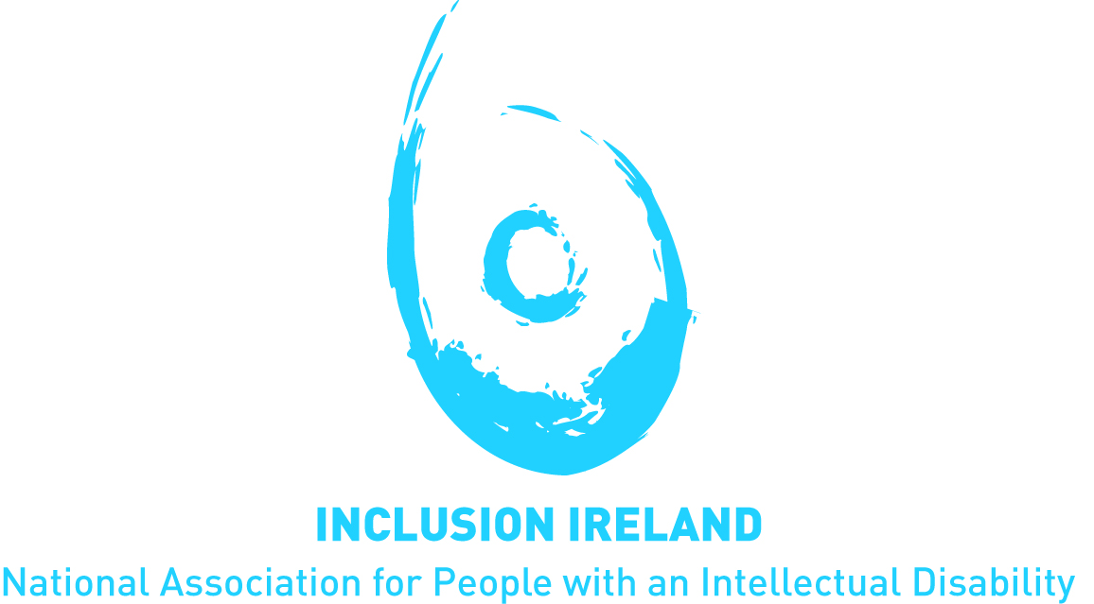

The Right to Housing for People with Disabilities
A submission to the UN Special Rapporteur on adequate housing, June 2017

This document is written in font 12 Verdana in line with Inclusion Ireland plain English guidelines.
- About Inclusion Ireland
Established in 1961, Inclusion Ireland is a national, rights based advocacy organisation that works to promote the rights of people with an intellectual disability.
Inclusion Ireland uses a human rights-based approach to its work. This recognises persons with an intellectual disability as rights holders with entitlements, and corresponding duty bearers and their obligations. Inclusion Ireland seeks to strengthen the capacities of persons with an intellectual disability to make their claims and of duty bearers to meet their obligations.
The vision of Inclusion Ireland is that of people with an intellectual disability living and participating in the community with equal rights as citizens, to live the life of their choice to their fullest potential. Inclusion Ireland’s work is underpinned by the values of dignity, inclusion, social justice, democracy and autonomy.

- Introduction
Inclusion Ireland welcomes the opportunity to contribute to the Special Rapporteur on the right to housing of people with disabilities. This Inclusion Ireland submission will concentrate on the policies in Ireland around moving people from institutional settings to homes in the community.
We know from data that people are not moving from institutions at an acceptable rate. We know from health watchdog reports that people are being deprived of their rights in institutions which are portrayed as unacceptable places to live in 2017.

Question 1. Inclusion Ireland is not aware of any legal or constitutional right to housing for people with disabilities.

Question 2. There is no comprehensive data on the level of homeless people with disabilities.
In a recent report, the Office of the Children’s Ombudsman (OCO) noted that homeless children with disabilities are not afforded any additional priority in the allocation of social housing. On launching the OCO annual report, Nuala Ward, director of investigations noted: “children with disabilities were struggling living in inappropriate housing, while children with disabilities or medical needs who are homeless were not always being prioritised for housing”.
Many people with an intellectual disability require support (e.g. personal assistant or support worker) to live in their own home. This support is not available except for ‘emergency’ situations leading to long waiting lists to access supported living.
The Health Research Board completes an annual report on service provision and future service requirements for people with intellectual disabilities. Up to 2020 the HRB estimate that 4,300 additional residential places or supports will be required. This is not being planned for by the HSE. For example, the 2017 HSE Service Plan only makes provision for 185 ‘emergency residential places’.
The HRB also note a historical lack of housing options for people with intellectual disabilities. In 2015, there were 4,039 people with intellectual disabilities aged over 35 living at home with aging parents. Of this number 734 were aged over 55 and living at home with their parents. Question 3. The Irish policy for the closing of institutions is ‘a Time to move on from congregated settings – a strategy for community inclusion’ which was published in 2011. The policy set a target of closing all institutions in 7 years (by 2018). At the time there was slightly over 4,000 people living in institutions.
In 2016, government set a new target of reducing the amount of people living in institutions by 1/3 by 2021. This is an admission of the failure of the policy to move all people out of institutions over a 7 year period. At the new proposed rate of moving people it will take a further 15 years to move all people out of institutions.
At present there are 2580 people with disabilities living in large institutions in Ireland.
Over a 6 year period (2011-2017) the amount of people living in institutions has reduced by almost 1,500. Not all of these people moved to community settings. In 2015, 123 people moved to a community house, 27 moved to a nursing home and 121 died.
Of those that moved in 2015, 53.4% moved to a home with 4 or more other people with a disability. The UNCRPD committee in a recent statement noted “neither large scale institutions with more than a hundred residents nor smaller group homes with five to eight individuals can be called independent living or community living arrangements.”
Less than 10% of people moved into their own accommodation.
In a backward step, 41 people moved into a large institutional setting in 2015 and 35 moved into a large institutional setting in 2016.
Question 5. (i) The Department of Health and the Health Service Executive made €100 million available in capital funding over a 5-year period to purchase houses in the community. These funds are directed towards a small number of institutions (10) that have been failing to meet basic standards of inspection by the Health Information and Quality Authority (HIQA). HIQA is the agency with statutory powers to inspect and regulate residential services for people with disabilities.
The Department of Housing, Planning, Community and Local Government made €10 million available to purchase houses to move people out of institutions in 2016. Only €2 million of this fund was drawn down.
To assist with transitioning people out of congregated settings into ordinary homes a Service Reform Fund has been established. The fund has €27m available to services over a 3-year period. Despite being announced in June 2015, no money has been allocated from this fund as at May 2017.
Despite significant funds being made available to move people out of institutions in 2016, less people moved than in 2015 when dedicated funds were not available. In 2016, only 52 people moved to community settings.
In the previous 4 years the HSE has set a target for people to move from institutions to community settings. The targets have never been met (fig 1).
In the last two years (2015 & 2016) there has been a greater likelihood of passing away in an institution (216) than moving to a home in the community (185).

Fig. 1
(ii) HIQA has been inspecting residential settings for people with disabilities since 2013. While many centres are performing well a significant number of large institutions are not protecting people’s rights. Inclusion Ireland’s report on the first 50 HIQA reports notes: “the inspection reports present a picture of extensive non-compliance with regulations in areas such as health and safety, independent advocacy, restrictive practices and correct checking of medicines”. It noted that a “significant issue with wide ramifications was whether residents could choose with whom they wished to live in community residences. Inspection reports provided evidence that living arrangements were sometimes bordering on the abusive”.
In a recent review of regulation for 2016, HIQA noted: “Unfortunately, there are still a significant number of people living in residential centres for people with disabilities that are not fit-for-purpose, where practices are institutionalised, and where vulnerable people living there are not adequately safeguarded. While increased funding and resources are necessary elements of addressing these failings, there is also a need to address outmoded staff practices, inappropriate placements and poor governance arrangements.”
(iii) There are no practices for people to challenge their places in institutions.
A National Advocacy Service (NAS) for people with disabilities has been established. The Citizens Information Act 2007 remains not commenced so advocates do not have statutory powers. NAS have reported poor co-operation of services in certain instances when they are supporting people with disabilities.
Conclusion
2580 people with disabilities are living in large institutions in Ireland. These people continue to live in places that are not fit for purpose, experience institutional practices and are not adequately safeguarded.
A small number of people moved into institutions in 2015 and 2016.
To date, government programs to move people to more appropriate community settings have not met targets. In the last two years, more people died in an institution than moved to a community setting.
More than half of people are moving out of institutions to homes of five and more in the community. Fewer than 10% moved into their own separate accommodation.
People cannot challenge their continued placement in an institution. They have very little if any choice of where they move to or with whom. Independent advocacy services to support people have no statutory powers.
No child should be homeless. However, in Ireland there is a growing number of homeless children. There is no additional priority given to homeless children with a disability or serious medical condition for social housing.
There are large waiting lists for people with a disability to access residential support. Very little is being done to address this issue.

Ombudsman for Children, Annual Report, 2016.
Annual Report of the National Intellectual Disability Database Committee 2015, Doyle, A & Carew, A., Health Research Board, 2016.
ibid
A time to move on from congregated settings – a strategy for community inclusion, HSE working group, 2011.
A program for partnership government, 2016.
Answer to PQ 5585/17, HSE, 2017.
HSE, Progress report on the implementation of Time to Move on from Congregated a strategy for community inclusion, Annual Report for 2015, 2017.
ibid
HSE documentation.
Lynch welcomes collaboration with The Atlantic Philanthropies on service reform fund, press release, June 16th 2015, available at www.merrionstreet.ie
Targets are taken from the HSE Service plan for that year; actual moves are taken from HSE Performance Data reports and HSE documentation.
Meagher M. & Conroy P., The Distant Voice, A working paper on the first 50 Health Information and Quality Authority (Hiqa) inspections of residential services for people with disabilities, Inclusion Ireland, 2014.
2016 Overview of regulation, Health Information and Quality Authority, 2017
National Advocacy Service Annual Report, 2015.

