COVID-19 and the Right to Housing
Washington Legal Clinic for the Homeless Submission
Washington, DC, USA

Contact: Caitlin Cocilova, Staff Attorney
Email: Caitlin.cocilova@legalclinic.org
Phone: +1-202-328-5500
Have any measures been taken to ensure that households are not cut-off from water, heat or other utility provision when they are unable to pay their bills?
Please note that our responses to these questions focus on the local response from the Washington, DC Mayor Muriel Bowser and the DC Council as a discrete example of what an individual municipality in the United States has done in response to COVID-19, in addition to the federal response.
DC Council passed several rounds of emergency legislation related to COVID-19. Among other protections, the legislation prohibited evictions from housing and shelter and prohibited utility cut-offs until after the public health emergency ended. Note that the initial legislation did not provide explicit relief for undocumented residents.
- First emergency legislation (March 2020): B23-0718 - COVID-19 Response Emergency Amendment Act of 2020
  - Summary from DC Council website
  - Article with summary (March 17, 2020): DC Council Passes Sweeping COVID-19 Emergency Bill
  - Article with summary of later version (April 7, 2020): Mortgages Deferred and Rent Frozen: DC Council Passes Supplemental COVID Response Bill
- Updated legislation (May 2020): B23-0750 - Coronavirus Omnibus Emergency Amendment Act of 2020
  - Summary from DC Council website
  - Article with summary (May 5, 2020): DC Council Passes Bill Requiring Payment Plans for DC Renters
Please provide any information about other legal or financial measures aimed to ensure that households do not lose their home if they cannot pay their rent or mortgage?
Please note that our responses to these questions focus on the local response from the Washington, DC Mayor Muriel Bowser and the DC Council as a discrete example of what an individual municipality in the United States has done in response to COVID-19, in addition to the federal response.
DC Council passed several rounds of emergency legislation related to COVID-19. Among other protections, the legislation prohibited evictions from housing and shelter and prohibited utility cut-offs until after the public health emergency ended. Note that the initial legislation did not provide explicit relief for undocumented residents.
- First emergency legislation (March 2020): B23-0718 - COVID-19 Response Emergency Amendment Act of 2020
  - Summary from DC Council website
  - Article with summary (March 17, 2020): DC Council Passes Sweeping COVID-19 Emergency Bill
  - Article with summary of later version (April 7, 2020): Mortgages Deferred and Rent Frozen: DC Council Passes Supplemental COVID Response Bill
- Updated legislation (May 2020): B23-0750 - Coronavirus Omnibus Emergency Amendment Act of 2020
  - Summary from DC Council website
  - Article with summary (May 5, 2020): DC Council Passes Bill Requiring Payment Plans for DC Renters
Have any measures been taken to provide safe accommodation for persons in situations of homelessness during the pandemic and in its aftermath?
Please note that our responses to these questions focus on the local response from the Washington, DC Mayor Muriel Bowser and the DC Council as a discrete example of what an individual municipality in the United States has done in response to COVID-19, in addition to the federal response.
- DC Council passed several rounds of emergency legislation related to COVID-19. Among other protections, the legislation prohibited evictions from housing and shelter and prohibited utility cut-offs until after the public health emergency ended. Note that the initial legislation did not provide explicit relief for undocumented residents.
  - First emergency legislation (March 2020): B23-0718 - COVID-19 Response Emergency Amendment Act of 2020
    - Summary from DC Council website
    - Article with summary (March 17, 2020): DC Council Passes Sweeping COVID-19 Emergency Bill
    - Article with summary of later version (April 7, 2020): Mortgages Deferred and Rent Frozen: DC Council Passes Supplemental COVID Response Bill
  - Updated legislation (May 2020): B23-0750 - Coronavirus Omnibus Emergency Amendment Act of 2020
    - Summary from DC Council website
    - Article with summary (May 5, 2020): DC Council Passes Bill Requiring Payment Plans for DC Renters

- Local Washington, DC government data and shifts in homeless and housing services
  - Washington Legal Clinic for the Homeless (Washington, DC) summary of measures taken by the DC government related to housing and homelessness during COVID-19. (Please note that the Washington Legal Clinic for the Homeless is a non-governmental nonprofit organization.)
  - DC coronavirus website
  - Human Services Agency COVID-19 Case Data - Numbers of cases and deaths in the unhoused population. Updated daily.
  - Public Safety Agency COVID-19 Case Data - Numbers of cases and deaths in the local jail and other related institutions. Updated daily.
  - COVID-19 Screening and Testing Protocol for Congregate Shelters and Outreach Programs (last updated April 3, 2020)
  - Article (April 23, 2020): More Than 200 Residents Experiencing Homelessness Are In Quarantine At Five D.C. Hotels

- How the shifts in services have played out in practice, from the perspective of people staying in shelters, on the street, and in quarantine sites.
  - Description: Several unhoused residents have been temporarily moved into hotels, if they are deemed to have been directly exposed to COVID within a shelter or if they are deemed medically vulnerable. Once the two week quarantine period is complete, the individuals not deemed medically vulnerable are sent back to the congregate settings.

  - Article (May 28, 2020): 'I Don't Want To Go Back To That Hell Hole' - “During the coronavirus pandemic, people experiencing homelessness are being shuffled back and forth between shelters and hotels. Many do not want to return to communal living settings.”

  - Observations of individuals experiencing homelessness, from street outreach conducted by Washington Legal Clinic for the Homeless in June 2020
    - Shelter is a filthy, dangerous, and toxic environment. It is like a “petri dish,” with mice and rats, and has all bunk beds, making it unsafe.
    - The DC mayor needs to move local money from shelters into housing. Desire for housing, not more shelters.
    - People experiencing homelessness don’t have their voices heard.
    - Being outside is safer and more peaceful than being in shelter, but it is still dangerous. Prefer to go to a safe place that is inside.

- Civil society communities across DC immediately created a vast array of mutual aid networks to ensure the survival and support of neighbors, including those who are currently unhoused. This was done with virtually no financial or labor support from the government. Individuals and organizations compiled resources to ensure organized and efficient referrals in the time of crisis. Mutual aid efforts have resulted in crowd funding for several individuals in need of utility assistance, rent, food, cleaning supplies, transportation, tutoring and education supports, and other needs.
  - Article and video (March 18, 2020): Group sets up hotline during coronavirus to helps underserved DC neighborhoods
  - Article (March 24, 2020): Help Ward 6 Mutual Aid Team Get Help to Families
  - Article (April 15, 2020): This woman is leading a charge to aid King Greenleaf residents
  - Website: The Mutual Aid Movement DC

Have you relied on the COVID-19 guidance notes developed by the previous Special Rapporteur in your work? Would you have any additional recommendations to protect the right to adequate housing during the pandemic and in its aftermath?
Coronavirus has exacerbated the crippling impacts of the commodification of housing. The capital of the United States, Washington, DC, provides a discrete example. Below, please find background on DC’s housing crisis and additional recommendations, many of which align with the guidance developed by previous Special Rapporteur Leilani Farha.
BACKGROUND
- Before COVID began, the District of Columbia (DC) boasted one of the highest per capita rates of homelessness, one of the highest intensities of gentrification, and the fourth highest rate of rent among states across the United States.
  - Fact Sheet (last updated October 2019) Fact Sheet on Housing Instability and Homelessness (Washington Legal Clinic for the Homeless)
  - Article (June 12, 2020): D.C.’s Annual Count Showed Fewer People Experiencing Homelessness As Of January. Experts Predict The Pandemic Will Change That

- DC has significant health disparities among residents, based on race, geographic location, and income level. For example, Black residents comprise less than 50% of the general population but make up almost 90% of the homeless population, roughly 80% of the jail population, and 80% of the COVID deaths.
  - Report (June 2, 2020): Health Disparities in the Black Community: An Imperative for Racial Equity in the District of Columbia (Georgetown University)
  - Report (February 8, 2019): 2018 Health Equity Report for the District of Columbia
- DC’s housing crisis and inability to end homelessness has been fuelled by profit-motivated development deals, public land giveaways, and the privatization of public housing.
  - 2013 Report: Deals for Developers - “The D.C. city council has approved more than $1 billion in tax breaks and other subsidies to developers over the past decade. At the same time, these developers donated millions of dollars in campaign cash. Officials say the subsidies spark revitalization. But who's really benefiting?”
  - Article (April 30, 2020): Can Mayor Bowser Follow Through on Her Plan to End Homelessness by 2025? - “Five years ago, the mayor announced an ambitious plan to end homelessness, but her first term is spotted with missed deadlines and false starts.”
  - Article (June 28, 2018): Residents Sue Washington D.C. For Racist Gentrification Practices - “[Civil rights lawyer Aristotle] Theresa’s clients worry that rising housing costs and gentrification will drive them out of their neighborhoods, as new luxury apartment buildings are being built in the city to attract the creative class, along with upscale developments such as the $2.5 billion construction of The Wharf. The lawsuit stated that around 39,000 black residents had been forced out of the city from 2000 to 2010, while the area gained 50,000 white residents.” (Lawsuit also cited in a recent New York Times article from June 13, 2020: The End of Black Politics)
  - Testimony (July 16, 2019): Washington Legal Clinic for the Homeless testimony on public land giveaways - “ [I]n the past nineteen months, over 130 parcels of land currently owned by the DC government have been or could be deemed ‘no longer required for public purposes’ and given away or sold to private entities.” (See also testimony on land giveaways from September 20, 2017.)
  - Article (January 17, 2019): DC Housing Authority Board Opens Door to Privatizing Some Public Housing (See also this article from December 20, 2018 regarding DC’s uninhabitable public housing stock.)

RECOMMENDATIONS

In collaboration with community members and other organizations, the Washington Legal Clinic for the Homeless compiled several recommendations submitted in a letter to Washington, DC Mayor Muriel Bowser on April 24, 2020. The recommendations align with the guidance developed by the previous Special Rapporteur. Below are more details on one of the recommendations and an additional recommendation regarding disinvesting from police.

- Immediately offer a placement to every person who lives on the street or in a congregate setting into a private and non-congregate setting, such as a hotel room, a private dormitory unit, or a vacant housing unit. Develop a system to screen and place people who become homeless during this time into private settings. In these non-congregate settings, provide food, staffing, other basic needs, and medical assistance, as appropriate. Ensure that those residents are checked on regularly.

  - General Description: Congregate settings like shelters are ripe for the spread of COVID-19. We have seen spikes in cases across shelters in Washington, DC, both among staff and residents. It is imperative to utilize all safe, habitable, individualized spaces to decongregate communal settings in order to prevent the further spread of COVID among the general population and especially among the unhoused. These spaces include vacant apartment units, vacant dorm rooms, and vacant hotels.
    - Article (May 4, 2020): '30,000 empty hotel rooms': Group calls for better shelter for DC's homeless amid COVID-19
    - Article (May 6, 2020): For Families On The Edge Of Homelessness, New Challenges From Coronavirus

  - Vacant to Virus-Reduction: Use Safe, Habitable Vacant Housing Units for Decongregation and Long-Term Housing

    - Description: DC must use vacant luxury units to house people who are currently unhoused in order to mitigate the public health crises of homelessness and COVID-19. DC routinely gives away public land and money to private developers to build luxury apartments. These units are frequently inaccessible to residents due to increasingly high rental costs (higher than voucher limits) and credit requirements. In 2019, DC had almost 10,000 vacant housing units. These units must be opened up to individuals who are currently at significant risk of contracting and spreading COVID due to currently living in unsafe congregate settings or on the streets.

    - Sources and Data
        - Report (December 2019): Office of the Chief Financial Officer District of Columbia Economic and Revenue Trends: December 2019 (p. 9) - As of November 15, 2019, DC had almost 10,000 vacant apartment units across about 3000 buildings. About 40% of those units were Class A luxury apartments.

        - Proposed Legislation (April 2020): House the Homeless Act: City of Rochester Anti-Vacancy Warehousing Legislation for April 2020 - Sample legislation in New York state regarding vacancies: “City Council or the Mayor can introduce legislation that declares housing a public good and creates a fee for those rental property owners who withhold vacant habitable apartments from the market.”

    - Corresponding Graphics
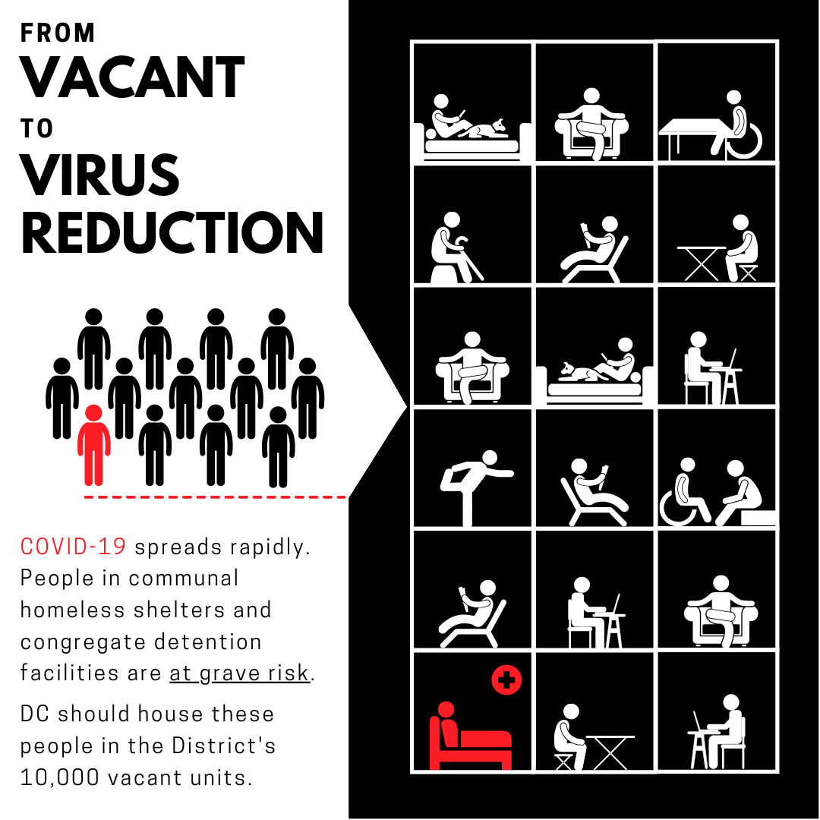

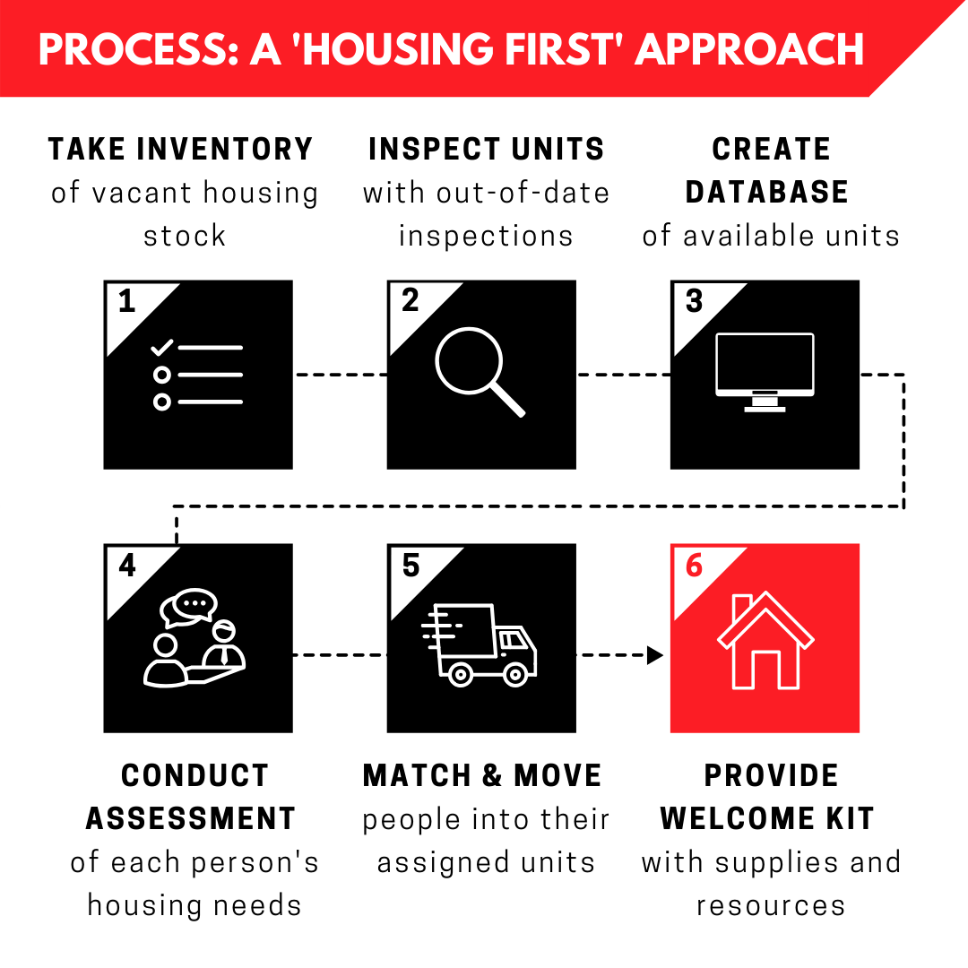
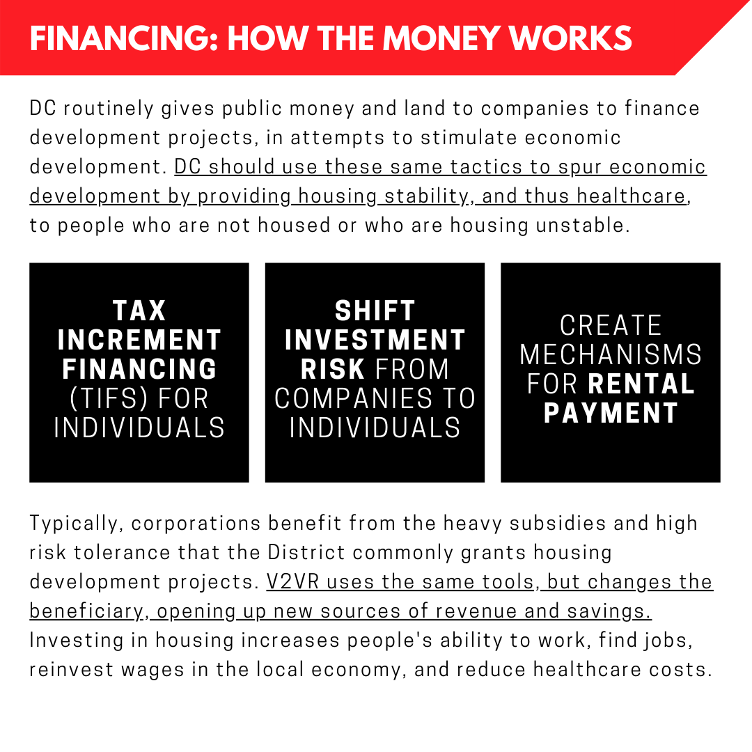

  - Dorms for Decongregation: Use Safe, Habitable Vacant Dorm Units for Decongregation and Short-Term Housing
    - Description: DC must collaborate with colleges, universities, and other schools with dorm space to utilize vacant suites and apartment-style dorms to provide temporary housing to people currently unhoused and/or living in congregate settings. While using hotels is also a beneficial step, apartment-style dorm rooms (and long-time stay hotel rooms) provide additional necessities, such as kitchens, that give people a greater ability and choice to further isolate and remain independent.

    - Sources and Data
      - Article (May 19, 2020) - D.C. should partner with universities to provide shelter (Georgetown University Law Center students)

    - Corresponding Graphics

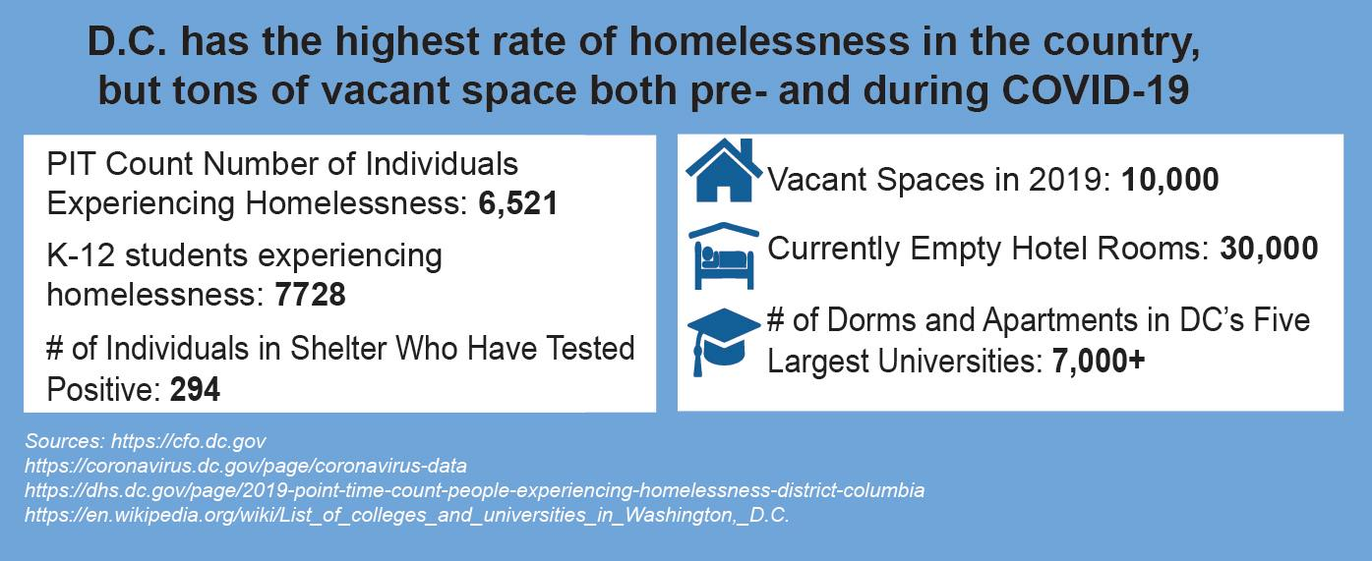

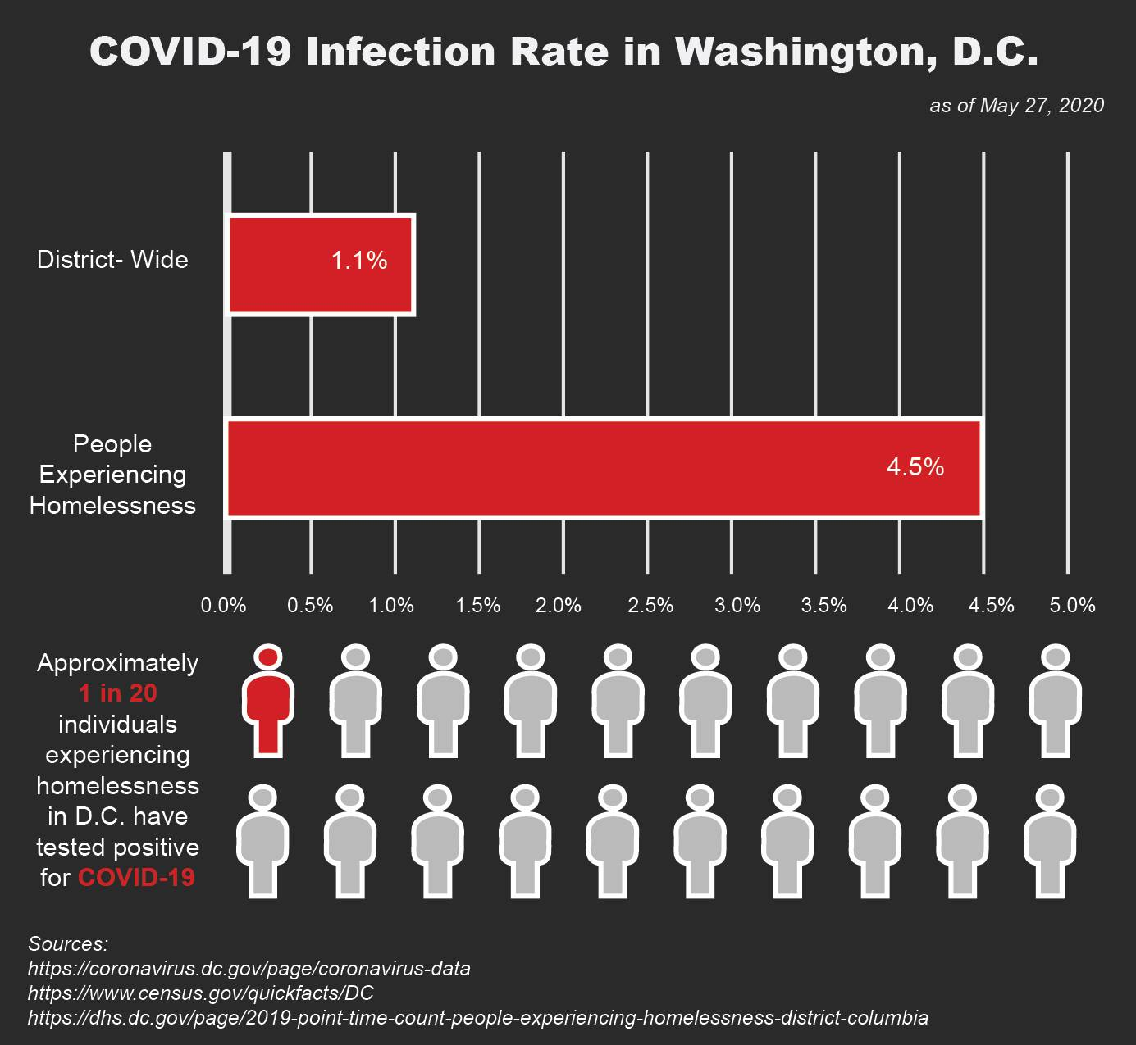

- Divest funds from policing and invest in communities, including putting more money into housing solutions that create truly affordable housing for people with no to low incomes.

  - Sources and Data
    - Testimony (June 6, 2020): Washington Legal Clinic for the Homeless testimony
    - Article (June 15, 2020): Residents And Activists Tell D.C. Council To Reject Bowser’s Police Budget Increase
    - Video (June 9, 2020): Metropolitan Police Department Budget Oversight Hearing (agency testimony) - Metropolitan Police Department (MPD) testifying virtually in front of DC Council regarding the local police budget. Facebook comments include public feedback.
    - Video (June 15, 2020): Metropolitan Police Department Budget Oversight Hearing (public testimony) - 16,000 people submitted testimony this year regarding MPD’s budget, compared to 24 submissions in 2019. Facebook comments include public feedback.

