A Report

Indian Cities: In-Adequacy of housing in times of COVID-19

2020

____________________________________________________________________
This report is a collective effort of the following organisations (in alphabetical order)
- Basti Surakhsha Manch, Odisha
- Construcion worker Union, Sangli
- Deenbandhu Samaj Sahayog, Indore
- Ghar Bachao Ghar Banao Andolan(GBGA)
- Housing and Livelihood Welfare Association (HALWA),Mumbai
- Homeless Collective, Mumbai
- Information and Resource centre for Deprived Urban Communities, Chennai
- Kachara Kamgar Union, Delhi
- Majlis Legal Centre, Mumbai
- Pani Haq Samiti( PHS), Mumbai
- Sajag Society (Delhi)
- Social Empowerment for Voluntary Action , Nashik
- Transforming M ward project, TISS; Mumbai

Introduction: Housing violations by omission during pandemic times in India

March 25th was a day on which the impending threat of the corona pandemic was converted into a humanitarian disaster of immense proportions and with multiple dimensions due to the announcement of a national lockdown. The lockdown imposed several restrictions on mobility, and everyday life in the interest of larger public health. The government also appealed to employers and house-owners to not impose undue hardships like loss of employment or wages and rents in the period of the lockdown. While the impact of lockdown on formal sector was minimal in terms of economic losses; the informal sector which constitutes a bulk of India’s urban population was impacted adversely. There are very few instances (for example Odisha) where the governments have evicted people during the period of the lockdown. Thus, there have been no acts of active violation of housing rights.

Urban poor in Indian cities are working poor and stay in housing that is also constructed informally on lands that are irregular and hence often find themselves considered illegal. Despite the knowledge of this reality, no level of government (National, state or local) applied itself consciously to a consideration of how the lockdown would impact the urban poor. It is this omission which has produced several negative impacts for several urban poor groups.

The following case studies describe housing and other human rights violations suffered by a variety of urban poor groups in India. These range from custodial populations to the homeless to those staying in informal settlements and resettlement colonies and to commercial sex workers. Some of these violations are linked to groups where the actions of the state have not been proactive and adequate to prevent the spread of the infection. In others, state actions in the past such as resettlement and rehabilitated housing have made people more vulnerable rather than resilient to the pandemic. Finally, there are also cases where the vulnerable have been de-housed from their existing space, thereby compelling them to live in worse housing conditions. Homeless have been sheltered but in less than desirable conditions and amidst threats of loss of control over space. Overall, the pandemic and the lockdown have enhanced the insecurity and command over housing and shelter for the varied urban poor groups.

While the conditions of lockdown have begun to be eased over the past few days, the insecurity and uncertainty of housing and livelihood faced by these groups continues. In fact, the issues surrounding the insecurity of housing are multiplying as narratives of restarting the economy( and hence collection of rents), of redeveloping slums( as they pose a risk to the city) and stray physical threats in the form of incidences of fires in informal settlements have begun to increase in cities across the country.

The case studies are organized thematically and city –wise. The names of the organisations that have contributed the case study are identified alongside.
Case studies

- Insecurity, vulnerability and crises of living in slums and informal settlements
Informal settlements form a significant chunk of the country’s urban population; in cities like Mumbai, they comprise roughly half the population. The cases described here are from Mumbai, Bhubaneswar, Puri, Cuttack, Indore and Chennai.

The key housing rights violations faced and elucidated are:
- Few cases of eviction during pandemic
- Harassment by house-owners over rent
- Loss of livelihood
- Crisis of hunger
- Enhanced vulnerability to infection due to inability to keep distancing
- Demands imposed by home quarantines which do not consider the small size of the houses

Mumbai

Ghar Banao Ghar Bachao Aandolan (GBGB)

The denial of right to housing has resulted in creation of slums where people live in sub human condition due the lack of basic amenities, adequate space and inadequate or no ventilation. The existence of slums on a large scale especially in Mumbai where half of its population lives in slum is in itself an evidence that the government whether state or central, has failed to ensure adequate housing to its poor citizens. Prime Minister’s ambitious plan of ‘Housing For All’ has a number of loopholes as result of which the most in need are denied housing.

The World Health Organisation (WHO) declared the COVID 19 as a pandemic on March 11, 2020, along with general guidelines to limit the spread of the virus. These include frequent hand washing, wearing face mask, and most importantly maintaining social distance.

India enforced the lockdown on March 25,2020 with the hope of maintaining social distancing and issued other important guidelines to prevent its 1.3 billion population from coronavirus, only permitting the conduct of essential services.

Social distancing has become a buzzword currently but inoperable in the context of informal settlements where houses are small, where the outside is as much part of the home as the inside. The scale of vulnerability in these slums is linked to the socio-economic conditions of the resident population and the sheer lack of physical, social, and health infrastructure. Due to the Covid-19 pandemic, economic activities and other financial activities have been halted. India has a workforce of nearly 50 crore in the country, out of which according to government data, 42 crores are in the informal sector. These informal workers in the country are at risk of falling into poverty as reported by the International Labour Organization. Migrant workers are an important subset of this informal workforce more than 45% of the working force in India is daily wage earners. Because of uncertain lockdown conditions, the question of survival looms dangerously ahead of them.

Mumbai has a population of 22 million, out of which nearly half-lives in slums. Approximately 9 million people in Mumbai live in areas where homes are hardly two meters apart. Here, maintaining social distancing borders on the impossible. The pandemic has exposed the glaring inequality prevalent in our society. The lack of adequate housing in Mumbai has severely impacted any attempts at social distancing as reflected in the rising number of COVID-19 patients in the city.

Below are three case studies of slum settlements of Mumbai where it is impossible to practice social distancing because of space paucity and lack of basic amenities.

- Sathenagar in Govandi M East ward:
Sathenagar has 5,000 houses with an average area of 150 sq ft. These are built in a row separated by a mutual wall on either side of the 1.5 meters narrow lane which has a open drain in the middle of the road. There is only one community toilet with 120 seats for the entire population of more than 20,000

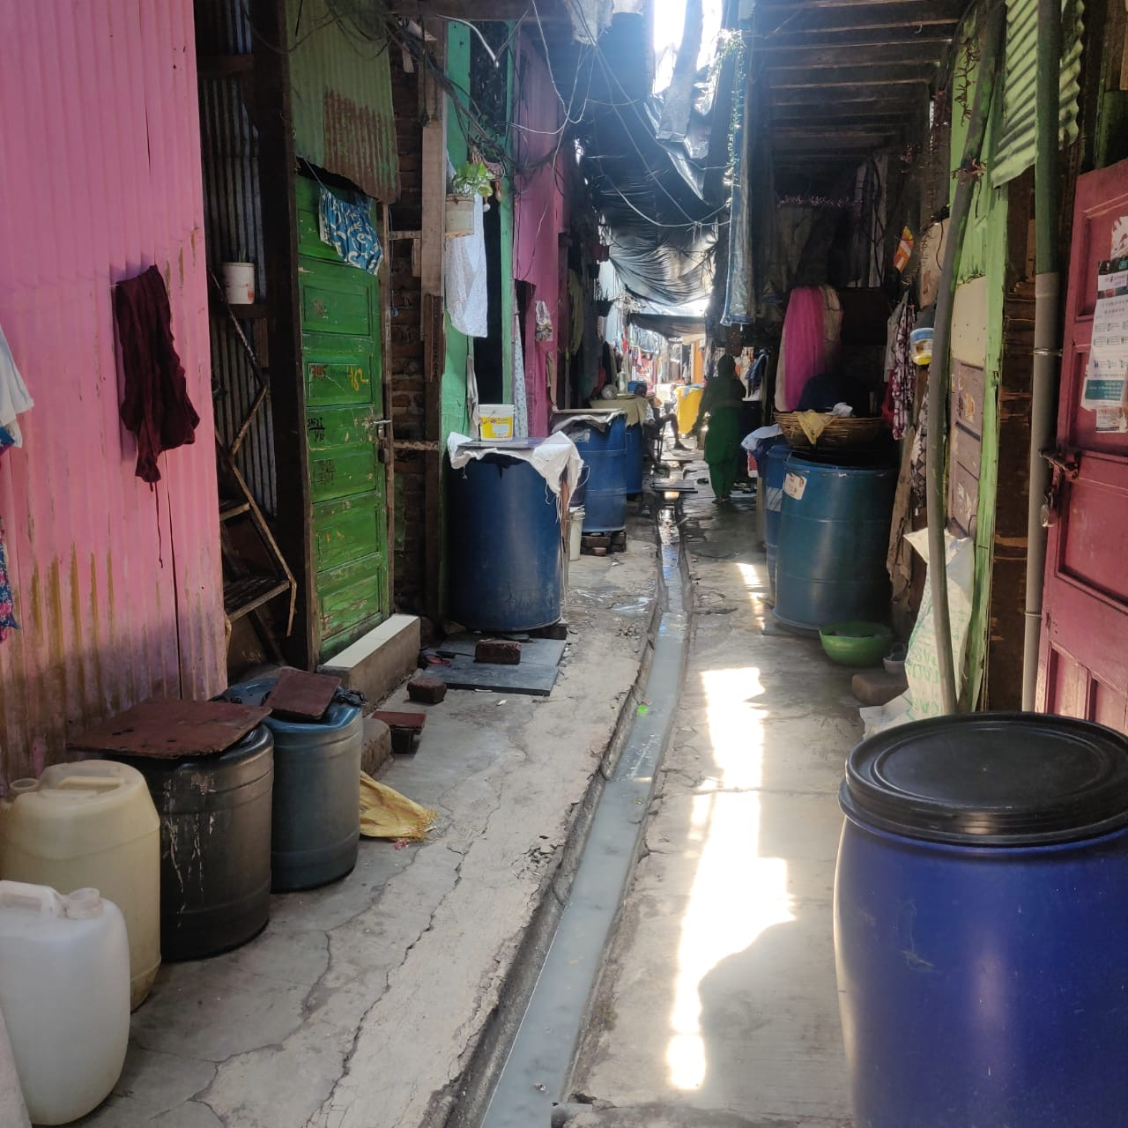
Sathe Nagar, Govandi

- Ambujwadi , P (North) ward :

Ambujwadi has a population of 50,000 with all the houses built next to each other. Each house has an average area of 150sq. ft. More than 25 years old Ambujwadi still lack drainage system, private toilets and potable water supply. Though there are makeshift arrangements created by the government by making few community toilets majority of them not functioning and are inadequate to its population size. Similarly, only two water tanks of 10,000L each are sent daily which only caters to a miniscule population of the Ambujwadi. This water is available at the rate of Rs. 10/40L, a rate higher than what a person living in a Mumbai middle class society pays.
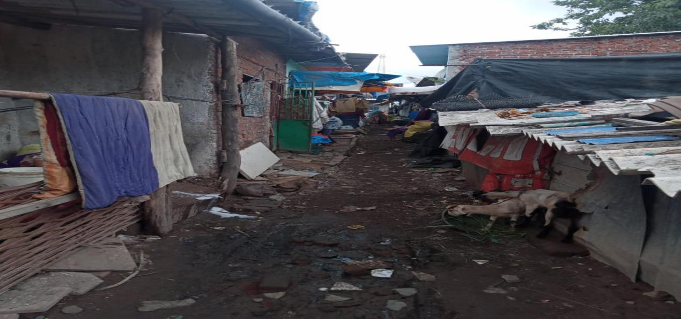

C.Siddharth Nagar, Andheri West

Siddharth Nagar has population of at least 4,000 with 600 households. More than a decade old settlement, Siddharth Nagar still does not have any basic amenity. There is no drainage system, no water connection, no toilets-whether private or community and no electricity connection. The average area of a house here is also 150sq.ft with all the houses lined up in a row next two each other on either side of 1-2 meters narrow lane.
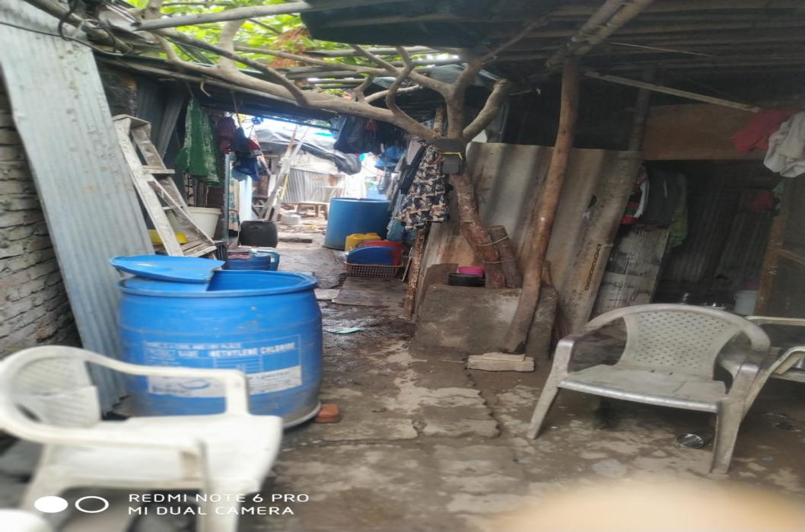

This is the basic layout of all the informal settlements in Mumbai which lack basic amenities including potable water, drainage system and sanitation. Those slums without drainage system will be at the receiving end of the communicable diseases arising out of stagnant water in these settlemen during the impending monsoon.

Also it is impossible to practice social distancing during the water distribution to thousands of people through mobile water tank. It also gets crowded when people have to queue to utilise the highly limited number of public toilets. Those who do not get access to these community toilets are forced to defecate in open. There are places, where the municipal corporation has shut community toilets to discourage crowding without making any other arrangement forcing people to defecate in open.

Photo of a shut toilet in Wadala:
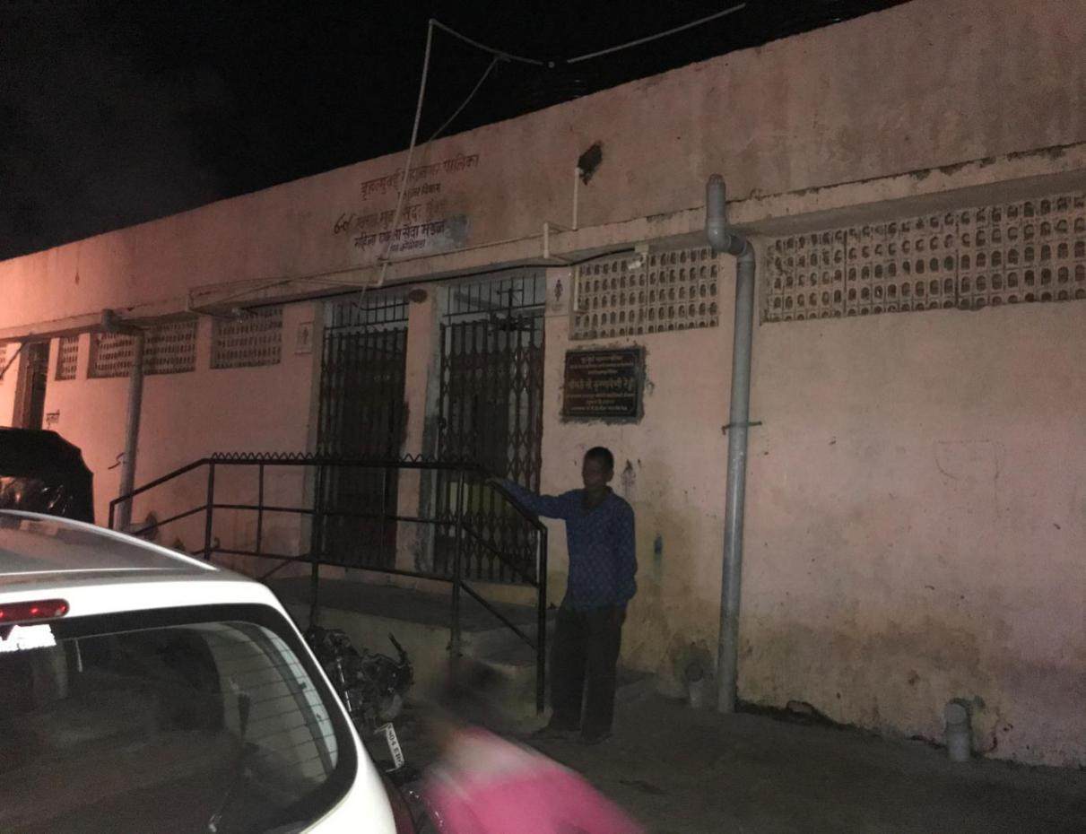

These three case studies are illustrative of how the small houses, dense layouts and poor water and sanitation infrastructure are compelling the urban poor to step out of their houses. The loss of livelihoods of these largely informal sector workers has also made them vulnerable to a crisis of hunger and dependence on state and relief agencies. Further, their compulsion to step out of their homes also makes them vulnerable to being seen as ‘those defying or working against the lockdown guidelines’ and therefore adds to their perception as ‘illegal’ residents of the city who put the entire city at risk. Their own living conditions however are being largely unattended. There is very little attention paid to the improvement of living conditions by the local governments. As a result, the infection count in informal settlements in Mumbai and other Indian cities is rising.

Odisha

Basti Suraksha Manch

It’s now going to be 3 months of lockdown in Odisha. Thousands of slum dweller families are experiencing a crisis of hunger, and loss of income. No work, no wages, many don’t have anything else to eat, many have nothing other than rice. No money to give house rent, electric bills, mobile recharges, online education fees, medicines. No money to repay EMI of loans taken for auto, bike, mobile, tv, led, fridge, air cooler etc. This is the situation of most residents.

Central and state governments declared many economic packages, but that did not reach to the lower strata of people. Those who had ration cards were given advance rice for 3 months and rupees one thousand as assistance. This too was received more than 37 days after the declaration of lockdown. By that time many daily wagers were already experiencing prolonged starvation. Further many slum dwellers don’t have ration cards. They did not get any relief. After 40 days of lockdown the state government declared that those without ration cards would also be provided ration. A survey was undertaken for the same but the number of beneficiaries was frozen at 2000 and the period of assistance was frozen at 15 days. The real need is estimated at more than 100 times of this number. So maximum people were forced to go hungry. Many private philanthropies tried to help but their help is very nominal and limited.

Ground level experience indicates that barely 1 percent of the landlords complied with the government plea to forego rent. This added to the misery of rental households in slums.

The most shocking act has however been the evictions in this period. On 29th and 30th May, the Bhubaneswar Municipal Corporation demolished more than 130 houses of Nilamadhav Basti of Niladri Vihar Area and around 40 houses of Mahisiakhal Basti of BJB Nagar area. Many street vendors and small trader’s cabins were also demolished. In Puri in 2017 May 3rd Baliapanda Basti was forcibly demolished by the Puri Municipality to provide that land to a private society.

The current policy of the Odisha state government is to ask all return migrants from various states to home quarantine themselves. Decisions such as these which do not give any consideration to the small space in the houses make impossible demands on the poor families. Almost all residents have a single room with many family members and use common latrines, bathrooms, water taps etc. This is how residents of informal settlements are becoming more vulnerable to the infection. Institutional quarantine is therefore a must with adequate health and other essential facilities. Further, there is a need for the government to take care of other concerns of these households.

- Denial of water and sanitation
Several informal settlements and homeless communities do not have access to adequate water and sanitation facilities. Some have no access at all, for others access is limited and thus, many people share a toilet or water connections. If the preventive measures for the infection are frequent hand washing and distancing; both are seriously compromised due to this access situation. The cases below describe even worse dimensions of this denial of water and sanitation in times of pandemic

- Mumbai

At least 2 million people in Mumbai are denied access to water connections by the Municipal Corporation of Greater Mumbai(MCGM) , the richest civic body in Asia.
In 2014, as a response to a PIL filed by PHS, the Bombay High Court gave a judgement upholding the Right to Water as a precondition to Right to Life and directed the MCGM to provide water to all people living within municipal boundaries irrespective of the date of their arrival in the city and legality of their residential structure. However, the political leadership of the Municipal Corporation was not convinced. It grudgingly adopted a “Water for all” policy which begins with a list of excluded citizens; those living on Central Government land, private land, homeless and pavement dwellers, people living “near the sea shore” and people residing on land where a “vital project” is planned. These conditions exclude up to 1.5 million people which constitutes a whopping 12% of the city population as per census 2011 data. Another estimated 500,000, who were previously denied water by the MCGM because their settlements came into existence after 1st January 1995, but are now included in the “Water for all” policy continue to face administrative blocks imposed by the MCGM in their application procedures for water connections.

In May 2015, Swachh Bharat Mission (SBM) promised to bring Universal water and sanitation access, even to those living in informal settlements. However, MCGM declared that informal settlements having residence evidences after the year 2000 will not be included in SBM. The state and union governments accepted this condition. Mumbai was declared ODF in 2017, despite the fact that millions still don't have access to safe sanitation and practice Open Defecation.

Pani Haq Samiti (PHS) is a collective of community leaders of 54 peoples’ settlements across 17 administrative wards of Mumbai. Some of the localities we work in are Ganpat Patil Nagar in Dahisar (W) home to approximately 30,000 families, Ambojwadi in Malad (W) (20,000 families), Siddharth Nagar in Versova (750 families), Bhim Nagar in Mankhurd (800 families), Chamunda Nagar in Bhandup (E) (300 families), Indira Nagar and Janata Nagar in Govandi (5000 families), Kokari Agar transit camp in Wadala (2900 families), Kaula Bunder in Reay Road (15000 families) to name just a few. Due to a denial of water connections, these families depend on informal suppliers who charge up to 100 times more than BMC water rates while offering compromised water quality. While BMC supplies 1000 litres for Rs. 5, these families pay the same amount for a mere 10 litres, greatly restricting their water use.

During the COVID-19 lockdown, these informal water suppliers have become unavailable, thereby making access to water supply and sanitation extremely difficult. Today residents of informal settlements who have already lose their livelihoods to the lockdown are also paying double the price for water, i.e. Rs. 10 for 10 litres. Residents must stand in serpentine queues to fill their water cans, exposing them to crowded situations and an increased risk of contracting the deadly virus. Washing hands, which is the first defence against COVID-19 spread, is a luxury they can no longer afford.
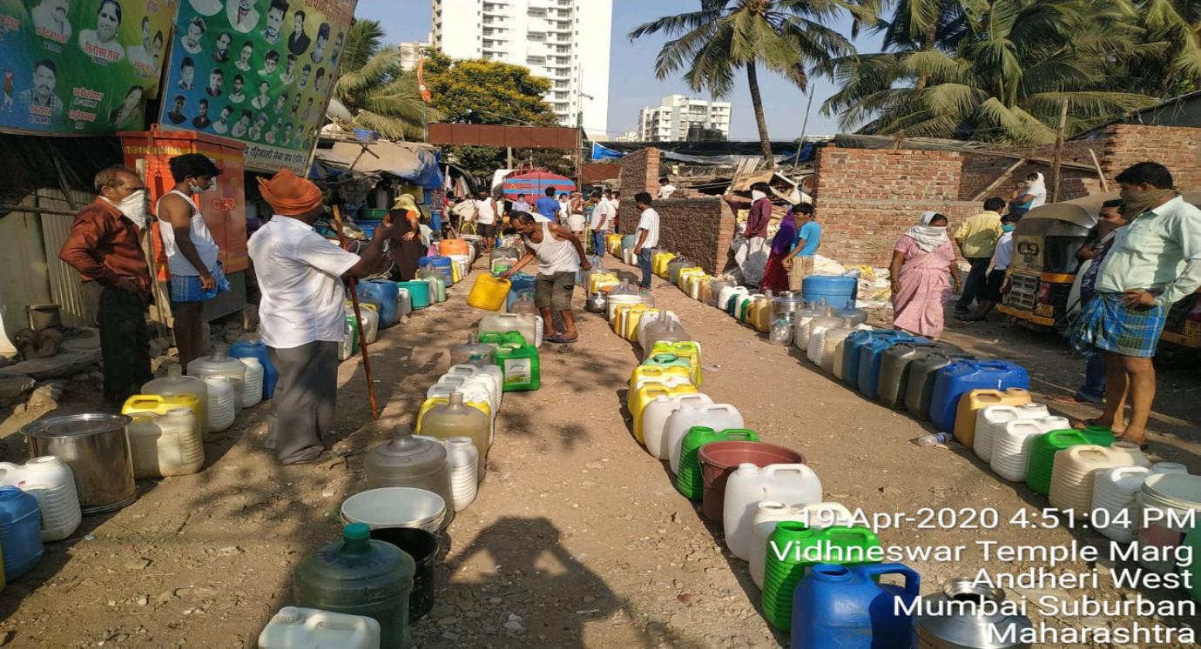Queue for collecting water from tanker at Siddhardh Nagar, Andheri West, Mumbai

PHS wrote to MCGM and Collector’s office asking to provide temporary toilet systems for all informal communities. A list of communities and their addresses was shared. However, the MCGM has denied these requests. Out of 750 pending water applications (from approximately 4000 families) submitted via PHS, only 19 connections (catering to 100 families) have been granted in Bhim Nagar, Mankhurd after a decade long struggle due to relentless advocacy during COVID-19 pandemic.

- Puri,Odisha

Basti Suraksha Manch

Just before the lockdown in Odisha,a basti in Puri was forcibly evicted; they were asked to occupy a nearby plot after interventions of the Basti Suraksha Manch. However, they have not been provided water and sanitation to date. They also do not have access to an electricity connection. The authorities are citing the lockdown as an excuse for the delay in provision of these basic amenities. As a result, the residents of this basti are staying without access to electricity, water and sanitation for the past two months.

- Emerging threats to existence of informal settlements

Incidences of fires

We have noticed that the pandemic and the migrant crisis in Indian cities has been accompanied with incidences of fire in informal settlements in quite a few cities. These fires whose causes remain unknown are not only threats to life and housing within themselves but also because they represent a threat to the claims of poor people to particular places. We record a few cases of such fires in different Indian cities.

- The case of Neemtalla in Tughalaquabad Slum

(Kachra Kamgar Union and Sajag Society, Delhi)

A massive fire broke out in Neemtalla Mohalla a slum in Tuglahalaquabad fort area on the midnight of 25th May,2020. No casualties were reported, a girl child is currently recuperating in the hospital at the time of writing this report with 30 % burn injuries. This is a basti of waste pickers and is located on the land belonging to the Archaeological Survey of India (ASI). Inhabitants of this basti are waste pickers belonging to scheduled caste, scheduled tribes, Muslims and other backward classes. The basti has existed for the over 2 decades and has faced recurrent fires in 2006, 2008, 2009, and 2011. As per the government, 2,661 bigha (unit of land) of land is around the ancient fort is with the ASI of which there is an encroachment on 1000 bigha land. According to ASI maps, lal dora (revenue record boundaries of old villages were identified by a red line, the area inside the marked territory is residential area) land can be used for residential purposes, however, it is merely 120 bigha.

In the year 2014, Kachra Kamgar Union working amongst the waste pickers got the residents registered in the electoral list. There are close to 1200 families living in Neemtall where the fire broke. This is a kuccha (temporary structures of mixed material) basti will people having very few entitlement documents. The waste pickers in the basti are bonded to scrap dealers, who also owns these temporary structures, they are also obligated to sell their daily waste collection to him/ her. The arrangements are such that no rent is sought till the waste pickers sell whatever scrap is collected to the scrap dealer cum tenement owner. The scrap dealer in turn buys the recyclable waste at a lower price than the market rate, the deficit is adjusted as rent. This arrangement by itself is exploitative in nature.

There are no civic amenities in the community and the community is doubly vulnerable due to their occupation and the tenancy arrangement. The fire added to these vulnerabilities. The cause of the fire which gutted down approximately 200 households is not known. . 10 days later a small fire broke out again this time affecting 60 households. A relief campaign was initiated by Kachra Kamgar Union and Sajag Society along with Working People’s Charter, however, the local scrap dealers have attempted to disrupt the relief efforts from time to time.

Currently, the community is out in the open and very susceptible to the pandemic. Since the fire, they are huddled in the remaining houses but it has not been possible to practice physical distancing. The vulnerabilities for the affected people were immense and unresponsive of the officials has further increased their vulnerability. On 12th June, a cash compensation of Rs 25000 has been provided by the district administration to those whose houses were burnt. The injured girl’s family has also received a compensation of Rs 2,00,000. This compensation has however only benefited the scrap dealers who own the houses. Meanwhile, all the affected households are waiting for permissions and assistance for reconstruction of their houses. They are anxious about their immediate future shelter because the incidence of fire is usually associated with attempting to bring in a new set of occupants. They expect protection from the state government which has not been forthcoming so far.

2500 sq yard = bigha

- Bhim wadi, Nashik

(Social empowerment for Voluntary Action, Nashik)

On 25thApril 2020, a massive fire broke in the basti of Bhim wadi at Nasjhik gutting down 104 houses. There were no casualties reported but all affected households lost their belongings. The land on which this basti is located is reserved for a garden. The slum, Bhim Wadi was is divided into 4 sections. One section of the slum caught fire. Bhim Wadi is recognized by the local municipality, tenemnts had access to community toilets and potable water connections. The slums tenements were made of tin sheets and plastic with very few concrete structures. All the affected families work in the informal sector and have been affected by the lockdown. This fire has further increased their vulnerability. 104 households are currently housed in B D Bhalekar School and Urdu School. Collectorate has provided each household with a cash compensation of Rs 5000/ household. They have also got a relief of Rs 10000 from the Chief Ministers Relief Fund. However, this was only possible due to the efforts of SEVA (Social Empowerment for Voluntary Action) organisation. The school is just a mere shelter but due to limited toilets and bathrooms and maintaining hygiene has been difficult. Therefore, their living arrangements and health is compromised.

The government has been responsive, but there have been no talks of rehabilitation and the future of these households remains uncertain. The prevailing spread of the disease in Nashik and the lack of housing options will exacerbate their vulnerabilities.

- Crisis of Rental Housing in informal settlements in Mumbai and other cities

(Habitat and Livelihood Welfare Association, Mumbai)

The Prime Minister appealed for a moratorium on rents as part of the announcement of the lockdown. However, this was not accompanied by any legal or financial measures to offer protection and relied on the good will of landlords. This was especially true of the extremely large and invisible rental segment that exists in slums and informal settlements in Indian cities.

Based on a rough calculation of slum population in Mumbai and an average ground plus 3 structures, a household size of 5, it can be deduced that there are approximately 7 lakh rental housing units in the slums of Mumbai. Though slum houses are not ideal or adequate housing, where civic amenities are scarce, overburdened, and lacking yet they provide some form of protection during the pandemic. Rental housing within the slums is a highly vulnerable category as there are no legal frameworks that address the questions and issues of tenants in a slums.

There are diverse rental practices in Mumbai. Usually, a deposit is paid which ranges from 20000 Rs to 50000 Rs for a tenement in slums. There is also an arrangement of heavy deposits when renters do not have to pay and rent for the period of their stay. In both cases when the family falls on difficult times and is unable to pay rent; the landlords cut into the deposit. And when this deposit is over the renters are either asked to vacate the tenement or are evicted. Extended lockdown due to the pandemic and livelihood losses have made many tenants vulnerable to eviction as their deposits have been exhausted. We have heard many compassionate narratives of landlords at the same time many narratives of evictions. The migrant workers/migrant families who were living on rent and have gone back home have vacated their living arrangements and compelled to forfeit their deposits as well.

A similar situation has also been reported in Jaipur where domestic workers who stay on rent in informal settlements have been unable to pay the rent demanded of them due to livelihood losses and been compelled to live in worse housing conditions at lesser rent.

In Pune, a difficulty in paying rents has been reported by informal waste workers who stay in informal settlements.

In all these cases, these problems and regulation of rent has been largely neglected by local governments and housing departments as slum legislation does not recognize tenancy and there are no legal contracts for rental arrangements.

- PLIGHT OF VICTIMS OF DOMESTIC VIOLENCE DURING THE LOCKDOWN

(Majlis Legal Centre, Mumbai)

The sudden imposition of the national lockdown in March 2020, resulted in scores of victims of domestic violence being “locked in their homes with their perpetrators”. It gave women no time to decide if they wanted to move out or devise a safety plan for themselves. Also, organisations working with victims of domestic violence had no prior opportunity to formulate a strategy for these victims.

Majlis Legal Centre has been providing socio-legal support to victims of domestic violence for the past 28 years. As soon as the lockdown was imposed, we conducted a rapid safety assessment of the victims that we are providing social support and legal representation. Victims residing with the perpetrators (eg: husbands) were identified as more vulnerable. This accounted for nearly 30% of the women supported by us. Though these women have been previously educated on how to handle incidents of domestic violence to ensure their safety, the present situation is peculiar and the team immediately contacted them to ensure their well-being, counsel them and provide them with information / contacts details in the event of domestic violence.

The team has been in regular communication with these women daily / every 2 days / weekly as per their requirement and consent. We have arranged for phone counselling, provided legal advice and updates, assisted with travel and transportation, emergency shelter, registration of FIR/NC and medical assistance. We have provided them with ration, medicines and hygiene equipment. We have even managed to reach woman outside Mumbai with the assistance of partner organisations. It is pertinent to note that as these women have cases pending in Court and most of them are empowered by an order of the Court (for protection, residence, maintenance, child custody, etc). This provides immense confidence to the woman to stand up to the perpetrator and protect herself. It also acts as a deterrent to the perpetrator who fears action by the Court.

In addition to the above, Majlis’ Helpline Number has been receiving 15-20 calls on an average per week, from victims of domestic violence. We also receive queries by e-mail. Broadly, the assistance sought by victims is as follows:
- Emergency assistance due to an ongoing episode of domestic violence
- Requirement of urgent shelter
- How to obtain permission to travel as they cannot continue to reside with the perpetrator
- Assistance with the Police for registration of NC / FIR due to an incident of violence
- Requirement of ration / supplies / medicine due to deliberate economic abuse by the perpetrator
- Legal advice on steps to be taken to file a case against the perpetrator
- Anxious about their pending legal proceedings as Courts have not been functioning during the lockdown
- Mental Health Support

One of the biggest hurdles faced during the lockdown is providing safe shelter to women. During early days of the lockdown, most shelter homes refused to admit women without a test confirming that she did not have COVID19. As per the BMC guidelines a doctor’s prescription is mandatory to conduct the test and if you do not have any symptoms, a doctor cannot prescribe a test. This left women with no options. Throughout this time, Majlis engaged with the Department of Women and Child Development, Protection Officers, Police and Hospitals. We repeatedly stressed on the need for a coordinated response to victims during this time and a protocol to be followed by Shelter Homes so that women are not deprived of safe alternatives.

In furtherance of the above, an online meeting between the Department of Women and Child Development, Protection Officers, Shelter Homes and NGOs working in Mumbai City and Suburban districts was held on 28th May 2020. During this meeting, the WCD Divisional Commissioner, Konkan Region clarified that it will not be mandatory for a woman to undergo a COVID19 test before admission into a Shelter Home. Shelter Homes must make adequate arrangements to quarantine a woman for 14 days when she arrives. Thereafter, she must be integrated with the other women in the home. This was a positive outcome and a cause of much relief for women.

We will be able to ascertain the extent of domestic violence and its impact on women during the lockdown only after the situation improves and restrictions are lifted. Helplines appear to be the most common mode of assistance offered by organisations during this time. However, scores of women do not have access to landlines / mobile phones. Many women who have access to phones, do not have money for recharge. There is no privacy in the home to make such a call and the perpetrator is always around. Due to these factors, the number of women who can reach out for assistance on a helpline is very limited. Several calls received on our helpline are from neighbours, friends and relatives. They inform us about the woman’s problems and re-lay our advice to her when they get an opportunity. Often, women call us from a neighbour’s house or mobile. Hence, it is evident that the home is not a safe space for most woman.

- Sex workers of Kamathipura, Mumbai

Dr. Ratoola Kundu, TISS , Mumbai

Kamathipura is one of the oldest red light districts in Asia and is located in the island city of Mumbai. This neighbourhood was initially developed by landowners who subdivided their plots of land into small parcels and built cheap housing meant to accommodate the poor lower caste migrant labourers of colonial Bombay. Eventually, given that the colonial rulers sought to segregate European prostitutes from the rest of the genteel population using public health as a reason, parts of Kamathipura became internationally known for its European brothels. Thus commercial sex work initially thrived in this area which was in close proximity to the mills, the port, the entertainment district of colonial Bombay and continued to evolve and grow into the Prohibition era as well. However, from the late 1980s and 90s, sex workers began to decline in the area as speculative real estate developers eyed the neighbourhood for lucrative redevelopment projects. This was also an era marked by the rise of HIV/AIDS epidemic which turned landlords against the brothel keepers and the sex workers for fear of the disease spreading. From 2000 onwards, many of the brothels have been converted into small scale manufacturing units. Brothel keepers have been bought off. Some rooms within these houses have been retained for the purposes of rentals by the hour so that the sex workers can continue their work, but at a premium. Many of the sex workers have been forced to relocate to the city’s margins, in precarious informal settlements by the raliway tracks, or to live on the pavements (particularly the elderly). Yet they continue to commute to Kamathipura to find clients and perform sex work. The few who continue to live in the really old , rickety buildings in Kamathipura (most buildings have not been repaired by land lords given the prevailing Rent Control Act applicable in this area), do so knowing full well that the building may collapse or else, it may go for redevelopment, leaving them homeless.

The COVID 19 situation has severely worsened the living and working conditions of these sex workers. Ground reports from newspaper accounts, NGO phone surveys, personal communication with ground contacts suggest that sex work has been completely stopped in the neighbourhood for three months leaving most of these women without any earning. Given that several parts of Kamathipura are in containment zones, sex workers have faced grave difficulties in accessing food , rations, and medicines such as drugs for HIV/Aids, putting their health at great risk. The rooms in which these women stay are typically small, partitioned with cardboard, shared by a number of women who already may have other severe health conditions or children. These rooms are dank, windowless and poorly lit or ventilated. Kamathipura as a whole has a sanitation issue as these old houses only have common toilets for residents that are seldom properly cleaned. Most of these women pay upto Rs. 6000 per month as rent to the brothel keeper/land lord. During the pandemic these sex workers have been spared from paying the rent immediately, but they do worry about when and if at all they will be able to resume their occupation in order to be able to pay their rents.

- Failure of rehabilitation housing

We have earlier discussed how conditions of living in informal settlements have created a vulnerability to the pandemic. The following are cases studies of how the rehabilitation housing constructed by the government is highly inadequate. The slum like living conditions make people prone to several diseases. Further, in cities like Mumbai these rehabilitation colonies are also being used as quarantine centres for poor and custodial populations.

- Mahul Rehabilitation Colony,Mumbai

(Students of TISS in collaboration with Ghar Bachao Ghar Banao Andolan)
Mahul, an erstwhile fishing village has been converted by the government of Maharashtra into a large rehabilitation colony housing 10,000-15,000 families or roughly 60,000 people. The cluster of 72 buildings, seven to eight storeys each, holds an estimated 5,500 families, in 225 sq. feet flats. The MMRDA colony in Mahul is a cluster of 72 seven-storey buildings packed so tight that many of the flats never see direct sunlight. Sewage leaks from overhead drainage pipes and fills the narrow alleyways between the buildings, often seeping into the underwater tanks that supply drinking water. An acrid chemical stench permeates the neighbourhood, and broad plumes of white smoke from the BPCL and Hindustan Petroleum Corp. Ltd (HPCL) refineries dominate the skyline. The Trombay Thermal Power Station is just down the road, as is a Rashtriya Chemical and Fertilizers plant, while the Bhabha Atomic Research Centre is also nearby.
On September 3 2019, hearing a clutch of writ petitions filed by Mahul residents, the Bombay High Court expressed shock over the conditions in which the government had pushed people rehabilitated due to its projects to live. Pulling up the Maharashtra government and Brihanmumbai Municipal Corporation (BMC), Chief Justice Pradeep Nandrajog said the State must treat all its citizens, rich or poor, with dignity. “You cannot let these thousands die. This is not correct,” he said, directing the government to assess the pollution levels in Mahul. The statement made by the court was based on a number of qualitative and extensive empirical research studies, most of which concluded that “The air quality of Mahul is not safe for use by the people”. The latest report is of the CSIR (Council of Scientific and Industrial Research)-NEERI (National Environmental Engineering Research Institute), released in 2018, after over three years of research. It recommended that Mahul be declared ‘Air Control Region’, with no residential premises allowed, and called for plugging of equipment leaks, pumps, valves at factories, and thorough inspections to reduce emissions from both plants and refineries. A 2013 survey by the Environment Pollution Research Center (EPRC) of King Edward Memorial hospital found that 67% of the residents in Mahul complained of breathlessness more than three times a month, 86.6% suffered from eye irritation and 84.5% reported a choking sensation due to bad air quality. The EPRC also noted that these symptoms match those caused by exposure to toluene di-isocyanides, a possible carcinogen that is toxic even in low concentrations. Mahul Township leads to low air-flow with the alleys. Normal ventilation at Mahul Township does not meet the ventilation effectiveness and is not sufficient to remove high concentration of air-pollutants from the site. Also, there is a limited direct sunlight in courtyards and alleys and a result of lesser distances between buildings. This low inter-building distance has adverse effects on the air-exchange rate, ventilation effectiveness and daylight levels within the Mahul Township. Also, according to the report published by IIT-Bombay, about 204 residents suffer skin infections, 129 live with chronic fever and colds, and around 200 have reported loss of wages and jobs. Indeed in 2015, the National Green Tribunal declared the air of Mahul unfit for human habitation, a claim that the state and the BMC have been denying. To make things worse, there aren’t any hospitals in Mahul except a local clinic that’s unpopular among the locals, mostly because the doctors often dismiss their symptoms.
The residents of Mahul were already economically vulnerable due to their forced displacement. With the beginning of the lockdown, there has been a further rise in unemployment, leading many residents to travel back to their native villages for survival. Those remaining are finding it difficult to pay for essential services, with many pushed into the informal sector as recorded in the interviews.
The following narratives were compiled through six telephonic interviews of Mahul residents between 11th and 12th June 2020. The interviews were unstructured with questions about the health history of family members, access to essential services and health facilities and the impact of the nation-wide lockdown in the region.
Life has not been kind to the residents of Mahul, with air choked with chemicals, poor water & sanitation, and this pandemic- the situation has aggravated to worse. Mahul, an unfortunate home to approx. 5000 families living in 225 Sq. feet each has remained aloof from almost all government initiatives. On an average, with more than 45 positive cases, every building has at least one corona patient and on enquiring whether social distancing has been possible in the Mahul, one of the respondents replied “Har building mein ek na ek case hai, khabardari koi nhi leta” (Every building has at least one corona positive patient, no one takes accountability of that) .Covid can escalate badly.“Badhega to bhi marna hai, nhi badhega to bhi marna hai- hamari jaan ki kisi ko nahi padi hai'', one of the respondent replied.
One other respondent explained that there was never ever any Social distancing in Mahul, “Social distancing hui hi nhi kabhi Mahul mein”, She said. With up to 9 members in an area of 225 Sq. Feet and with no facility of public quarantine, there is not much space also for maintaining social distancing. Though sanitization has been done few times in Mahul but in place of door-to-door sanitization, it has been done on main roads only which has remained less effective as most of the patients are home quarantined and without proper sanitization
Another 60-year old respondent with a heart condition lives with her sons; she is afraid even to step out of the house and tries her best to avoid it. On seeing others in the locality without masks, she reprimands them. Due to the poor quality of the water available, she purchases water from the market. To get essential services like food grains and medicines, one must walk at least 20-25 minutes. Even then it was difficult to get essential items as shops were mostly closed. The long distance travelled had to be undertaken frequently for perishable commodities, making it cumbersome. Sanitizers and masks were largely unavailable. The closing of shops apart from causing difficulty in accessing goods, had also led shopkeepers to hike up their prices. In terms of health services, one had to travel to Ghatkopar from Mahul to get access to a big hospital. There were even no nursing homes nearby. It is dangerous to approach the medicine centres provided by the Corporation as it was crowded. It was safer to visit medical centres with lesser crowds.
There are no quarantine facilities nearby. If influenza-like symptoms were seen in residents, they called up the municipal authorities for testing. Individuals tested positive at home were quarantined within their homes for 14 days. It is extremely difficult for such people to obtain essential items and even their neighbours to help out. Door-to-door checks inquiring about the people’s health status had also been undertaken. Unlike many residents who travelled back to their native places in Maharashtra or other northern states in the face of widespread unemployment, the respondent chose to stay to avoid travel expenses and gather savings. Her sons had been out of work for the last three months. However, they could stay at home unlike others who had to step out their homes for work and survive.
Thus, due to the faulty structural layouts, overcrowding, inadequate access to essential facilities, poor water and sanitation facilities, the highly polluted environment of Mahul, it was extremely vulnerable to an outbreak of covid-19. The prevalent worsening health condition of its residents also has the potential to negatively affect Covid-19 fatality rates due to co-morbidities. The protocols of social distancing have been impossible to follow in such a setup, with patients testing positive left with no other option than home quarantine due to lack of access to hospitals. It is difficult for neighbours, without appropriate protection, to provide them with essential services. Neglect of the area by city authorities is consistent cause of worry. Further, the nationwide lockdown has compounded the problems of Mahul residents, even struggling for bare survival with difficult access to subsidized food and medicines. The subsequent loss of jobs and inflationary hike in essential commodities is continuing to push these already vulnerable residents to the socio-economic margins.
- Anna Bhau Sathe Nagar, Indore
(Deen Bandhu Samaj Sahayog)
Suresh Chandne was the prominent leader of housing right campaign in Madhya Pradesh, He died two years back by disease due to un-hygienic conditions in Anna Bhau Sathe Nagar colony where he was living since 1995, shifted by Indore Municipal Corporation in 15% reserved land for economically weaker section. He left three son & one daughters along with his wife Susheela, one of his son Aakash also died in same conditions, nine years back. And one more son Sagar died again in same conditions last year. Now remaining two son Amar & Prem are doing waste picking job with their mother and sister Sanjana is doing segregation work at home as Suresh don’t want her to go outside for work and want that she should study, but after his death conditions are changed.
They all were somehow trying to run their life with joint effort, but the conditions became more critical after the lockdown was declared. They were unprepared to deal with for this, they had no savings , the conditions of their slum & houses were inadequate and so now they had to deal with hunger & disease both.
A routine call, to the mother produced the following narrative: “ Didi hum log bhuke to mar hi jayenge lekin mera beta Prem ko khun ki ulti ho rahi hai, dawai bhi nahi mil rahi, police wale maar rahe hai, paise nahin hai, yaha ki halat aisi hai ki 21 din me na jane kitno ki halat kharab ho jayegi, kitne mar jayenge, hume ek bhi mouka nahi diya sambhalne ka on shahar band kar diya”(We are hungry, there is no food to eat, no money and no money for medicines for my son). Sushila started crying.
This was not only the condition of single family but, most of the families were suffering from these problems and not only in Anna Bhau Sathe Nagar but in many more slums of Indore, Bhopal & Jabalpur, where DBSS is working.

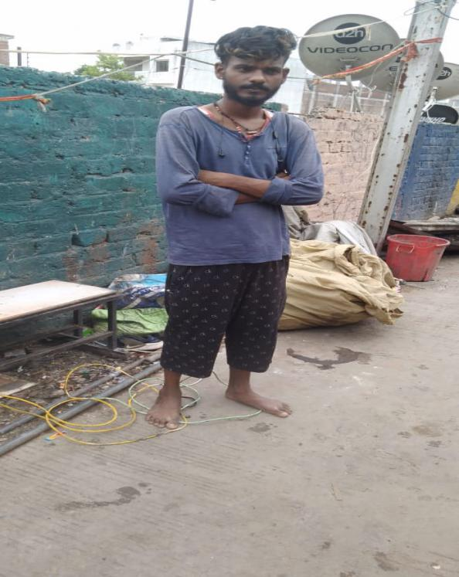
Prem who also suffers from T.B and is a member of Chandne family
Anna Bhau Sathe Nagar was supposed to be one of the best rehabilitation models of administration but unfortunately it is not. They were supposed to get registry of their plots till now but still not. People here are in position to improve their housing through incremental process, but waiting for government to give approval and register their plots.

More critical conditions were in the resettled colonies i.e. Bada Bangarda, Panchshil Nagar, Nainod, Ahirkhedi, (all were BSUP and communities are shifted in 2011 or around). Here it was not possible to maintain the guidelines of administration or any agency due to the design & structure. Maximum here are engaged in waste picking, mistri work or labour work. They are facing both hunger & pandemic problem.
- The plight of Construction Workers
(Construction workers union, Sangli, Maharashtra)
After the announcement of the lockdown, all the states were asked by the Central Government to offer protection to the workers. However, the Maharashtra Government and Maharashtra Construction Workers Welfare Board did not undertake any measures for construction workers. The decision to pay every construction worker a sum of Rs 2000 from the construction workers cess, which has been unutilized since 2005 and in Maharashtra now amounts to more than Rs 10000 cr would have given partial relief to construction workers who had lost their livelihoods and were in desperate need of cash. However, majority of the construction workers are yet to receive this sum of Rs 2000. Currently the construction workers registered in Maharashtra is 12,16000. Of these, only 7,00,000 workers have received the amount.
Many construction workers are migrants and hence desired to return back home. They had demanded a cash amount of Rs 10,000 for the same. The government not only rejected this demand but also denied permission to leave destination cities. This generated an unprecedented migration crisis. Thousands of workers walked on the roads; their feet swell; pregnant women in the last stage of their deliveries also walked, young children walked or were partly carried by their elders. They received help in some places but overall more than 80 workers lost their lives en-route. The Government of India and every state government has been completely failed in providing effective support to these migrant workers. Some workers traveled as far as Jharkhand, Bihar, Uttar Pradesh covering distances of 1000 km.
Arrangements for repatriation through railways were made very late and were extremely inadequate. Maharashtra government could have been some arranged for free bus transport, but these were also very insufficient. The processes of registration, getting a police permission and health checkups were complicated; resulted in chaotic situations and several instances of crowding. The lack of coordination between sending states and destination states, the fixing of fiscal responsibility and finalization of protocols took a lot of time. Several organisations throughout the country then filed a case in the supreme court; and its directions have provided some relief. However, a lot of hardship could have been avoided if the Government of Maharashtra had ensured the award of cash compensation and money for repatriation in the first place.
IX: The Situation of Homeless
The homeless are perhaps one of the worst impacted population groups among the urban poor. In several cities, there have been attempts to move the homeless off the streets and into shelters. However, both the manner of displacing them from their existing shelters and shifting them to places where living conditions were poor and amenities inadequate has made them vulnerable to the pandemic as well as increased their vulnerability to impacts of shifting policies of the state.
- Mumbai
Homeless Collective, Mumbai

As per 2011 census, across the nation there were 5,56,896 homeless families. Of these, 57,416 homeless people were in Mumbai. The Homeless Collective strongly opines that this is a gross underestimation and the real figure is approximately 1,50,000 in Mumbai alone.

On 5th May 2010, the Supreme Court issued the following guidelines on this issue: Every large metropolitan area, i.e. with a population of more than 5 lakh, must provide a shelter with a capacity of 100 for every 1 lakh people. As per census 2011, the population of Mumbai Municipal Corporation is 1,24,76,000. Therefore, as per the Supreme Court guidelines, it must be equipped with at least 125 shelters with a total capacity of 12,500. Under the Deendayal Antyodaya Yojana - National Urban Livelihoods Mission (DAY-NULM), the Ministry of Housing and Urban Affairs Government of India granted 126 crore rupees to MCGM for building shelters for the homeless in 2012. The MCGM has not built a single shelter but they support 23 shelters operated by NGOs with a total capacity of only 500 minors. The fact remains that nearly the entire homeless population of Mumbai lives without a roof over their heads.

Despite the Bombay High Court issuing an order against all evictions during the COVID-19 lockdown, the MCGM has continued its illegal practice of evicting the homeless from their makeshift shelters during the pandemic. The Homeless Collective wrote to MCGM demanding a stop to evictions. The Chief Minister gave a directive that the homeless must be accommodated in shelters during the COVID-19 lockdown. However, in the experience of the Homeless Collective, the administration did not take adequate measures to ensure this.

Following are the reported cases of illegal evictions:

25th March, Goregaon (P-South Ward)
The MCGM shifted 50 homeless families (180 people) to a school in Goregaon. However, on the very same day, the Collector objected to sheltering homeless persons in school buildings. Next morning, they were relocated to a MCGM-owned multipurpose hall where they were not given any food until 4 p.m. Subsequently, residents of the neighbourhood complained about the presence of homeless persons, expressing fear that they may be infected with COVID-19 and will spread the virus. They insisted that they do not wish to see homeless people anywhere near their buildings. The MCGM neither tested those in the shelter for COVID-19, nor did they reassure the residents. Out of fear of being attacked and under pressure to leave, the homeless families ran away on 27th March night and returned to the place they were previously occupying.

27th May, Vile Parle (W) station
18 homeless families reside here who earn their livelihood through hawking and contractual conservancy work (cleaning the city's drains and other sanitation services). The lock-down had already taken away their livelihood since they are daily wage workers. Members of the community had been employed by MCGM contractors for pre-monsoon cleaning of storm-water drains. While they were away doing this work, their shelters were demolished on orders from MCGM under police protection. No notice was issued prior to the demolition. When affected people tried to complain to the police, they refused to register a complaint. Families were not given any alternative accommodation and were told to "disappear" with a warning that they must not be seen in the area henceforth. One of the families had a baby born 10 days before the eviction. In such a situation, their eviction is nearly a death sentence.
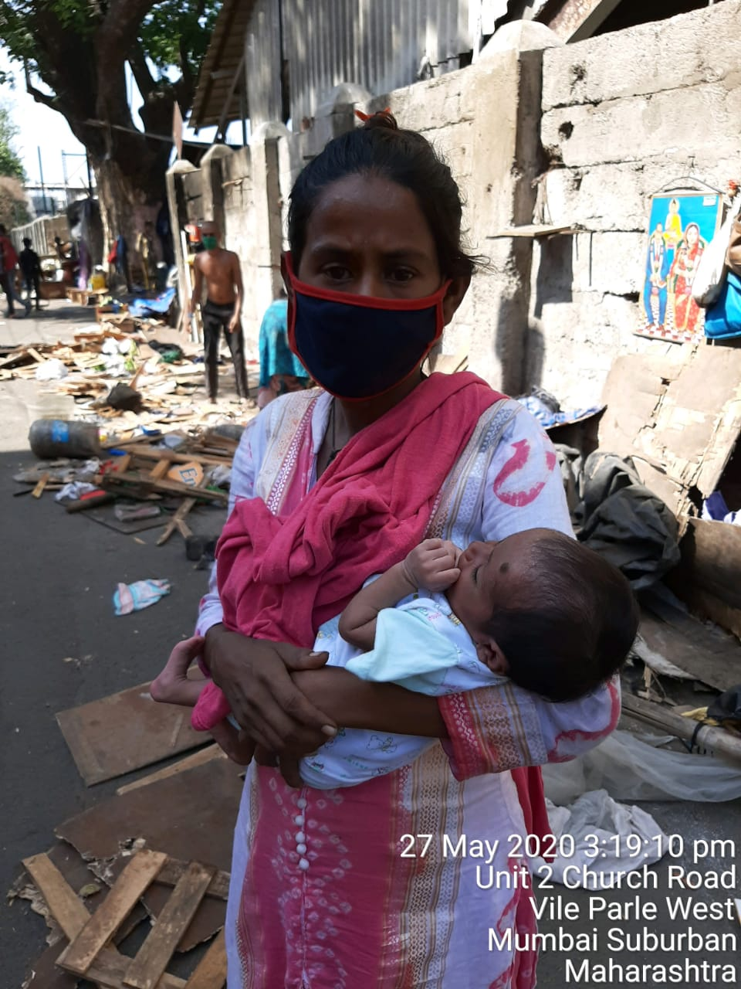

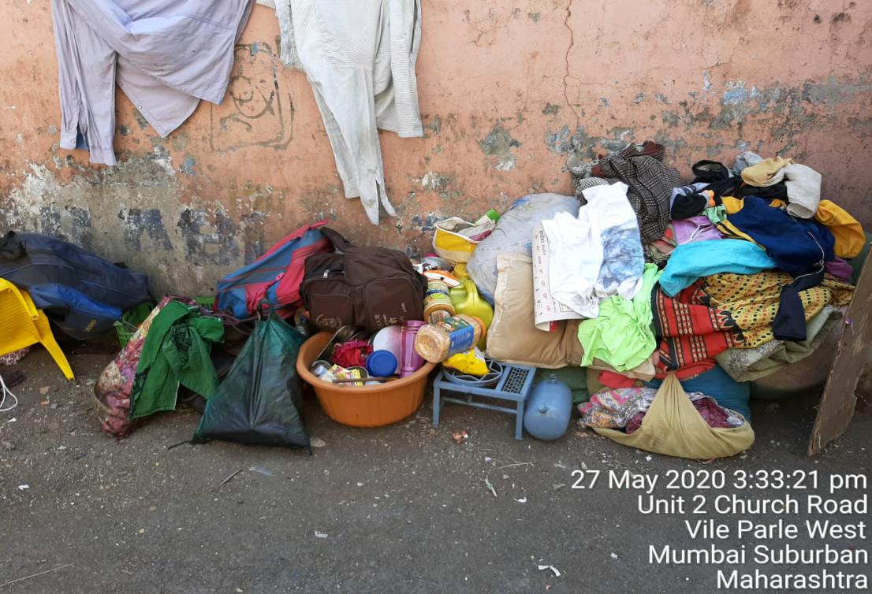

3rd June, Poisar Gymkhaana, Kandivali (W)
35 families were sheltering along a wall. MCGM wanted to use this wall for painting a Public Service Announcement about protection from the Corona virus. They demolished two families' shelters before the other families raised their collective voice against the action of authorities and forced them to leave.

1st May, Bahaar Cinema Signal, Vile Parle (E)
12 families reside at the signal juncture under the bridge. In an attempt to evict them by force, police burnt the belongings of 6 families including their clothes and grocery items. The rest ran away with their belongings as they were told to "not be seen here again". However, lacking other prospects, the families returned to stay at the same site. On 17th June, at 2 a.m., the police returned, burnt the belongings of one more family and warned them all to leave. Involvement of MCGM is unclear.

Neither the MCGM nor the police are willing to report these complaints. When affected persons have attempted to lodge complaints, the police have threatened to arrest them under false charges of selling drugs. While the MCGM is mandated to build permanent shelters for the homeless as per Supreme Court guidelines and has also received government funds to build these, none of the evicted families have been offered rehabilitation, temporary shelter to practice social distancing or even eviction notices. They have abruptly been told to leave.
Other issues faced by the homeless are:

Access to food: Most homeless families do not have ration cards that allow them access to food from the public distribution system. Therefore, Homeless Collective demanded rations for non-ration card holders. The Assistant Municipal Commissioner agreed to provide grains and delivered them in 2 wards; A and P-South. However, the Assistant Commissioner was soon transferred and the process got stuck, following which all homeless families became completely dependent on charity from civil society organisations or residents near their shelters.

Access to WASH: The homeless in Mumbai use public toilets built by the MCGM but run by private operators. During the lock-down public toilets were closed for the first 15 days. When the toilets were re-opened, they charged money for every use, even though the MCGM issued a circular prohibiting this. Since people did not have money to pay for toilet use, Homeless Collective initiated a discussion with the public toilet operators. Some agreed to not charge money but most continue charging because the MCGM has not offered private operators any funds as compensation.

The homeless are dependent on nearby housing societies, public toilets etc. for water supply. Due to the fear of COVID-19, their access to these water sources has been halted. In spite of the Homeless Collective's requests to the MCGM to provide water to communities, supply through tankers was only secured on one site near Poisar Gymkhaana. Therefore, during the pandemic, when the need for maintaining hygiene was prudent, water and sanitation access was taken away from these communities entirely making them more vulnerable to the disease while simultaneously denying them dignity of life.
B.Chennai
(Information and Resource Centre for the Deprived Urban Communities,Chennai)
Have any measures been taken to provide safe accommodation for persons in the situation of homelessness during the pandemic and in its aftermath?
The Urban Homeless and the Informal Settlements are the most affected during the COVID-19 Lockdown Absence of Shelter: When ‘staying indoors’ is one of the important strategies for the control and prevention of COVID-19, for the homeless ‘staying indoors’ is not a possibility. In Chennai, there are nearly 7 containment areas where the urban homeless families are residing. In one of the area located in North Chennai, the homeless families were ‘home quarantined’ in the streets. There were no specific relief camps organised for urban homeless families who were unable to access the other shelters for the individuals

Loss of Livelihood: The COVID -19 lock down affected the livelihoods of the urban homeless (who are engaged in street vending, unloading/loading works, domestic and construction works) are affected and they are unable to afford for their meals. Most of the homeless buy foods from the street vendors who provide food for subsidized rate or from Amma Unavagam (Canteens providing subsidized food) but now the vendors who used to provide food have shut down.

Increased Vulnerabilities of the Elderly Homeless: Though there were Amma Unavagam that was to provide free food for the urban homeless, the most affected were the elderly, as they were unable to walk to the Amma Unavagam in the neighbourhoods to access food. With most of the shelters for the homeless brimming to its full capacity there were many destitute homeless continuing to reside in the streets, with no access to food, water or health care services.

Access to Water and Sanitation: 79% of the urban homeless depend on the public toilets for toilet, bathing, and washing clothes and lack of hygiene in these toilets continues to be a cause of concern and there were no strategies adopted by GCC to ensure social distancing or disinfectants of these toilets. There are public toilets available in the areas especially in Zone IV and V not constructed specifically for the homeless but because these are highly commercial areas with increased number of persons visiting the area. In Zone 5 (Royapuram), nearly 1500 homeless individuals were dependent on one public toilet. Non-availability of adequate water facility (for drinking and hand washing) and the lack of income to afford for disinfectants and masks further increased the vulnerability of the homeless.

Issues faced by Children and Women: With most of the children not enrolled in ICDS centres and with the schools closed the children are unable to access adequate nutrition. Many of the destitute elderly were rescued from the streets with no food or water. The homeless elderly, children, pregnant women, lactating mothers, and those with comorbid conditions who were continuing to reside in the streets were at risk, especially without access to shelters..

There were also instances when many shelters (especially those located in the hotspot locations) and the relief camps were full, that many homeless were asked to go back to the streets. COVID-19 lockdown has exposed the gaps in the existing programmes that had failed to safeguard the urban homeless in the city and in the state.

References:
https://timesofindia.indiatimes.com/city/chennai/shelter-homes-turn-away-the-homeless-citing-coronavirus-contraction-fears/articleshow/74739445.cms

https://www.newindianexpress.com/cities/chennai/2020/mar/22/corp-schools-to-be-opened-up-to-homeless-2119995.html

https://www.newindianexpress.com/cities/chennai/2020/mar/31/around-30-homeless-people-street-quarantined-in-chennai-without-toilets-and-masks-2123885.html

What measures (if any) have been taken to protect persons in informal settlements, in refugee or IDP camps, or in the situation of overcrowding from COVID-19?

In Chennai, over 90 Non Government Organisations were involved by Greater Chennai Corporation for providing awareness, distribution of masks, conducting fever camps, identifying most vulnerable and those with co-morbid conditions. However, the main challenges faced in the informal settlements are as follows
(a) Most of the settlements practicing physical distancing is not possible because of the congested nature of the settlement;
(b) Scarcity of water for washing hands and shared toilets is a cause of concern;
(c) Small residing space and less of opens spaces in the settlements renders it difficult to stay indoors
(d) The adverse impact of the lockdown on the livelihoods of the individuals resulted in increased domestic violence in the families

Of the 1,131 city slums surveyed under Rajiv Awas Yojana, 60 per cent of residents were found to be staying in houses smaller than 215 square feet, making social distancing a challenge in itself.

Information compiled by Information and Resource Centre for the Deprived Urban Communities reveals that of the 701 containment zones listed as on May 16, at least 170 are in slums. Of these, 21 were ‘untenable’ and located in areas such as near water bodies or rail tracks.

References:

https://thefederal.com/the-eighth-column/bursting-at-the-seams-urban-slums-became-soft-targets-for-coronavirus/
https://www.newindianexpress.com/cities/chennai/2020/may/25/covid-19-pandemic-social-distancing-is-an-illusion-in-chennais-slums-2147555.html

