Joint Submission to the UN Special Rapporteur on Human Rights and the Environment

Project Dryad and Terre des Hommes Germany welcome the opportunity to submit written information following the UN Special Rapporteur’s call for inputs for his report regarding the human right to a safe climate. This input is provided, recognising:

- Children’s heightened vulnerability to the impacts of environmental harm, including the impacts of climate change which are already occurring, and the anticipated impacts which will disproportionately affect children and future generations.
- The corresponding heightened obligations of States (and duties of businesses) to uphold children’s rights as set down in the UN Convention on the Rights of the Child, noting its near universal ratification.
- The consistent infringement of children’s right to be heard on environmental issues, including climate change, as vividly demonstrated by the disconnect between the current emissions gap, policies and the demands of the growing movement of school strikes for the climate (Fridays for Future).

This submission provides a summary of messages received from children and adolescents around the world regarding climate change and the action that must be taken by Governments in particular.

These messages were received via a global poll that is being conducted as part of the Global Initiative on Advancing Children’s Right to a Healthy and Sustainable Environment. As you know, the Global Initiative seeks to promote the recognition and implementation of children’s right to a healthy and sustainable environment at national, regional and international levels.

The poll opened in May and will remain open for the duration of the Global Initiative (2019-2020), with a view to gathering as many inputs as possible. The responses included in this submission represent only a selected sample of those received that relate to climate change, and which have been condensed/consolidated, and grouped thematically. The full results are available at the following links in English, Spanish, and Portuguese. The WordCloud on the final page represents the results of all (translated) responses received.

In particular, it should be noted that an overwhelming number of responses emphasised the need for environmental education.

Summary of responses from children (<18 years old) to the question:

“What actions do you want world leaders to take that you would like to be included in a Global Declaration on Child Rights and the Environment?”

- General messages

“There's no doubt that Earth is a giving planet. So far, it's the only giving planet, everything we ever needed to live, to survive, to enjoy the wonders of the world was provided by nature: oxygen, water, food, shelter… yet we are destroying the only life we ever knew. We humans have become the most dangerous threat to life on Earth.” – Indigenous Youth leader Doreen Ocheing

“Today we consume 1.5 planets a year. In the same way that a government's finances are monitored so that it does not spend more than it collects, so the exploitation of the resources of the planet must be balanced and supervised.”

“I want leaders to recognize that climate change is real and take serious action”

“We must consider all the 3Ps equally PLANET PEOPLE ‍‍‍ PROFIT ”

“I want world leaders to not be the people who will not help solve climate change because it costs money. I want world leaders to help people, particularly the people who are affected by climate change the most. I want world leaders to solve climate change, save animals and our world”

“Accept that we are facing a new challenge and if we don’t work together our planet won’t survive. The children won’t have a home. We have to work together. Raise our voices and help each other to do better for us and our planet.”

“We want a world which ensures a peaceful and protective environment for children around the world... Especially to all the powerful countries around the world who have power and resources not [only] to change their own country but to also play a significant role in developing other countries ...just for the sake of children [as] they are our hope for the future.”

“To take into the account that children live in the world left behind by the current world leaders, and that we do not need hope, we need action. The actions taken by world leaders today are those that will define them and their legacy in future. Children and future generations are watching. It is a child's right to grow up in a healthy and safe environment [that is] conducive to their success. Based on current trends, that may not be the future environment that children will grow up in.”

- Limiting and responding to climate change

“Globally move to a carbon neutral society and 100% renewable energy. A transition and phase-out of coal, oil and gas (fossil fuels). A circular economy. Prioritise the future of my generations, and younger generations over everything else.”

“All public policies should be based on true sustainability, considering that all action has a reaction for present and future generations”

“Plant trees, stop greenhouse gas emissions and save the planet’s water”

“Transition to renewable energy sources and a significant reduction of animal agriculture to make way for more sustainable farming practices”

“Forced deadlines to migrate to green energies”

“Strict control of the emission of polluting gases in the world, with real follow-up to the agreements made in previous years”

“Sanctions for countries that break global treaties and protocols”

“No public money to fossil fuel development”

“All schools powered by renewable energy”

“Establish an independent global investigative body, to investigate abuses of children's environmental rights”

“Introduce a carbon tax”

“Introduce a GREEN NEW DEAL Circular Economy”

“Start taxing every anti-ecological action. People do what's easier and cheaper. Well, let's make it way more expensive and promote the right decisions”

- Transport

“End of the prioritization of cars as a means of transportation”

“Create accessible, cheap public transport”

“Promote electric green vehicle”

“Everyone should cycle to school”

- Trees

“Stop cutting trees!”

“Plant a tree on birthdays”

“Plant a seed for each new born everywhere in the world”
“It should be made compulsory to plant a sapling at least once in a week for every citizen just like paying income tax”

“More trees in schools”

“Reforestation of deforested areas”

“The territory of the Amazon forest should be put in permanent preservation”

“Limit the deforestation caused by agriculture”

- The role of businesses

“World leaders need to pass laws to make sure that big corporations cannot damage our earth any more than they already have”

“Create a law that [requires] every company to save energy”

“Legal actions against large industries that pollute in large quantities”

“Severely sanction companies that use non-renewable energy sources”

“More severe fines on companies that pollute, with funds earmarked for the recovery of the environment or impacted communities, or financing of economic initiatives (creation of green jobs, for example) to promote sustainable development”

“Effective control and inspection actions of industries that are polluting or using natural resources outside the parameters established in global agreements”

- Education

“There must be compulsory education from the first phase of student life about environment and our duties towards the environment”

“It is crucial that children from infancy learn about environmental culture, through a school course to address environmental education, green solutions, [and] technological advances for the care of the environment”

“I would like leaders to include climate education and resilience in the local curricula and also live by example”

“Create programmes with the sole purpose of educating people regarding the climate crisis, create a mandatory one-year course in schools for young children in which children will be taught the dangers of climate crisis in detail and how they can help reverse it”

“Adoption of environmental education in schools, aiming at an educational impact both with the students themselves as well as with those responsible for the child and / or young people who attend this institution, making each one in a didactic and easy to understand,
“Promotion of cultural-environmental school projects for children from all parts of the world, with the aim of giving children the necessary knowledge about environmental problems and instigating them to protect the fauna and flora of their natural territory”

“The right to receive environmental sustainability education as a core subject in the curriculum, as well as incentives for actions that apply what has been learned. This [would ensure] that new generations grow up considering the consequences of their actions for the environment”

“Environmental education in all areas of education, both with practical and theoretical classes
brings environmental education to all schools, not forgetting the poorest and favelas”

- Empowerment of young people

“Allow young people to play a more integral part in policy making as it relates to environmental preservation and global sustainable development in general”

“I would like world leaders to stop fooling around. Children are the number one priority because their future needs to be protected. Let children be leaders…Enable children to attend COP with world leaders”

“Take opinions from children as well because although we may not be old enough to make big decisions, we still have opinions about them”

“Leadership must include listening to the smallest idea that contributes to change in the world 🌎. Children, youth must be carried along. We are the future and we must start taking part now”

“Establish [a way for] girls, boys and young men and women to participate, where they formulate management proposals on environmental issues. These should be taken into account by the member governments, making them viable”

“Incorporate children in workshops or conferences where you hear their voice”

“Support the initiatives of young people, because most of their proposals are not accepted”

“Ask their opinion about what measures to take. Even if they are not implemented, children will have already established that their voice matters and will be more aware of their future decisions while teaching people close to them about what is happening”

“There is little participation of children and young people in relation to their own rights and health. From before adolescence, the citizen already has the discernment to help solve environmental problems”

“Young people should monitor and evaluate their leaders on how they perform in protecting the environment”

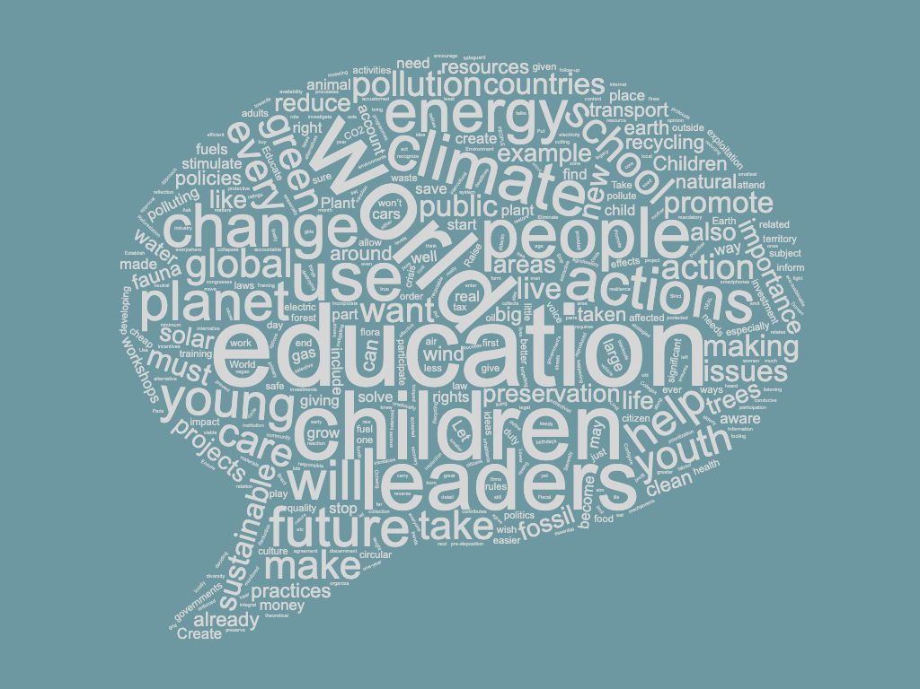

Currently, the poll is available in English, French, Portuguese, and Spanish, and is hosted on the UNICEF Voices of Youth ‘Climate Action’ platform.
The Global Initiative is taking place under the auspices of the UN Special Rapporteur on Human Rights and the Environment, in collaboration with Terre des Hommes and Project Dryad, and a number of other core partner organizations. The concept note is available here.

