Response to Call for Inputs:
Climate Change and Human Rights: a Safe Climate

Submission on Loss and Damage and Human Rights

This submission is a response to questions 6, 7 and 8 of the questionnaire on Climate Change and Human Rights by the UN Special Rapporteur on human rights and environment. This response is based on a peer-reviewed article accepted and forthcoming in the journal Climate Policy in a special issue on loss and damage, available upon request.
In a nutshell, we advocate the adoption of a human rights-based approach (HRBA) to loss and damage from climate change under the United Nations Framework Convention on Climate Change (UNFCCC) regime. The rationale is for an HRBA in this context is clear. States have pledged to address climate loss and damage under Article 8 of the Paris Agreement and are working through the Warsaw International Mechanism (WIM) to provide solutions. Despite being in place since 2013, the WIM’s efforts have yet to produce concrete measures to enhance action and support for those most affected by loss and damage, in accordance with its mandate. This leaves the protection of human rights of people who already and in future suffer the consequences of climate change impacts in limbo.
Given the likely human rights infringements resulting from unavoided loss and damage, we invite the UN Special Rapporteur when preparing his report on the Right to a Safe Climate to critically consider the UNFCCC's and specifically the WIM's work on this fundamental issue. We consider the Special Rapporteur to be in a unique position to urge policymakers under the UNFCCC to adopt an HRBA for addressing loss and damage.
I. Background
Loss and damage refers to the adverse impacts of climate change that people have not been able to cope with or adapt to, resulting in repairable damage or irreversible losses. It can be economic in nature but can imply the loss of non-economic features such as cultures, traditions, languages, for example, in the case of displacement of affected island communities. The Intergovernmental Panel on Climate Change (IPCC) noted that “residual damage will occur from climate change despite adaptation and mitigation action” and in its 2018 Special Report on 1.5°C, the explicitly addressed the residual risks, limits to adaptation and Loss and Damage.
Loss and damage is a policy term in that has been officially in use under the UNFCCC since 2007. In 2010 a work programme on loss and damage was adopted, and in 2013 – in the wake of Typhoon Haiyan – the Warsaw International Mechanism (WIM) was created to address this issue. Under the 2015 Paris Agreement, Parties agreed to cooperate to avert, minimize, and address loss and damage from climate change. Article 8 of the treaty established loss and damage as a key pillar of the international response to climate change alongside mitigation and adaptation. The Paris COP Decision excludes any liability or compensation for loss and damage under the treaty. However, this does not prevent states from seeking relief under general international law, nor does it exclude states’ obligations under human rights law or from revising this COP decision. Under Article 8, Parties should enhance understanding, action, and support for loss and damage on a cooperative and facilitative basis, including through the WIM. The WIM shall also collaborate with bodies outside UNFCCC, which includes human rights bodies.
Given that the WIM is the principal body under the UNFCCC mandated to address loss and damage, the efforts undertaken within its scope have fallen short of expectations. In particular, the WIM has thus far failed to leverage any additional finance, frustrating a core demand by many vulnerable countries and civil society observers. In the absence of meaningful progress under the UNFCCC, affected communities, the national governments of vulnerable countries, and civil society continue to expend efforts to deal effectively with loss and damage. Moreover, there now there exists a wealth of academic literature on loss and damage across disciplines.
II. Adopting a Human Rights-Based Approach
We understand the HRBA as a conceptual and methodological framework championed by the OHCHR to mainstream human rights and the normative basis of human rights law into policymaking. Adopting an HRBA to loss and damage requires recognition of the existing linkages between loss and damage and human rights obligations in international and regional human rights instruments. The table in the annex illustrates the principal human rights implications of certain loss and damage types and the human rights affected. Thanks to advances in attribution science, it is becoming increasingly evident that many natural disasters occurring at a higher frequency and with greater intensity than previously recorded can be linked to climate change.
Adopting an HRBA places the fundamental human rights of the individual at the center of decision-making. While the ongoing policy debate frames loss and damage in abstract terms, as an eventuality befalling vulnerable developing countries, in particular, small island developing states, adopting an HRBA helps to focus attention on the people behind this abstraction. By calling attention to the fundamental human rights of the individual, the approach requires consideration of the intersectionality of loss and damage impacts, including questions of race, gender, class, age, and economic well-being. As former UN Special Rapporteur John Knox noted, states have heightened duties with respect to members of vulnerable groups and “should seek to protect the most vulnerable in developing and implementing all climate-related actions”.
The HRBA principle of participation and inclusion – which derives its normative basis from relevant international and regional legal instruments – provides valuable guidance to policymakers and implementers of loss and damage actions. Applied to the loss and damage context, it requires states to ensure the effective participation of those most directly affected in the design and implementation of loss and damage policies and actions. This reflects a recognition that actual and potential victims of loss and damage should be empowered as “active participants” in decisions that concern their lives and livelihoods. By going beyond mere rhetoric, an HRBA promotes the institutionalization of cooperation between states and those most affected. An HRBA could thus prove a strategic tool to strengthen the international response to loss and damage in terms of human rights and to remind policymakers and implementers that international climate policy does not operate in a vacuum.
Moreover, an HRBA emphasizes the obligations States already have under existing international and regional human rights treaties. It thus serves as a reminder that climate policy does not exist in isolation from the general obligations of international law. Also, it reminds us of the obligation of States to take meaningful actions to cooperate and assist regarding the enjoyment and fulfillment of human rights. These obligations exist not only between countries but towards individuals. In this light, an HRBA on loss and damage has the potential to both shape climate policies and hold countries accountable for their climate commitments.
III. Recommendations
This is a major opportunity for the Special Rapporteur to call attention to the human rights implications of loss and damage, which are largely absent from the discussions under the UNFCCC and WIM. Here the Special Rapporteur has a chance to directly call on the processes mandated to deal with loss and damage, e.g. the WIM but also the UNFCCC more broadly, to enhance strengthen the integration of human rights. The WIM will be subject to review at the Climate Conference (COP25) in Chile in December 2019; thus the presentation of the Special Rapporteur's recommendations in October 2019 would be timely.
Moreover, the Special Rapporteur should call on states to step up their efforts to avert, minimize, and address loss and damage, both through the WIM and outside the UNFCCC. It could do this by reminding states of their obligation to protect human rights under the international and regional human rights treaties they ratified and in accordance with the Paris Agreement’s preamble reference to human rights.
One of the core functions of the WIM is to provide action and support, including finance for loss and damage. The Special Rapporteur could note the efforts undertaken in the WIM so far, including the Suva Expert Dialogue held in May 2018 and the technical paper on sources of financial support currently being prepared by the UNFCCC Secretariat, but should emphasize that the lack of finance and other support means implies that the human rights of those most affected by loss and damage cannot be adequately safeguarded.
Beyond merely recalling what states have committed to under international climate and human rights law, the Special Rapporteur could recommend the adoption of a human rights-based approach (HRBA) to loss and damage policies and actions. In our forthcoming peer-reviewed article, we propose the following recommendations for adopting an HRBA to loss and damage under the UNFCCC.
Specifically, the Special Rapporteur could:
  - call on the WIM to develop guidelines for mainstreaming human rights into loss and damage policies and actions, including guidance for monitoring and reporting both efforts undertaken and human rights infringements;
  - recommend the WIM to develop guidelines for ex-ante human rights impact assessments of loss and damage policies and actions;
  - recommend the establishment of a specialized body on human rights under the WIM to oversee the implementation of an HRBA, provide recommendations, and assist with drafting the above guidelines; and
  - having regard to the right to public participation, call on the WIM to involve affected groups directly in its proceedings, giving them a voice and platform to share their experiences and demands first-hand with decision-makers;
  - recommend a stronger engagement of human rights bodies with the topic of loss and damage, particularly the UN Human Rights Council, the OHCHR, as well as national human rights institutions (NHRI);
  - urge states to report under the UNHRC how their efforts to address loss and damage under the WIM and mechanisms of the Paris Agreement are human rights-compliant; and call on Convention Committees to evaluate how climate loss and damage affects the fulfilment of human rights under the relevant convention
  - recommend the establishment of a Human Rights Focal Point in UNFCCC Secretariat which could be modeled after the UNFCCC Gender Focal Point and tasked with implementation, monitoring of the HRBA as well as coordination, particularly with the WIM.
Authors:  MA. Adrian Martinez Blanco  Director of La Ruta del Clima  Ph.D. Candidate University of Eastern Finland |  | Patrick Toussaint  Research Associate, Institute for Advanced Sustainability Studies e.V. (IASS)  Ph.D. Candidate University of Eastern Finland
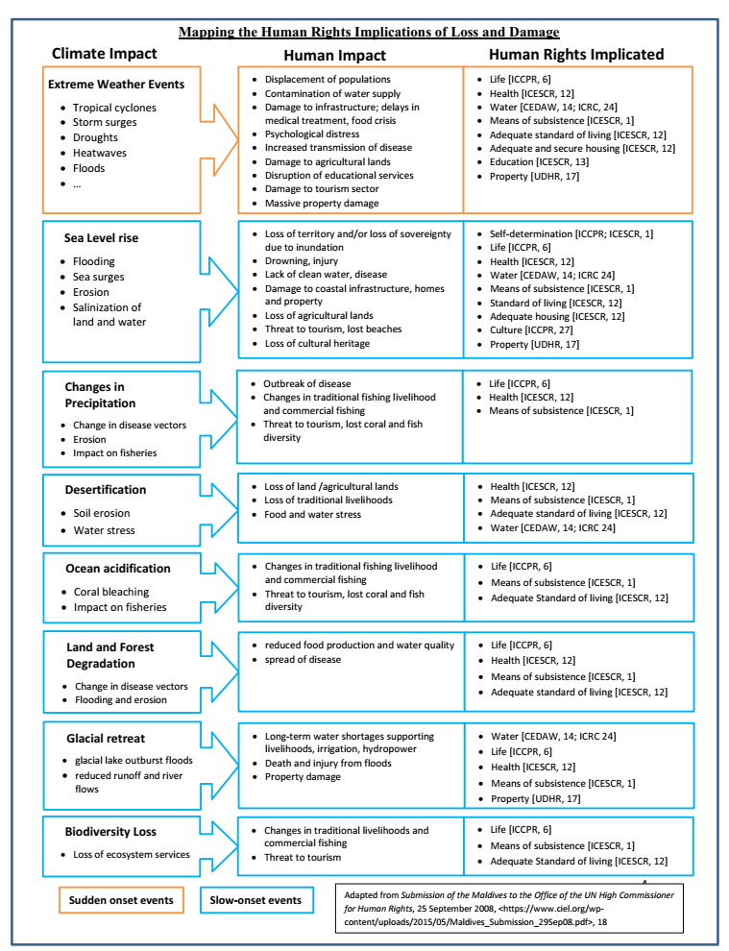
Annex: Table 1

References Warner, K., Van der Geest, K., Huq, S., Harmeling, S., Kusters, K., de Sherbinin, A., & Kreft, S. (2012). Evidence from the frontlines of climate change: Loss and damage to communities despite coping and adaptation. UNU-EHS Report. UNU- EHS, p. 20.
For a recent overview of non-economic loss and damage, see Serdeczny, O. (2019). Non-economic loss and damage and the Warsaw international mechanism. In Loss and Damage from Climate Change (pp. 205-220). Springer, Cham. Online <https://link.springer.com/chapter/10.1007/978-3-319-72026-5_8>.
Klein, R. J. T. et al., 'Adaptation Opportunities, Constraints, and Limits' in Chris B Field et al. (eds), Climate Change 2014: Impacts, Adaptation, and Vulnerability. Part A: Global and Sectoral Aspects. Contribution of Working Group II to the Fifth Assessment Report of the Intergovernmental Panel on Climate Change (Cambridge University Press 2014) 899, p. 903.
IPCC. (2018). "Sustainable Development, Poverty Eradication, and Reducing Inequalities." In Global Warming of 1.5°C. An IPCC Special Report on the impacts of global warming of 1.5°C above pre-industrial levels and related global greenhouse gas emission pathways, in the context of strengthening the global response to the threat of climate change, sustainable development, and efforts to eradicate poverty. Cambridge: Cambridge University Press.
UNFCCC, Decision 1/CP.16.
Huq, S. “Typhoon Haiyan shows why COP19 must deliver on loss and damage”, IIED Blog, 13 November 2013. Online <https://www.iied.org/typhoon-haiyan-shows-why-cop19-must-deliver-loss-damage>.
UNFCCC, Decision 2/CP.19.
UNFCCC, Decision 1/CP.21, paragraph 51.
See also Mace, M. J., and R. Verheyen. (2016) “Loss, Damage and Responsibility after COP21: All Options Open for the Paris Agreement”, RECIEL 25(2), pp. 197–214.
UNFCCC, Paris Agreement, Article 8.3.
ibid., Article 8.5.
Toussaint, P. (2018). Voices unheard–affected communities and the climate negotiations on loss and damage. Third World Thematics: A TWQ Journal 3(5-6), pp.1–20.
Haque, M., Pervin, M., Sultana, S., & Huq, S. (2019). Towards Establishing a National Mechanism to Address Losses and Damages: A Case Study from Bangladesh. In Loss and Damage from Climate Change (pp. 451-473). Springer.
See, for example, the recent open access book by Mechler, R., Bouwer, L., Schinko, T., Surminski, S., & Linnerooth-Bayer, J. (Eds.). (2018). Loss and damage from climate change: Concepts, methods, and policy options. Springer, which includes contributions from natural scientists, social scientists, and international lawyers.
Toussaint (n 12).
UNHRC. (2016). Report of the Special Rapporteur on the issue of human rights obligations relating to the enjoyment of a safe, clean, healthy and sustainable environment. A/HRC/31/52, paras. 81-82
Including the 1992 Rio Declaration on Environment and Development, Principle 10; the UNECE Convention on Access to Information, Public Participation in Decision-making and Access to Justice in Environmental Matters, Aarhus 25 June 1998 (Aarhus Convention, in force 30 October 2001); the UNECLAC Regional Agreement on Access to Information, Public Participation and Justice in Environmental Matters in Latin America and the Caribbean, Escazú, 4 March 2018 (Escazú Agreement, not yet in force); and the Almaty Guidelines on Promoting the Application of the Principles of the Aarhus Convention in International Forums, UN Doc. ECE/MP.PP/2005/2/Add.5, 20 June 2005, Almaty 27 May 2005, Annex.
Broberg, M. and Sano, H. (2018) Strengths and weaknesses in a human rights-based approach to international development – an analysis of a rights-based approach to development assistance based on practical experiences, The International Journal of Human Rights, 22(5), p. 670
ibid. p. 669.
UN Charter, Articles 1, para. 3, 55, and 56.
Report of the Office of the United Nations High Commissioner for Human Rights on the relationship between climate change and human rights, paragraph 87.
UNHRC. (2017). Analytical study on the relationship between climate change and the full and effective enjoyment of the rights of the child. A/HRC/35/13, para. 31.
UNFCCC, Decision 2/CP.19, paras 5(a)-(c).
Based on Walker, S. (2005). Human rights impact assessments of trade-related policies. Gehring M., Cordonier-Segger M. Claire. Sustainable Development in World Trade Law. Kluwer: Law, pp. 217-256.
The WIM is mandated to establish specialized bodies through UNFCCC Decision 2/CP.20, paragraph 8, and has done this most recently at the request of the COP in 2015 to create the Task Force on Displacement (Decision 1/CP.21, paragraph 49).
As enshrined in international and regional human rights instruments, including the 1992 Rio Declaration (Principle 10), the 1998 Aarhus Convention (Articles 1 and 3), the 2005 Almaty Guidelines, and the 2018 Escazú Agreement.
At COP24 in December 2018, the COP explicitly encouraged the WIM to increase its consideration of groups vulnerable to the adverse impacts of climate change (UNFCCC, Decision 10/CP.24, para 5(e)).

