Technical Note No. 7/2019 / CGMOC / DBFLO
PROCESS No. 02000.008579/2019-01
INTERESTED: MMA SECRETARIAT OF INTERNATIONAL RELATIONS - ENVIRONMENT AND LATIN AMERICA DEPARTMENT

SUBJECT MATTER
Request for contributions for the thematic reports on good practice in implementing the right to a safe, clean, healthy and sustainable environment from the Special Rapporteur of the United Nations’ Office of the High Commissioner for Human Rights (OHCHR).

REFERENCES
Message 261 - Ministry of Foreign Affairs (5374866)
OHCHR Link
Official No. 4531/2019 / MMA (5373793)
Order No. 5377801/2019-DBFLO (5377801)

EXECUTIVE SUMMARY
Request for contributions for the thematic reports on good practice in implementing the right to a safe, clean, healthy and sustainable environment from the Special Rapporteur of the United Nations’ Office of the High Commissioner for Human Rights (OHCHR), Mr. David R. Boyd, sent by the Ministry of Foreign Affairs to the Ministry of the Environment. The purpose of the consultation is to obtain subsidies for the preparation of two thematic reports.

ANALYSES
Message 261 - MRE (5374866) presents several questions from the Special Rapporteur of the United Nations’ Office of the High Commissioner for Human Rights (OHCHR), Mr David R. Boyd, who will serve as input for the preparation of two thematic reports:
(i) On the importance of a safe climate for the enjoyment of human rights, to be presented at the 74th session of the United Nations General Assembly in October 2019;
ii) On good practices in implementation of the right to a safe, clean, healthy and sustainable environment, to be presented during the 43rd session of the Human Rights Council (HRC) in March 2020.
The questions are:
(…)
We now answer some of the questions listed, based on the activities related to this General Coordination for Monitoring Biodiversity’s Use and Foreign Trade (CGMOC in Portuguese):

Question a):
The guarantee of the right to an ecologically balanced environment, good of common use of the people and essential to the healthy quality of life is contained in article 225 of the Brazilian Federal Constitution of 1988. In addition to the contents of the magna Carta, we can mention, among others:
Law nº 12,651 of 25th of May 2012, which establishes general rules on vegetation protection, Permanent Preservation areas and Legal Reserve areas; forest exploitation, the supply of forest raw materials, the control of the origin of forest products and the control and prevention of forest fires, and provides for economic and financial instruments to achieve its objectives;
Law nº 6,938 of August 31, 1981, which establishes the National Environmental Policy, its purposes, formulation and application mechanisms, constitutes the National Environment System (Sisnama) and establishes the Environmental Defense Registry;
Law nº 11.284 of March 2, 2006, which provides for the management of public forests for sustainable production, establishes the Brazilian Forest Service - SFB, within the structure of the Ministry of the Environment, and creates the National Forest Development Fund - FNDF;
Ibama (Brazilian Institute for the Environment and Renewable Natural Resources) being the Federal Agency executing the National Environmental Policy, it is responsible for instituting norms and other measures to achieve a safe, clean, healthy and sustainable environment. All the Institute's activities have direct and / or indirect effects on this fundamental human right.
This CGMOC is responsible for implementing, integrating and managing information systems for the management of the use of wildlife, fisheries and forest resources within the scope of Sisnama, as well as coordinating, supervising, executing, guiding the elaboration and establishment of criteria, standards and proposition of norms. related to the control of the use of wildlife, fisheries and forest resources.
As examples of supply chains that make economic use of Brazilian biodiversity that are controlled and monitored by this CGMOC, using electronic systems as a tool for this purpose, we can mention: (i) The wood supply chain that is controlled by the National System to Control the Forestry Products’ Origin (Sinaflor) - which controls and monitors the entire authorization process for logging, transportation, use, conversions and storage of all native timber and lumber in Brazil; (ii) The amateur breeding of birds using the SisPass system for registration of births, deaths, sale and transportation of herds; (iii) International trade of parts and products of Brazilian fauna and flora, in particular the species listed in the CITES annexes, which is controlled by the SisCITES system, where all Brazilian imports and exports of species of Brazilian biodiversity are recorded. Thus, its activities have a direct relationship with the human right to a safe, clean, healthy and sustainable environment, since the systems managed by this General Coordination guarantee the sustainable and controlled use of Brazilian biodiversity.

Question b):
All systems under management of this CGMOC are freely available on the Internet for anyone interested in the use of natural resources. In addition, they are also used by civil servants of different environmental agencies at federal, state and municipal levels, so that they can perform their activities in a more organized and quick manner.
Since these systems provide the user with information about the procedural flow of their application, store information for each access - such as machine IP, user ID, time spent on each activity, etc. - and are fully auditable, it is possible to state that they ensure the implementation of the human right to a safe, clean, healthy and sustainable environment, by bringing greater transparency, accountability and access to information to all links in the Brazilian environmental production chain.
Moreover, as these systems regulate legal economic activities by controlling and monitoring the original location, movement and use of all Brazilian biodiversity products, they ensure healthy ecosystems and the protection of biodiversity by supporting management, governance and decision making through its extensive data and information.

Question c):
Evidence of the measures identified above can be demonstrated in the analyzes presented by the Business Intelligence (BI) solutions installed at IBAMA, through a project with the participation of IDB, GEF and CATIE.
These BI solutions enable cross-checking of data and multivariate big data analysis contained in CGMOC-managed system databases, transforming data into strategic information, assisting public participation in the environmental decision-making process. Below are some BI dashboard screens:
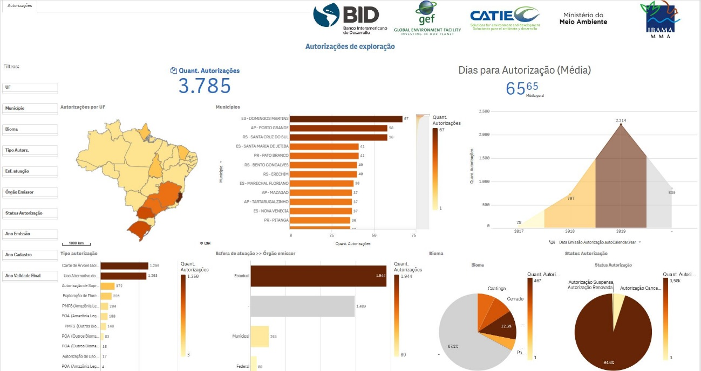
Fig 1: Dashboard of authorizations issued by Sinaflor, from 2017 to 2019.
In this figure it is possible to observe the temporal evolution of the authorizations issued by Sinaflor system in the upper right corner, demonstrating the constant and significant increase in the use of the system. In addition, this panel shows the average time for issuing permits, which in this case is 65 days.
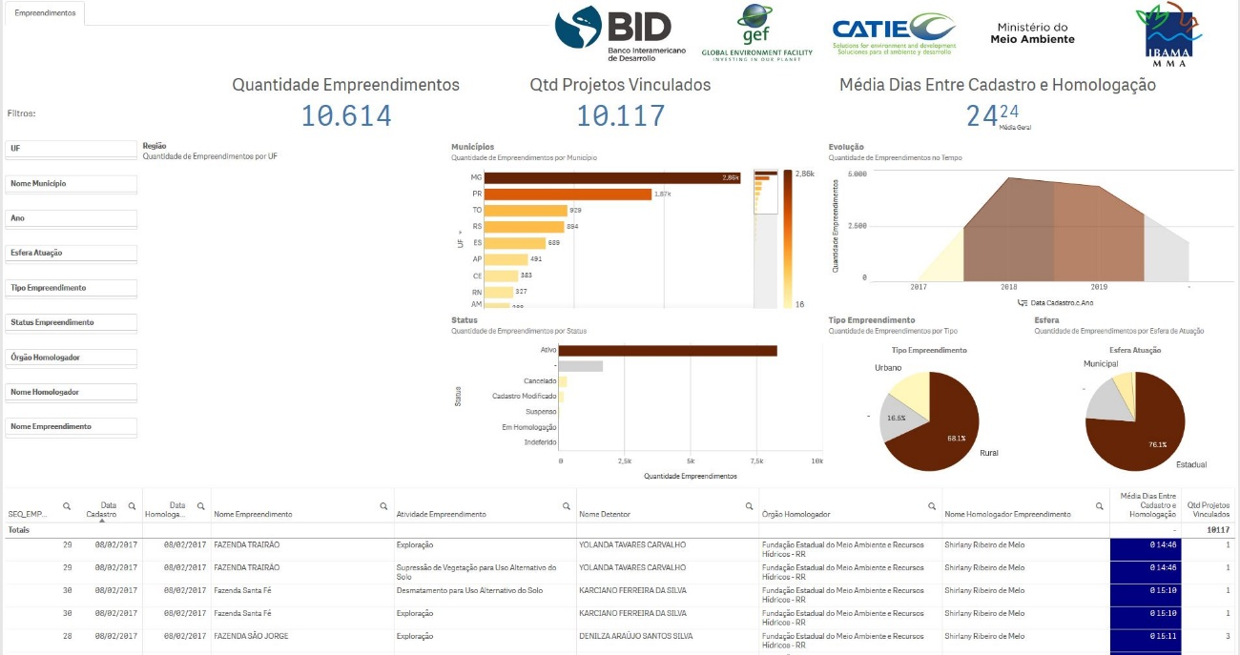
Fig 2: Dashboard of projects registered at Sinaflor, from 2017 to 2019.
In this case it is possible to notice the large number of registered enterprises and controlled by this system (10,614 enterprises), as well as the temporal evolution of the registrations. It is possible to observe the level of control offered by the system, since the table at the bottom of the figure presents complete data about each project, from its owner up to the agency and the person who approved this project in the system.

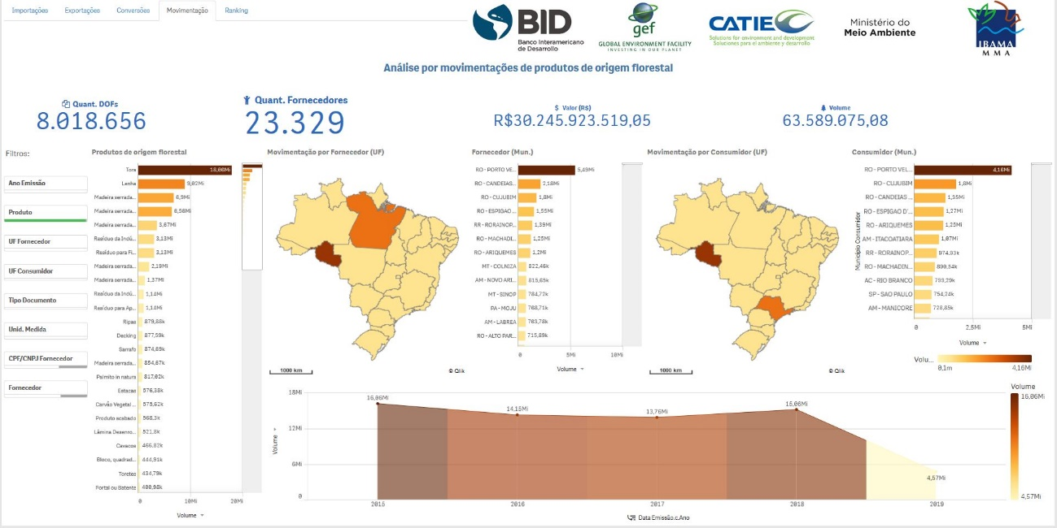
Fig 3: Dashboard showing forest products transportation in Brazil, from 2015 to 2019.
This dashboard shows the movement of Brazilian forest products, their supplying and consuming municipalities, by volume, which reached approximately 63.5 million cubic meters of wood in the period. It is possible to infer that the most transported forest product in these 5 years analyzed is roundwood, followed by firewood and beam lumber.
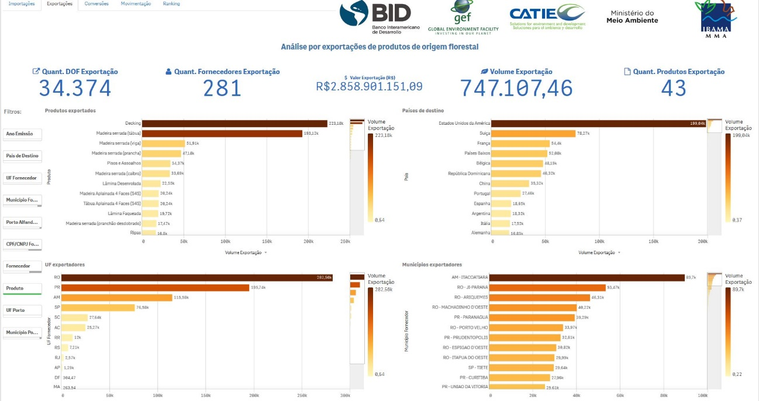
Fig 4: Figure 3: Forest products exports in Brazil, from 2015 to 2019.
Finally, this figure shows exports of forest products by volume and by country of destination. It is noticeable the large amount of wood destined for the United States, being the main consumer, followed by Switzerland and France. The main products exported in the period are decking, board and beam.
All these analyses and cross-checks allow for a level of transparency and environmental governance that, coupled with Ibama's satellite monitoring data, can bring ever more refined, sophisticated, replicable and reliable data to detect rates of illegal deforestation, emissions of greenhouse gases and environmental degradation that are adverse impacts on the human right to a safe, clean, healthy and sustainable environment.

Question d):
The challenges encountered by Ibama in general and CGMOC in particular in fulfilling their obligations towards a human right to a safe, clean, healthy and sustainable environment relate to the limited availability of resources and technical staff. To circumvent these limitations, CGMOC maintains a constant will to establish partnerships and projects with international bodies and funds, while promoting constant improvement and exchange of experience with countries and international environmental agencies.

Question e):
This General Coordination for Monitoring Biodiversity Use and Foreign Trade, through its criteria, standards, norms and systems ensures legal access to the natural resources of Brazilian biodiversity to all citizens, without distinction and discrimination. This ensures that exploitation is done sustainably, perpetuating ecosystems for future generations, avoiding environmental degradation and thus mitigating the impacts of climate change at local and global scales.

Question f) and g):
We have no comments to make.

CONCLUSION
The work carried out by Ibama, as the Federal Agency responsible for implementing the National Environmental Policy, and CGMOC, as the department responsible for monitoring and controlling legal access to natural resources, has a direct impact on the implementation of the right to a safe environment. clean, healthy and sustainable, being a key piece to ensure good practices in production chains that make economic use of Brazilian biodiversity.

