The Children’s Environmental Rights Initiative (CERI) welcomes the opportunity to submit written information following the UN Special Rapporteur’s call for inputs for his report regarding human rights and associated obligations related to water pollution, water scarcity and floods. This input is provided, recognising:

- Children’s heightened vulnerability to the impacts of environmental harm:

  - According to UNICEF, almost 600 million - nearly 1 in 4 - children will live in areas with extremely limited water resources by 2040.
  - Even today, approximately 500 million children are living in areas at extremely high risk of flooding due to weather events such as cyclones, hurricanes and storms, as well as rising sea levels. Disasters can destroy or contaminate entire water supplies, increasing the risk of diseases such as cholera and typhoid, to which children are particularly vulnerable.
  - Water and sanitation-related diseases are one of the leading causes of death in children under the age of 5. Every day, more than 700 children under 5 die from diarrhoea linked to inadequate water, sanitation and hygiene.

- The corresponding heightened obligations of States (and duties of businesses) to uphold children’s rights as set down in the UN Convention on the Rights of the Child, noting its near universal ratification.

- The consistent oversight of children’s right to be heard on environmental issues, and the additional barriers they face with respect to access to information, meaningful participation in decision-making processes, and access to remedy for harm.

CERI seeks to secure the recognition and implementation of children’s right to a healthy and sustainable environment at national, regional and international levels. In April 2019 we launched a global poll to collect and integrate children’s voices into a series of reports from each world region, a new ‘Global Charter on Child Rights and the Environment’ and relevant high-level policy processes and fora, with a view to raising awareness and children’s voices with respect to their environmental rights. The poll will remain open until the Global Charter is finalized (2022, TBC).

This submission provides a summary of the online poll messages received from over 1,000 children (under the age of 18) from 70 plus countries regarding the global water crisis in response to “What actions do you want world leaders to take that you would like to be included in a Global Declaration on Child Rights and the Environment?”

Key message: Make clean water and sanitation accessible to all

“..the universalization of sanitation is one of the priorities for decision making in matters involving health, education and the environment, in addition to infrastructure.”

...especially children

“Children should have the right to rivers with sufficient water, free of litter or harmful substances for recreation or other uses.”

“For every child in the world to have fresh water and healthy food available”
“To make sure that the global situation of water doesn't get worse. Because every child has the right to grow up with access to clear water.”

...and the most vulnerable.

“Provide access to potable water as well as security for poorer countries at risk of rising sea levels”

“...treated and piped water for the entire population, especially the most needy.”

Key message: Stop wasting water

“Adequate measures to supply the required amount of water rather than it being provided without any limit.”

“Take shorter showers”

“Put up signs in public bathrooms that make people feel guilty about wasting water”

“Recognize the coast as a limited resource”

“...make actions like water recycling in gardens essential”

...including the reduction of agricultural water consumption.

“... we waste too much water on meat”

“...more bureaucracy for agriculture (mainly when it comes to large estates), for less water consumption and less deforestation”

Key message: Stop polluting water

“...stop littering and stop throwing rubbish in the water”

“Stop pumping sewage into the sea”

“Do some litter picking so waste doesn't get in the sea and harm the sea creatures”

“...more recycling programs should be implemented to curb excessive garbage disposal, particularly in urban areas, and efforts should be made to preserve the rivers our parents played in but are running dry today.”

“We should be able to save the environment by using our vehicles less. That's what causes acid rain.”

...especially with plastic.

“I don't like how people litter. It goes into the ocean and kills animals. Turtles get stuck in plastic and that harms them. One time my friend told me that she went to a beach and all you could see was trash. When my friend told me that I felt bad for all the animals. People should take a minute to pick up some trash they see.”

“We should reduce the amount of plastic in the classroom and in food packets. I believe we should all work together to try and clean the great Pacific garbage patch to prevent animals from eating the plastic.”

“Start cleaning the sea and oceans from plastic.”

“rivers are flowing with #SingleUsePlastic. Yet the plastic production continues? We must consider all the 3Ps equally PLANET 🌎 PEOPLE 👨‍👩‍👧‍👂 PROFIT 💰”

Key message: Invest in clean water.

“Fund the removal of plastic from the neighboring seas or oceans.”

“Collect money to clean out the oceans...”

“Give more money to charities supporting children’s basic rights, like clean water and a safe place.”

“Encourage investments in technologies that reduce environmental impact, such as solar energy, sustainable land use, water desalination.”

Key message: Establish and enforce laws that protect water.

“I want world leaders to take immediate action to save the planet - pass laws to ensure the oceans are cleaned, pollution is reduced, animals are protected, life is sustained.”

“...make strict rules and if they aren't followed big punishments”

“I would like world leaders to act on a straw ban for the world so that straws can stop polluting the ocean and save animals and the world.”

“Banning single use plastic.”

Key message: Hold industries accountable to water pollution and privatization.

“...make it so that basic human necessities, like water, can not be privatized and capitalized on by large corporations”

“It must be compulsory for factories and industries to neutralize the waste before discharging it into streams or any other water body/environment.”

“Prohibition of sewers that dump industrial / hospital / toxic waste in open sea regions or that have access to some region of water concentration. And not only the prohibition, but also punishments for companies or other sectors that practice such action, such as collecting fines, cleaning the areas affected by the discarded garbage, treating the population's water (if it reaches a region where this water is used for provide to citizens), reforestation, among other measures that could be taken and that were declared in an effective and safe way.”

“Measures taken to tackle ocean pollution: Incentives for businesses to use and create products from recycled materials, Ban on styrofoam, Takeaway packaging to be more sustainable.”

Key Message: Use water as a nature-based solution.

“Respect for nature is essential. Nations have in their hands the ability to protect key ecosystems to combat climate change: rivers, wetlands, oceans, forests and mangroves absorb large amounts of carbon, reversing the problem.”

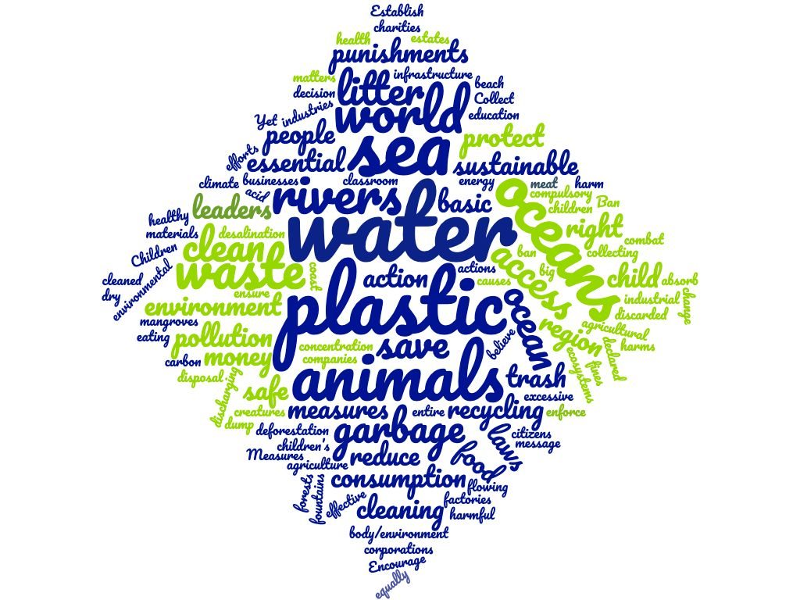

UNICEF (2017), Thirsting for a Future: Water and Children in a Changing Climate.

