Freedom, religion, and schooling:
Cultural dimensions of the right to education in the United States
T.J. D’Agostino
University of Notre Dame, Notre Dame, IN, USA
Cultural diversity and cultural rights are one important aspect of the right to education. In their educational systems, societies must balance the goals of an inclusive, equitable, and quality education for all that helps shape a common national character and civic life among citizens with the goals of protecting freedom and the flourishing of cultural diversity and the cultural rights of each person. This cultural freedom and respect for diversity is reflected in international human rights law pertaining to the right to education. For example: Article 26 of the Universal Declaration of Human Rights (1948) states: “parents have the fundamental right to choose the kind of education that shall be given to their children.” Similarly, Article 13 of the International Covenant on Economic, Social and Cultural Rights require states to:
respect…the liberty of parents…to choose for their children schools, other than those established by the public authorities, which conform to such minimum educational standards as may be laid down or approved by the State and to ensure the religious and moral education of their children in conformity with their own convictions.
This Covenant goes further, protecting the autonomy of civil society institutions to create and manage schools that are distinctive and reflective of cultural and religious diversity, stating: “No part of this article shall be construed so as to interfere with the liberty of individuals and bodies to establish and direct educational institutions.” This provision emphasizes the relationship between autonomy for civil society institutions and an authentic educational freedom. If schools are denied adequate autonomy to operate distinctive educational projects, educational freedom is not possible, as families’ choice sets are constrained. These ideas are reflected in what a number of scholars have begun to identify as the concept of “educational pluralism.”
In these human rights documents, the emphasis is on the state’s appropriate role in setting minimal standards, but standards that nevertheless respect the autonomy of civil society institutions and parental rights. This delicate balance is threatened by calls for more muscular regulation and a bias for state run schools that regard non-state actors with suspicion and requiring of robust regulatory regimes. Rather, what is needed is a balance between minimal standards to ensure equity, quality, and civic aims that do not intervene any more than is necessary so as to protect the autonomy of civil society institutions and the freedom of parents that are essential for cultural and religious diversity in pluralistic societies.
What of educational freedom, respect for cultural diversity, and educational pluralism in the United States?
1. Historical antecedents: anti-Catholicism, social-mobility, and pricing out the poor
First, it is important to mention that the U.S. has signed, but not ratified, many major international human rights treaties that establish the right to education. Therefore, to consider the question of the right to education in the United States, we must look to the U.S. Constitution, state constitutions, and the relevant federal and state case law to understand the legal framework for a right to education in the U.S.
While education is not mentioned in the United States Constitution, the Supreme Court defended the right of educational freedom as early as 1925. In a landmark case, the Court overturned an Oregon law aimed at prohibiting Catholic schools, arguing, “The child is not the mere creature of the State” and recognizing the “high duty” of parents “to prepare children for additional obligations.” In this, the Court offered by the first Constitutional precedent implying a right to education as well as one that specifically protected parents’ cultural rights and religious liberties as it relates to making educational choices for their children.
However, in the U.S. this has historically been a weak freedom, as it only protects the right for private and faith-based schools to exist and parents to choose to enroll their children, but it does not require any provision of financial support for families that choose to enroll in a faith-based school. This weak freedom stems from the U.S. historical context. Beginning with the Common School movement of the 1830s, public schools were established to form ethical, Protestant republicans. When waves of Catholic immigrants began to reach America’s shores, they were met with discrimination in these de facto Protestant public schools.
In response, Catholics began creating their own schools, for which they sought public funds. This led to rather ferocious anti-Catholic and anti-immigrant backlash, culminating in the passage – in nearly forty state constitutions – of ‘Blaine Amendments,’ which sought to prevent public funds from going to Catholic, or ‘sectarian,’ schools.
The cartoon below, authored by Thomas Nast in 1871, is indicative of the anti-Catholic sentiment fueled by the public funding debate. Note that the crocodiles emerging from the water are Catholic bishops coming to attack American children, who are being defended by a public-school teacher. The school in the background – brandishing the Vatican flag and resembling The Basilica of Saint Peter – is called “The Political Roman Catholic School.” The U.S. Public School is in ruins and Lady Liberty is being led off to the gallows. This cartoon illustrates that the Protestant majority at the time viewed Catholic schools – and public funding for Catholic schools, in particular – as a profound threat to American democracy and its de facto Protestant public school system.

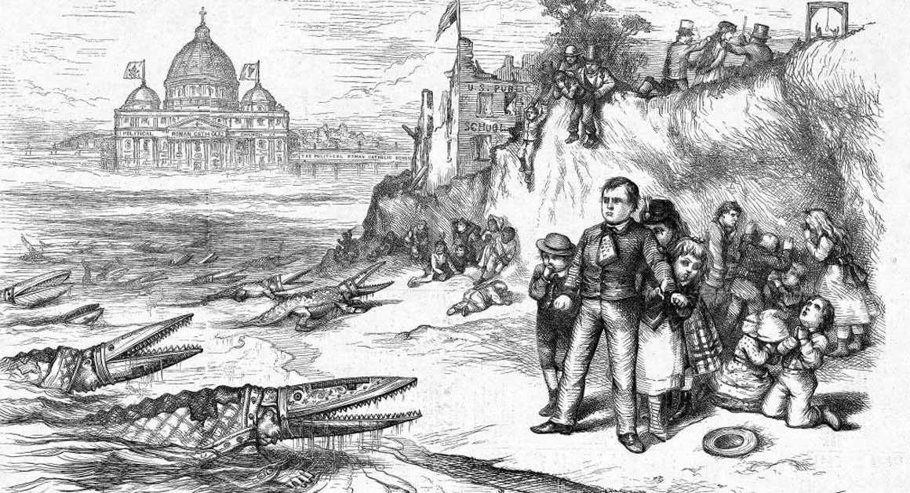
Figure 1: T. Nast. The American River Ganges. The priests and the children," illus. in Harper's Weekly 15 / 770 - 30 September 1871, p. 916 (https://omeka.chrc-phila.org/items/show/7357).
In the face of this hostility, Catholics fought for, but largely failed to secure, public funding for Catholic schools. Despite being deprived of public support, Catholic schools nonetheless steadily grew and would go on to serve waves of Catholic immigrants. Subsidized by the low-cost labor of religious men and women, they served Irish, Germans, Italians, and Poles, among many others, in culturally-sustaining religious and ethnic communities that helped Catholic immigrants adapt to American life while preserving their identities, culture, language, and beliefs. These schools were a source of social capital, academic opportunity, and civic and social virtue, and they helped facilitate the socio-economic success and cultural and political integration of American Catholics over generations.
At their peak in the mid-1960s, Catholic schools educated 5.5 million children, or 13% of American students. Enrollment today is now down to 1.8 million, serving only 3% of U.S. students. This major decline was the result of many factors - including the movement of socially mobile Catholics to suburbs where they had access to relatively high quality public schools and the loss of the labor subsidy accruing from the decline in religious vocations - but none has been more important than the lack of public funding mixed with the rising cost of education. The result is a Catholic school system that has become increasingly inaccessible to the poor and middle class.
2. Policy Shifts: Slow growth of vouchers and other religious schools amidst declining supply of Catholic schools
This landscape, however, has begun to shift over the last 20 years, albeit incrementally and sporadically. Education policy in the United States is controlled primarily at the state and local level. Thus, our education policy is really comprised of 50 different state legal landscapes, a panoply of educational policy experiments.
In the past twenty years, there have been two major policy trends relevant to this discussion: the rise of charter schools and the creation of voucher-like policies, both starting in the early 1990s. Charter schools are privately managed public schools that are legally required to be secular, often imitating the strong discipline and values-focus of Catholic schools. They have spread rapidly with bipartisan support. Vouchers, which are essentially a form of publicly funded or tax-incentivized scholarship, had a slow start due to questions of their Constitutional permissibility and saw much stiffer political opposition. The Constitutional questions focused on what is permissible in terms of Church-state relations and funding of religious schools. The over a period of a few decades, the Court wrestled with the question of public support for religious schools and whether this would run afoul of the First Amendment’s Free Exercise and Establishment Clauses that protect religious liberties, protect religion from state intervention, and prohibit state-sponsored religion.
The Constitutional question over vouchers were largely settled in 2002 in a breakthrough Supreme Court case that affirmed that vouchers do not run afoul of First Amendment religion clause prohibitions. The case affirmed that publicly funded scholarships or vouchers do not constitute the State’s direct funding of religion (which would not be permitted), but is a form of indirect aid that is mediated by the free and private choices of parents and therefore is neutral towards religion and permissible under First Amendment principles.
Since then the U.S. has seen steady growth in the number of voucher programs and tax-incentivized scholarships available. This, in turn, has resulted in more public scholarships for low-income students to attend private and religious schools that reflect their cultural and value preferences. Compared to charter school growth, however, the increase in vouchers has paled in comparison. Charter enrollment has grown eight times faster. The graph below depicts the relative growth of enrollment in charter schools (in blue) compared to the modest growth in enrollment from voucher and tax-credit scholarships (in red) between 2000 and 2013. The net result has been a quickening in the net decline of religious schools, as new, free, secular alternatives have entered the educational milieu, putting competitive pressures on already financially fragile urban faith-based schools.
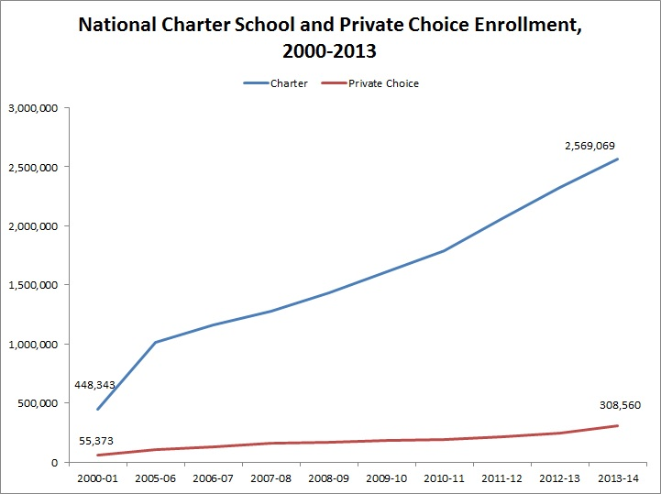
Figure 2. Charter school and private school enrollment trends. Source: M. Ladner, “The future of private schooling, if any,” Jay P. Greene’s Blog, 22 September 2014 (https://jaypgreene.com/tag/charter-school-enrollment-growth/).
There has also been a gradual shift in case law, suggesting increasing legal openness to educational pluralism and leading some to suggest that fully religious charter schools may even be possible. But while the legal and policy context has begun to support more educational freedom, and there has been modest growth in other forms of religious schools, the supply of Catholic schools is shrinking resulting in a net decline of faith-based schools.
There are now twenty-five private school choice (i.e. voucher-like) programs nationally, but relatively few have strong policies and are large enough to be meaningful.
The states with more robust school choice policies include: Arizona, Alabama, Florida, Illinois, Indiana, Louisiana, Ohio, and Wisconsin. In these places, faith-based schools tend to have stronger enrollment and are on financially stronger footing, while also being more accessible to the poor.
In terms of autonomy, U.S. private and faith-based schools enjoy, comparatively, a great deal, which is rooted both in our Constitutional system, with its First Amendment protections of religious freedom, and our history with Catholics in the minority fighting for their independence and against discrimination.
There are some minimal requirements to which private and faith-based schools must adhere. Generally, private schools need to be registered at the State level. Most faith-based schools are exempted from requirements that teachers be state-certified or licensed. The vast majority of religious schools are not unionized, so they have much more freedom to make personnel decisions at the school level.
There are also loose regulations regarding curriculum. While some states require students in private schools to take state tests, religious and private schools have not been required to participate in the high stakes accountability and testing policies that public schools have since 2001, with the exception of some states with voucher policies that have included testing and accountability requirements.
Finally, there are minimal quality and safety standards. But there is no direct state management, no direct budgetary oversight, no control of or posting of teachers or school leaders, no prescribed curriculum, and no monitoring by state officials. In short, faith-based schools in the U.S. are – compared to many other countries – very autonomous. This autonomy also enables private and faith-based schools to have a degree of protection from state interference in ways that could undermine their distinctive mission and religious identities.
A recent case moving through the court system in the State of New York provides an illustrative example of the possible tensions between religious liberties and cultural rights and state regulatory efforts. In Yeshivas v. New York, a group of former students in Orthodox Jewish schools (called Yeshivas) claimed that they had been denied a quality education in accordance with New York State Law requiring that private schools be “substantially equivalent” to public schools. While the substantial equivalence language is vague and problematic for many reasons, the case nevertheless raises important questions. In some Yeshivas, there appears to be rather extreme examples of the schools teaching religious subject matter at the almost complete exclusion of secular subjects. This is a reflection of the cultural and religious concept of “Bitul Torah,” the notion that an observant Jewish person should not “neglect the study of the Torah,” which can sometimes have maximalist interpretations. The result, in the eyes of some and as claimed by a group of former students, is harm to students that are being denied the basic elements of a quality, secular education. In the eyes of the Yeshivas and many Orthodox Jews in New York, this is a matter of cultural rights and religious liberty. This will ultimately be adjudicated in the courts, but reflects an ongoing debate and the tensions and fault lines in the right to education, public duties to set and enforce minimal educational standards, and cultural dimensions to the right to education and religious liberty issues in the freedom of education.

Garnett, N. S. (2011). Are Charters Enough Choice-School Choice and the Future of Catholic Schools. Notre Dame L. Rev., 87, 1891; Berner, A. R. (2016). Pluralism and American public education: No one way to school. Springer.
U.S. Supreme Court, Pierce v. Society of Sisters, 268 US 510 – 1925.
A set of lawsuits in the 1980s sought public funding for religious schools based on free exercise rights of religious parents who objected to public school curricula. These cases (Brusca v. State of Missouri and McDonough v. Aylward) were not successful; see N.S. Garnett 2015 and T.J. D’Agostino 2018, p. 511, endnote 6.
C.F. Kaestle, Pillars of the republic: Common schools and American society, 1780-1869 (Vol. 154), Hill & Wang, New York 1983.
C.L. Glenn, The myth of the common school, University of Massachusetts Press, Amherst, MA 1988; and J.T. McGreevy, “Catholicism and American freedom,” Historically Speaking 6 / 1 – 2004, pp. 25–26.
A.R. Berner, Pluralism and American public education: No one way to school, Springer, New York 2017; Glenn 1988; and McGreevy 2004.
R.W. Garnett, “Church, state & playgrounds,” Commonweal 144 / 14 – 2017, p. 12; and J.P. Viteritti, “Blaine’s wake: School choice, the first amendment, and state constitutional law,” Harvard Journal of Law & Public Policy 21 - 1998, p. 657.
T. Bryk et al., Catholic schools and the common good, Harvard University Press, Cambridge, MA 1993; A.M. Greeley, P.H. Rossi, The education of Catholic Americans, Aldine Publishing Company, Chicago 1966; J.S. Coleman, T. Hoffer, Public and private high schools: The impact of communities (Vol. 41), Basic Books, New York 1987; and P.J. Wolf, “Civics exam: Schools of choice boost civic values,” Program on Education Policy and Governance, Harvard University 07 / 05 - 2007.
National Catholic Educational Association (NCEA), NCEA annual report 2018: Lead. Learn. Proclaim., NCEA, Arlington, VA 2018.
Notre Dame Task Force on Catholic Education 2006.
Murnane, Reardon 2018.
A. Saiger, “Charter schools, the establishment clause, and the neoliberal turn in public education,” Cardozo Law Reviews 1163 – 2012, p. 34.
N.S. Garnett 2017; and Saiger 2012.
U.S. Supreme Court, Zelman v. Simmons-Harris, 536 US 639 - 2002.
D’Agostino 2018.
N.S. Garnett 2015, 2017.
D’Agostino 2018; N.S. Garnett 2015, 2017; and Saiger 2012.
D’Agostino 2018.
D’Agostino, T. J., Dowd, R., & Mugo, J. (2019). Faith-Based Education in Changing Social, Economic, and Political Contexts: Perspectives from Catholic Educators in Kenya. The Review of Faith & International Affairs, 17(4), 76-88; D’Agostino, T. J. (2017). Precarious values in publicly funded religious schools: The effects of government-aid on the institutional character of Ugandan Catholic schools. International Journal of Educational Development, 57, 30-43.

