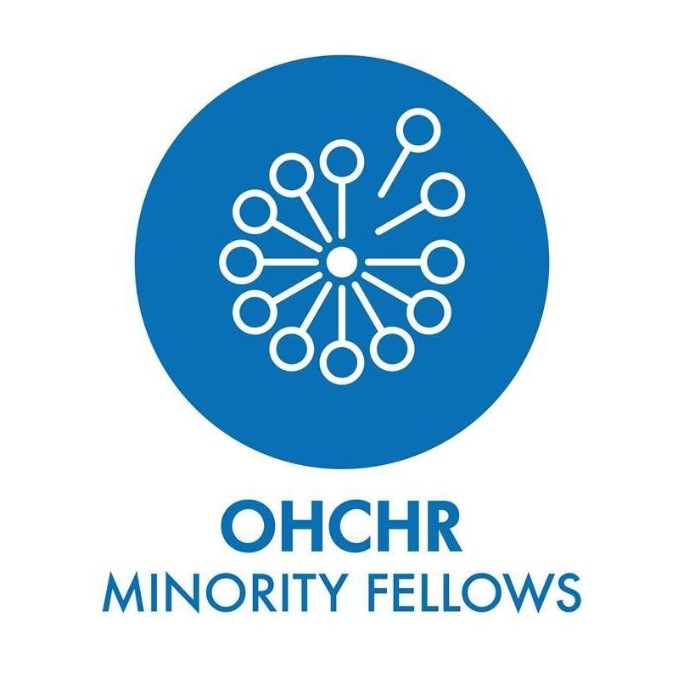

Joint submission for the 2020 HRC report of the Special Rapporteur on the right to education on behalf of former OHCHR Minority Fellows representing the following organisations:

- Youth Platform of Interethnic Solidarity of Moldova

- Latvian Human Rights Committee
- Tamount association for Amazighe rights (Tunisia)
- Tsakhur National Cultural Autonomy (Russia)
- NGO “Nomus va Insof” (Dignity and Integrity), Tajikistan
- Alexander Bekmurzin, Former UN Minority Fellow, Russian ethnic minority from Kyrgyzstan
- Sarvar Salimov, Former UN Minority Fellow, Uzbek national minority from Kyrgyzstan
- Farkat Ibrahimov, Former UN Minority Fellow, Uyghur ethnic minority from Kyrgyzstan
- Jairo Rodriguez Davis, Former UN Minority Fellow, Raizal ethnic minority -under Colombia
- Jack Jendo, Assyrian Ethnic, Linguistic and Religious Minority in Lebanon
- Elizabete Krivcova, Former UN Minority Fellow, Russian linguistic minority from Latvia
- Marian Luca, Senior Fellow, Roma Minority Romania/Germany
- Makarios Lahzy, Senior Fellow, Coptic Minority, Egypt
Question 6. What recommendations should be provided to States and other stakeholders on these issues?

As minorities youth many of us have been growing in the societies where we have been told that “minorities issues” are not Human Rights, therefore our claims to get access to education in our mother tongues have no ground.

It is worth noting that, in the countries represented by us, the areas of the use of minority languages have been drastically shrinking for years.

Recognizing and experiencing the interlinkages between the topic of the Forum and access to Human Rights education for minority youth we recommend to the UN member states, intergovernamental and donor organizations the following :

- To increase financial support to the OHCHR Minorities Fellowship Programme which empowered many of us to effectively stand up for the right to education for minorities;

- To support Human Rights Education initiatives of minorities youth at the local level and engage in the dialogue and consultations with the minorities youth. As, for instance, Moldovan parliament did this year by supporting the 3rd edition of the National Minorities Youth Forum in Moldova;

- To support cross-regional Human Rights education initiatives of minorities youth which can enhance exchange of good practices. E.x. by organizing Summer Schools for and with minorities youth in the accessible regional languages. This is something Former Fellows are striving to organize in MENA region and post-Soviet area;

- To mainstream the minorities youth issues in the UN System, e.x. in the Social Forum and OHCHR strategic work on Youth and Human Rights;

- To make Human Rights education resources accessible in different regional languages and for people with disabilities;

- To organize training sessions for the staff of the Ministries of education on the right to education for minorities with involvement of minority youth as co-facilitators;

- To establish UN Fund for Minorities;

- To make a particular focus on development and minority youth residing in rural areas and ensure the proper infrastructure to enable them the attendance of the educational institutions and get a qualitative education.

- Creation of a multimedia platform for minorities to network and share their stories related to human rights violations

- In the parts of States where ethnic and linguistic minority communities make up a significant proportion of the population, it is essential to officially recognize the languages spoken by minority communities by granting those languages a regional or official status with a view to enabling minority youth to receive a quality education in their mother tongues

- The creation of joint projects between local Offices/Authorities for Education and Offices for Social Services for socially disadvantaged young people (or who dropped the school) in order to re-access the educational system and get a professional qualification; similarly, to provide education on intersectional issues, on LGBTI and ensure a safe space for young LGBTI people and other underrepresented groups in the schools and ensure psycho-social counselling.

- In the parts of States where ethnic, linguistic and/or religious a, then, consider to establish or maintain separate educational systems or institutions for them (Article 2b of UNESCO Convention against Discrimination in Education), with their own system of education, culturally-suitable, of high quality and in their mother tongue.

Launched in 2005, the Minorities Fellowship Programme (MFP) is OHCHR’s most comprehensive training programme for human rights and minority rights defenders belonging to national or ethnic, religious and linguistic minorities: https://www.ohchr.org/EN/Issues/Minorities/Pages/Fellowship.aspx
The following recommendations have been also addressed by the OHCHR Minoroties Fellows during the 12th session of the UN Forum on Minorities Issues in 2019 in Geneva

