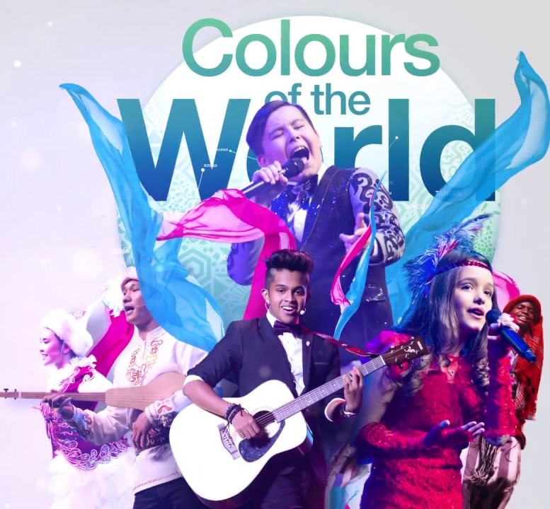  Contributions of Gulen (Hizmet) Schools in the World to the  cultural dImensIon of the rIght to educatIon | M. Fethullah Gulen* define the importance of culture with the following words. “Culture is a stable mix of such fundamental elements as language, education, tradition, and art, all of which form a community's structure and lifestyle. It is a kind of blindness to ignore the reality that these fundamental elements have (and ought to have) unique features, and different characters and temperaments, for they reflect the people to whom they belong.”  By International Broken Chalk Platform  February, 2020
Content

Introduction: 1
Points from UN Convention on the Rights of the Child (CRC): 1
True Story: Gulen (Hizmet) Movement Schools: 2
Language vs Culture: 3
International Festival of Language and Culture: 4
Recommendations 4

Introduction:

When the results of scientific studies in the field of Educational Sciences are subjected to a re-evaluation process by meta-analysis or meta-synthesis method, it is seen that the focus is braided around the man and his needs and problems. It can be said that the source and solution point of both worldly and peripheral problems is human.
Science, education, and culture are integral parts of human life. Those who neglect education and culture are considered dead while they are alive.
When educators think about diversity in the classroom, culture may be one of the characteristics that cross their minds. But as they select their curriculum and develop their lessons, most teachers are not accounting for how culture will impact a student’s ability to participate and learn, says Almitra Berry-Jones, Ed.D., nationally recognized speaker, author, and consultant on the topic of culturally and linguistically diverse learners at-risk.
According to the Berry-Jones, Culture is a social construct, not genetic, and most students have at least three: home, peer, and school. Students are influenced by variables such as language, religion, ethnicity, social class, and region.
The value judgments and social norms of individuals with completely different backgrounds try to survive in the same environment, bring serious communication and compliance problems, and even lay the ground for problems that make the solution difficult over time. This situation disrupts the political, social, economic and cultural balances of the countries.
Having established the definition of culture, we can now analyze the unquestionable link between cultural rights and the right to education. Indeed, the UN Committee on Economic, Social and Cultural Rights stresses that “The right of everyone to take part in cultural life is also intrinsically linked to the right to education (arts. 13 and 14), through which individuals and communities pass on their values, religion, customs, language, and other cultural references, and which helps to foster an atmosphere of mutual understanding and respect for cultural values”.
Therefore, the study on the "cultural dimension of the right to education" to be submitted to the UN human rights council is a very appropriate decision. I think that it would be better to formulate this subject in terms of both direction and detailing.

Points from UN Convention on the Rights of the Child (CRC):

Nearly all the countries in the world are agreed on 17 Global Goals in 2030 under the umbrella of the UN in 2015. Education was the fourth in this list after no poverty, zero hunger and good health. The World Leaders wanted everyone to have access to inclusive, equitable quality education.
According to the Universal Declaration of Human Rights, cultural rights is one of the requirements for human beings to enjoy freedom.
In the UN Convention on the Rights of the Child (CRC), November 1989, the Preamble section following section indicates the importance of the culture for the child's education.
Taking due account of the importance of the traditions and cultural values of each people for the protection and harmonious development of the child, Recognizing the importance of international cooperation for improving the living conditions of children in every country, in particular in the developing countries.
In the UN CRC,
Article 20 (children unable to live with their family):
If a child cannot be looked after by their immediate family, the government must give them special protection and assistance. This includes making sure the child is provided with alternative care that is continuous and respects the child’s culture, language, and religion
Article 29 (goals of education):
Education must develop every child’s personality, talents, and abilities to the full. It must encourage the child’s respect for human rights, as well as respect for their parents, their own and other cultures, and the environment
Article 30 (children from minority or indigenous groups):
Every child has the right to learn and use the language, customs, and religion of their family, whether or not these are shared by the majority of the people in the country where they live.
As observed from the above statements cultural aspect of education is a right for the child and guaranteed by the UN. But international organizations and governmental departments' efforts may not be enough to give this right to human beings. Apart from the government policies, there is a need for the stakeholders and NGOs to put effort to achieve this.

True Story: Gulen (Hizmet) Movement Schools:

The following text is written by Mayge Kaag as a piece of brief information on the said schools:
“So-called Turkish schools have popped up in many African countries (and elsewhere in the world) over the last one or two decades. These schools are linked to the Gülen movement. Fethullah Gülen is a Turkish Muslim intellectual, who developed a philosophy of education that aims to reconcile religion with science [20]. He distinguishes between teaching and education, the latter being more than just transferring knowledge. By contrast, his understanding of education is “the illumination of the mind in science and knowledge, and the light of the heart in faith and virtue” (Gülen quoted in [20]). The Gülen schools are private, secular schools. While Gülen’s inspiration is clear in Islam, the Gülen schools do not offer Islamic education, but a kind of universalistic moral education focused on values. The strategy is not da’wa, proselytizing, but setting a good example [21]. These good examples are provided by the teachers who are followers of Gülen. Their commitment to the educational cause is called hizmet, a religiously inspired service to the community.”
The following statement is taken from Dagu Erkil’s book named Fethullah Gulen and the Gulen Movement in 100 Questions.
Today, the Gulen schools are operating in vast geography extending from Central Asia to Japon, from the Far East to the United States of America. Looking back, 35 years have passed since the beginning of Gulen and his followers' interest in the field of education.
As a result of perseverance, selecting the right individuals, a quality curriculum adapting to the political structure and the local culture, and maintaining an educational level desired by the students’ parents have resulted in amazing achievement and success.
In this report, our focus area will be Gulen (Hizmet) movement schools all over the World which achieve great success to give the right of cultural dimension to her students. The teachers who are teaching in such schools are mostly not aware of the UN Convention on the Rights of the Child but they were giving all the rights to their students, with the effect of that they had a great success of uplifting the child in both characteristic and academic views.
When a person searches on google as a “cultural dimension of the right to education” he/she can find many books, articles, and reports about the topic. After studying, those he/she can produce a wonderful report on the issue. Then the number of articles will be plus 1 on google. But humanity needs a true story who succeeds in that field. Then the content of the article should be how those people got that achievement, make let the others aware of a working solution. Then the researchers write on the to stories of achievement and add include their experience to make the working solution better.
Because of the above reason, this report will take the Gulen (Hizmet) Movement schools' contribution to the CULTURAL DIMENSION OF THE RIGHT TO EDUCATION as a sample.
In the Nigerian education system, there is a religious knowledge lesson for both Christians and Muslims separately. A state in Nigeria called Yobe has 99% Muslim population. A Gulen (Hizmet) movement school in that state has only 1 student in some classes who are Christian but still manage to arrange Christian Religious Knowledge lessons and Sunday ceremonies for her students.
The following example is from one of the Gulen (Hizmet) Movement schools in Turkmenistan but the words belong to a Student from Kyrgyzstan.
A Kyrgyz Student, who studied in such schools, said that he prefers the school as it develops his morality and a positive attitude to religion. Turkish teachers want to serve Turkmenistan/Kyrgyzstan; they identify with and adapt easily to the common language and culture of the learners. Parents support the school because of the high academic standard, and dedication of the teachers who share a common culture with them.
In today's World, developt countries have more respect for Culturel Dimension of Right to Education, and also in UN CRC mainly take the attention of developing countries.
In the Gülen (Hizmet) Movement School, the Muslim child maintains an Islamic identity in a secular environment. This is not possible in the liberal state school, where religion or moral values are not respected and encouraged; nor is it possible in the Islamic private schools, where a Muslim laager mentality is nurtured, making it difficult for them to adapt to secular culture and pluralistic context. It is this balance between preserving moral values of an Islamic identity, (but which are also shared by pupils of other religions) and adapting to a secular school context, that attracted many parents to send their children to these schools.
In such schools, in as much as Turkish teacher share their Turkish culture with the pupils to open doors for them to learn their student's culture. When the students starting to learn a different culture, then all the pupils in the school start to share their own cultural identity. The schools are recognizing not only all the cultural events within their region but also students from different regions.

Language vs Culture:

An article published at www.ukessays.com on the relationship between language and culture has a conclusion as follows.
Form this study, it is clear that linguistic relativism is an evidenced theory. The relationships between language and culture are bilateral.
Language is created to fulfill human needs. Therefore different society created their languages in different ways. The traits of a language are shaped by the culture of a society that created the language. The communication styles, vocabulary, grammar of a language, are all able to reflect a unique culture of a place. Language can be the epitome of culture and even society.
Language is a tool to express human thought and spread culture. The traits and limitations of a language affect the thinking style and cognitions of its speakers. When time goes by, it can shape the culture of a single place.

International Festival of Language and Culture:

In those schools, the local language has great importance with their culture. When the students will themselves as if they are in their environment teaching and learning become easier.
This school organized the International Festival of Language and Culture for more than 15 years annually throughout the World. IFLC gives a short definition on their web site as
IFLC is a premier organization for promoting world languages and cultures. It is dedicated to cultivating artistic self-expression among youth and creating a platform from them to share their cultural heritage with peers around the world.
The International Festival of Language & Culture (IFLC) is an annual celebration of language diversity that showcases talent from across the globe.
The IFLC first started in 2003 with only 17 countries participating. As of today, over 2,000 performers and production members from more than 160 nations have taken part in our events.
Onstage, young students offer a song, dance and inspiring storytelling around themes of compassion, respect, and mutual understanding. Offstage, in every city we visit, our performers enjoy opportunities to engage with members of the local community, explore unique educational experiences and build lasting friendships. It’s the IFLC way of raising hopes for world peace

Recommendations

- Ensuring educational equality for all individuals and including different cultures in the learning environment,
- Combining different cultural heritages, establishing a connection between students' learning and real-life experiences in a multicultural environment,
- Providing students to learn common value judgments and social norms,
- It is foreseen that the value judgment, which is aimed to be brought to the individual, is the same in the family, school, society and mass media, and the programs are structured according to this perspective,
- Recognizing that systematic change is a developmental process,
- Bringing the concepts of dialogue, tolerance, self-sacrifice, sacrifice and other spirituality to individuals, which will enable the development of the multicultural environment,
- Democracy and universal law norms, which are effective in communication and interaction among individuals, are practiced by experts by individuals.
- Although the structure, function, and goals of each Organized Education Mechanism are different, its common goal is to help the individual develop and socialize his personality.
- In the educational institutions and organizations providing formal education, the education, training, and implicit programs prepared are planned in a way that will bring the cultural identity of the individual to the cultural identity he/she lives in without abuse,
- Having the knowledge, skill, attitude, experience and psychological structure of the specialists who will apply the programs, as well as the ability to develop flexible programs suitable for scientific development and differentiation in the individual,
- Introducing different cultures to the individual, and determining the points that will connect with the social culture in which they live,
- Establishing the link between new learning and existing experiences and experiences,
- Programs are designed in a pedagogical approach to meet the needs,
- Both the multicultural environment and educational programs prepared are designed to cover the subjects that will enable the individual to develop in different fields,
- Implementing programs carried out informal education institutions based on cooperation and coordination with non-formal education institutions.

BY STACEY PUSEY, https://www.eschoolnews.com/2018/04/17/culture-impact-ability-learn/
THE RIGHT TO EDUCATION - A CORNERSTONE OF CULTURAL RIGHTS by ALFRED FERNANDEZ & IGNASI GRAU I CALLIZO
https://www.globalgoals.org/
https://www.un.org/en/universal-declaration-human-rights/
https://www.ohchr.org/documents/professionalinterest/crc.pdf
https://www.ohchr.org/documents/professionalinterest/crc.pdf
Mayke Kaag is a social and political anthropologist interested in processes of change and continuity in West and West-Central Africa., https://www.ascleiden.nl/organization/people/mayke-kaag
https://www.mdpi.com/2071-1050/10/2/496/htm
Dogu Ergil has worked with various NGOs on developing more effective leadership, conflict management, and creative problem solving. He has won awards for his work in international organizations promoting peace and democracy.
By Dogu Ergil, Fethullah Gulen and the Gulen Movement in 100 Questions
https://fgulen.com/en/home/1341-fgulen-com-english/conference-papers/contributions-of-the-gulen-movement/25891-the-educational-philosophy-of-fethullah-gulen-and-its-application-in-south-africa
https://fgulen.com/en/home/1341-fgulen-com-english/conference-papers/contributions-of-the-gulen-movement/25891-the-educational-philosophy-of-fethullah-gulen-and-its-application-in-south-africa
https://www.ukessays.com/essays/english-language/relationships-between-language-and-culture-english-language-essay.php?vref=1
http://www.intflc.org/

