ECSWE Contribution to
United Nations Questionnaire on the Cultural Dimension of the Right to Education

As one of the biggest organizations promoting alternative education in Europe, the European Council of Steiner/Waldorf Education (ECSWE) showcases a lot of good practice in dealing with cultural diversity and cultural rights within schools. We appreciate the initiative of the United Nations’ Special Rapporteur on the right to education to consult stakeholders on the cultural dimension of the right to education and would like to share our perspective on the matter.
We firmly believe that every child brings their own unique potential into the world and it is the school’s responsibility to help the children discover it. As Jappe Delva, a 12th grader at Steiner school in Lier said: “Here they really regard you as an individual, they respect your talents and they look for best ways to fully develop them”. We believe that using this untapped potential is not only important for the sole individual, but it also brings about a better appreciation and celebration towards communal diversity. When one takes a closer look at universal pedagogies like the Steiner/Waldorf Education, it will become apparent that Steiner/Waldorf school’s foster cultural diversity in various ways.
First and foremost, our schools around the world contribute to cultural diversity by offering an alternative to public/mainstream education, by utilizing their own local Waldorf curriculum. In many countries, these schools are the only ones that enable the parents to exercise their right to choose education due to their pedagogical beliefs. For that reason additionally, it is our aim to strive that all our schools have the best possible working conditions. Our school’s growth in Europe and the world over the last century has clearly shown a demand for this form of education. Most of our schools were founded by local groups made up of parents and teachers who had the initiative to create and provide a new and holistic approach to teaching. As a result, to this day, our schools’ alternative curriculum and methodology is being offered to families in 1,182 schools in over 60 countries making us the largest independent school movement in the world.
Secondly within Steiner/Waldorf, we foster cohesive understanding of cultural diversity and we also strive to realize the cultural rights within each child by acknowledging the individuality and their unique potential.
Our schools are open to children from all social backgrounds. We strive to respectfully embrace and build on their diversity. To create mutual understanding within Steiner/Waldorf, our pedagogy is based on strong pupil–teacher interaction and cooperation that offers a learning experience for both sides. The aim of that relationship is to preserve the individuality of each child and enable them to become a more free-thinking individual who is not afraid to pose questions, critically observe, and better understand the world around them. As Line, a 12th grader from Steiner school in Lier once put it: “This education gives me choices so I can decide what I like doing, what I want to develop further and what my interests are.”

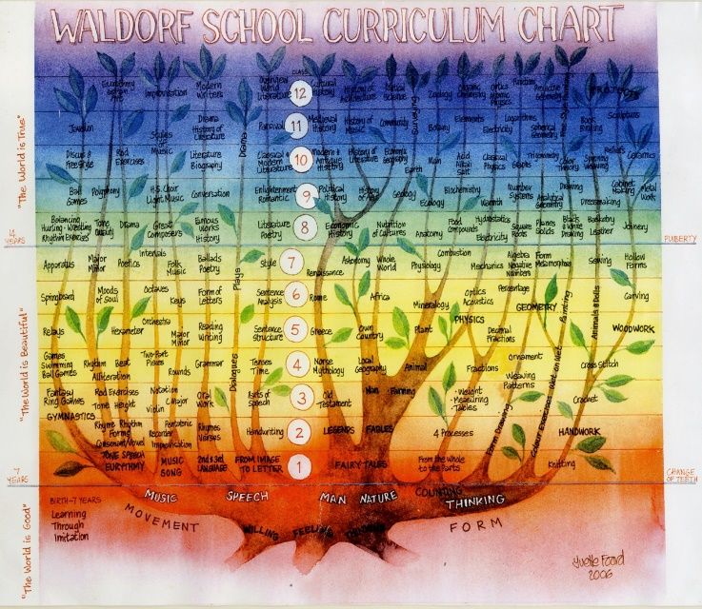
Steiner/Waldorf school curriculum chart from kindergarten through 1st to 12th grade
Furthermore, this pedagogy is based on a developmental approach that is transferable and can be tailored to different cultural and religious environments. It is often stressed that in Steiner/Waldorf schools, the children are the basis and the starting point of our curriculum. This means that while teaching, the school must give respect to the inner impulses of each child. For this reason, there needs to be a resilient parent – pupil – teacher triangle allowing for a daily comprehensive approach between the teacher and the child.
As the first school opened for the children of factory workers in September of 1919 in Stuttgart, Germany, it strived to accept every child, no matter the gender, economic, cultural or national background. What mattered was the child’s willingness to cooperate with the teacher and desire to be a part of the school.
This integrative approach is evident in the establishment of several intercultural Waldorf schools where they also took the initiative to voluntarily open their doors to refugee children. Accepting differences is deeply embedded in our holistic approach that appeals to the head, heart and hands of every learner. This can be challenging at times as the schools rely on a considerable degree of parental involvement. A healthy relationship between the parents and school help develop understanding of the child’s cultural background and is thus of key importance in Steiner/Waldorf schools.
As children are usually unconsciously aware of their cultural traits, it is important that we intentionally incorporate children’s cultural heritage into the class. Therefore it is imperative that we assist the children to connect consciously with their culture. Doing this helps us to create a sense of belonging by offering them an opportunity to position themselves in the world around them. To accomplish this, Waldorf schools invite family and friends to meet with the school, to participate in school’s events and to celebrate life together. Enio Montalto, 11th grader from Steiner school in Lier explains: “We have a special bond here, I would say because we do a lot together, work together and trust each other."
The use of Waldorf pedagogy in different cultural circumstances proves that it can be adopted regardless of religious, economic, racial, historical or cultural backgrounds. Apart from understanding the child and its immediate social environment, the Waldorf curriculum needs to adapt to local culture as much as possible. Even though the “traditional Waldorf curriculum is the dominant Eurocentric model” (Rawson, 2019:14), “each country has its educational and cultural histories that have determined which literature and cultural resources are privileged and which neglected” (Rawson, 2019:13) within the curriculum. This translates into different curricula used across the world while a common pedagogical approach remains effective across local, regional and national diverse environments. So while storytelling may be the means to portray archetypical characters, the stories themselves may differ depending on the local context: “When we tell stories as Waldorf teachers, we also have the license to modify stories in ways that reflect our values” (Rawson, 2019:17). Thus, as a guiding principle Rawson offers for teachers to locate their “material in the linguistic and cultural contexts you [they] are in, acknowledging that this will inevitably be complex” (Rawson, 2019:17). Our pedagogical approach allows us to reflect the inner diversity of pupils. Johannes van Goethem, a Waldorf alumnus, testifies: “This school is very open. They want us to have a broad range of things to learn, to give us as much experience as possible.”
According to B. Dahlin (2007), the research showed that while accepting and embracing differences, it is evident that upper school Waldorf pupils felt to greater extent responsible for social and moral issues compared to the results among the pupils in municipal schools. Dr. Christian Pfeiffer’s 2009 research for the Lower Saxony Criminological Research Institute showed that among 45,000 ninth-graders in Germany xenophobic reactions are minimal in Steiner/Waldorf schools (All schools: 27%, Gymnasia: 8.3%, Steiner/Waldorf schools: 2.8%).
The founding principles of the first Waldorf School in 1919 highlight the need to educate children towards a more peaceful world after the end of the First World War. To achieve this, pupils would learn the national languages of their countries recent opponents. Additionally to learning languages as a guide towards cultural diversity, Rawson highlights the need to tell stories of the emancipation of various cultures – “It must also be the task of Waldorf pedagogy to enable those lost voices to resonate in contemporary souls” (Rawson, 2019:16) as this helps to counter historical oppression. Di Johnson from Australia testifies that “the children here [in Australia] are taught the Indigenous seasons, those taught by the local Aboriginal people, and our [their] walks and nature study, many songs and stories are linked to these” (Rawson, 2019:15). Since cultural stereotypes often happen when an outsider writes about a culture, when using original stories from a certain culture, we get to build an image of that culture without stereotypes. For that reason, for example, in England’s Steiner/Waldorf schools, pupils read “tales from Zimbabwe, South Africa, Nigeria, Ghana, Jamaica and India, as well as stories by first generation immigrants to the UK” (Rawson, 2019:16).
After all, Steiner/Waldorf education values individuality and cultural differences making the lessons richer. While the demographics of many Steiner/Waldorf schools still predominantly feature white middle class families, schools regularly strive to be open and accessible for everyone. Unfortunately, many educational systems still do not provide sufficient funding for alternative educational approaches. As a result, parents need to pay for their child’s tuition fees on top of the taxes that fund the educational system allowing limited flexibility and diversity in its approach. By practicing solidarity, many schools try to include all children, regardless of the financial means of their parents. Regardless of the challenges, Steiner/Waldorf schools are continuing to deliver a learning space that is welcoming and fruitful to the enrolled children where the learning process takes place in all directions.
A few other Steiner/Waldorf methods for embracing cultural diversity are:
- No segregation of pupils for as long as possible to keep them aware of their complementary differences;
- Using free play (in kindergarten) enables children incorporate their complementary differences from early age;
- Using diverse assessment practices to adapt to pupils from different backgrounds;
- Having local (indigenous, minorities, etc.) languages present at the school;
- Mandatory gathering for choir singing or playing in an orchestra;
- Project-based learning outside of the regular classroom setting.

Looking at Article 26, section 2 of the Universal Declaration of Human Rights:
“Education shall be directed to the full development of the human personality and to the strengthening of respect for human rights and fundamental freedoms. It shall promote understanding, tolerance and friendship among all nations, racial or religious groups, and shall further the activities of the United Nations for the maintenance of peace”,
Steiner/Waldorf pedagogy is confident that it delivers an educational program that is in accordance with their basic values and goals. The biggest challenge that faces Waldorf pedagogy movement lays in section 3 of the same article that claims: “Parents have a prior right to choose the kind of education that shall be given to their children”. Parents are often not given the right to choose the school of choice because either the school that they would prefer is nonexistent or is not financially supported by the state. To better address this issue, in accordance with our values cited here, Steiner/Waldorf schools will continue to work offering that alternative choice to parents and we will continue to be the type of educational system that embraces differences. Through these efforts, we will create an even stronger synergy between the public schools and their home governments.
This is best achieved, if the following political and legal conditions are met:
- National school associations and local schools can define and fully implement their own school curricula;
- The freedom of parental school choice as described in Article 26, Universal Declaration of Human Rights of the United Nations is granted Europe wide;
- Full public funding for independent non-profit schools is granted Europe wide to realize the right of parental school choice, irrespective of financial means;
- Diversity in assessment is a reality and Waldorf schools may develop and provide their own, state-recognised diploma;
- Standardised and centralised tests are replaced with alternative assessment methods;
- Our schools can provide their own ICT and media pedagogy based on our development-oriented and age-appropriate approach.

References:
Dahlin, B., 2007. The Waldorf School - Cultivating Humanity? A Report from an evaluation of Waldorf Schools in Sweden. (Research Report 2007:29) Karlstad: Karlstad University Studies.
Pfeiffer, C., 2009. Young people in Germany as victims and perpetrators of violence. Hanover, Germany: Criminological Research Institute of Lower Saxony.
Rawson, M., 2019. International Waldorf 100 Curriculum Project: Some guidelines for choosing story material. Hamburg, Germany. Pacifica Journal, No. 56, Vol.2.
“Steinerschool Bio-ecological buiding, MSV Lier, Belgium”, 2015. Available at: https://vimeo.com/143461440.
United Nations,1948. Universal Declaration of Human Rights. Available at: https://www.un.org/en/universal-declaration-human-rights/.

