THE PHILIPPINES’ ADDITIONAL CONTRIBUTION

TO THE OHCHR ANALYTICAL REPORT ON THE RIGHT TO WORK

AND THE ENJOYMENT OF ALL HUMAN RIGHTS

BY PERSONS WITH DISABILITIES (PWDs)

(pursuant to HRC resolution A/HRC/43/7)

Inputs provided by the Philippines´ National Economic and Development Authority (NEDA) on the Measure to Enhance the Economic Participation of Persons with Disabilities

- The 2016 National Disability Prevalence Survey (NDPS) finds the following concerns as factors that limit the economic participation of persons with disabilities in the country:

  - Limited educational qualifications. Persons with disabilities tend to finish lower levels of education. Looking at the 2016 National Disability Prevalence Survey (NDPS), it is evident that the degree of disability and level of school attainment are inversely related (see figure below lifted from the 2016 NDPS report). There are more individuals with severe disability with no education, only had some elementary education, or finished only elementary school.

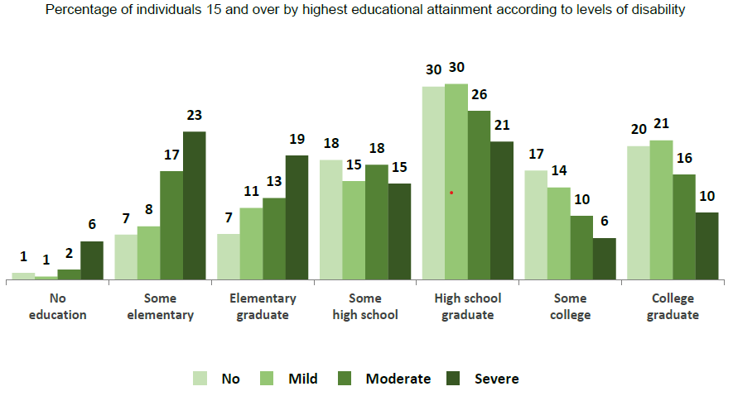

  - Physical and social barriers. The 2016 NDPS also shows that those with severe disabilities find transportation (43%), and workplace and schools (32%) hindering. Looking at workplaces, 34 percent of them found it very problematic or extremely problematic to apply for a job, and 11 percent had difficulty getting things done at work.

They may also face employment discrimination. Twenty-two percent of persons with severe disabilities, nineteen percent of those with moderate disabilities, and seventeen percent of those with mild disabilities are hindered to participate due to negative attitudes. Also, more individuals with severe (20%) and moderate disability (14%) experienced unfair treatment compared to those with mild (8%) and no disability (8%).

  - Unmet needs for assistive devices and support services. The 2016 NDPS shows that eight percent of those with severe disability who already have personal assistance noted that they need more assistance, while 10 percent of those with severe disability without personal assistance said they need assistance. Those with severe disability also reported having unmet needs for assistive devices (8% for mobility and self-care, 19% on seeing, and 11% on hearing and communication). These unmet needs may limit the functioning of individuals, and hinder their economic productivity.

  - Disability-related costs. The abovementioned challenges especially those on mobility and support services result in disability-related added costs. A 2016 study by the National Council on Disability Affairs on two Philippine provinces shows that disability-related added costs are usually on medicine, transportation, and medical services. These costs are hindering – taking a taxi instead of the cheaper jeepney, or needing to hire a personal assistant can prevent individuals from applying for or reporting to work.

- Below are some of the initiatives undertaken by the Philippine Government to help persons with disability overcome the abovementioned challenges:

  - Equal opportunity and anti-discrimination policy. Republic Act No. (RA) 7277 promotes equal opportunities and illegalizes employment discrimination against persons with disabilities.” Aside from enumerating acts of discrimination on employment, it also provides for incentives and programs, which supports the employment of persons with disabilities.

Department of Labor and Employment (DOLE) - Labor Advisory no. 14 s. 2018 provides further guidance on RA 7277, which emphasizes that all qualified employees with disability shall be entitled to all the rights and benefits granted under the Labor Code. It reiterates that qualified employees with disability shall be mandatorily covered under the Social Security System (SSS), PhilHealth, and Pag-IBIG Fund, whenever applicable. Moreover, qualified employees with disability are also entitled to service incentive leaves provided that conditions for entitlement are met.

  - Employer incentives. RA 7277 provides for tax incentives for firms that hire persons with disability (deduction of 25% of the individuals’ salary from firm’s gross income), and modify their facilities to provide reasonable accommodation (deduction of 50% of modification costs to the firms’ net taxable income).

  - Vocational training and sheltered workshop. Aside from pursuing inclusive education, there are efforts to enhance the capacities through vocational education. RA 7277 provides for the sheltered workshop and vocational rehabilitation and training of persons with disabilities so that they may obtain decent work. According to the Department of Social Welfare and Development - Social Marketing, these vocational rehabilitation centers provide “social, medical and psychological services, livelihood and vocational skills training, job placement, sheltered employment, and capability building activities,” and are located in seven areas nationwide. These facilities served 671 clients in the first semester of 2018.

Executive Order no. (EO) 417 s. 2005 directs the Department of Education, the Commission on Higher Education, and the Technical Education and Skills Development Authority (TESDA), to develop a system of academic equivalency to ensure that persons with disabilities have access to employment and entrepreneurship opportunities. At present, TESDA provides mainstream vocational training programs, which can be availed by persons with disabilities. Also, the National Council on Disability Affairs partners with TESDA to provide free skills training to persons with disability under the Training for Work Scholarship Program. Upon completion of the training, beneficiaries are given a National Certificate for job application purposes.

  - Employment and livelihood assistance. The DOLE Integrated Livelihood and Emergency Employment Program (DILEEP) provides livelihood support to poor, vulnerable and marginalized individuals through emergency employment or entrepreneurship support. From 2008 to 2018, 19,206 persons with disabilities benefited from the program. For the first quarter of 2019, 1,900 persons with disabilities received livelihood assistance totaling to PHP1.51 million.

There are also efforts to support business of persons with disability. From July to August 2020, the Department of Trade and Investments implemented the Biz-Ability Online Trade Fair which features micro, small, and medium enterprises that are either owned by persons with disability or establishments which employ persons with disability in their business. Furthermore, Executive Order no. 417 s. 2005 orders government offices to procure at least 10 percent of their needed goods and services from persons with disability cooperatives and organizations, where possible and applicable.

Also, consistent with the Philippine Development Plan 2017-2022 strategy on ensuring labor market information and employment facilitation systems responsive to vulnerable groups, the Public Employment Service Office, a non-fee charging multi-dimensional employment service facility established in all LGUs nationwide ensures delivery of employment services and programs, includes conduct of employability enhancement trainings or seminars for job seekers and vulnerable groups including persons with disabilities.

  - Employment quota and reasonable accommodation. RA 10524 reserves at least one percent of all positions in government agencies, offices or corporations. Civil Service Commission Memorandum Circular No. 31 s. 2017 provides for reasonable accommodation by extending the time limit of examinations by one hour for the visually impaired and deaf/hard of hearing examinees.

  - Disability benefit. The SSS, Government Service Insurance System (GSIS), and Employees’ Compensation Commission (ECC) provide disability benefits to help their members manage shocks due to the onset of disability.
Program | Qualifying Condition | Benefit
SSS/Disability Benefits | Member becomes permanently disabled, either partially or totally; he/she should at least have paid one monthly contribution before the semester of disability | Monthly pension or lump sum amount depending on length of SSS contribution; amount depends on members’ contribution amount and length; members also receive supplemental allowance and dependent’s allowance
GSIS/Disability Benefits | In the service at time of disability; or depends on the length of contribution and fulfilment of other conditions if already separated | For those who become permanently and totally disabled: Monthly income benefits for life equivalent to the basic monthly pension effective from date of disability; Cash payment equivalent to 18 times the basic monthly pension for those in service at the time of disability
ECC/Employees’ Compensation Program | Injury is work-related | Disability income depends on type of disability; Supplemental/Carer’s Allowance increased to PhP1,000 starting May 19, 2018; 13th month; and Dependent’s Pension

  - Return-to-work program. The Katulong at Gabay sa Manggagawang may Kapansanan (KaGabay) Program of the DOLE-ECC helps those who acquired work-related disabilities regain their economic productivity. It also provides for physical or occupational therapy services, prosthesis and assistive devices, skills training, and entrepreneurship seminars. The program also provided aid to those who lost their work due to the COVID-19 pandemic by providing livelihood support package worth PHP20,000.

  - Disability ID. The Persons with Disabilities Identification Card provides qualified individuals access to benefits and privileges including concessions (as provided by Republic Act 9442), and automatic PhilHealth coverage (as provided by Republic Act 11228). PhilHealth membership may not only help access needed medical services but also packages which support the habilitation/rehabilitation of persons with disabilities.

  - Concessions. Among others, Republic Acts 9442 and 10754 provide persons with disabilities 20 percent discount and value-added tax exemption for a list of goods and services including the payment of transportation fares. This initiative may help offset disability-related extra costs.

  - Survey on the impact of the COVID-19 pandemic to PWD workers. More recently, the DOLE, in partnership with various concerned government agencies and organizations, conducted a rapid assessment survey on the impact of the COVID-19 pandemic on the ways of work of persons with disability workers. The survey entitled “Moving​ Towards Disability Inclusive Recovery in Employment and Livelihood in the time of COVID-19”, was launched last July 2020 in observance of the 2020 National Disability Prevention and Rehabilitation Week.

Based on the survey, 70 percent of the respondents said that their employment was affected by the pandemic. They are working either on work from home arrangement, on no-work-no-pay, or on reduced working hours policy, while others are at risk of losing their jobs. Moreover, the survey shows the respondents’ issues in coping with the new normal (i.e., they believe it will take a long time for them to adjust to the new normal and it will be more challenging for them to find employment opportunities). The results of the said survey are set to guide stakeholders and policymakers to formulate recovery measures towards creating a supportive environment for decent and equitable work and livelihood opportunities for persons with disabilities in the new normal. END.

Philippine Statistics Authority. (2019). 2016 Disability Prevalence Survey: Model Functioning Survey. Retrieved October 1, 2020, from https://psa.gov.ph/content/national-disability-prevalence-survey
National Council on Disability Affairs. (2016). An Analysis of Government Support and Disability-Related Costs in Eastern Samar and Rizal Provinces. Retrieved October 4, 2020, from https://drive.google.com/file/d/0B4703hvO4j2pZ09PeE1YQVZfbWc/view
DSWD Social Marketing. (2018). DSWD supports right of employment of PWDs; promotes May 1% Ka Ba? Campaign. Retrieved from: https://www.dswd.gov.ph/dswd-supports-right-of-employment-of-pwds-promotes-may-1-ka-ba-campaign/
Department of Labor and Employment (DOLE). (n.d.). DOLE Integrated Livelihood Program and Emergency Employment Programs. Retrieved from: https://bwsc.dole.gov.ph/programs-and-projects-submenu1/dileep.html
Department of Labor and Employment. (2019). Govt Assures Employment, Livelihood Opportunities for PWDs. Retrieved from: https://www.dole.gov.ph/news/govt-assures-employment-livelihood-opportunities-for-pwds
https://www.dti.gov.ph/archives/news-archives/dti-biz-ability-online-trade-fair-pwd/
Social Security System (SSS). (n.d.). Disability Benefit: Overview. https://www.sss.gov.ph/sss/appmanager/pages.jsp?page=disabilitypension
“Monthly pension - a cash benefit paid to a disabled member who has paid at least 36 monthly contributions to the SSS prior to the semester of disability; lumpsum amount - granted to those who have not paid the required 36 monthly contributions, and for disability claims whose approved pension duration is less than 12 months”
“In addition to the monthly pension, a supplemental allowance of P500.00 is paid to the total or partial disability pensioner. The allowance will provide additional financial assistance to meet the extra needs arising from the disability.”
“The dependent legitimate, legitimated, legally adopted and illegitimate children, conceived on or before the date of contingency of a totally disabled pensioner will each receive a dependent's allowance equivalent to 10 percent of the member's pension, or P250, whichever is higher.” Limited to five children.
Government Service Insurance System (GSIS). (n.d.). Disability. Retrieved from: https://www.gsis.gov.ph/active-members/benefits/disability/
Government Service Insurance System (GSIS). (n.d.). Disability. Retrieved from: https://www.gsis.gov.ph/active-members/benefits/disability/
For carers of members who acquire permanent partial or total disability as a result of work-related injury.
Employment Compensation Commission (ECC). (n.d.). Frequently Asked Questions about the Employee’s Compensation Program. Retrieved from: http://ecc.gov.ph/wp-content/uploads/2017/06/FAQs_Handbook.pdf
Department of Labor and Employment [DOLE]. (2020). PWDs get livelihood aid amid pandemic. Retrieved from: https://www.dole.gov.ph/news/pwds-get-livelihood-aid-amid-pandemic/
Moving towards disability-inclusive recovery in employment and livelihood in the time of COVID-19; retrieved from: https://www.dole.gov.ph/news/moving-towards-disability-inclusive-recovery-in-employment-and-livelihood-in-the-time-of-covid-19/

