**Visit to the United Kingdom by the United Nations Special Rapporteur on extreme poverty and human rights.  Submission from the** [**Rev Paul Nicolson,**](https://www.huffingtonpost.co.uk/author/reverend-paul-nicolson/)**Taxpayers Against Poverty**

**Please publish on website of Special Rapporteur on extreme poverty.**

Taxpayers Against Poverty (TAP) was founded in 2012 [in response to a letter I had published in *The Guardian*.](https://www.theguardian.com/society/2012/feb/16/taxpayers-alliance-social-justice) Since 1997, I had been founder and chairman of a charity called the Zacchaeus 2000 Trust (Z2K). Z2K works with and for the very poorest UK citizens entangled in the benefits system. It now handles around 3,000 cases a year, drawn from Westminster and the surrounding boroughs. TAP has 21,300 followers on Facebook and 550 members. Both TAP and Z2K work with and for the poorest UK citizens without allegiance to any political party.

We were concerned about the legal restrictions on the political activities of charities, therefore set up TAP as a not-for-profit business, the objects of which are focused on Article 25 of the Universal Declaration of Human Rights: social and economic rights.

TAP is not a charity. The restrictions on such activities by charities were even more severely curtailed by the Lobbying Act 2014. We challenged the Charity Commission on this matter (see attached letter). However, the ruling made it clear that neither charities nor the Churches

can oppose a political party – even a fascist one – that fails to obey the letter or the spirit of the Universal Declaration of Human Rights.

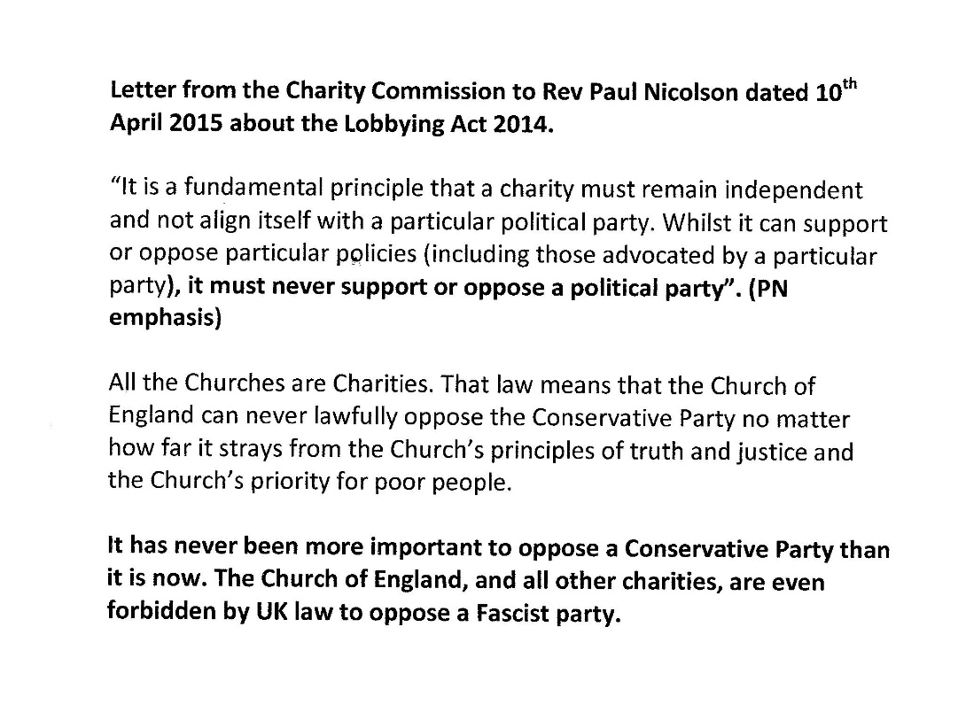

**We would like to provide evidence in answer to one of your questions, which is:**

(1) What is the **definition of poverty and extreme poverty** that your organisation employs in the context of the United Kingdom and to what extent do official definitions used by the State adequately encompass poverty in all its dimensions?

**Our response:**

(a) We define **poverty** as an income below the level of minimum-income standards, after housing costs and council tax have been met, which risks the mental and physical health of men, women and children.

(b) We define **extreme poverty** as being when the income in (a) is required by the State to pay housing costs and council tax, so creating hunger an debt and risking the mental and physical health of men, women and children.

The **official definitions used by the State** fail adequately to encompass poverty in all its dimensions, as we go on to explain below.

**Background**

Z2K was registered as a charity in 1997. Its foundation was as a consequence of discussions among a group of Christians, in the rooms of the Dean of Clare College Cambridge, about the impact of the poll tax on the poorest UK citizens. We were concerned that the government had decided to tax social security incomes without knowing the minimum income needed for healthy living.

In 1997 there was no adequacy report available to the government on which to base decisions about the level of statutory minimum incomes. Z2K therefore raised £100,000 and commissioned the Family Budget Unit to research the minimum required for a couple and for a single parent with two young children. The results were published 20 years ago, in 1998, as ["Low Cost but Acceptable – a minimum income standard for the UK" – see page 68.](http://taxpayersagainstpoverty.org.uk/wp-content/uploads/2014/02/Low-cost-but-acceptable.pdf) It showed that unemployment benefits for a couple with two young children were £39 a week below what we called the minimum-income standard (MIS).

The care with which the items included in the minimum-income standard were researched and calculated is illustrated by the attached "MIS: the food budget working paper".

The published research was given in 1997 to:

1.   The trades union Unison and community-organising alliance London Citizens (now Citizens UK), which, in 2001, used it to persuade the Mayor of London to launch the London Living Wage.

2.   The Secretary of State at the Department for Work and Pensions, who said increases in benefits would have to be incremental. The 1997 Labour government of the time added those increases to children's and pensioners' benefits, but the working-aged adult unemployment benefit was left to "wither on the vine", as it had done since 1979.

The social-change organisation the Joseph Rowntree Foundation then took on the funding of minimum-income-standard research at Loughborough University, updating it annually for the Living Wage Foundation.

**Income & health**

“Income can impact on health in different ways. Income impacts on health directly, for instance, because of insufficient money to heat your home or provide yourself with a balanced diet. Cold homes increase rates of respiratory disease, cardiovascular disease, excess winter deaths and mental illness. An inadequate diet increases the risk of malnutrition, obesity, diabetes and cardiovascular disease.

Low income, and particularly insufficient income or debt, also impacts on health indirectly, through increased stress, depression and anxiety, and sub-optimal coping behaviours, such as increased rates of smoking and drinking.”

*Dr Angela Donkin, Institute of Health Equity*

[The expert opinion above is from one of a series of nine blogs on health inequality by health professionals on our website](http://taxpayersagainstpoverty.org.uk/news/9-blogs-tackle-the-stark-reality-of-health-inequality-in-modern-britain.-th)

**The adult unemployed in the UK are in extreme poverty**

The level of the single-adult unemployment benefit is currently £73.10 a week (the outgoing Jobseeker's Allowance, or JSA), which equates to £317 a month (the recently introduced Universal Credit). It has been losing value since 1979 and has been frozen since 2011. For a couple, JSA is £114.85pw, and Universal Credit £498pm.

[Letter published in *The Guardian*, May 2009](https://www.theguardian.com/money/2009/may/15/letter-jobseeker-allowance-unemployment)

“When unemployment benefit started, in 1912, it was 7 shillings a week – about 22% of average male earnings in manufacturing. The percentage fluctuated over the succeeding decades, but, by 1979, the benefit rate was still about 21% of average earnings (manual and non-manual, male and female). By 2008, however, as a result of the policy of tying benefits to the price index while real earnings increased, the renamed Jobseeker's Allowance had fallen to an all-time low of 10.5% of average earnings. And while, in the past, means-tested allowances raised unemployed income to a higher minimum level, the Jobseeker's Allowance rates are now the same, whether means-tested or not.

*Jonathan Bradshaw, University of York, and Tony Lynes, London”*

All childrens', disability, Housing and Council Tax benefits are added to JSA/Universal Credit, which is [paid to about 3.8 million people.](https://www.ons.gov.uk/employmentandlabourmarket/peoplenotinwork/outofworkbenefits/datasets/mainoutofworkbenefitsben01) It is below the Joseph Rowntree Foundation's minimum-income standards for food, water, fuel, clothes, transport of £92.92 per week, which is a very bare minimum, and a long way below the full MIS [(Joseph Rowntree Foundation, 2018 – see page 37).](https://www.jrf.org.uk/report/minimum-income-standard-uk-2018)

Before April 2013, the £73.10 was supported by 100% Housing and Council Tax benefits. Since April 2013, however, Council Tax has been charged at 8.5 to 30% against State-benefit incomes by [277 councils out of 326 in England.](https://www.npi.org.uk/files/5114/9132/4194/Key_changes_to_council_tax_support_in_201718_.pdf)And those councils add court costs and bailiffs' fees to any arrears, which clearly cannot be paid out of a single-adult unemployment benefit of £73.10 a week.

Since April 2013, rent also has to be paid out of that £73.10: that was when the government first started to cut Housing Benefit, via an overall benefit cap, the so-called Bedroom Tax (a measure introduced in the Welfare Reform Act 2012, by which the amount of Housing Benefit paid to a claimant is reduced if the property they are renting is judged to have more bedrooms than necessary) and Local Housing Allowance (rates used to calculate Housing Benefit for tenants renting from private landlords). A cut in Housing Benefit means an increase in rent for the tenant. And that rent is ever rising, owing to the chaotic UK housing market.

For the UK’s 7 million tenants, the housing crisis is worsening. They possess no equity to fall back on. There is no escape from Council Tax, Income Tax or VAT (value-added tax on goods purchased). Moreover, rents and Council Tax are increasing, while incomes remain stagnant.

If a disabled person fails the Work Capability Assessment, he or she is forced on to £73.10 a week JSA, which is not sufficient to support healthy living even for an able-bodied person.

In short, the adult unemployed in the UK – and especially the disabled – are in extreme poverty.

**Poor maternal nutrition**

I live in Tottenham, on the borders of the Northumberland Park Ward, which is the most deprived ward in the London Borough of Haringey and among the 5% that make up the most deprived wards in England. The expectation of life, according to the 2011 census, is seven years shorter than in Highgate, in the west of the borough. Low birth weight is at 10 to 12%, or at near developing-world levels.

Attached is a paper by Professor Michael Crawford, of the Institute of Brain Chemistry and Human Nutrition. The evidence it contains has been submitted to UK governments frequently since 1972. In it, Prof Crawford makes the point that poor maternal nutrition adds substantially to the risk of low birth weight and permanent developmental brain disorder in the babies of impoverished mothers. £73.10 a week adult unemployment benefit is so inadequate that the risks of poor maternal nutrition and its consequences are high. Three days' food from a food bank is not adequate to make up the shortfall.  And depriving a pregnant woman of all income needed to buy food with a benefit sanction must, in some cases, have catastrophic results for their babies. Graph published by the British Medical Journal.

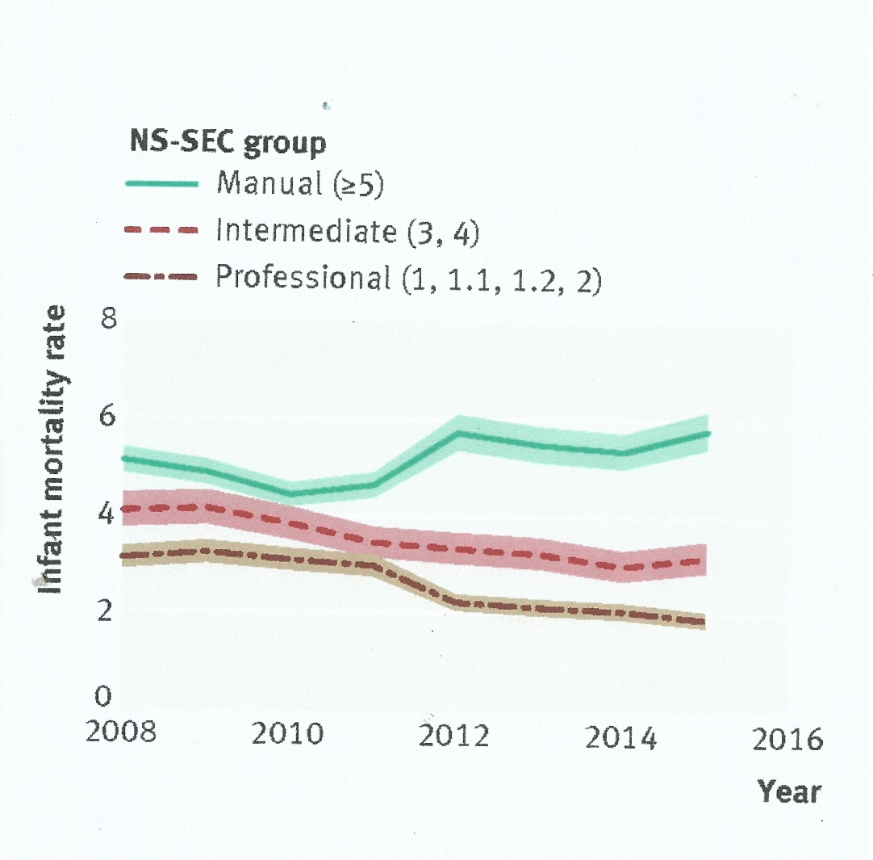

**The impact of benefit sanctions**

While it is possible to understand the reason why politicians insist on conditionality when using taxpayers' money to pay the unemployed, it is impossible to support a Department for Work and Pensions (DWP) that punishes the unemployed more severely than the Ministry of Justice (MoJ) punishes thieves, and without even a fair trial.

For failing to turn up at a work-related interview at a Job Centre, an unemployed person can have his/her income stopped for three months. That is a fine of £951. In contrast, when a person appears before a magistrate, having committed a first or second criminal offence, the magistrate will levy a fine proportionate to the defendant's income and apply the Wednesbury Principles of reasonableness (see attachment). The Job Centre official makes the decision in his or her office with no transparent legal process akin to the magistrate's.

**Benefit sanctions: a case history**

I helped John Smith (name changed), through the traumatic aftermath of a benefit sanction, imposed for missing one appointment at the Job Centre.

Three powerful government departments had descended on this single unemployed adult with a history of depression. The DWP stopped his income and the Department for Communities & Local Government/Local Authority enforced rent and Council Tax arrears, and the MOJ enforced a TV-licence fine, all with threats of eviction, the bailiffs and prison.

During a three-month benefit sanction, the unmanageable debts piled up. [When it ended, they were enforced against a totally inedequate £73.10 a week JSA.](http://taxpayersagainstpoverty.org.uk/news/the-great-injustice-in-cutting-esa-by-30-a-wee)

He was then told his block of council flats was due for demolition. He spoke candidly to me about his thoughts of throwing himself off the balcony of his 5th-floor flat.

These extreme punishments imposed by the State, extending to well over a year, owing to the enforcement of debts, were totally disproportionate to the offence of missing an appointment. John Smith did not receive a fair trial at the Job Centre.

When the bailiffs called on John Smith, I told them I was taking the case back to the Magistrates' Court. Here follows the case I put to them, after which they remitted the £135 fine and dismissed the bailiffs.

**To the Magistrates, Highbury Corner Magistrates Court, March 2015**

Re: John Smith, Tottenham.

We are asking you for a statutory declaration or the remission of the £135 fine in full on the following grounds:

The fine should never have been imposed; he is a vulnerable person as described by the Ministry of Justice; he also cannot afford to pay. In addition:

1.    Mr John Smith has no record of ever being fined.

2.    The first he heard of the fine was when the bailiffs called to tell him he had been fined for TV-licence evasion, demanding a £445 down payment at 7.30am.

3.    He protested that was impossible because the TV Licence Authority representative had frequently told him he was not liable because his TV set is only used for games and DVDs.  He does not require a TV licence. He has no TV or broadband account. Two men from the TV Licencing Authority have inspected his flat and agreed that this is the case.

4.    He called me at 8am the same morning and I  informed the bailiffs about his circumstances and they agreed to suspend their action.

5.    He has a long history of anxiety and depression and has been treated by NHS Psychological Services.

6.    On 1st January 2014, he was sanctioned for three months for attending a Job Centre interview on the wrong day.

7.    His Housing and Council Tax benefits were stopped, creating rent and Council Tax arrears. He is still paying off rent arrears at £10 every two weeks out of his £72.40 a week adult unemployment benefit (Employment Support Allowance).

8.    It was after the sanction that NHS Psychological Services referred him for 12 50-minute sessions of therapy.

9.    He received a letter from Haringey Council this week giving notice of intended demolition of the block of flats where he lives.

10. His means statement was

attached.

11. The court’s attention is drawn to the Joseph Rowntree Foundation's minimum food standard for a healthy diet of £43 a week and the impossibility of buying such a diet and all other necessities on £72.40 a week, which will be raised by 1% on April 1st  2015 to £73.10. <http://www.jrf.org.uk/publications/minimum-income-standard-2014>

12. Mr Smith’s mental health is not improved by debt.

The court’s attention is drawn to the link between debt and mental-health problems, which has been reported on by the Government Office for Science and the Royal College of Psychiatrists.

<https://mail.google.com/mail/u/1/#search/royal+college+of+psychiatrists+debtors>

WHAT IS THE RELATIONSHIP BETWEEN DEBT AND MENTAL-HEALTH PROBLEMS?

One in four people has a mental-health problem

One in four people with a mental-health problem is in debt

One in two people in debt have a mental-health problem

Debt may be a cause and a consequence of mental-health problems

We also draw the attention of the court to the [Taking Control of Goods; National Standards](https://www.gov.uk/government/uploads/system/uploads/attachment_data/file/353396/taking-control-of-goods-national-standards.pdf)(sections 70-78) published by the Ministry of Justice in April 2014.

It states; “Enforcement agents/agencies and creditors must recognise that they each have a role in ensuring that the vulnerable and socially excluded are protected and that the recovery process includes procedures agreed between the agent/agency and creditor about how such situations should be dealt with.”

After that case was over, Mr Smith found a job on a zero-hours contract and was transferred to Universal Credit, which, one month, paid him £0.01 via his bank account.

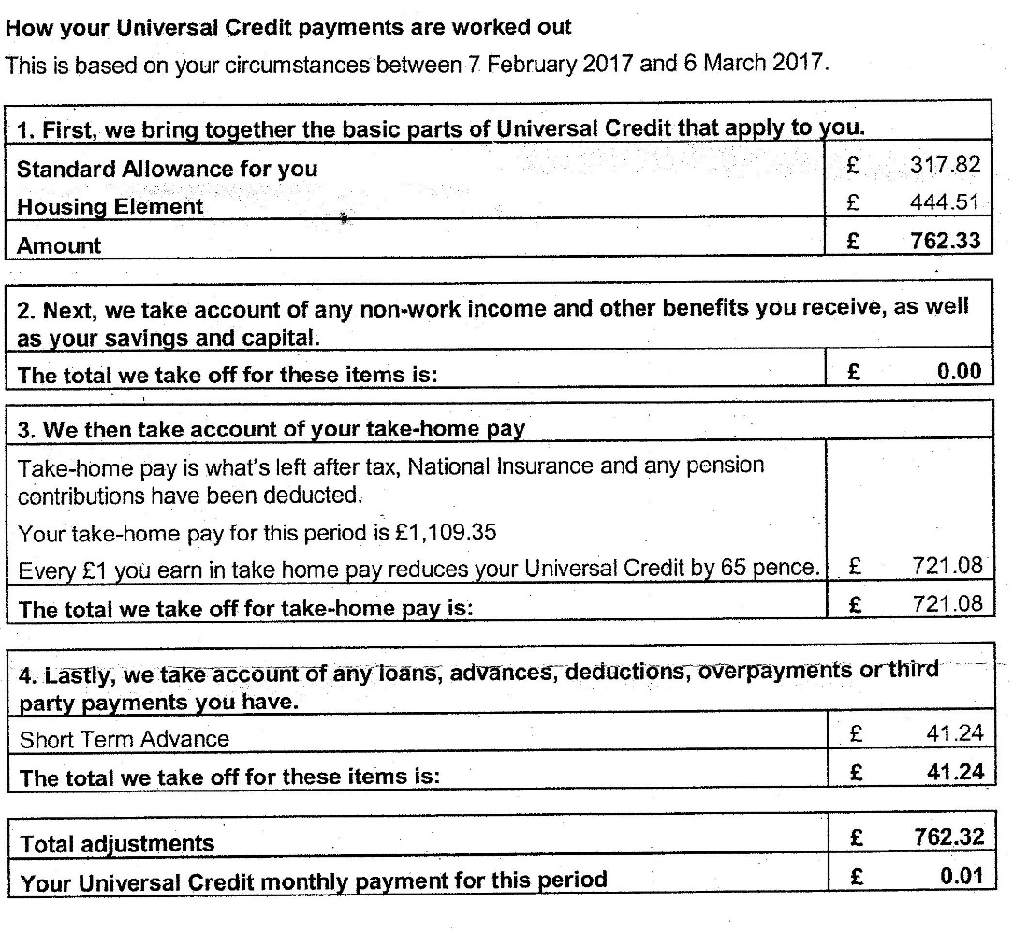

**APPENDIX.**

[In 2005 the Zacchaeus 2000 Trust sent the following](https://www.yumpu.com/en/document/view/33563483/memorandum-to-the-prime-minister-on-unaffordable-housing) [to Prime Minister Tony Blair](https://www.yumpu.com/en/document/view/33563483/memorandum-to-the-prime-minister-on-unaffordable-housing) [in a memoradum by the late Professor Peter Ambrose](https://www.yumpu.com/en/document/view/33563483/memorandum-to-the-prime-minister-on-unaffordable-housing)

[. It remains sadly true in 2018.](https://www.yumpu.com/en/document/view/33563483/memorandum-to-the-prime-minister-on-unaffordable-housing)

“We hold that land exists for the common good. It provides the basic needs of shelter, food and clothing of which everyone should have a just minimum share. But UK housing and land have become investments, from which speculators, moneylenders and the banks grow ever wealthier. Governments have allowed the market to exploit

the shortage of land by allowing unregulated lending to lift the price of housing  above the needs of the poor in the UK.

'Affordable' in relation to housing requires precise definition. It means that once the cost of rent or mortgage (including service charges) and council tax has been met from the income of a household, be it an individual, a family or pensioners, there remains sufficient to sustain safe and healthy living, provision for the future and participation in the community. 'Unaffordable' housing means that the remaining income is insufficient to ensure these outcomes,

An economy that provides health and education services free at the point of delivery, and is competing in the global market, cannot afford to leave expenditure on housing at a level that damages health. Statutory minimum incomes are being used up by a growing proportion of expenditure on rent/Dlortgage and council tax. Inequalities in wealth need to be corrected by minimum income standards “

From the Reverend Paul Nicolson

### Taxpayers Against Poverty

### A VOICE FOR THE COMPASSIONATE MAJORITY

### No citizen without an affordable home and an adequate income in work or unemployment.

### TAP DEPENDS ON SUPPORTERS - PLEASE CONSIDER a

[**MONTHLY CONTRIBUTION - THANKS**](http://taxpayersagainstpoverty.org.uk/donate)

### 93 Campbell Road, Tottenham, London N17 0BF, 0208 3765455, 07961 177889,

### <https://www.facebook.com/Taxpayers-Against-Poverty-299911526728884/>

### <https://twitter.com/taxpayers_a_p>  [www.taxpayersagainstpoverty.org.uk](http://www.taxpayersagainstpoverty.org.uk),  [www.z2k.org](http://www.z2k.org)