MAY BE PUBLISHED ON WEBSITE
Alexander Tiffin
14 Raven Croft
Culbokie
Dingwall
Ross Shire
IV7 8NF

Tel: 01349 877649
Mob: 07375069497
Email: alex.tiffin88@gmail.com

United Nations Human Rights
Office of The High Commissioner
Professor Philip Alston
Special Rapporteur on Extreme Poverty and Human Rights to UK

Dear Professor Alston,

My name is Alexander Tiffin, I am 30-years-old, and I live in the Scottish Highlands. I am disabled with several complex health conditions and I am on Universal Credit.
I was previously on the sickness benefit called Employment and Support Allowance, I was in the “Support Group”. This meant I was classed as not fit for work and did not need to look for work.
I was forced to move to Universal Credit last October, the new benefits system the government is rolling out.
When you make the transition, regardless of any previous decisions, you are required to have a new Work Capability Assessment. This is one of the most stressful things someone with an illness must go through.
After my assessment, I was classed as “Limited Capability for Work or LCW”. In April 2017, the government removed the additional premium this included, so now I just receive the basic allowance. I am still expected to look for work, despite the advice of six NHS doctors. I am appealing the decision, but I have to go to a Tribunal which can take over a year to be heard. More than half of cases that go to a tribunal result in the DWP decision being overturned.
I wrote a diary of my experience on Universal Credit in May which I am now sharing with you.
There are numerous links throughout this article to back everything up, such as academic studies and governmental agency reports.
Please contact me if you need anything further.

2 Weeks on Universal Credit

4 May 2018
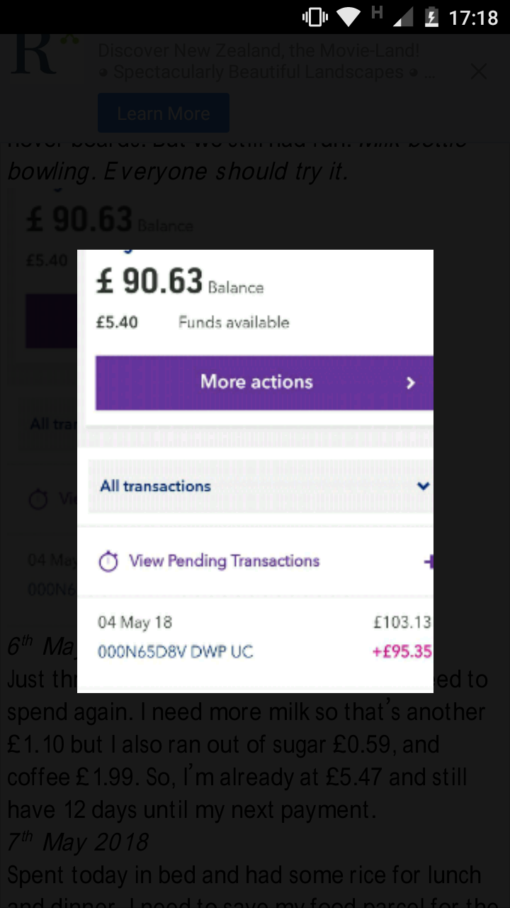
It’s been two weeks since I got my last £95.35 Universal Credit (UC) payment and ten days since I last had any money; but my next payment is finally here. This is how my life goes on a fortnightly basis since I was moved from Employment and Support Allowance to Universal Credit.
Now that I have the latest payment, it’s time to watch most of it disappear on bills.
- TV licence: £12.56;
- broadband: £15.99;
- baby milk: £9.50;
- electricity and gas: £31.80; and
- fuel £15.
That leaves me with a grand total of a whopping £10.50 of Universal Credit for the next two weeks.
Yes, £10.50.
Before I write any more, I should probably explain why the amount is so low. After all, Universal Credit allowance is supposed to be £317 a month.
However, when I was changed over to Universal Credit, I had to wait seven weeks for my first payment. At the same time, I also happened to be moving to a new property that suited my disability needs, and, to be allowed to sign the lease, the housing association required one month’s rent up front. I also had to buy myself and my sons food.
The Jobcentre advised I ask for an advance, which they happily arranged to be paid to me. I did not understand at the time that I’d be £125 a month worse off for 12 months.
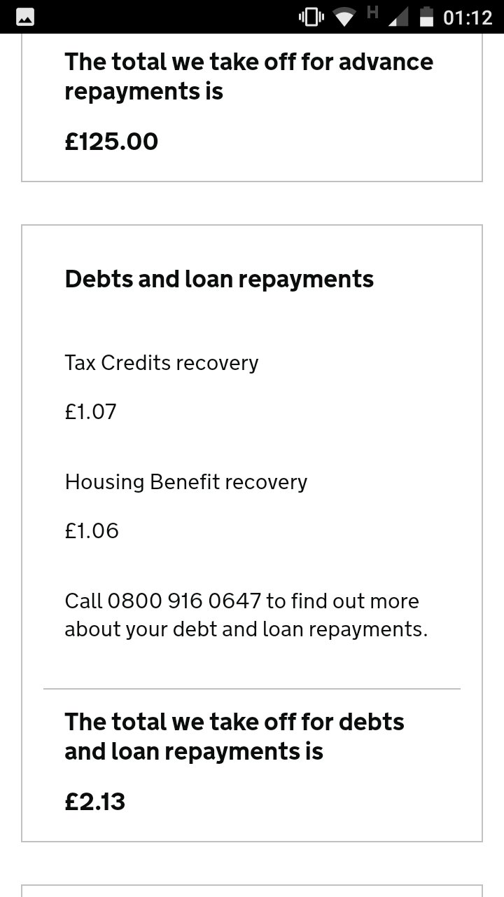
So why do I spend what I have listed?
I have two sons I look after every weekend. One, aged three, has autism and the other was born in January this year. They are the one thing that has kept me going. My three-year-old watches TV as it keeps him calm, namely the CBeebies channel.
Broadband? Well, I live in the rural Highlands of Scotland, I have no disabled accessible bus route and no library for 15 miles. Broadband is a lifeline to me. More importantly, I MUST log in to my Universal Credit account daily or face being sanctioned. So, having broadband is essential.
Equally linked to my rural location, are my electricity and gas costs. While it may be summer, it still gets cold here, especially at night.
When I don’t have my kids, I already switch off my heating and just lie in bed to keep warm – so I can’t cut down anymore.
I had to buy the infant formula milk, as I do not get any child-related benefits, although their mother does help when she can.
After I paid all my bills, I went for my weekly foodbank parcel. My local foodbank is an independent one run by the church.
At one time in February, I had no food at all for two weeks. I probably ate on less than a quarter of the days in that month. I just had nothing. I lost two and a half stone.
After that, I found out about such services, swallowed my pride and asked for help. Since January this year, my weight has dropped from 79kg to 59kg 25% of my entire mass, my hair has started falling out and my teeth are loose due to a lack of vitamin intake.
Foodbanks are underappreciated and underfunded. Nine in ten of all foodbank donations come from generous members of the public. Not a penny of help comes from government, with some government ministers even saying; it’s good that we have them.

5 May 2018
I need milk for myself and my three-year-old, so I get that for £1.10 and because my son has been good I get him a Freddo chocolate bar for 25p. He still deserves to be treated now and again. In just two days, I’ve gone from £95 to £9.15, and I have nothing to show for it.
It is pretty demoralising knowing you can’t treat your kids, take them out or even buy them presents on their birthdays, but you must stay strong for them.

6 May 2018
Just three days after my payment, and I need to spend again. I need more milk, so that’s another £1.10, but I also ran out of sugar (59p), and coffee (£1.99). So, I’m already at £5.47 and still have 12 days until my next payment. My kids went home, so I switched off the heating and just got into my bed as usual.

7 May 2018
Spent today in bed. Had some rice for lunch and dinner. I need to save my food parcel for the kids as I only get the size designed for a single person.

8 May 2018
I decided I wanted to be able to make myself some sandwiches, so I brought a loaf of bread for 45p and a small block of cheese for £1.72. This left me with £3.30. I must admit that I felt bad after buying it as, I shouldn’t have wasted the money.

9 May 2018
Today I felt depressed about my situation. Since I left the army, I have had mental health problems. I suffer from depression, and I was diagnosed with Borderline Personality Disorder last June, after I split up with my partner But now I just have to move on and show that I am not that person, and try to be a good role model to my kids.
I have been far more depressed since coming onto Universal Credit. This also includes an attempt on my life in March as I just couldn’t cope with the situation I was in anymore.

10 May 2018
My remaining cash dropped to £2.20 as I got a bit overzealous with the milk but being trapped in a house all day does limit what you can do, especially if you can’t physically do much yourself as well.

11 May 2018
Absolutely freezing here. I’ve had to put my heating on for 30 minutes to take the chill off, and it’s 12 degrees Celsius in the house. As the heating is on, it heats the small hot water tank in the boiler. I take advantage of this and have a wash with warm water instead of cold. It feels amazing. Seven days until my next payment. Still £2.20 left, plus a few slices of bread and a box of cheesy pasta. Oh, and about 100g of rice.

12 May 2018 No money left
And it’s happened: the final £2.20 has been spent on UHT milk and bread. With six days to go, I now have nothing. To add insult to injury, it’s actually nine days to my next payment, because of the May Day bank holiday; I was paid early last time around.

13 May 2018
I wrote in my journal in my Universal Credit account, literally begging them to reduce the amount at which I’m paying back my advance. £125 out of £317 is just too much. I can’t keep this up.

14-16 May 2018
Totally depressed, stayed in bed, my health issues are flaring up again, partly caused by stress. I have lost any incentive to get out of bed. I feel awful, mentally and physically. Would see the doctor but I can’t get there. It’s seven miles away.
The days I spend in bed, I don't eat anything. I am so low I just don't feel like doing anything at all. Plus I couldn't eat much anyway. It is a struggle to get a three-day food parcel to last a fortnight, even by rationing it.

17 May 2018
Received a reply from my work coach. They refused to lower my repayment amount. They don’t address my pleas at all. Instead, they offer me “budgeting advice” and arrange an appointment in two days’ time, to attend the Jobcentre to “teach me how to manage my money better”. I advise that the Citizens Advice Bureau have already done this and, regardless, I literally cannot get to the Jobcentre, both because of my health and the fact there is no bus.
They cancel the appointment and offer no other advice. Apparently, I’ve had all the support available. I’m warned though that I will be sanctioned if I don’t attend in future.

My thoughts
There it is. A fortnight in my life as a Universal Credit claimant. No extravagance, no fun, fancy tech, nothing. All I know is destitution and pain. UC has made my life a living hell.
This cannot go on.
The government needs to act to alleviate the crisis the system is in before rolling it out any further as has been recommended by the National Audit Office.
Foodbank referrals are up 52 per cent in “full service” areas according to the foodbank charity Trussell Trust’s figures. Seven in ten of new claimants are entering debt as a direct result of the five-week waiting period.
Most alarming is the increase of the occurrence of mental health conditions: 46 per cent of claimants have reported some form of mental health condition since claiming Universal Credit.
The government has failed to act, despite repeated warnings from;
- Department for Work and Pensions staff,
- A vote by the House of Commons last year in favour of halting the Universal Credit roll out,
- The highly critical National Audit Office report on Universal Credit roll-out
- Countless constituents contacting their MPs for help.
- The Joseph Rowntree Foundation report which found 1.5 million live in destitution and 4 million use foodbanks.
Ignoring this is, in my humble opinion, either bordering on gross negligence or just plain wilful neglect.
There have been deaths. Perhaps they were not caused by Universal Credit directly, but because of malnutrition, due to a poor diet, or hypothermia, due to lack of heating. Not to mention people whom have taken their own lives.
It seems that it’s more important to steamroll this system in than stop it. Why? Because that would look like a failure and this government especially Work and Pensions Secretary cannot accept that it’s not perfect.
She was found to have lied to parliament about the NAO report and was forced to back track and apologize.
I hope that you find this helpful and should you need any further information please do not hesitate to contact me.
Kind Regards
Alexander Tiffin
Annex Attached
NAO Report on Universal Credit Roll-out
JRF Report on UK Destitution
Trussell Trust and Oxford University Study on Foodbank Use

