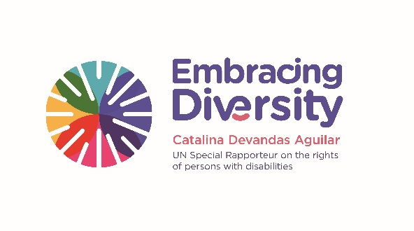english

**Expert Group Meeting**

**Intersections between women’s rights and the rights of persons with disabilities**

**19 March 2019**

UNICEF House, Danny Kaye space

3 UN Plaza, 10017 New York

**List of Participants**

1. **Ms. Gladys ACOSTA VARGAS**, Vice-Chair, CEDAW Committee
2. **Ms. Toyin Janet ADEREMI-IGE**, Former Director CBM Nigeria
3. **Ms. Meltem AGDUK,** Programme Officer, UNFPA
4. **Ms. Patty ALLEMAN**, Senior Adviser, Gender Section and focal point of Gender and Disability, UNICEF
5. **Ms. Katrina ANDERSON,** Independent consultant on gender and sexuality, KEA consulting
6. **Ms. Rebecca BROWN**, Director of Global Advocacy, Center for Reproductive Rights
7. **Ms. Courtney CARSON**, Senior manager, policy & advocacy, Women Deliver
8. **Ms. Maria Soledad CISTERNAS REYES,** Special Envoy of the SG on Disability and Accessibility
9. **Mr. Christian COURTIS**, Gender Adviser, OHCHR-NYO
10. **Ms. Catalina DEVANDAS AGUILAR**, Special Rapporteur on the rights of persons with disabilities
11. **Ms. Emilie FILMER-WILSON**, Human Rights Advisor, UNFPA
12. **Ms. Pratima GURUNG**, Chair, National Indigenous Disabled Women Association Nepal
13. **Ms. Helena JAUHIAINEN**, First Secretary, Permanent Mission of Finland to the UN
14. **Ms. Akiko ITO**, Chief, Secretariat for the Convention on the Rights of Persons with Disabilities, DESA
15. **Mr. Monjurul KABIR**, Senior Policy Adviser, Rule of Law, Justice & Security, UN Women
16. **Ms. Rupsa MALLIK**, Director, Programs and Innovation
17. **Ms. Cristina MICHELS**, Human Rights Officer, OHCHR, Mandate of the Special Rapporteur on the rights of persons with disabilities
18. **Ms. Gertrude OFORIWA FEFOAME**, Member of CRPD Committee
19. **Ms. Stephanie ORTOLEVA**, Executive Director, Women Enabled International
20. **Ms. Bandana RANA**, Vice-Chair, CEDAW Committee
21. **Ms. Diane RICHLER,** Chair, Inclusion International’s Catalyst for Inclusive Education
22. **Ms. Naureen SHAMEEN**, Advancing universal rights and justice programme manager, Association for Women's Rights in Development (WID)
23. **Ms. Dubravka ŠIMONOVIC**, Special Rapporteur on violence against women, its causes and consequences
24. **Ms. Megan SMITH**, Gender and Development Officer, International Disability Alliance
25. **Ms. Myroslava TATARYN**, Disability Rights Program Officer, International Human Rights Program at Wellspring Philanthropic Fund
26. **Ms. Catherine TOWNSEND**, Disability inclusion adviser
27. **Ms. Megan T. TUCKER**, Programme Specialist and Gender Focal Point, Disability Section, UNICEF
28. **Ms. Eeva TUPI**, Executive Director, World Federation of the Deaf
29. **Mr. Alberto VASQUEZ ENCALADA**, Research coordinator, Office of the Special Rapporteur on the rights of persons with disabilities
30. **Ms. Carla VILLARREAL LOPEZ**, Fellow, Office of the Special Rapporteur on the rights of persons with disabilities