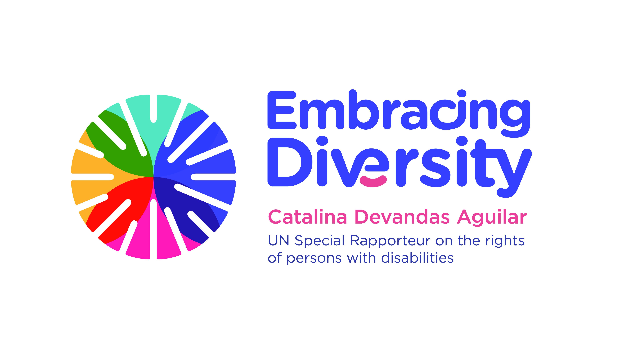english

**Expert Group Meeting**

**Intersections between women’s rights and the rights of persons with disabilities**

**19 March 2019**

UNICEF House, Danny Kaye space

3 UN Plaza, 10017 New York

**Agenda**

|  |  |  |
| --- | --- | --- |
| **Time** | **Session** | **Moderator** |
| 09.45-10.00 | **Arrival of participants and registration** |  |
| 10.00-10.15 | **Opening and welcome remarks**   * **H.E. Amb. Kai Sauer**, Permanent Representative of Finland to the United Nations (3 min) * **Ms. Catalina Devandas Aguilar**, Special Rapporteur on the Rights of Persons with Disabilities (3 min) * **Ms. Dubravka Šimonović**, Special Rapporteur on violence against women, its causes and consequences (3 min) |  |
| 10.15-10.30 | **Introduction of participants and objectives of the meeting** | Catalina Devandas Aguilar |
| 10.30-11.45 | **Session 1: Human rights violations experienced by women and girls with disabilities**   * What are the more pressing human rights violations that women and girls with disabilities experience, particularly in the enjoyment of sexual and reproductive health and rights? * What are the main contributions of the CRPD? * What are the existing good practices, including advocacy and strategic litigation, to promote and protect the rights of women and girls with disabilities? | Moderator:  Cristina Michels  Panellists:  - Gertrude Oforiwa Fefoame, CRPD Committee  - Bandana Rana, CEDAW Committee  - Eeva Tupi, WFD |
| 11.45-12.00 | Coffee break |  |
| 12.00-13.15 | **Session 2: Including a ‘gender perspective’ in disability policies and a ‘disability-rights perspective’ in policies promoting gender equality**   * How far have we come to include women’s rights issues in the disability rights agenda, and a disability-rights perspective in the women’srights agenda? * What are the main challenges, gaps and potential areas of tension to include women’s rights considerations in the disability-rights agenda, and a disability-rights perspective in the women’srights agenda? * Are there any good practices for the implementation of a disability-rights perspective in prevention mechanisms and response services for gender-based violence? | Moderator:  Catherine Townsend  Panellists:  - Patty Alleman, UNICEF  - Toyin Aderemi-Ige  - Monjurul Kabir, UN Women |
| 13.15-14.45 | Lunch break |  |
| 14.45-16.15 | **Session 3: Promoting the human rights of women and of persons with disabilities in discussions related to care and support, prenatal screening, and abortion**   * How to use the intersectional approach in discussions related to care and support, prenatal screening, and abortion? * How to combat stereotypes, prejudices and harmful practices relating to persons with disabilities, including gender stereotypes, in the context of care and support, prenatal screening, and abortion? * Are there any good practices to overcome the challenges for promoting the human rights of women and of persons with disabilities in discussions related to care and support, prenatal screening, and abortion? | Moderator:  Arlene Kanter  Panellists:  - Rupsa Mallik, CREA  - AWID representative  - Stephanie Ortoleva, WEI |
| 16:15-16.30 | Coffee break |  |
| 16:30-17:15 | **Session 4: Building synergies and alliances for a common agenda**   * What collaborative strategies can we employ to promote the inclusion of women’s rights considerations in the disability rights agenda and a disability rights perspective in the women’srights agenda? * How could we increase cooperation, and build a shared agenda between the women’s movement and disability rights movement? | Moderator: Catalina Devandas  Panellists:  - Megan Smith, IDA  - Rebecca Brown, CRR |
| 17:15- 17:25 | **Closing remarks**   * **Ms. Catalina Devandas Aguilar**, Special Rapporteur on the Rights of Persons with Disabilities |  |