Subject: The Right to Sport and Leisure of People with Disabilities
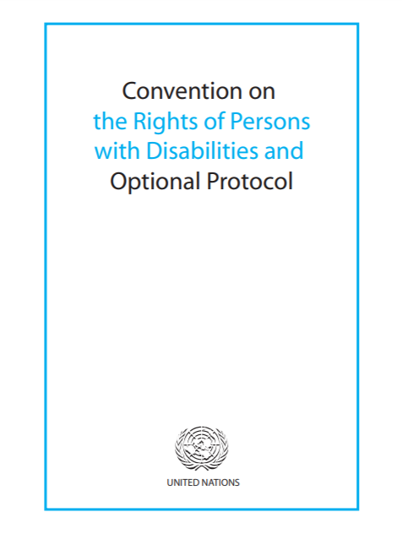 | The Convention on the Rights of Persons with Disabilities is an important agreement. This agreement is sometimes called the CRPD. It explains what countries must do to make sure that the rights of people with disabilities become a reality.
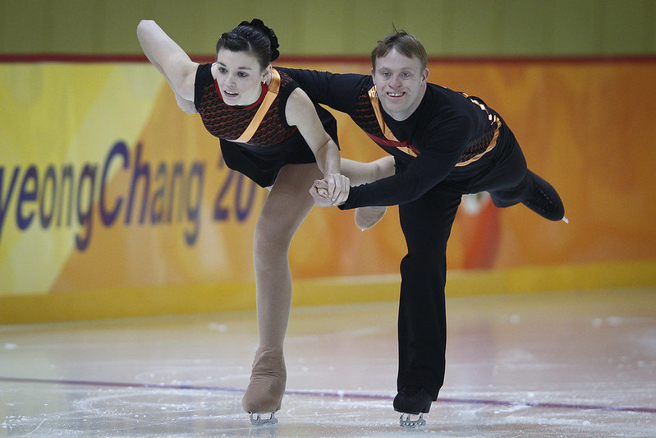 | The right to sport and leisure is one of the rights in the CRPD.  People with disabilities have the same right to take part in sports and leisure as anybody else.
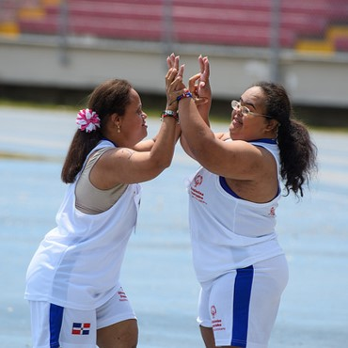 | Special Olympics helps involve people with intellectual disabilities in sport activities.  People with intellectual disabilities include those who have Down syndrome, autism spectrum disorders, and more.  People with intellectual disabilities all over the world do sports with Special Olympics.
Special Olympics wants to provide information it has about people with intellectual disabilities doing sport around the world.
We are providing this information to the United Nations Office of the High Commissioner for Human Rights (UNHCHR).
The UNHCHR’s job is to promote and protect all human rights for all people.
We want to thank many countries for helping make the right to sport a reality for many people with intellectual disabilities.
We also want to ask countries to continue their hard work and support. There is still a lot to do. For example:
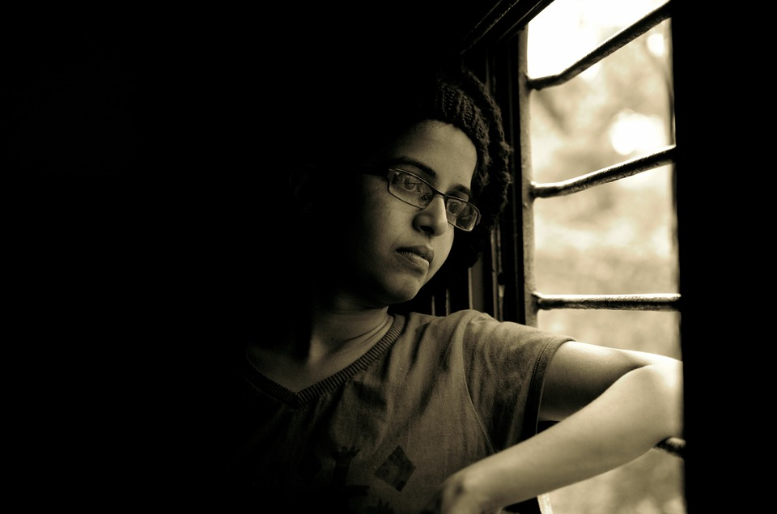 | Many people with intellectual disabilities have contact with few people outside of their homes.  That means that many people in the world have not met a person with intellectual disabilities.  Many people are afraid of what they do not know.  It is important for people with and without disabilities to meet each other and get to know each other.
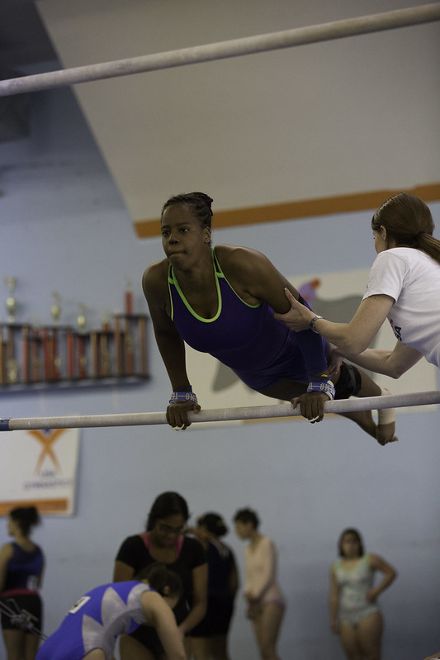 | - Many physical education teachers and personal trainers do not know people with intellectual disabilities.  - They do not know that people with intellectual disabilities can do physical activity, like yoga or lifting weights.  - They do not know that people with intellectual disabilities can play sports, like football and badminton.  - They do not know how to teach or coach people with intellectual disabilities.
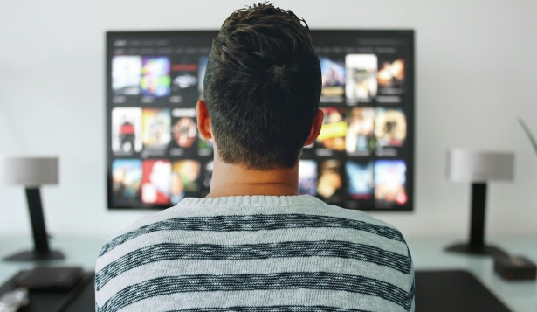 | - So instead of playing on a sports team, many people with intellectual disabilities spend time alone.  - Instead of moving their bodies, like playing basketball or going for a walk, many people with intellectual disabilities may watch more television.
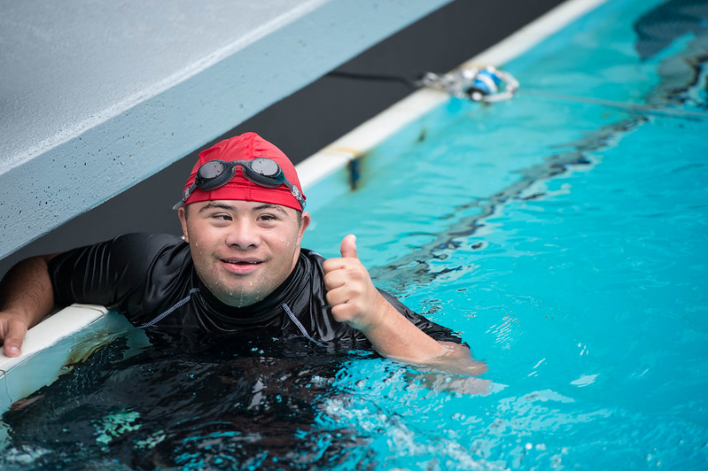 | Playing sport and doing physical activity makes people feel better and happier. It makes them healthier. When people with intellectual disabilities cannot do sport or physical activity, they are less healthy.
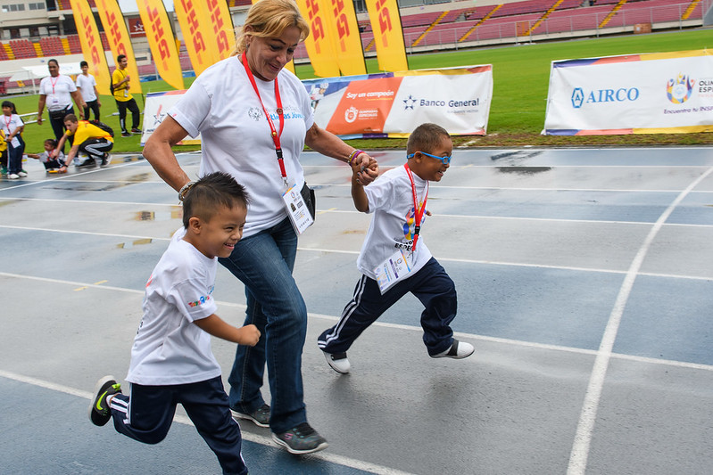 | - It is extra important for children to have the chance to move their bodies.  - Children can learn a lot, very quickly. Moving their bodies helps them learn. It gives them skills to be physically active as they get bigger.  - Children with intellectual disabilities especially need these chances to learn and move their bodies.  - Sadly, they often do not get to do these things. One of the reasons is that many activities are only for children without disabilities.

Recreation and leisure
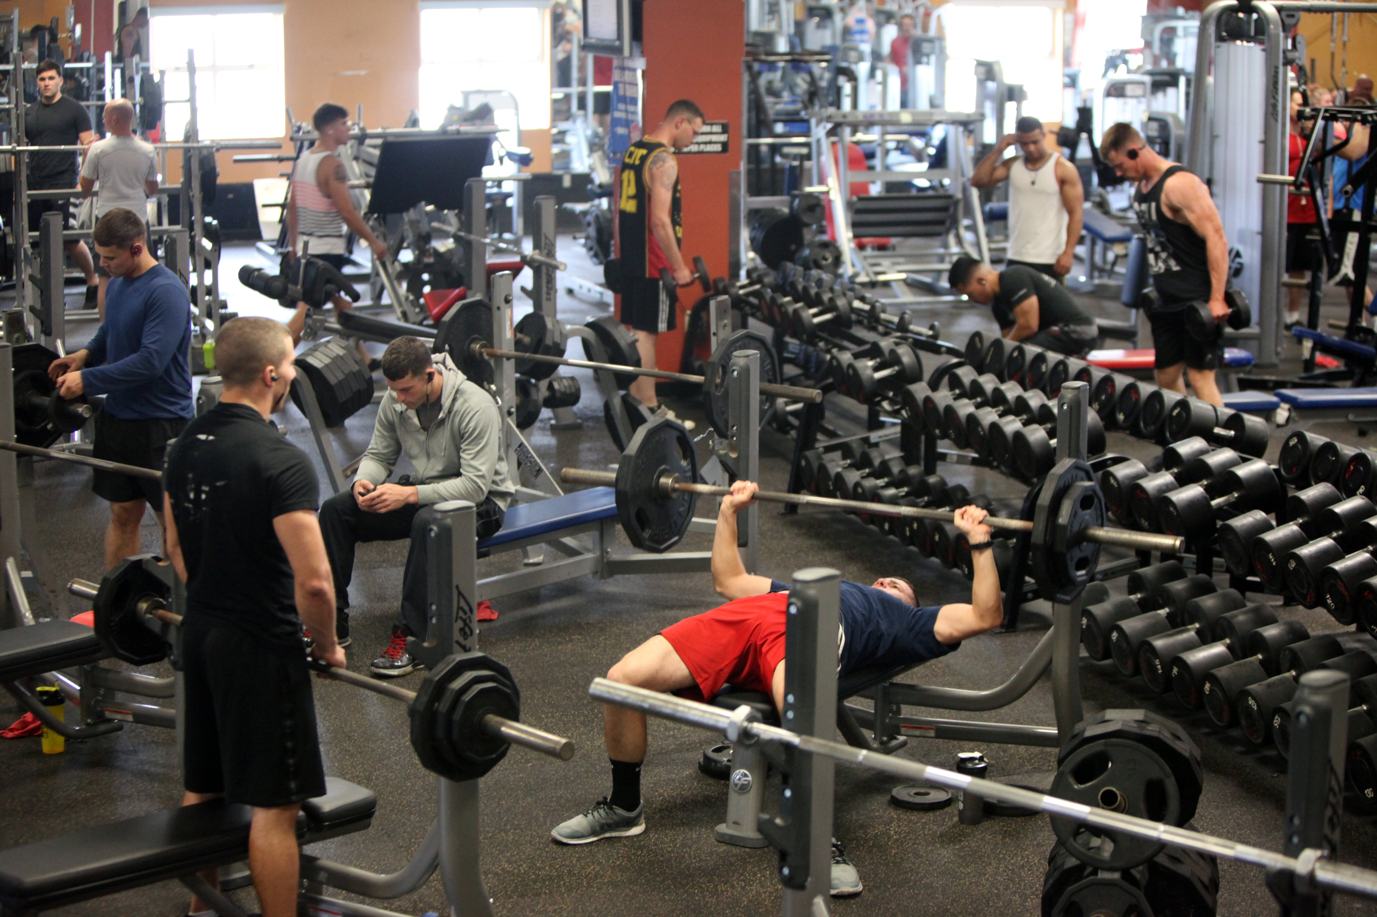 | The spaces we use for recreation and leisure include private gyms, swimming pools, playgrounds, and more.  People have fun at these places. They also improve their health at these places.  Sadly, many of these places do not include people with intellectual disabilities.
There are some success stories:
In Bosnia and Herzegovina, people with intellectual disabilities are involved in sports clubs that are for everyone.
In Chile, Special Olympics works with the government to help people do physical activity and live healthily. Special Olympics teaches people working at government centres about how to work with people with intellectual disabilities.
In many countries, Special Olympics works with spaces for recreation and leisure.
They want to make sure people with intellectual disabilities will be accepted and served at these places.
Hungary, Mongolia, and Pakistan are three countries where Special Olympics does this. There are many more.
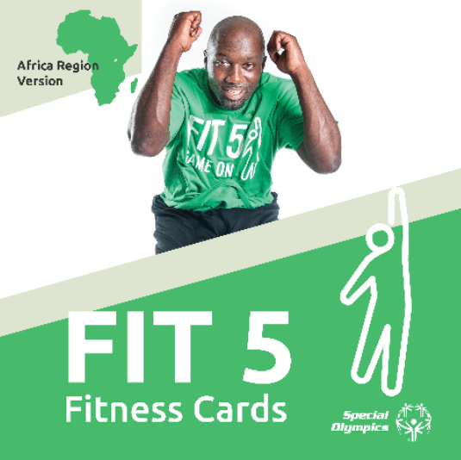 | Special Olympics has lots of resources to help people with intellectual disabilities be physically active.  Some governments are helping get these to people with intellectual disabilities and their families. This includes the governments of Peru, Kenya, and Montenegro.  This is especially important during the COVID-19 pandemic. People should not go to places like gyms during COVID-19.

Education
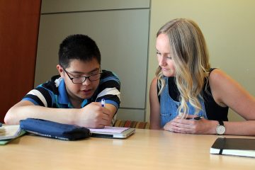 | In Estonia, students of physical education can take a few classes about disability. They do not have to take any class on this subject. The situation is similar in Ireland.  In Serbia, universities offer courses on disability and physical education. But these classes are not in the sport faculty, where most students of physical education study. This makes it more difficult for students to take these classes.
Poland is different. In Poland, a person must study special education and physical education to coach people with disabilities.
It is good for people to have these specific studies. But being so specific may mean that fewer people will do these studies. This can limit the number of coaches for people with disabilities.
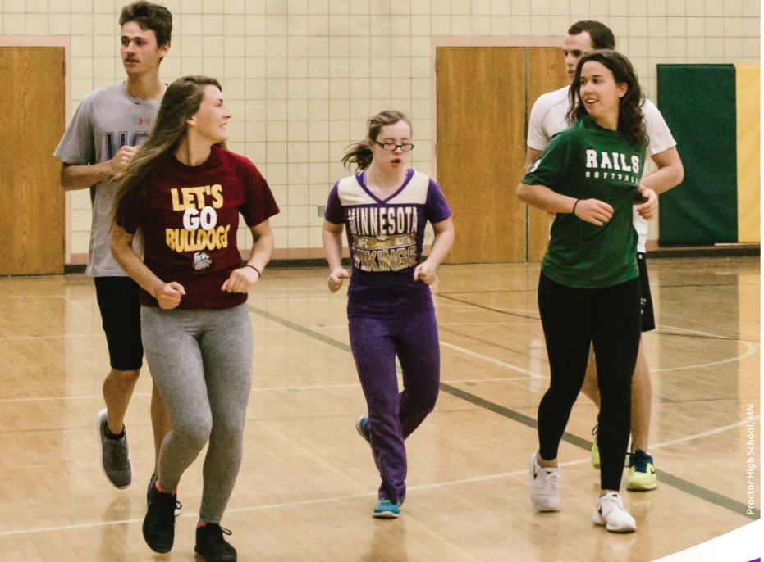 | In many countries, Special Olympics has helped make the physical education more inclusive.  In Russia and Poland, Special Olympics has helped change what future physical education teachers learn.  Now they learn about adapted physical education. New teachers know how to teach physical education to people with intellectual disabilities.
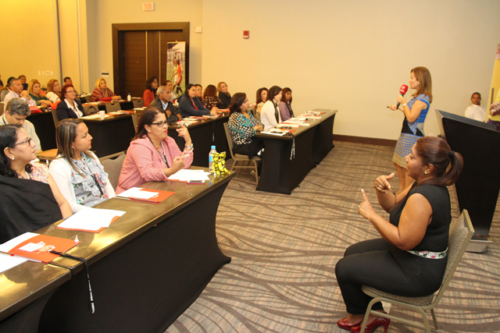 | Special Olympics also trains teachers in many countries on how to include people with intellectual disabilities in physical education.  These countries include Bosnia and Herzegovina and Serbia.
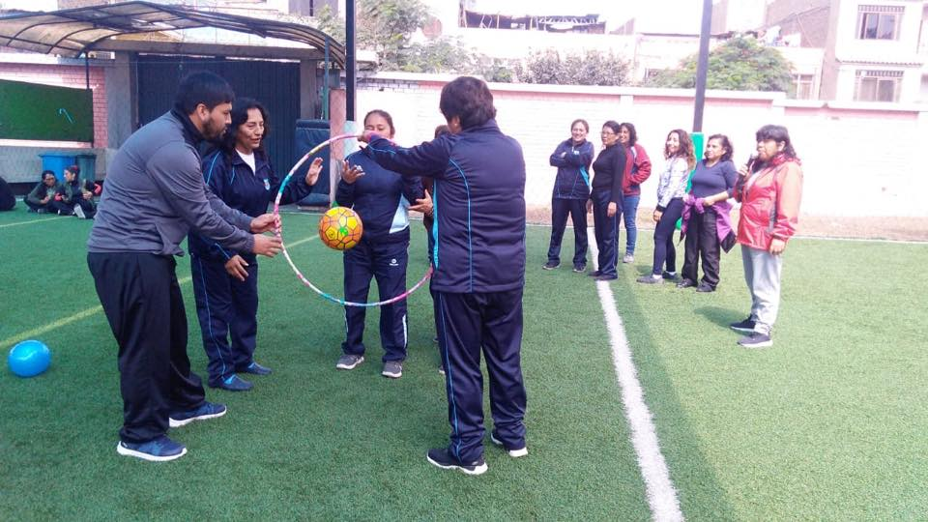 | Many countries have opened up their schools to Special Olympics. At many schools, Special Olympics trains physical education and other teachers.  It teaches them on how to work with students with intellectual disabilities. It teaches them how to include students with intellectual disabilities.  The countries where Special Olympics teaches teachers and school staff include Argentina, Botswana, Brazil, Canada, Chile, Costa Rica, El Salvador, Guatemala, India, Kenya, Mexico, Nigeria Panama, Peru, the United States, and Zambia.  Agreements with national and local education authorities make this work possible. These trainings are an important first step to make sure students with disabilities can participate in physical education.
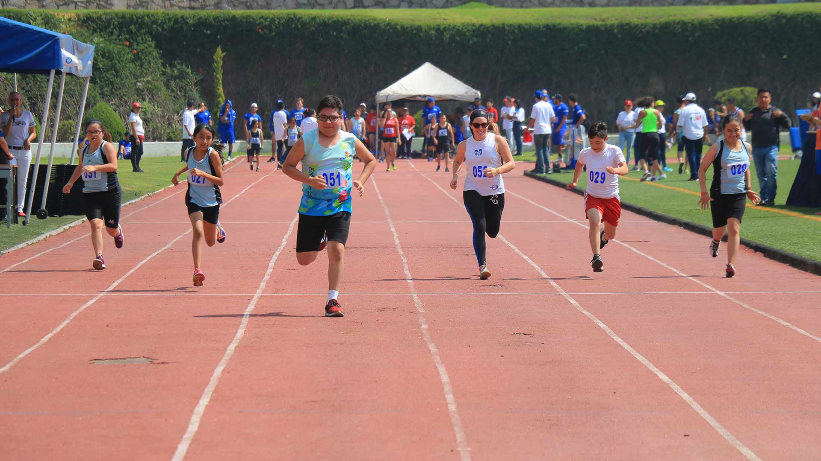 | Inclusive opportunities are also very important. In inclusive sports, athletes with and without disabilities play together.  In many countries, students with and without disabilities go to different schools. This makes it hard to do inclusive sport or physical education at school.
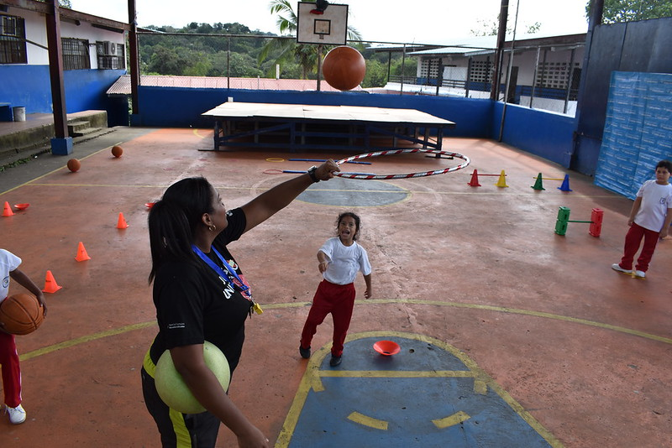 | Special Olympics also has a program for children ages 2 through 7.  In this program, children with and without intellectual disabilities play together.  They also learn important skills like running, kicking, and throwing. These skills are important for doing sports and being physically active.  The government in many countries helps Special Olympics reach these children. These countries include El Salvador, Kenya, Montenegro, and Panama.

Sports
Competitions
Special Olympics holds over over 100,000 Games and competitions every year. These occur at many levels, from small towns to people from many countries together.
Some competitions are just for one sport. Other events include competition in multiple sports.
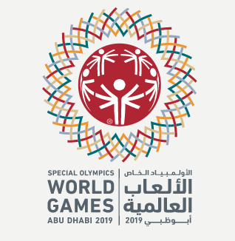 | Special Olympics’ international competitions in recent years include:  - Summer World Games (Greece, 2011)  - Winter World Games (South Korea 2013)  - Summer World Games (Los Angeles, USA 2015)  - Winter World Games (Austria 2017)  - Latin American Regional Games (Panama 2017)  - World Tennis Invitational (Dominican Republic 2018)  - Summer World Games (United Arab Emirates 2019)  - 1st Pan-African Games (Egypt 2020)  Planned international competitions include:  - Latin American Regional Games (Peru 2022)  - Winter World Games (Russia 2022)  - Summer World Games (Germany 2023)
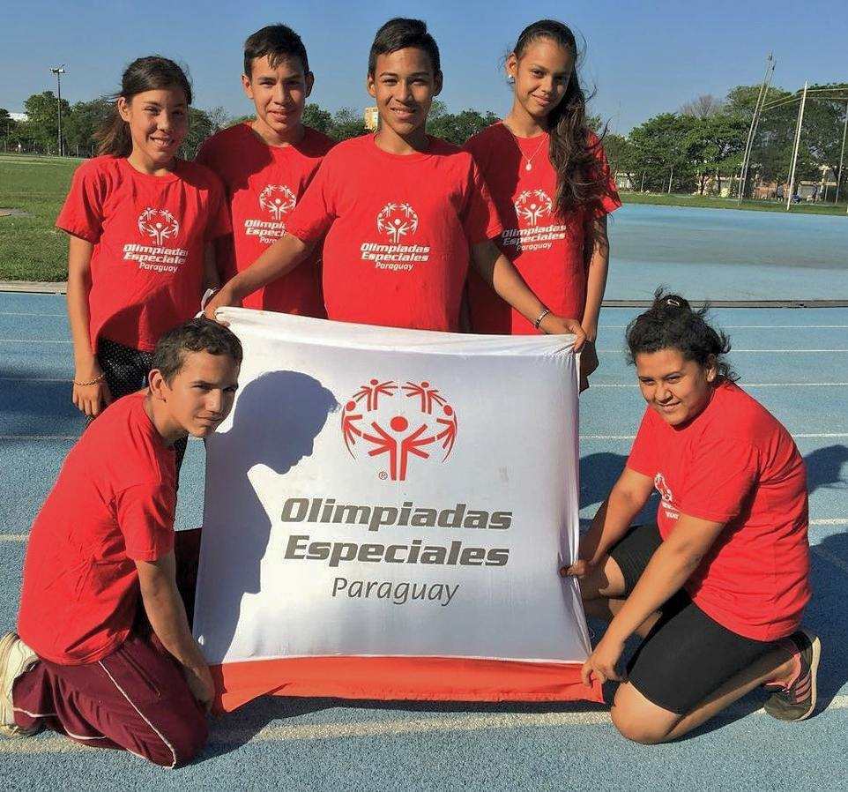 | Athletes with intellectual disabilities also compete outside of Special Olympics. In Chile and Paraguay, athletes with intellectual disabilities compete in national school games.
Structure and organization of sports
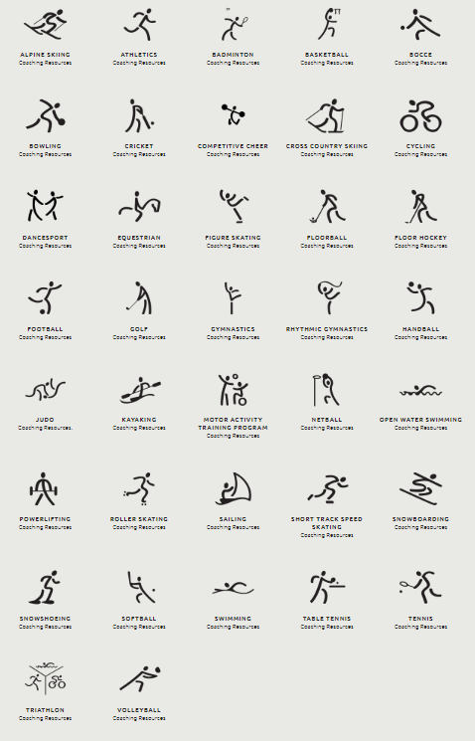 | Worldwide, Special Olympics offers more than 30 Olympic-type sports.  Special Olympics operates in more than 190+ countries and territories.  In most countries, Special Olympics has activities in many areas of the country. This includes areas far from big cities. Each area has a different number and types of sports.
Many countries provide funding to Special Olympics.
Many countries also provide benefits, like use of government sporting facilities, like pools and fields.
Governments rarely organize inclusive sporting activities. But in many cases, they support inclusive activities that Special Olympics organizes.
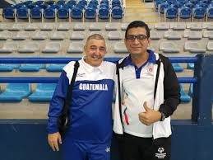 | There are a few countries where Special Olympics is part of mainstream sports federations. Serbia is one of these countries.  It is more common that Special Olympics operates separate from the mainstream federations and clubs.  Special Olympics often has a relationship or formal agreement with mainstream federations and clubs.
The relationships between Special Olympics and mainstream federations and clubs has helped promote inclusive sports activities.
For example,
In Germany, people with intellectual disabilities participate in mainstream sports clubs. This helps them have a lifetime of sport activities.
Special Olympics partners with the Union of European Football Associations (UEFA). Many of UEFA's National Associations say working with Special Olympics helps develop inclusive football.
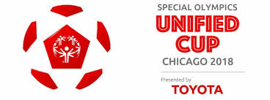 | - In 2018, Special Olympics held an international inclusive football tournament. It was called the Unified Cup. Teams from 19 countries participated in the Unified Cup.  - To play in the Unified Cup, a country needed to have a partnership with a national federation or club. The hope was for them to develop inclusive football after the Cup.  - Slovakia participated in the Unified Cup. A coach from the national federation went. Players from its national development team played inclusive football. Slovakia's women's team won the tournament!  - Inclusive football has grown in most of the countries who had teams play in the Cup.
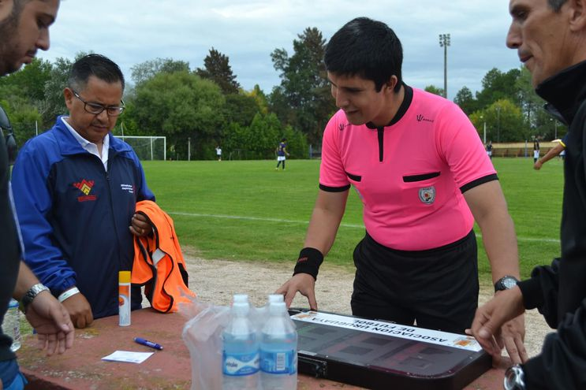  Source: https://www.abc.com.py/deportes/polideportivo/paraguayo-hassan-zogaib-debuta-como-arbitro-1468037.html | Being an athlete is just one of ways to be part of the world of sport.  Some Special Olympics athletes with intellectual disabilities have been certified as coaches and referees. They have been referees at various levels. This includes Special Olympics World Games in 2015 and 2019.  Some people with intellectual disabilities are also sport advisers in Special Olympics. Others are on rules committees. And others are (assistant) technical delegates in competitions.

Thank you for allowing us to provide this information.
Sincerely,

David Evangelista
President and Managing Director, Special Olympics Europe Eurasia

