english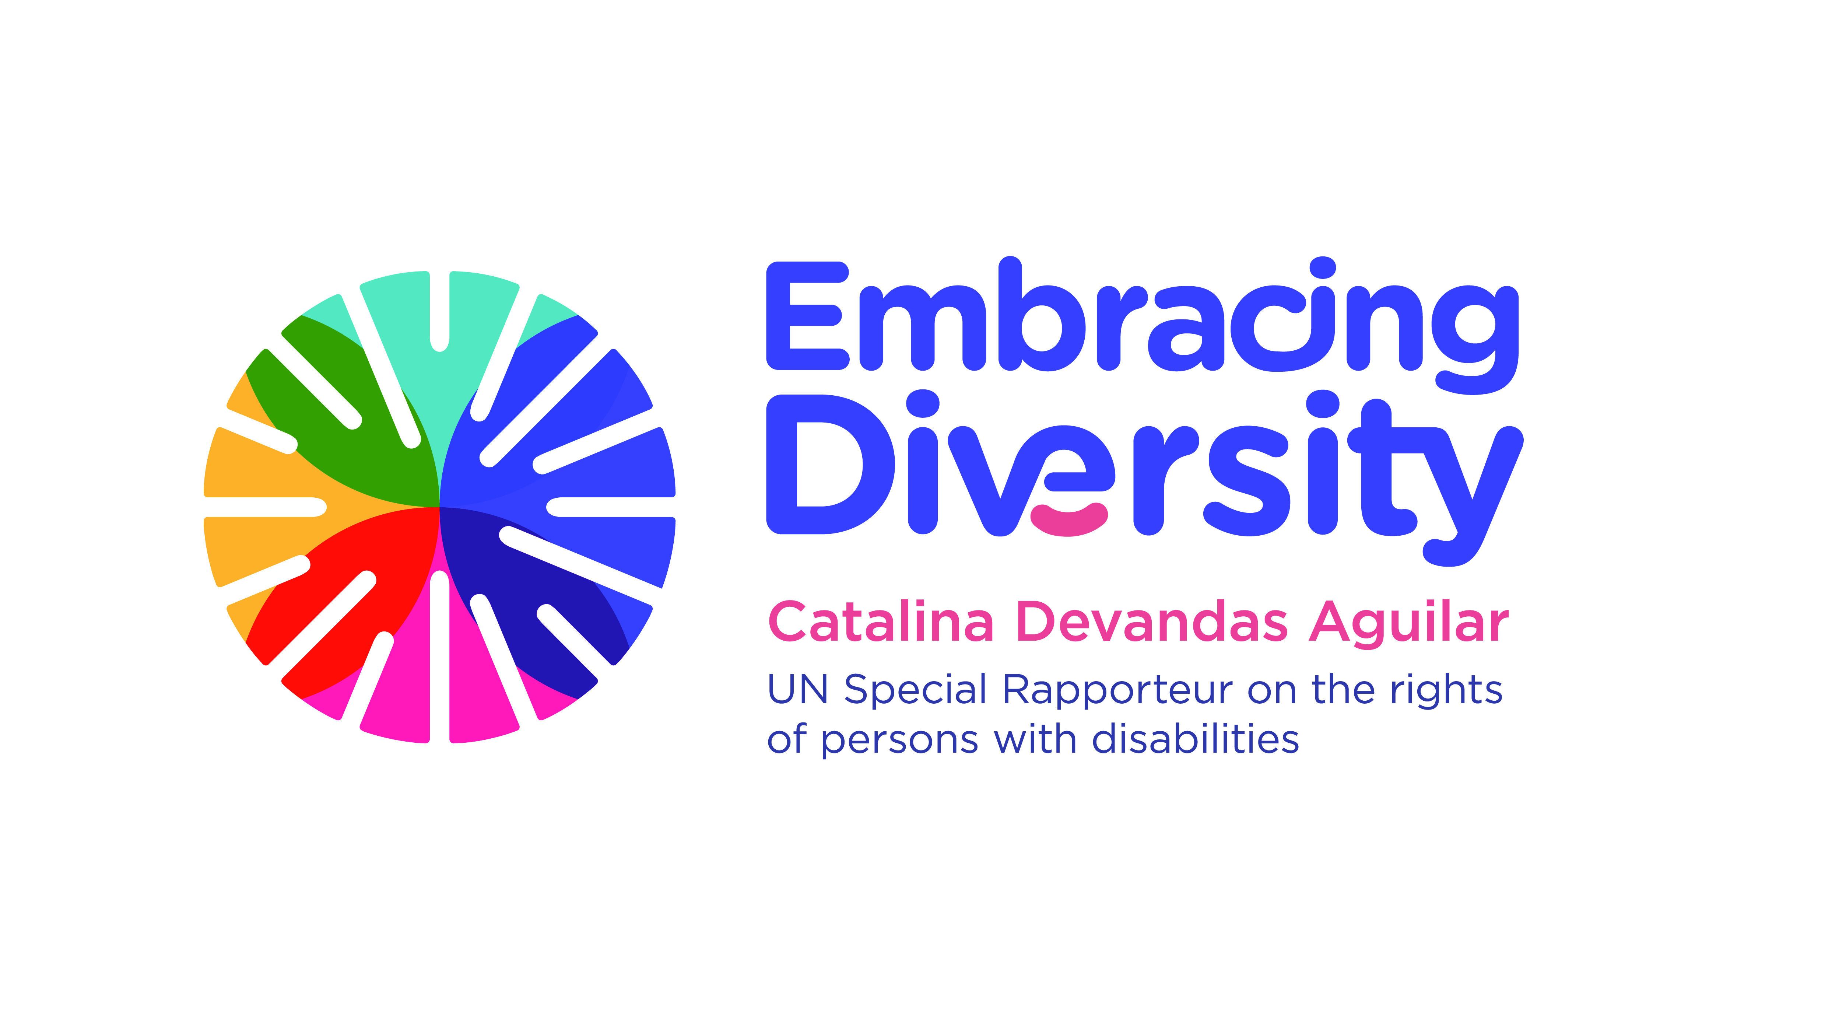

**Expert Group Meeting**

**The right of persons with disabilities to the highest attainable standard of physical and mental health**

15 and 16 May 2018

Room XVI, Palais des Nations, Geneva, Switzerland

**LIST OF PARTICIPANTS**

1. **Ms. Catalina DEVANDAS AGUILAR**, UN Special Rapporteur on the rights of persons with disabilities, [sr.disability@ohchr.org](mailto:sr.disability@ohchr.org)
2. **Ms. Patricia ALMEIDA**, Down Syndrome International, [patricia.smalmeida@gmail.com](mailto:patricia.smalmeida@gmail.com)
3. **Mr. Lieven BAUWENS**, Secretary General, International Federation for Spina Bifida and Hydrocephalus, [lieven.bauwens@ifglobal.org](mailto:lieven.bauwens@ifglobal.org)
4. **Mr. Leonardo CASTILHO**, Human Rights Officer, OHCHR Human Rights and Economic and Social Issues Section, [lcastilho@ohchr.org](mailto:lcastilho@ohchr.org)
5. **Mr. Facundo CHAVEZ PENILLAS**, Human Rights and Disability Advisor, OHCHR, [fchavezpenillas@ohchr.org](mailto:fchavezpenillas@ohchr.org)
6. **Ms. Alarcos CIEZA**, Department for Management of Non communicable Diseases, Disability, Violence and Injury Prevention, World Health Organization, [ciezaa@who.int](mailto:ciezaa@who.int)
7. **Ms. Samantha CRANE**, Director of Public Policy, Autistic Self Advocacy Network, [scrane@autisticadvocacy.org](mailto:scrane@autisticadvocacy.org)
8. **Mr. Alexander COTE**, Expert on disability rights, [alex.cote@inclusive-policy.org](mailto:alex.cote@inclusive-policy.org)

1. **Ms. Bhargavi DAVAR**, Director, Bapu Trust for Research on Mind and Discourse, [bapu.crpdadvocacy@gmail.com](mailto:bapu.crpdadvocacy@gmail.com)
2. **Ms. Lucía DE LA SIERRA**, Human Rights Officer, Mandate of the SR on the right to heath, OHCHR, [ldelasierra@ohchr.org](mailto:ldelasierra@ohchr.org)
3. **Mr. Vincent GIRARD**, Housing First France, [vincent.girard.46@gmail.com](mailto:vincent.girard.46@gmail.com)

1. **Mr. Peter HAUSER**, World Federation of the Deaf, [Peter.Hauser@RIT.edu](mailto:Peter.Hauser@RIT.edu)
2. **Mr. Geir JENSEN**, President, World Federation of the Deafblind, [geir.jensen@fndb.no](mailto:geir.jensen@fndb.no)

1. **Ms. Navleen KAUR**, Associate Human Rights Officer, Mandate of the SR on the rights of persons with disabilities, OHCHR
2. **Ms. Hannah KUPER,** Director, International Centre for Evidence in Disability, London School of Hygiene and Tropical Medicine,[Hannah.Kuper@lshtm.ac.uk](mailto:Hannah.Kuper@lshtm.ac.uk)
3. **Ms. Victoria Lee**, Programme manager, OHCHR Human Rights and Economic and Social Issues Section, [vlee@ohchr.org](mailto:vlee@ohchr.org)
4. **Ms. Cristina MICHELS**, Human Rights Officer, Mandate of the SR on the rights of persons with disabilities, OHCHR, [cmichels@ohchr.org](mailto:cmichels@ohchr.org)
5. **Mr. Anthony MUGEERE**, Lecturer/Coordinator, Department of Sociology and Anthropology, Makerere University, Kampala, [mugeere2010@gmail.com](mailto:mugeere2010@gmail.com) (or [amugeere@chuss.mak.ac.ug](mailto:amugeere@chuss.mak.ac.ug))
6. **Mr. Michael NJENGA,** CEO, Users and Survivors of Psychiatry in Kenyaand Memberof theAfrican Disability Forum, , [michael.njenga@uspkenya.org](mailto:michael.njenga@uspkenya.org)
7. **Mr. Dainius PURAS,** UN Special Rapporteur on the right of everyone to the enjoyment of the highest attainable standard of physical and mental health, [srhealth@ohchr.org](mailto:srhealth@ohchr.org)
8. **Ms. Silvia QUAN**, Senior Human Rights Advisor, International Disability Alliance, [squan@idasecretariat.org](mailto:squan@idasecretariat.org)
9. **Ms. Ilka RIDDLE**, Director, University Center for Excellence in Developmental Disabilities, Association of University Centers on Disabilities, [ilka.riddle@cchmc.org](mailto:ilka.riddle@cchmc.org)
10. **Mr. Tom SHAKESPEARE**,Professor of Disability Research, Norwich Medical School, University of East Anglia, [Tom.Shakespeare@uea.ac.uk](mailto:Tom.Shakespeare@uea.ac.uk)
11. **Ms. Kriti SHARMA**, Disability Rights Researcher, Human Rights Watch, [Kriti.Sharma@hrw.org](mailto:Kriti.Sharma@hrw.org)
12. **Ms. Liya SOLOMON KIDANEMARIAM**, Light for the World, [solomonliya@yahoo.com](mailto:solomonliya@yahoo.com)
13. **Mr. Peter STASTNY**, International Network Toward Alternatives and Recovery (INTAR),

1. **Ms. Paloma TEJADA**, International Director, Rare Diseases, EURORDIS, [paloma.tejada@eurordis.org](mailto:paloma.tejada@eurordis.org)
2. **Mr. Alberto VASQUEZ ENCALADA**, Research coordinator, Office of the SR on the rights of persons with disabilities, [research@sr-disability.org](mailto:research@sr-disability.org)