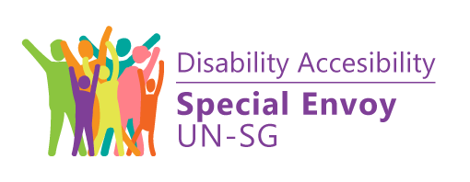

International Principles and Guidelines on Access to Justice for Persons with Disabilities
Endorsed by:

International Principles and Guidelines on Access to Justice for Persons with Disabilities

Geneva, August 2020

FOREWORD BY THE UNITED NATIONS HIGH COMMISSIONER FOR HUMAN RIGHTS
Persons with disabilities are a primary focus of my Office’s work, in part because they are among those left furthest behind. For far too long, they have been ignored, neglected and misunderstood and their rights simply denied. Laws, procedures and practices continue to discriminate against persons with disabilities, and the justice system has a critical role to play in preventing those outcomes and providing effective reparations when they occur, particularly when they stem from unfair laws.

Guaranteeing access to justice is indispensable to democratic governance and the rule of law, as well as to combating inequality and exclusion. Since the adoption of the Convention on the Rights of Persons with Disabilities, there has been a blueprint for achieving inclusion based on the human rights-based approach to disability. The International Principles and Guidelines on Access to Justice for Persons with Disabilities, developed under the leadership of the Special Rapporteur on the rights of persons with disabilities, Catalina Devandas Aguilar, are firmly rooted in the Convention and I welcome them as the first tool of their kind to provide comprehensive guidance and practical instruction on how to ensure access to justice for persons with disabilities on an equal basis with others.

The Principles and Guidelines will be of benefit to judicial actors, national human rights institutions and civil society, including organizations of persons with disabilities, to strengthen awareness-raising activities, training and the provision of accommodations to ensure respect for the rights of persons with disabilities and their enhanced representation and participation within proceedings. In addition, they provide a framework for the inclusion and participation of persons with disabilities in diverse roles within the administration of justice (e.g. judge, juror and witness) as a democratic imperative involving and reflecting all facets of society, in effect, shaping the society in which we live. The Principles and Guidelines are an indispensable contribution to achieving justice for all.

Michelle Bachelet
United Nations High Commissioner for Human Rights

FOREWORD BY JUAN MANUEL FERNÁNDEZ MARTÍNEZ
The rule of law – namely, the subjugation of the people and public powers to the due process of law – is the cornerstone of any democracy. However, alone this is not enough to maintain a democracy; the formulation of a legal order must be based on a scrupulous respect for human rights, constituted, throughout the history of democratic nations, by a series of fundamental rights that form the backbone of peaceful, inclusive and egalitarian coexistence.

Of these principles, the ones that stand out are the equality of all persons and the absolute respect for human dignity, regardless of personal, family or social circumstances.
That is, equality before the law, without discrimination based on age, birth, race, disability, sex, religion, opinion or any other personal or social condition or circumstance; and dignity, which in democratic legal systems is considered as the inherent quality of the human condition from which emanate fundamental rights, together with the free development of personality, inviolable and inalienable precisely because they are fundamental.

The mere formulation of these principles, however, is not enough. Human rights cannot be limited to a simple show of
good intentions or rhetorical declarations devoid of any practical effectiveness.
True democratic coexistence, sustained by respect for the equality and dignity of all persons, requires active policies on the part of public powers. The legal system must establish with absolute clarity the minimum and indispensable limits for the regulation of fundamental rights, but must do so in combination with measures to remove the obstacles that impede or hinder its fullness and to promote the equality of all people.

The International Principles and Guidelines on Access to Justice for Persons with Disabilities, which I am honoured to preface, reflect the enormous work accomplished over the past few years by the United Nations human rights mechanisms on this essential right of access to justice.

As mentioned above, there is no democracy without respect for the rule of law, and there is no true respect for the law without a judicial power guaranteeing compliance therewith. The duty to promote equality among all persons, especially to ensure that everyone has the right to access justice on an equal basis with others, rests with the judiciary. The impartiality of judges in the resolution of conflicts cannot be confused with a cold and insensitive neutrality to social reality, since that reality acts as a criterion for interpretation in the application of laws. As judges, we guarantee compliance with laws and with it the reality of democratic coexistence. We are also the ultimate guarantors of human rights. In the interpretation and enforcement of the law, it is possible, and necessary, to establish a dialogue with the other powers of the State, stating the reasons that justify certain changes in legal regulations.

While it is not possible to summarize in such a short space all the initiatives that the United Nations human rights mechanisms have promoted over the past few years, I would, however, like to highlight the definitive impetus given to the full recognition of the legal capacity of persons with disabilities.
The right to recognition of legal capacity is regulated in article 12 of the Convention on the Rights of Persons with Disabilities, without prejudice to the adoption of the support
measures that are necessary for the exercise of such capacity. This impetus has found expression in a number of legal systems.

Respect for the rights of all persons, including persons with disabilities, the fulfilment of their full equality and the protection of their dignity reveal what kind of society we are and will be.

Juan Manuel Fernández Martínez
Member of the General Council of the Judiciary, Spain

BACKGROUND
In November 2018, the Special Rapporteur on the rights of persons with disabilities, Catalina Devandas Aguilar, together with the Office of the United Nations High Commissioner for Human Rights (OHCHR) and with the support of the
Government of Spain, hosted an expert group meeting in Geneva to discuss implementation of the rights to legal capacity and access to justice for persons with disabilities. Following this meeting, the Special Rapporteur commissioned a study to identify the relevant principles, interventions and strategies to ensure effective access to justice for persons with disabilities on an equal basis with others.

On 21 February 2020, the Special Rapporteur convened another expert group meeting in Geneva to discuss the need to adopt international principles and guidelines on access to justice for persons with disabilities to guide States in implementing their international obligations in this field.

The Committee on the Rights of Persons with Disabilities and the Special Envoy of the Secretary-General on Disability and Accessibility have been closely involved in these activities and contributed to the development of the International Principles and Guidelines on Access to Justice for Persons with Disabilities. Organizations of persons with disabilities have been consulted and involved throughout the entire process.

Pursuant to General Assembly resolution 73/177, the Secretary-General will submit a report on the latest developments, challenges and good practices in human rights in the administration of justice, including on the situation of persons with disabilities in the administration of justice, to the Assembly at its seventy-fifth session (A/75/327). In the report, he recommends the development, in consultation with persons with disabilities, of international principles and guidelines on access to justice to support the efforts of States on this issue. The efforts made to develop such guidelines are acknowledged in the report.

The Principles and Guidelines have been endorsed by the International Commission of Jurists, the International Disability Alliance and the United Nations Development Programme.

INTRODUCTION
Everyone should, on an equal basis with others, enjoy the rights to equality before the law, to equal protection under the law, to a fair resolution of disputes, to meaningful participation and to be heard. States must ensure equal access to justice for all persons with disabilities by providing the necessary substantive, procedural, and age- and gender- appropriate accommodations and support.

The Principles and Guidelines are intended to assist States and other actors to design,
develop, modify and implement justice systems that provide equal access to justice for all persons with disabilities, regardless of their roles in the process, in accordance with the Convention on the Rights of Persons with Disabilities.

Articles 12 and 13 of the Convention represent a paradigm shift in the legal recognition of the autonomy of persons with disabilities. The Convention rejects historically entrenched understandings of disability that deprive persons with disabilities of any means to exercise their will and preferences, which in many countries have effectively resulted
in their being denied access to justice and procedural safeguards on an equal basis with others. Among the key provisions of article 12 on equal recognition before the law and article 13 on access to justice, States must:

- Recognize that persons with disabilities enjoy legal capacity on an equal basis with others in all aspects of life;
- Take appropriate measures to provide access to persons with disabilities to the support they may require in exercising their legal capacity;
- Ensure that all measures that relate to the exercise of legal capacity provide for appropriate and effective safeguards to prevent abuse, including by ensuring that measures relating to the exercise of legal capacity respect the rights, will and preferences of the person;
- Ensure effective access to justice for persons with disabilities on an equal basis with others, including through the provision of procedural and age- appropriate accommodations, in order to facilitate their effective role as direct and indirect participants, including as witnesses, in all legal proceedings, including at investigative and other preliminary stages.

While access to justice is fundamental for the enjoyment and fulfilment of all human rights, many barriers prevent persons with disabilities from accessing justice on an equal basis with others. Such barriers include restrictions on the exercise of legal capacity; lack of physical access to justice facilities, such as courts and police stations; lack of accessible transportation to and from these facilities; obstacles in accessing legal assistance and representation; lack of information in accessible formats; paternalistic or negative attitudes questioning the abilities of persons with disabilities to participate during all phases of the administration of justice; and lack of training for professionals working in the field of justice. In the justice system, persons with disabilities are often considered to be unworthy of, unable to benefit from or even likely to be harmed by due process protection provided to all other citizens. Even fundamental rights, such as the right to remain silent and the presumption of innocence, may be denied either directly in law or policy or indirectly in custom and practice. The risks are extreme – e.g. false confessions, erroneous verdicts and unlawful deprivation of liberty.

Justice systems reflect the values of the societies in which they are embedded.
When interacting with the justice system and law enforcement officials, a person may be confronted with individual and system biases, racism and structural inequality on a variety of grounds. While recognizing that these intersecting variables cannot be disentangled and must be challenged as a whole, the Principles and Guidelines pinpoint the unequal access to justice that is the consequence of bias, stigma and the lack of understanding about persons with disabilities by officials in the justice system. In the context of defendants and suspects in criminal cases, wrongful convictions can result from false confessions, mistaken identification and official misconduct, which may be the consequence of coercion and lack of information and understanding by persons with disabilities. While the design of courtrooms and the formal and technical language and procedures used in legal proceedings alienate anyone not familiar with them, this experience of alienation is exacerbated for persons with disabilities by the physical and other barriers. Some persons with disabilities may not understand or be aware of the consequences of legal steps or actions, underestimating the importance of timely action. Complainants and victims with disabilities risk their testimonies not being considered credible, thereby providing impunity to the perpetrators of crimes against persons with disabilities. Hence, the importance of the Principles and Guidelines in facilitating effective access to justice for persons with disabilities.

The Principles and Guidelines are not intended to describe in detail a particular system of justice. Rather, drawing on the consensus of contemporary thought and on actual experience, they seek to set out what is generally accepted as good practice in guaranteeing, without discrimination, equal and fair access to justice, in accordance with article 13 and other relevant provisions of the Convention. In implementing the Principles and Guidelines, States should be cognizant of and address multiple and intersectional discrimination in access to justice. Consistent with their obligations under the Convention, it is also critically important that States closely consult with and actively involve persons with disabilities and their representative organizations.

The rights of individuals and the obligations of States described herein apply to all legal proceedings (civil, criminal and administrative), regardless of forum or dispute resolution process, and during investigation, arrest and other preliminary stages, as well as post-adjudication stages, including in the provision of remedies. Accordingly, the Principles and Guidelines will be useful for, among others, lawmakers, policymakers, the judiciary, law enforcement and corrections officials, and persons with disabilities and their representative organizations. As appropriate, they apply to all direct and indirect participants in all legal proceedings, including, without limitation, suspects, detainees, defendants, claimants, victims, jurors, judicial officers, law enforcement officials and witnesses.

Despite the wide variety of legal, social, economic and geographical systems in the world, States can and should align their laws, rules, regulations, guidelines, protocols, practices, and policies on these Principles and Guidelines. However, the Principles and Guidelines are not intended to preclude innovation, provided that such innovation complies with the Convention and the Principles and Guidelines and that it seeks to ensure equal access to justice. Nor should they be interpreted as limiting any other international, regional or national laws or standards that are more conducive to the realization of the right of access to justice for persons with disabilities.

Persons with disabilities are entitled to enjoy the standards contained in all previously adopted international and regional human rights instruments that are relevant to justice systems, access to justice and, more generally, the administration of justice on an equal basis with others without discrimination. Some of those standards are referred to at the end of the present document.

Catalina Devandas Aguilar
Special Rapporteur on the rights of persons with disabilities
Danlami Basharu
Chair of the Committee on the Rights of Persons with Disabilities

María Soledad Cisternas Reyes
Special Envoy of the Secretary-General on Disability and Accessibility

GLOSSARY OF TERMS
First responders: persons, such as police officers, emergency health-care workers or crisis workers, who are among those responsible for going immediately to the scene of an emergency or crisis to provide assistance.

Intermediaries (also known as “facilitators”): persons who work, as required, with justice system personnel and persons with disabilities to ensure effective communication during legal proceedings. They support persons with disabilities to understand and make informed choices, making sure that things are explained and talked about in ways that they can understand and that appropriate accommodations and support are provided. Intermediaries are neutral and they do not speak for persons with disabilities or for the justice system, nor do they lead or influence decisions or outcomes.

Legal capacity: the capacity to be both a holder of rights and an actor under the law. Legal capacity to be a holder of rights entitles persons to full protection of their rights by the legal system. Legal capacity to act under the law recognizes that person as an agent with the power to engage in transactions and create, modify or end legal relationships.

Monitoring mechanisms: such mechanisms include national human rights institutions, national preventive mechanisms and bodies created under article 33 (2) of the Convention on the Rights of Persons with Disabilities that have a specific role in monitoring the implementation of the Convention. States are also under an obligation to ensure that all services provided – including within the justice system – to persons with disabilities to prevent exploitation, violence and abuse, in accordance with article 16 (3) of the Convention, are effectively monitored by independent authorities.

Reasonable accommodation: all necessary and appropriate modifications and adjustments not imposing a disproportionate or undue burden, where needed in a particular case, to ensure to persons with disabilities the enjoyment or exercise on an equal basis with others of all human rights and fundamental freedoms.

Procedural accommodation: all necessary and appropriate modifications and adjustments in the context of access to justice, where needed in a particular case, to ensure the participation of persons with disabilities on an equal basis with others. Unlike reasonable accommodations, procedural accommodations are not limited by the concept of “disproportionate or undue burden”.

Representative organization of persons with disabilities: organizations that are led, directed and governed by persons with disabilities. They are established predominantly with the aim of collectively acting, expressing, promoting, pursuing and/or defending the rights of persons with disabilities.

Substituted decision-making: when legal capacity is removed from persons, even if this is in respect of a single decision; or substitute decision makers (i.e. guardians, guardians ad litem, attorneys or experts) are appointed by someone other than the persons concerned against their will; or decisions are made by substitute decision makers based on the “best interests” of the persons concerned, as opposed to being based on the will and preferences of such persons.

Universal design: the design of products, environments, programmes, devices and services to be usable by all people, to the greatest extent possible, without the need for adaptation or specialized design.

International Principles and Guidelines on Access to Justice for Persons with Disabilities

Principle 1
All persons with disabilities have legal capacity and, therefore, no one shall be denied access to justice on the basis of disability.

Principle 2
Facilities and services must be universally accessible to ensure equal access to justice without discrimination of persons with disabilities.

Principle 3
Persons with disabilities, including children with disabilities, have the right to appropriate procedural accommodations.

Principle 4
Persons with disabilities have the right to access legal notices and information in a timely and accessible manner on an equal basis with others.

Principle 5
Persons with disabilities are entitled to all substantive and procedural safeguards recognized in international law on an equal basis with others, and States must provide the necessary accommodations to guarantee due process.

Principle 6
Persons with disabilities have the right to free or affordable legal assistance.

Principle 7
Persons with disabilities have the right to participate in the administration of justice on an equal basis with others.

Principle 8
Persons with disabilities have the rights to report complaints and initiate legal proceedings concerning human rights violations and crimes, have their complaints investigated and be afforded effective remedies.

Principle 9
Effective and robust monitoring mechanisms play a critical role in supporting access to justice for persons with disabilities.

Principle 10
All those working in the justice system must be provided with awareness-raising and training programmes addressing the rights of persons with disabilities, in particular in the context of access to justice.

Principle 1

All persons with disabilities have legal capacity and, therefore, no one shall be denied access to justice on the basis of disability

GUIDELINES

  - States shall guarantee that persons with disabilities enjoy legal capacity on an equal basis with others and, where necessary, shall provide the support and accommodations necessary to exercise legal capacity and guarantee access to justice.
  - To that end, States shall:
    - Ensure that all persons with disabilities are considered to have legal capacity, and the right to act on and exercise legal capacity;
    - Recognize and assume the full capacity and right of persons with disabilities to participate in the proceedings of all courts, tribunals and forums;
    - Ensure that constructs such as “cognitive incapacity” and “mental incapacity”, as determined, for instance, by functional or mental status assessments, are not used to restrict a person’s right to legal capacity;
    - Repeal or amend all laws, regulations, policies, guidelines and practices that directly or indirectly restrict the legal capacity of persons with disabilities, including those that allow for substituted decision-making and those that require that a person be “of sound mind” to take any action, thereby excluding persons with disabilities from equal access to justice;
    - Repeal or amend all laws, regulations, policies, guidelines and practices that establish and apply doctrines of “unfitness to stand trial” and “incapacity to plead”, which prevent persons with disabilities from participating in legal processes based on questions about or determinations of their capacity;
    - Repeal or amend all laws, regulations, policies, guidelines and practices that restrict or exclude witnesses with disabilities from presenting testimony based on assessments of their capacity to testify;
    - Repeal or amend all laws, regulations, policies, guidelines and practices that authorize or otherwise empower medical professionals to be the sole or preferred “experts” in determining or opining on a person’s capacity to make decisions, to testify or for any other purpose;
    - Repeal or amend all laws, regulations, policies, guidelines and practices preventing persons with disabilities from initiating and pursuing legal claims;
    - Create an actionable and enforceable right to receive the individually determined procedural accommodations, including support, necessary to enable persons with disabilities to participate effectively in all proceedings in any court, tribunal or forum;
    - Provide intermediaries or facilitators, wherever and whenever needed, to enable clear communication among and between persons with disabilities and courts, tribunals and law enforcement agencies to ensure safe, fair and effective engagement and the opportunity to fully participate in legal processes;
    - Ensure that persons who have been declared to be without capacity for any purpose have the right to appeal or otherwise seek restoration of their legal capacity and have access to legal assistance to pursue their claims;
    - Establish or support alternative justice mechanisms, such as restorative justice, alternative dispute resolution mechanisms, and cultural and social forms and forums of justice, that are available to persons with disabilities on an equal basis with others, without regard for any construct of capacity to participate;
    - Repeal or amend laws, regulations, policies, guidelines and practices, including court orders, that subject defendants with disabilities to detention in a prison, a mental health facility or other institution for a definite or indefinite term (sometimes referred to as “care-related hospitalization”, “security measures” or “detainment at the governor’s pleasure”) based on perceived dangerousness or need for care.

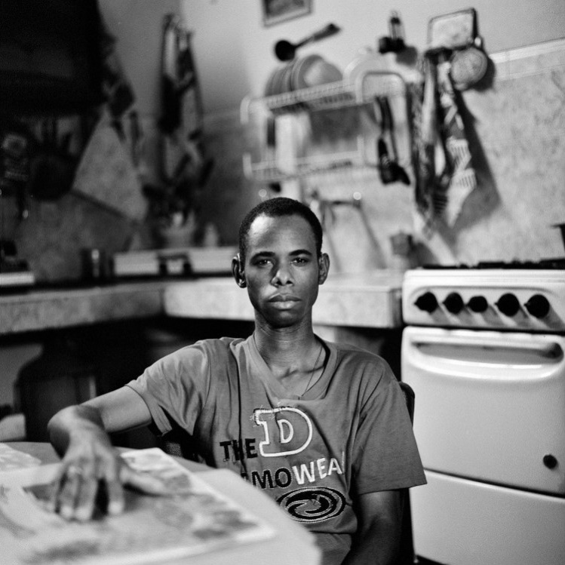

Principle 2

Facilities and services must be universally accessible to ensure equal access to justice without discrimination of persons with disabilities

GUIDELINE

  - To guarantee equal access to justice and non-discrimination, States must ensure that the facilities and services used in legal systems are built, developed and provided on the basis of the principles of universal design by taking, at a minimum, the following actions:
    - Enacting and implementing enforceable laws, regulations, policies, guidelines and practices that guarantee the accessibility of all facilities and services used in the justice system, based on the principles of universal design, including:
      - Courts, police facilities, prisons, detention and forensic facilities, jury facilities, administrative offices and other such places (including toilets, cells, offices, entrances, lifts, canteens and recreational spaces in those places);
      - Information, communications and other services, including information and communications technology and systems;
    - Ensuring that all means of transportation used in the justice system are accessible;
    - Ensuring that adequate financial resources are available to make the justice system physically accessible to persons with disabilities in accordance with the principles of universal design;
    - Guaranteeing the provision of procedural accommodations when facilities and services fail to ensure access to the existing physical environment, transportation, information and communications for persons with disabilities.

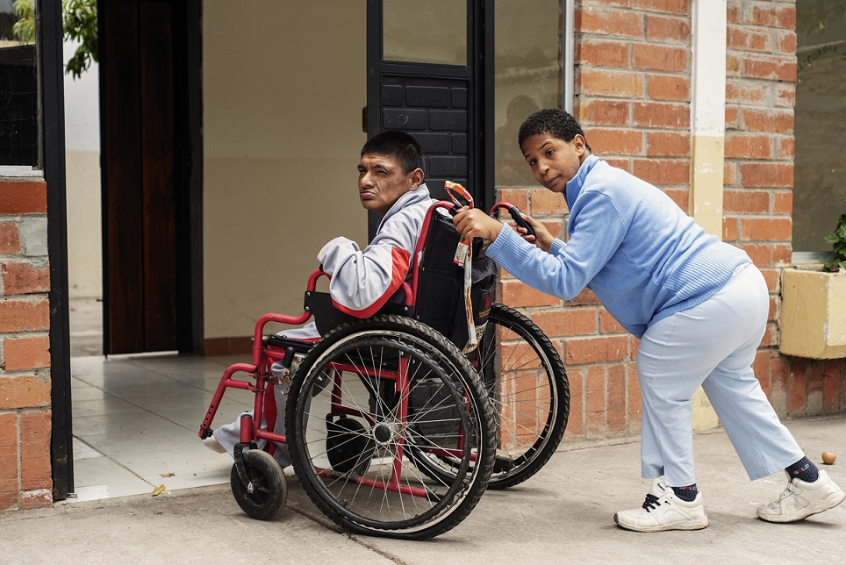

Principle 3

Persons with disabilities, including children with disabilities, have the right to appropriate procedural accommodations

GUIDELINES

  - To avoid discrimination and guarantee the effective and equal participation of persons with disabilities in all legal proceedings, States shall provide gender- and age-appropriate individualized procedural accommodations for persons with disabilities. They encompass all the necessary and appropriate modifications and adjustments needed in a particular case, including intermediaries or facilitators, procedural adjustments and modifications, adjustments to the environment and communication support, to ensure access to justice for persons with disabilities. To the fullest extent possible, accommodations should be organized before the commencement of proceedings.
  - States shall ensure the provision of a range of procedural accommodations, while also ensuring that such accommodations are implemented so as to properly balance and respect the rights of all parties by, among other things:

Independent intermediaries and facilitators
- Establishing, funding and implementing a programme of independent intermediaries or facilitators trained to provide communication assistance to parties to the proceedings and the justice system to determine whether accommodations and support are necessary and which accommodations and support are appropriate, and to assist with communication throughout the course of the proceedings;
- Designing and implementing a programme of independent intermediaries or facilitators in a manner consistent with local procedures and customs, and in line with the Convention on the Rights of Persons with Disabilities;

Procedural adjustments and modifications
- Adopting procedures for hearings that ensure the fair treatment and full participation of persons with disabilities, including children with disabilities, during proceedings, as appropriate, such as:
  - Adaptation of the venue;
  - Appropriate waiting spaces;
  - Removal of cloaks and wigs;
  - Adjustments to the pace of proceedings;
  - Separate building entrances and waiting rooms and protective screens to separate persons with disabilities from others if necessary due to physical or emotional distress;
  - Modifications to the method of questioning in appropriate circumstances, such as allowing leading questions, avoiding compound questions, finding alternatives to complex hypothetical questions, providing extra time to answer, permitting breaks as needed and using plain language;
  - Use of pre-trial video recording of evidence and testimony, if necessary, practical and possible, in such a manner as not to contravene basic rights, such as the right to confront and cross- examine witnesses;
- Allowing persons with disabilities, at all stages of the process if they so choose, to be accompanied by family, friends or others to provide emotional and moral support, without replacing, however, the role of an intermediary or facilitator;

Communication support
- Ensuring that all processes in the justice system provide the technical and other support necessary for parties, witnesses, claimants, defendants and jurors to use any form of communication as necessary for their full participation, including:
- Assistive listening systems and devices;
- Open, closed and real-time captioning, and closed caption decoders and devices;
- Voice, text and video-based telecommunications products;
- Videotext displays;
- Computer-assisted real-time transcription;
- Screen reader software, magnification software and optical readers;
- Video description and secondary auditory programming devices that pick up audio feeds for television programmes;
- Supporting communication, in addition to intermediaries or facilitators, through the use of third parties, including:
- Note-takers;
- Qualified sign language and oral interpreters;
- Relay services;
- Tactile interpreters;
- Ensuring that all interpreters are able to interpret effectively, accurately and impartially, both receptively (i.e. understanding what persons with disabilities are saying) and expressively (i.e. having the skill necessary to convey information back to those persons), while using any necessary specialized vocabulary (e.g. legal or medical) and respecting professional and ethical standards;

Procedural accommodations for persons accused of crimes, prisoners and detainees
- Ensuring that police officers, prosecutors and others involved in arrests and investigations of criminal offences are knowledgeable about the rights of persons with disabilities, are alert to the possibility that a person may have a disability and, throughout the course of an arrest or investigation, adjust their responses accordingly;
- Ensuring that independent third persons, such as attorneys or others, are available to accompany persons with disabilities to the police station to assist them in the investigative process, including, for example, fingerprinting or giving a biological sample, and that intermediaries or facilitators, or similar, are available to facilitate communication between persons with disabilities and law enforcement and court personnel;
- Removing barriers that prevent or discourage prisoners and detainees with disabilities from challenging their imprisonment and remedying conditions of confinement by, for instance, providing legal standing to prisoners’ rights organizations and representative organizations of persons with disabilities, simplifying procedures, shortening timelines for decisions and providing effective remedies;

Requests for and offers of accommodations
- Enacting and implementing laws, regulations, policies, guidelines, practices and processes that enable persons with disabilities to request procedural accommodations, including modifications of or support in legal processes, with appropriate protection of their privacy;
- Ensuring, throughout the course of legal proceedings, that all participants are advised of the availability of procedural accommodations if needed and desired because of disability;
- Ensuring a process for determining the need for and providing procedural accommodations, including communication assistance, to children with disabilities, as well as additional safeguards, when necessary, according to their evolving capacities and their right to have their views heard.

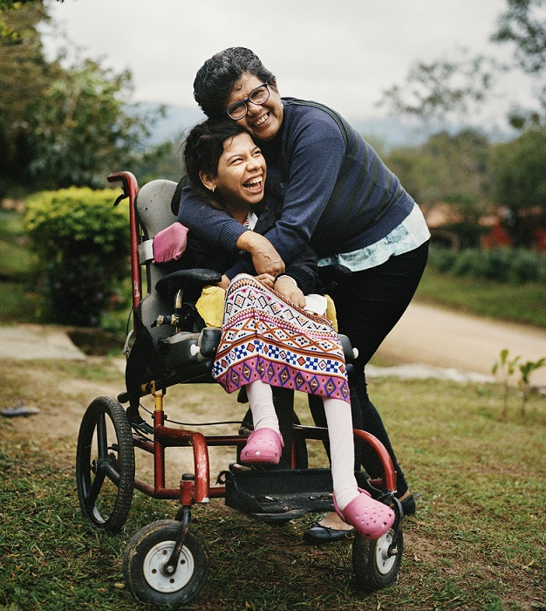

Principle 4

Persons with disabilities have the right to access legal notices and information in a timely and accessible manner on an equal basis with others

GUIDELINE

  - To guarantee the right to timely and accessible information, States shall:
- Enact enforceable laws, regulations, policies and guidelines that fully recognize a right to timely notice and information about all aspects of judicial processes;
- Ensure that information about justice systems and procedures can be accessed by various methods, including, as appropriate and needed:
  - Sign language;
  - Video and audio guides;
  - Telephone line advice and referral services;
  - Accessible websites;
  - Induction loop, radio or infrared systems;
  - Amplification devices and document magnifiers;
  - Closed captioning;
  - Braille;
  - Easy Read and plain language;
  - Facilitated communication;
- Ensure that all notices that require a response or an action to be taken (e.g. summonses, subpoenas, writs, orders and sentences) are available by accessible means and in accessible formats, such as those listed above in guideline 4.1 (b);
- Ensure that notices and information include clear understandable information about how a procedure works, what to expect during a process, what is expected of a person, where to get help with understanding the process and the person’s rights in the process, in language that is not merely a repetition of the statute, regulation, policy or guideline – for example, plain language;
- Ensure that support is available in real time for individuals who need assistance to understand notices and information by providing, for instance, interpreters, guides, readers, intermediaries and facilitators, and other forms of support.

Principle 5

Persons with disabilities are entitled to all substantive and procedural safeguards recognized in international law on an equal basis with others, and States must provide the necessary accommodations to guarantee due process

GUIDELINES

  - States shall ensure that all substantive and procedural safeguards recognized in international law, whether in criminal, civil or administrative procedures, including the presumption of innocence and the right to remain silent, are afforded to all persons with disabilities, on an equal basis with others. Procedural accommodations, when needed, must be available to all persons with disabilities, including suspects and accused persons, who require assistance to participate effectively in investigations and judicial proceedings.
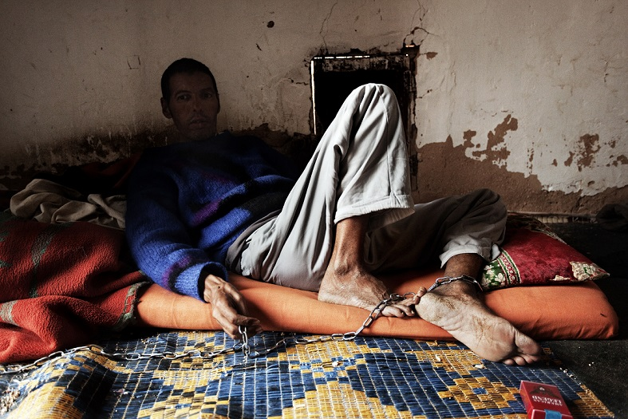
  - Accordingly, States shall:
- Ensure that all suspects and accused persons with disabilities are presumed innocent until proven guilty under the law;
- Ensure that suspects or accused persons with disabilities are provided with accessible and understandable information about their rights, including the right not to incriminate oneself;
- Ensure that, in all interactions with first responders, persons with disabilities have the right to be free from discrimination and any use of force or coercion based on disability – for example, perceived differences in behaviour or manner of communication – including through the provision of adequate support that is unrelated to and independent of police or law enforcement involvement;
- Ensure the provision of procedural accommodations to persons with disabilities at the time of their arrest, including procedural adjustments and communication support, and the use of de-escalation techniques, as appropriate, to safeguard all due process guarantees and prevent police violence and abuse;
- Draft, enact and implement laws, regulations, guidelines, procedures and policies to protect persons with disabilities from being exploited on account of their disability in any phase of the justice process;
- Ensure that procedural accommodations, including support, for effective participation are available so that persons with disabilities have the right, on an equal basis with others, to make their own choices of how to defend themselves;
- Ensure that health-care and psychosocial support are available at the request of persons with disabilities, based on their free and informed consent, irrespective of the outcome of any police action or judicial proceedings, and not contingent on a plea bargain, confession or conviction.

Principle 6

Persons with disabilities have the right to free or affordable legal assistance

GUIDELINES
- To guarantee the right to a fair trial, States shall provide free or affordable legal assistance to children with disabilities in all matters, and to all other persons with disabilities in all legal procedures and proceedings that relate to violations of human rights or fundamental freedoms or those that could negatively affect such rights or freedoms, in particular the rights to life, liberty, personal integrity, property, adequate housing, decision- making autonomy and family integrity. Legal assistance must be competent and available in a timely manner for persons with disabilities to participate equally in any legal proceedings.
- To that end, States shall:
  - Enact and implement laws, regulations, policies, guidelines and practices affording the right to legal assistance in all judicial and quasi-judicial proceedings, regardless of the role of persons with disabilities in the process or the possible consequences or outcomes;
  - Create, fund and implement legal assistance programmes to provide free legal representation to persons who cannot afford to retain legal assistance, including persons with disabilities, at a minimum in matters concerning:
    - Loss of life or liberty, including by imprisonment, detainment, placement in an institution, forced or involuntary medical treatment (e.g. sterilization) or involuntary hospitalization; loss of legal capacity (e.g. guardianship); or loss of family integrity by forfeiture of parental or custodial rights;
    - Loss of housing, shelter or property;
    - Any other situation, including all criminal matters that do not carry the risk of incarceration, small claims and civil cases, in which a person with disabilities may be disadvantaged in communicating, understanding or being understood in the process;
  - Ensure, in addition to the matters listed above in guideline 6.2 (b), that free legal assistance is available to persons with disabilities on terms that are no less favourable than those for persons without disabilities and, at a minimum, whenever necessary, on an individualized basis, as a procedural accommodation;
  - Ensure, in addition to legal assistance, access to legal advice through, for example, telephone or digital gateway services, paralegal services and online legal help services, using assistive technology as necessary;
  - Repeal or amend any laws, regulations, policies, guidelines or practices that restrict the legal capacity of persons with disabilities to retain and instruct a lawyer;
  - Ensure easy access to legal assistance, removing all administrative, communication and physical barriers to such access;
  - Ensure that specialized services for victims (e.g. gender-based violence units) are equally accessible for persons with disabilities;
  - Make procedural accommodations, such as interpreters, assistive technology and intermediaries and facilitators, or the resources necessary to obtain such accommodations, available to lawyers to support effective communication with clients, witnesses and other persons with disabilities in the discharge of their professional duties;
  - Amend, when necessary, ethical and other relevant regulations applicable to lawyers to require them to respect and advocate for the will and preferences of their clients with disabilities and to follow their expressed instructions; any laws, regulations, policies, guidelines or practices to the contrary should be repealed or amended;
  - Repeal or amend all laws, regulations, policies, guidelines and practices that impose substituted decision-making in legal proceedings, including those that allow for the appointment of decision makers against the will of persons with disabilities (e.g. guardians ad litem, next friends and similar arrangements); or decisions made on the basis of the “best interests” of the persons concerned, as opposed to being based on their own will and preferences;
  - Provide free legal assistance and support to all persons with disabilities who have experienced violence, in particular women and girls with disabilities, including professional victim support, advice about legal rights, and assistance in reporting crimes and initiating legal proceedings.

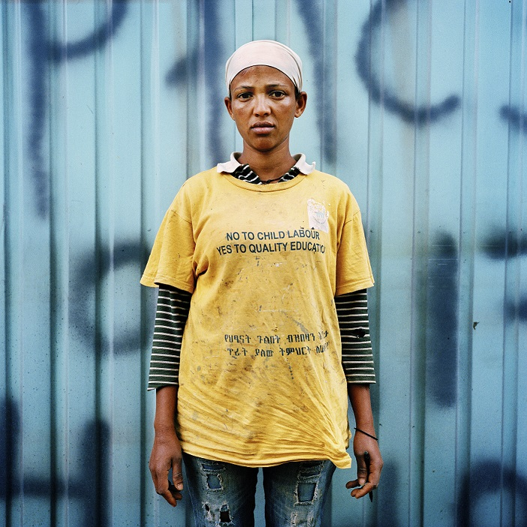

Principle 7

Persons with disabilities have the right to participate in the administration of justice on an equal basis with others

GUIDELINES

  - The right to equal access to justice requires that persons with disabilities have the opportunity to participate directly in adjudicative processes and be involved in various roles in the administration of justice on an equal basis with others. States should ensure that persons with disabilities are able to act as judges, lawyers, prosecutors, witnesses, jurors, experts and court officials in the justice system without discrimination.
  - To this end, Governments, legislatures and other authorities, including judicial councils and other independent judicial governing bodies and independent self-governing legal professional bodies, must each, within their respective roles, take the following actions:
    - Remove barriers that prevent or discourage persons with disabilities from entering justice system-related professions by, for instance:
- Providing reasonable accommodations throughout legal and justice-related education programmes;
- Providing reasonable accommodations during certification and licensing examinations or processes;
- Prohibiting questions about health and disability in applications for admission to the legal profession and positions in the justice system;
- Ensuring that all facilities and structures in the justice system are universally accessible to workers with disabilities.
    - Remove all disability-related barriers, including laws, that prevent persons with disabilities from being judges or jurors or serving in any other justice- related positions;
    - Ensure the equal participation of persons with disabilities in the jury system by providing all necessary support, reasonable accommodations and procedural accommodations;
    - Consult closely with and actively involve persons with disabilities and their representative organizations in all discussions and decision-making about justice-related issues by, for example, providing meaningful participation on boards, committees, commissions, sentencing councils and other guidance and oversight organizations;
    - Collect disaggregated data on the participation of persons with disabilities in the justice system and, using that data develop and implement strategies to reform policies, practices and laws to ensure equal access to justice.
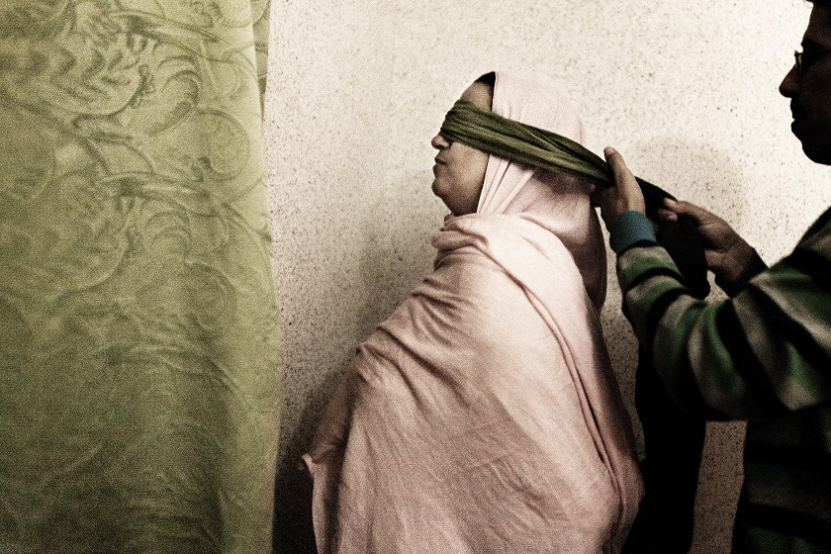

Principle 8

Persons with disabilities have the rights to report complaints and initiate legal proceedings concerning human rights violations and crimes, have their complaints investigated and be afforded effective remedies

GUIDELINES

  - States must have accessible, easy-to-use, transparent and effective mechanisms for individuals to report complaints about human rights violations and crimes. Complaint adjudicators and tribunals must provide remedies that are individually tailored and may include redress and reparation.
  - Accordingly, States shall:

Complaint mechanisms
- Establish complaint mechanisms – for instance, national human rights institutions, tribunals and administrative bodies – with the power to hear complaints, including complaints about disability-based discrimination, from persons with disabilities and others and to order remedies;
- Ensure that persons with disabilities may file criminal complaints on an equal basis with others;
- Ensure that civil and criminal complaint mechanisms are accessible, using, for example, hotlines and e-service complaint methods;
- Provide voluntary alternative dispute resolution mechanisms, such as conciliation, mediation, arbitration and restorative justice;
- Ensure that complaint mechanisms and investigations are gender sensitive to guarantee that victims of gender-based violence are able and willing to come forward safely;
- Ensure that special protection units (e.g. those dealing with gender-based violence, hate crime, children and trafficking in persons) are accessible to persons with disabilities and responsive to their needs;
- Ensure that mechanisms, when appropriate and desired, provide for anonymity and confidentiality;

Responding to grave, systematic, group or large-scale violations
- Ensure that complaint systems and the justice system are capable of detecting and responding to grave, systematic, group and large-scale violations of human rights through, for instance, class actions, actiones populares, public inquiries and prosecutions, following a complaint or on the initiative of the system itself;

Investigations
- Ensure that all investigators, including law enforcement officials, are knowledgeable about the rights of persons with disabilities and are alert, throughout the course of investigations, to the potential need for procedural accommodations when investigations involve persons with disabilities;
- Ensure that, when appropriate, an intermediary or facilitator or other appropriate third party is enlisted to assist in the investigation process;
- Ensure that, when working with victims with disabilities, law enforcement officials assess the risk of the former being subjected to further offences, and whether any voluntary protective measures (such as a safe haven) are needed;

Remedies
- Ensure, in the criminal context, that those who abuse or otherwise mistreat persons with disabilities are prosecuted and, when appropriate, convicted or subject to other effective sanctions;
- Ensure that effective remedies are in place for human rights violations, including the right to be free from disability-based discrimination and the rights to restitution, compensation, rehabilitation, satisfaction and guarantees of non-repetition. Such remedies should, among other things:
  - Be enforceable, individualized and tailored to meet the needs of claimants;
  - Ensure that victims are protected from repeat violations of their human rights;
  - Be proportional to the gravity of the violations and the circumstances of each case;
  - Be provided on the basis that an individual’s free and informed consent is required for any rehabilitative measures;
  - Address the systemic nature of human rights violations.

Principle 9

Effective and robust monitoring mechanisms play a critical role in supporting access to justice for persons with disabilities

GUIDELINES

  - States have an obligation to designate independent frameworks to promote, protect and monitor implementation of the rights of persons with disabilities and their equal access to justice. To ensure independent monitoring, States shall either provide the necessary mandates and resources to established monitoring mechanisms or create new ones when they do not exist.
  - States, therefore, should take the following actions:
    - Designate independent monitoring mechanisms in accordance with article 33 (2) of the Convention on the Rights of Persons with Disabilities, including establishing and maintaining national human rights institutions in accordance with the principles relating to the status of national institutions for the promotion and protection of human rights (the Paris Principles) with a mandate to monitor implementation of the Convention;
    - Ensure that all monitoring mechanisms have institutional, financial and political independence;
    - Promote the regular exchange of information among monitoring mechanisms to identify challenges and implement strategies to address common issues;
    - Ensure the meaningful participation of persons with disabilities and their representative organizations in designing and implementing independent monitoring mechanisms;
    - Include a mandate to actively monitor and identify violations of the rights of persons with disabilities, particularly those deprived of liberty and placed in institutional settings;
    - Include a mandate for the independent monitoring mechanisms to gather and publicly report data on human rights violations, including barriers to access to justice;
    - Ensure a mandate and funding for raising awareness about the human rights-based approach to disability and support training programmes for this purpose.

Principle 10

All those working in the justice system must be provided with awareness-raising and training programmes addressing the rights of persons with disabilities, in particular in the context of access to justice

GUIDELINES

  - States must remove barriers to justice for persons with disabilities by providing training on the rights of persons with disabilities to all justice officials, including the police, judicial officers, lawyers, health professionals, forensic experts, victim service professionals, social workers, and probation, prison and youth detention staff.
  - To this end, Governments, legislatures and other authorities, including judicial councils and other independent judicial governing bodies and independent self- governing legal professional bodies, must each, within their respective roles, take the following actions:
- Enact and implement laws, regulations, policies, guidelines and practices that create a legal obligation for all persons who have a role in the administration of justice to participate in human rights- based training on the rights of persons with disabilities and the provision of accommodations in accordance with guideline 10.2 (j);
- Provide training on an ongoing basis to all those working in the administration of justice, including by national human rights institutions and representative organizations of persons with disabilities;
- Ensure that persons with disabilities and their representative organizations participate in the development and presentation of all training referenced in the present guidelines;
- Monitor and evaluate training and ensure the participation and active involvement of representative organizations of persons with disabilities in such monitoring and evaluation;
- Launch awareness-raising strategies that include training programmes and media campaigns, based on the human rights model of disability, for all judicial officers, lawmakers, policymakers and law enforcement officials to eliminate prejudice and promote recognition of rights;
- Make training manuals widely available for all those engaged in the administration of justice, especially police officers, prosecution authorities and judicial officers;
- Use training to familiarize police officers, including first responders and investigators, prosecution personnel and judicial officers, with good practices in interactions with persons with disabilities, including response, behaviour and appropriate accommodations;
- Develop, fund and implement guidelines and training for lawyers and law students on the rights of persons with disabilities and procedural accommodations, in accordance with guideline 10.2 (j);
- Provide persons with disabilities and their families with training and access to information on rights, remedies, claiming redress and the legal process;
- Ensure that training programmes are comprehensive and address at least the following topics:
  - Factors or system features that can result in barriers for persons with disabilities;
  - Removal of barriers to access to justice for persons with disabilities;
  - The Convention on the Rights of Persons with Disabilities and the human rights model of disability;
  - The acknowledgement that persons with disabilities have the right to recognition as persons before the law, including combating harmful gender and disability stereotypes and prejudices;
  - The obligation to respect the legal capacity of persons with disabilities, including legal agency and standing;
  - Communication skills, including identifying the need to engage experts for communication assistance;
  - De-escalation of situations and prevention of the use of force;
  - Procedural accommodations;
  - Reasonable accommodations;
  - Combating ableism and overcoming prejudice against persons with disabilities;
  - Sexual, reproductive and family rights;
  - Intersecting forms of discrimination on the basis of disability and other grounds, including sex, gender, indigenous status, race, sexual orientation, migration status, minorities and disadvantaged communities, and poverty;
  - Awareness and understanding of the rights of persons with disabilities to have equal access to information.

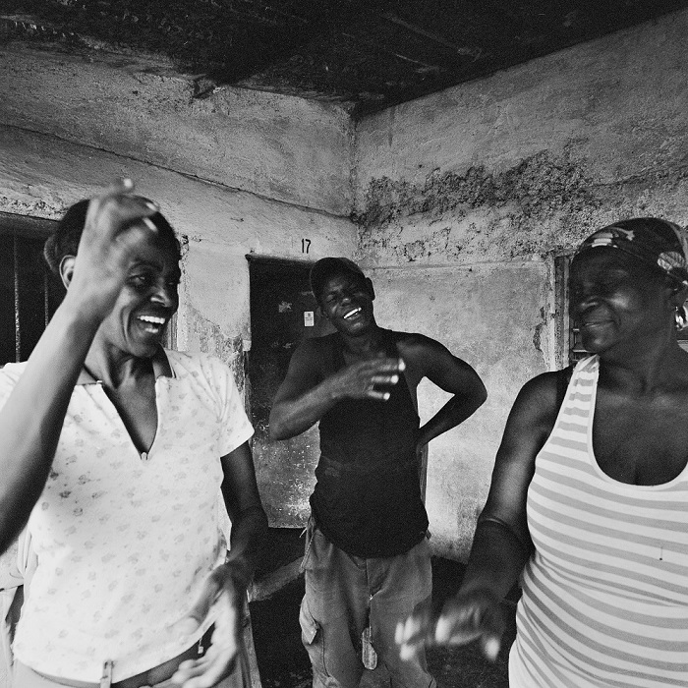
ADDITIONAL RESOURCES

Disability-specific reference documents and standards
Committee on the Rights of Persons with Disabilities, general comment No. 1 (2014) on equal recognition before the law
general comment No. 2 (2014) on accessibility.
general comment No. 3 (2016) on women and girls with disabilities.
general comment No. 6 (2018) on equality and non-discrimination.
general comment No. 7 (2018) on the participation of persons with disabilities, including children with disabilities, through their representative organizations, in the implementation and monitoring of the Convention.

Convention on the Rights of Persons with Disabilities (2006)

Flynn, Eilionóir, and others, Final Report: Access to Justice of Persons with Disabilities. Galway: Centre for Disability Law and Policy, National University of Ireland, Galway, 2019.

G3ict (Global Initiative for Inclusive Information and Communication Technologies), Inclusive courts checklist.

Atlanta, 2020.

United Nations, General Assembly,
Rights of persons with disabilities. 9 August 2016. A/71/314.
Sexual and reproductive health and rights of girls and young women with disabilities. 14 July 2017. A/72/133.

United Nations, Human Rights Council,
Report of the Special Rapporteur on the rights of persons with disabilities. 12 January 2016. A/HRC/31/62.
Report of the Special Rapporteur on the rights of persons with disabilities. 20 December 2016. A/HRC/34/58.
Report of the Special Rapporteur on the rights of persons with disabilities. 12 December 2017. A/HRC/37/56.
Right to access to justice under article 13 of the Convention on the Rights of Persons with Disabilities. 27 December 2017. A/HRC/37/25.
Rights of persons with disabilities. 11 January 2019. A/HRC/40/54.

General reference documents and standards on access to justice

Treaties and treaty bodies

International Convention on the Elimination of All Forms of Racial Discrimination (1965), articles 5 and 6.

- Committee on the Elimination of Racial Discrimination, general recommendation No. 31 (2005) on the prevention of racial discrimination in the administration and functioning of the criminal justice system.
International Covenant on Civil and Political Rights (1966), articles 2, 9, 14 and 26.
- Human Rights Committee, general comment No. 32 (2007) on the right to equality before courts and tribunals and to a fair trial.

Convention on the Elimination of All Forms of Discrimination against Women (1979), articles 2 and 15.
- Committee on the Elimination of Discrimination against Women, general recommendation No. 33 (2015) on women’s access to justice.

Convention against Torture and Other Cruel, Inhuman or Degrading Treatment or Punishment (1985), articles 13 and 14.
- Committee against Torture, general comment No. 3 (2012) on the implementation of article 14.

Convention on the Rights of the Child (1989), articles 12, 23, 37 and 40
- Committee on the Rights of the Child, general comment No. 24 (2019) on children’s rights in the child justice system.

International Convention on the Protection of the Rights of All Migrant Workers and Members of Their Families (1990), articles 16 to 20.

International Convention for the Protection of All Persons from Enforced Disappearance (2006), article 24.

Other instruments
Basic Principles on the Independence of the Judiciary (1985).

Declaration of Basic Principles of Justice for Victims of Crime and Abuse of Power (1985).

United Nations Standard Minimum Rules for the Administration of Juvenile Justice (the Beijing Rules) (1985).

Body of Principles for the Protection of All Persons under Any Form of Detention or Imprisonment (1988).

Basic Principles on the Role of Lawyers (1990).

Guidelines on the Role of Prosecutors (1990).

United Nations Standard Minimum Rules for Non-custodial Measures (the Tokyo Rules) (1990).

United Nations Rules for the Protection of Juveniles Deprived of their Liberty (1990).

Guidelines for Action on Children in the Criminal Justice System (1997).

Basic Principles and Guidelines on the Right to a Remedy and Reparation for Victims of Gross Violations of International Human Rights Law and Serious Violations of International Humanitarian Law (2005).

Updated set of principles for the protection and promotion of human rights through action to combat impunity (2005).
United Nations Declaration on the Rights of Indigenous Peoples (2007), articles 22 and 40.

United Nations Rules for the Treatment of Women Prisoners and Non-custodial Measures for Women Offenders (the Bangkok Rules) (2010).

United Nations Principles and Guidelines on Access to Legal Aid in Criminal Justice Systems (2012).

United Nations Standard Minimum Rules for the Treatment of Prisoners (the Nelson Mandela Rules) (revised, 2015).

International standards applicable in situations of armed conflict

Geneva Convention relative to the Treatment of Prisoners of War (1949), articles 3 and 102–108.

Geneva Convention relative to the Protection of Civilian Persons in Time of War (1949), articles 3, 5, 66 and 71.

Protocol Additional to the Geneva Conventions of 12 August 1949, and relating to the Protection of Victims of International Armed Conflicts (Protocol I) (1977), article 75 (4).

Protocol Additional to the Geneva Conventions of 12 August 1949, and relating to the Protection of Victims of Non-International Armed Conflicts (Protocol II) (1977), article 6.

International Committee of the Red Cross, study on customary international humanitarian law, rule 100 (“No one may be convicted or sentenced, except pursuant to a fair trial affording all essential judicial guarantees” (2005).

Regional human rights instruments

American Declaration of the Rights and Duties of Man (1948), articles II, XVIII and XXVI.

Convention for the Protection of Human Rights and Fundamental Freedoms (1950), articles 6 and 13. American Convention on Human Rights (1969), articles 8 and 24–25.

African Charter on Human and Peoples’ Rights (1981), articles 7 and 26.

Principles and Guidelines on the Right to a Fair Trial and Legal Assistance in Africa (2003). Arab Charter on Human Rights (2004), articles 11–19 and 23.

Directive 2012/29/EU of the European Parliament and of the Council of 25 October 2012 establishing minimum standards on the rights, support and protection of victims of crime, and replacing Council Framework Decision 2001/220/JHA (2012)
END

United Nations Special Rapporteur on the rights of persons with disabilities
sr.disability@ohchr.org

United Nations Committee on the Rights of Persons with Disabilities www.ohchr.org/EN/HRBodies/CRPD/Pages/CRPDIndex.aspx
crpd@ohchr.org

Special Envoy of the Secretary-General of the United Nations on Disability and Accessibility
www.un.org/development/desa/disabilities/resources/special-envoy-of-the-secretary-general-on- disability-and-accessibility.htm
se.disability.secretariat@gmail.com

Committee on the Rights of Persons with Disabilities, general comment No. 1 (2014) on equal recognition before the law, para. 12
Convention on the Rights of Persons with Disabilities, art. 2.
A/HRC/34/26, para. 35.
Committee on the Rights of Persons with Disabilities, general comment No. 7 (2018) on the participation of persons with disabilities, including children with disabilities, through their representative organizations, in the implementation and monitoring of the Convention, para. 11.
General comment No. 1, para. 27.
Convention on the Rights of Persons with Disabilities, art. 2.

