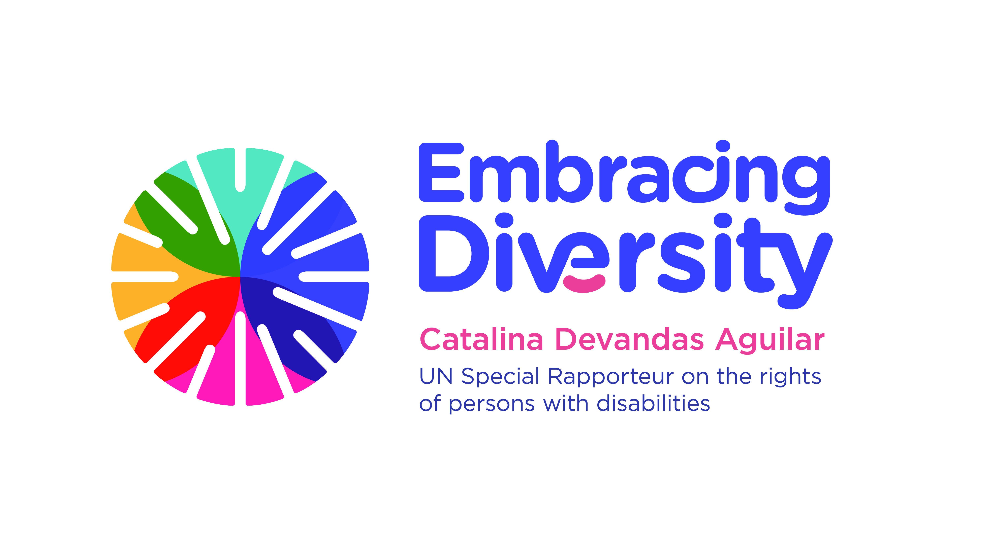english

**Expert Consultation on**

**Sexual and reproductive health and rights of girls with disabilities**

13 June 2017, New York (1-6 pm)

UNFPA Office, Room 4B

List of participants

1. **Ms. Catalina DEVANDAS AGUILAR**, Special Rapporteur on the rights of persons with disabilities,
2. **Ms. Patty ALLEMAN**, UNICEF
3. **Ms. Rosangela BERMAN BIELER**, UNICEF
4. **Ms. Anne-Claire BLOK**, Plan International
5. **Ms. Joelle BROUNER**, independent expert with disabilities
6. **Ms. Rebecca BROWN**, Centre for Reproductive Rights (CRR)
7. **Ms. Mariana CAMACHO**, International Disability Alliance (IDA)
8. **Mr. Aoife Nic CHARTHAIG**, International Solutions Group (ISG)
9. **Ms. Maribel DERJANI-BAYEH,** UN Women
10. **Ms. Georgia DOMINIK**, International Disability Alliance (IDA)
11. **Ms. Emilie FILMER-WILSON**, UNFPA
12. **Ms. Priscille GEISER**, Handicap International (HI)
13. **Ms. Lotta GOLLER**, Office of the Special Rapporteur
14. **Ms. Abigail GOTTER**, Women Enabled International
15. **Ms. Nidhi GOYAL**, Point of View
16. **Mr. Aidan LEAVY**, Plan International
17. **Ms. Victoria LEE,** OHCHR
18. **Ms. Anne-Sophie LOIS**, Plan International
19. **Ms. Cristina MICHELS**, OHCHR
20. **Ms. Olga MONTUFAR,** Indigenous Persons with Disabilities Global Network
21. **Mr. Luis MORA**, UNFPA
22. **Mr. Brian O’CALLAGHAN,** International Solutions Group (ISG)
23. **Ms. Stephanie ORTOLEVA**, Women Enabled International (WEI)
24. **Ms. Andrea PARRA**, Washington College of Law (WCL)
25. **Ms. Mona PARE**, University of Ottawa
26. **Ms. Ana PELAEZ**, Fundación ONCE
27. **Ms. Suzannah PHILLIPS SRINIVASAN**, Women Enabled International (WEI)
28. **Ms. Silvia QUAN**, International Disability Alliance (IDA)
29. **Ms. Shantha RAU**, Human Rights Watch
30. **Ms. Therese SANDS**, Women with Disabilities Australia (WWDA)
31. **Ms. Leyla SHARAFI**, UNFPA
32. **Ms. Purna SEN**, UN Women
33. **Mr. Alberto VASQUEZ ENCALADA**, Office of the Special Rapporteur