english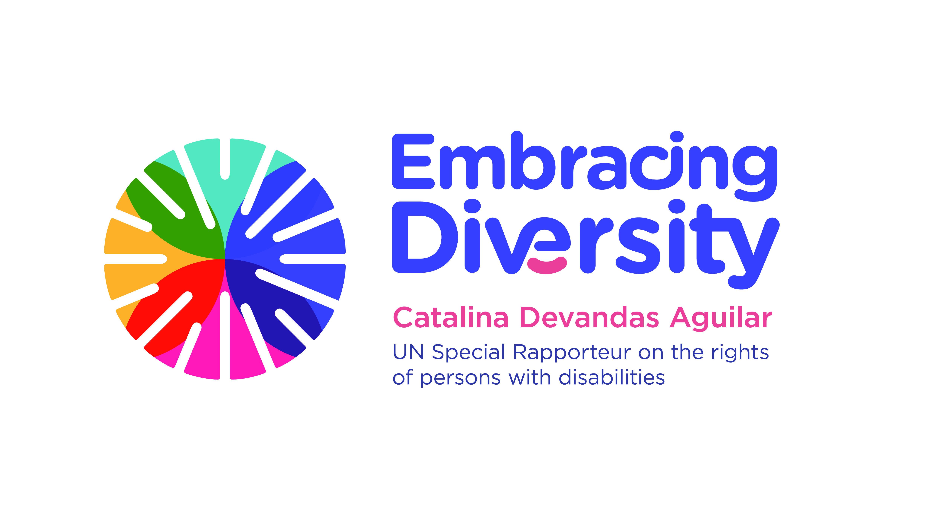

**Expert Consultation on**

**Sexual and reproductive health and rights of girls with disabilities**

13 June 2017, New York (1-6 pm)

UNFPA Office, Room 4B

**Concept note and agenda**

1. **Background**

Ms. Catalina Devandas-Aguilar (Costa Rica) took office as the first Special Rapporteur on the Rights of Persons with Disabilities on 1 December 2014, following Human Rights Council resolution 26/20. The Special Rapporteur is mandated, inter alia, to develop a regular dialogue and consult with States and other stakeholders to identify and promote good practices relating to the realization of the rights of persons with disabilities; gather and exchange information and communications with States on alleged human rights violations; make recommendations on how to promote and protect the rights of persons with disabilities; and to integrate a gender perspective throughout the work of the mandate and to address multiple, intersecting and aggravated forms of discrimination faced by persons with disabilities. In this frame, the Special Rapporteur reports annually to the Human Rights Council and the UN General Assembly.

The Special Rapporteur has underscored in her past thematic reports[1] the importance of ensuring a gender perspective in all interventions related to persons with disabilities, stressing particularly the significant additional barriers that women and girls with disabilities encounter in exercising rights and accessing services. As outlined in her first report to the HRC (A/HRC/28/58), international and national efforts on disability have too often failed to systematically take into account a gender perspective, and there is an urgent need to address the multifaceted discrimination and marginalization and the compounded violations of human rights that women and girls with disabilities face in most societies.

Against this background, the Special Rapporteur decided to focus on the sexual and reproductive health and rights of girls with disabilities for her next report to the UN General Assembly in October 2017. The Special Rapporteur is currently in the process of collecting and analysing information on this area. In addition, and thanks to the support of Plan International, the International Solutions Group (ISG) is conducting research work to inform her report.

1. **Context**

Across the globe, there are nearly one billion people with disabilities. Women and girls are disproportionately represented, with an estimated rate of 19%, compared to 15% of the general population. Women and girls with disabilities face multiple and intersecting forms of discrimination, while their specific needs are frequently overlooked and neglected. For example, they are at heightened risk of violence, exploitation and abuse, compared to the broader female population.

Women and girls with disabilities experience significant inequalities in the areas of sexual and reproductive health and rights. Misguided stereotyping related to disability and gender particularly affects the realization of sexual and reproductive health and rights, and the right to establish a family. Women and girls with disabilities are often denied the legal capacity and freedom to make decisions affecting their own sexual and reproductive health. Restricting or removing legal capacity can lead to forced interventions, such as sterilization, abortion, contraception, female genital mutilation, or surgery. Additionally, they often encounter significant barriers to obtaining information, medical care, and health services; and are denied access to information and communication, including comprehensive sexuality education.

The forthcoming report of the Special Rapporteur aims to identify global challenges and trends in the enjoyment of sexual and reproductive health and rights by girls with disabilities, as well as legal and policy responses and good practices for ensuring their full and equal enjoyment of these rights. For this purpose, the ISG has carried out a qualitative research study to collect the views and perspectives of children and youths on the situation of sexual and reproductive health and rights of girls with disabilities. Desk research on data, literature, legal and policy documents related to the implementation of sexual and reproductive health and rights of girls with disabilities worldwide has also been conducted.

On the basis of the research findings, as well as the contributions received from Governments, national human rights institutions, independent monitoring mechanisms, civil society organizations and networks, including organizations of persons with disabilities, the report of the Special Rapporteur will contain recommendations to guarantee equal access to and full recognition of sexual and reproductive health and rights, by girls with disabilities.

1. **Objectives and expected outcomes**

The specific objectives of this meeting are:

1. Present the preliminary results of the research study on the situation of sexual and reproductive health and rights of girls with disabilities;
2. Discuss the preliminary outline of the forthcoming report of the Special Rapporteur on sexual and reproductive health and rights of girls with disabilities;
3. Identify gaps and challenges in the implementation of existing international and regional human rights frameworks in relation to the sexual and reproductive health and rights for girls with disabilities;
4. Identify CRPD-compliant practices for the equal enjoyment of sexual and reproductive health rights by girls with disabilities.

The findings of the meeting will also inform the Special Rapporteur’s report.

1. **Methodology**

The Expert group meeting consultation will take place on **13 June 2017 at the UNFPA Office** (605 Third Avenue, between 39 and 40 street) in **Conference Room 4 B**. There will be approximately 30-35 experts from UN entities, organizations of persons with disabilities, civil society and academia, with a variety of expertise, perspectives, and regional representation.

To prepare for the consultation, we encourage experts to think about gaps and challenges in the area of sexual and reproductive health and rights for girls with disabilities, and to share good practices, examples and lessons based on their experience and expertise in this area.

The consultation will be held in English. No interpretation will be provided

1. **Agenda**

12:45 – 1:00 PM Arrival of participants and registration

1:00 – 1:20 PM Introduction and opening remarks

1:20 – 2:00 PM Preliminary findings of the research study

2:00 – 3:15 PM Presentation of the outline of the report and discussion

3:15 – 3:30 PM Break

3:30 – 5:00 PM Group work: Identifying and discussing priority areas, and reporting back in plenary

5:00 – 5:45 PM Discussion on key recommendations

5:45 – 6:00 PM Closing

1. The right to social protection of persons with disabilities (A/70/297), the right of persons with disabilities to participate in decision-making (A/HRC/31/62), disability-inclusive policies (A/71/314), and access to rights-based support for persons with disabilities (A/HRC/34/58).