To the attention of:

Ms. Catalina Devandas Aguilar
Special Rapporteur on the rights of persons with disabilities
c/o Office of the High Commissioner for Human Rights
United Nations Office at Geneva
Ch-1211 – Geneva 10
Switzerland
Vienna, 14 October 2016
Ref: 2016-outgoing-001408

Subject: Study of the Special Rapporteur on the rights of persons with disabilities on the provision of support to persons with disabilities.

Dear Ms Devandas Aguilar,

I am pleased to provide you with the European Union Agency for Fundamental Rights’ (FRA) contribution to the above-mentioned study.

1. Information on the following services that are available for persons with disabilities a) Personal assistance; b) In-home, residential and community support; c) Support in decision-making, including peer support; and d) Communication support, including support for augmentative and alternative communication.

2. How persons with disabilities can access information about existing services, including referral procedures, eligibility criteria and application requirements.
In 2012, FRA published the report Choice and control: the right to independent living, which highlights how persons with disabilities experience and use services in their day-to-day lives. It draws on personal testimony of persons with disabilities in nine EU Member States to examine their experience of personal assistance (p. 31 and p. 53), person-centred support (p. 32 and p. 52-4), community-based health services (p. 50) and peer support (p. 34 and p. 55). The report also illustrates some of the barriers persons with disabilities may face in accessing services, including administrative barriers (p. 36).
Drawing on the findings on this research, FRA emphasised that adequate, good quality and freely-chosen personalised support should be provided regardless of living arrangements. Whatever the type of support, it is important to ensure that the user can choose and control its use. The provisions of personalised support should not replace support provided by other services and facilities. Furthermore, FRA called for processes to demonstrate eligibility and to apply for particular services to be as simple as possible, and clearly explained to persons with disabilities.

FRA is currently implementing a multi-annual project on the right to independent living from which the Special Rapporteur could draw evidence. One aspect of this project is a mapping of types of institutional and community-based services in existence in the 28 EU Member States. The mapping is based on information about key characteristics of different types of service, including: age group, typical size of service, category of people with disabilities targeted, level of support, user’s control, typical provider, typical funder, eligibility criteria. The results of the mapping exercise are expected to be published in 2017.
In addition, as part of this project FRA has developed human rights indicators on Article 19 of the CRPD, in close cooperation with stakeholders. These are currently being applied with data from all EU Member States and will be available in 2017. The indicators on Article 19(b) cover core aspects such as access to support services, transferability of support services, eligibility for community support services, user control, adaptations to place of residence and informal support. Initial analysis of data collected in all 28 EU Member States show that in only a third of EU Member States do laws provide for community services to be transferred across different administrative regions (within countries), and often stipulate various criteria that must be met before services can be transferred.
6. Involvement of people with disabilities and their representative organisations in the design, planning, implementation and evaluation of support services.
In 2013 and 2014, FRA developed human rights indicators on the right to political participation of persons with disabilities. One of these indicators focuses on the involvement of disabled persons organisations (DPOs) in the development of laws and policies which concern them. The research shows that 13 out of the 28 EU Member States have set up mechanisms established by law ensuring the consultation and involvement of DPOs in the development of laws and policies. In another 11 EU Member States the consultation and involvement of DPOs is not provided for by law, but through various mechanisms put in place to ensure systematic consultation. These are, for example, consultative bodies that include members of DPOs or special codes of good practice requiring concerned groups to be closely involved. (For concrete examples of modalities of involvement, see: Indicator on Article 4 (3), CRPD “Are disabled persons’ organisations consulted and involved in the development of laws and policies?”.)
Furthermore, FRA’s human rights indicators on Article 19 of the CRPD include relevant indicators such as: are there mechanisms to involve DPOs in the design and delivery of specialised and general services; and is there a legal obligation to involve people with disabilities in the process of selecting living arrangements.
7. Please provide any other relevant information and statistics (including surveys, censuses, administrative data, reports, and studies) related to the provision of support to persons with disabilities in your country.
Data collected by FRA illustrate that that information and statistics regarding the provision of support to persons with disabilities vary considerably across EU Member States. In particular, systematic data on the provision of community-based services for persons with disabilities is lacking.
As part of its work developing human rights indicators on Article 19 of the CRPD, FRA is currently finalising statistical outcome indicators drawing on EU-wide data from existing European Social Surveys. This includes data on help available for persons with disabilities from persons beyond the household, whether people with disabilities receive formal help at home with personal care or domestic tasks, and if persons with disabilities receive enough help with daily living. This analysis is currently being finalised.
I enclose a list of FRA publications on the rights of persons with disabilities for your information. Should you need any further information, please consult the thematic page on our website and do not hesitate to contact me.

Yours sincerely,

Martha Stickings
Equality & Citizens’ Rights Department
European Union Agency for Fundamental Rights (FRA)

cc: Paul d’Auchamp, Deputy Regional Representative for Europe, Office of the United Nations High Commissioner for Human Rights
Facundo Chávez Penillas, Human Rights & Disability Advisor, Office of the United Nations High Commissioner for Human Rights

Annex of FRA publications on the rights of persons with disabilities

FRA product |  | Short description | Languages  (in 2016)
 | Monthly data collection on the current migration situation in the EU  Thematic focus: Disability  August 2016 | Persons with disabilities make up around 15% of the global population, and comprise a significant minority of refugees and migrants. In addition to pre-existing physical, sensory, intellectual or psychosocial impairments, people may acquire or develop impairments during the migration process. When identified, these impairments place an obligation on Member States to provide specific support throughout the arrival, registration and asylum process. This thematic focus explores practices in four areas crucial to persons with disabilities and victims of torture in the current migrant situation | en
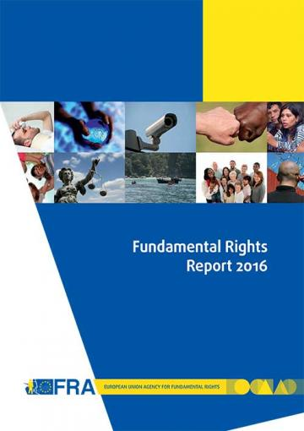 | Fundamental Rights Report 2016  Chapter 8: developments in the implementation of the Convention on the Rights of Persons with Disabilities  May 2016 | Five years on from the EU’s accession to the Convention on the Rights of Persons with Disabilities (CRPD), for the first time in 2015 a United Nations (UN) treaty body, the Committee on the Rights of Persons with Disabilities (CRPD Committee), reviewed the EU’s fulfilment of its human rights obligations. In its concluding observations, the CRPD Committee created a blueprint for the additional steps required for the EU to meet its obligations under the convention. At national level, the CRPD is driving wide-ranging change processes as Member States seek to harmonise their legal frameworks with the convention’s standards. | en  (summary en – fr)
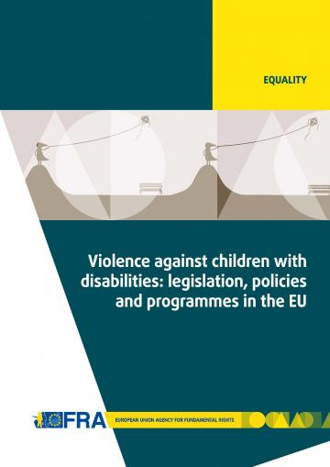 | Violence against children with disabilities: legislation, policies and programmes in the EU  December 2015 | The report outlines relevant international and European standards and reviews national legislation and policies addressing violence against children with disabilities. The report also explores the extent and different causes, settings and forms of such violence, and presents measures and initiatives to prevent it. | en
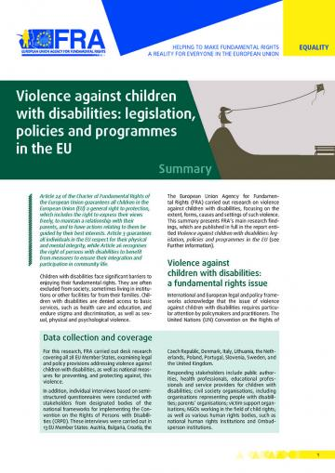 | Summary report:  Violence against children with disabilities: legislation, policies and programmes in the EU  December 2015 | This summary report presents the main research findings identified in the FRA report on Violence against children with disabilities: legislation, policies and programmes in the EU. The report gives a short summary of the key findings and outlines 10 key areas where policymakers and relevant stakeholders should concentrate their efforts to fight violence against children with disabilities, and to effectively protect them from abuse and exclusion across the EU. | bg - cs - da - de - en - fr - hr - it - lt - nl - pl - pt - sl - sv  (et - el - es - lv - hu - ro - sk - fi)
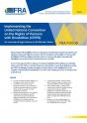 | Implementing the UN CRPD: An overview of legal reforms in EU Member States  May 2015 | The Focus paper outlines how Member States across the EU have reformed their laws and policies to meet their obligations under the CRPD. By bringing together examples of such reforms, it also highlights how the adoption of international commitments can drive wide-ranging processes of change at the national level. | en
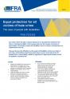 | Equal protection for all victims of hate crime - The case of people with disabilities  March 2015 | The paper discusses the difficulties faced by people with disabilities who become victims of hate crime, and the different legal frameworks in place to protect such victims in the EU’s Member States. It ends by listing a number of suggestions for improving the situation at both the legislative and policy levels. | en
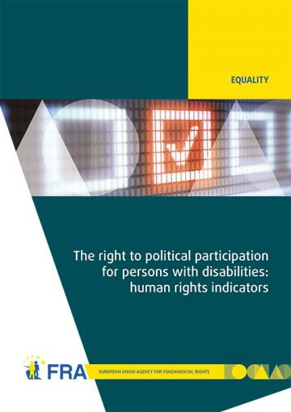 | The right to political participation for persons with disabilities: human rights indicators  May 2014 | The opportunity to be involved in political life, whether by standing for elected office, joining a political party, or following political news stories in the media, is at the heart of what it means to live in a democratic society. The report analyses data on the situation of political participation of persons with disabilities collected from across the 28 EU Member States by the FRA and the European Commission-funded Academic Network of European Disability Experts (ANED).  Data visualisation of the 28 human rights indicators is also available online. | en
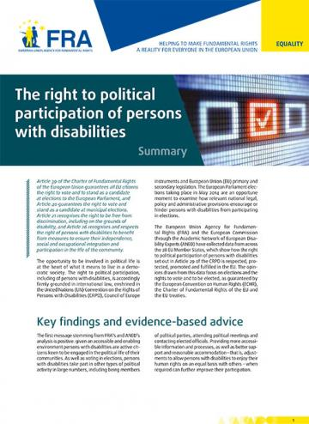 | Summary report:  The right to political participation of persons with disabilities  May 2014 | The human rights indicators presented in the report show that legal and administrative barriers, inaccessible processes and information, and a lack of awareness about political rights can deny persons with disabilities the opportunity to participate in the political lives of their communities. | bg - cs - da - de - en - et - el - es - fr - hr- it - lv - lt - hu - nl - pl - pt - ro - sk - sl - fi - sv
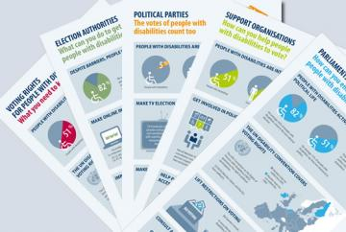 | Infographics on voting rights of people with disabilities  September 2014 | FRA has developed a family of five infographics to help raise awareness of the voting rights of people with disabilities. Each infographic targets a different audience and draws on FRA research into the right to political participation of people with disabilities. | bg - cs - da - de – en - et - el - es - fr - hr- it - lv - lt - hu - nl - pl - pt - ro - sk - sl - fi - sv
 | Legal capacity of persons with intellectual disabilities and persons with mental health problems  July 2013 | Equal recognition of persons before the law is a long-established human rights principle. Nevertheless, legal frameworks in many European Union (EU) Member States allow for the legal capacity of persons with intellectual disabilities and persons with mental health problems to be restricted or removed under certain conditions.  This report analyses the current legal standards on legal capacity across the EU, set against the backdrop of the experiences of interviewees who have had their legal capacity removed or restricted. The FRA report reveals the gap between the promise of the CRPD and the reality those with disabilities face in the EU every day, and, by so doing, hopes to contribute to closing it. | en - de - fr
 | Factsheet:  Legal capacity of persons with intellectual disabilities and persons with mental health problems  October 2013 | This factsheet presents the key challenges identified by the FRA report on Legal capacity of persons with intellectual disabilities and persons with mental health problems.  The entry into force of the CRPD has prompted discussions about the current legal frameworks governing legal capacity in the EU Member States, aiming at developing models based on supported decision making which promote the independence and autonomy of persons with disabilities. | bg - cs - da - de - en - et - el - es - fr - hr- it - lv - lt - hu - nl - pl - pt - ro - sk - sl - fi - sv
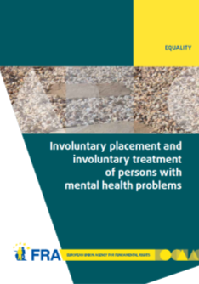 | Involuntary placement and involuntary treatment of persons with mental health problems  June 2012 | Involuntary placement and involuntary treatment of persons with mental health problems affects the most fundamental of rights, including the right to liberty and the right to freedom from torture. Strict safeguards at United Nations and European level attempt to limit undue interference with such rights.  This report analyses the shifting legal panorama and, informed by fieldwork in nine EU Member States on the actual experiences of those involuntarily placed and treated and other stakeholders, points to the need for a renewed discussion of compulsory placement and treatment in the EU. | en - de - fr
 | Factsheet:  Involuntary placement and involuntary treatment of persons with mental health problems  June 2012 | This factsheet presents the key challenges identified by the FRA report on Involuntary placement and involuntary treatment of persons with mental health problems. Mental health problems are experienced by about one in 10 European Union (EU) citizens. Many seek help voluntarily, but some may be placed in institutions or treated without their consent. This might affect their fundamental rights. | en - bg - da - de - el - fr - hu - lv - ro - sv
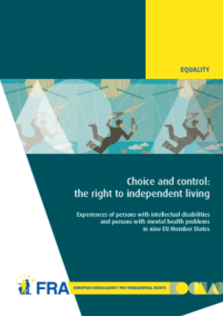 | Choice and control: the right to independent living  June 2012 | Article 19 of the United Nations Convention on the Rights of Persons with Disabilities establishes the right to live independently and be included in the community. Drawing on the findings of interview-based research with persons with mental health problems and persons with intellectual disabilities, this report examines how they experience the principles of autonomy, inclusion and participation in their day-to-day lives. | en - fr - de
 | Summary report: Choice and control: the right to independent living  June 2012 | This summary report presents the key findings identified in the FRA report on Choice and control: the right to independent living. The results show that although much has been done, more efforts are needed to ensure that persons with mental health problems and persons with intellectual disabilities have more choice and control over their lives and are included in the community on an equal basis with others. | en - da - el
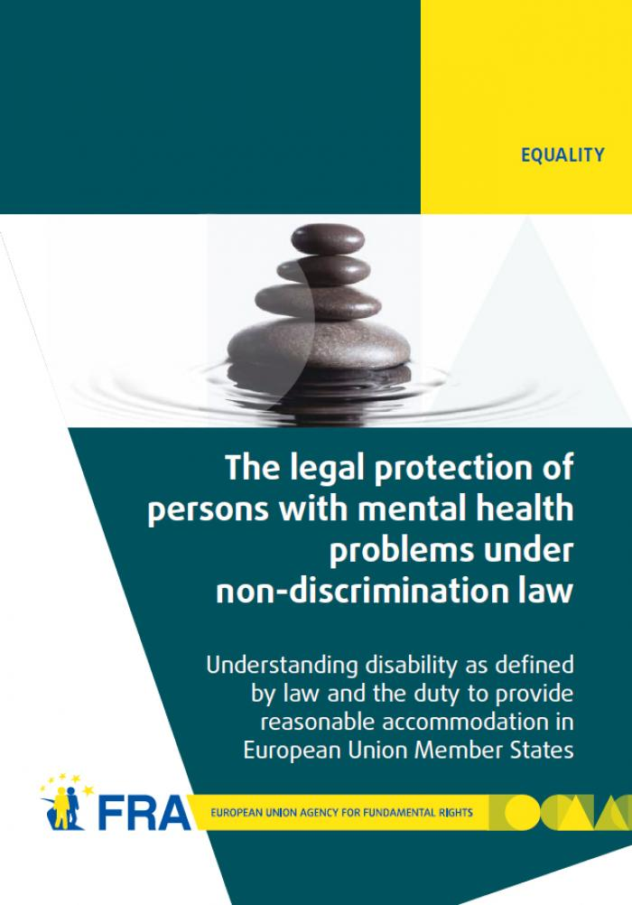 | The legal protection of persons with mental health problems under non-discrimination law  October 2011 | The report examines how disability is defined in international and European law and then explores the obligation to provide reasonable accommodation as contained in international and European standards. The report's findings show that in almost all EU Member States non-discrimination legislation does indeed protect persons with mental health problems. In most cases persons with mental health problems also benefit from reasonable accommodation measures, or other protection measures, in the employment context. | en - de - fr - da
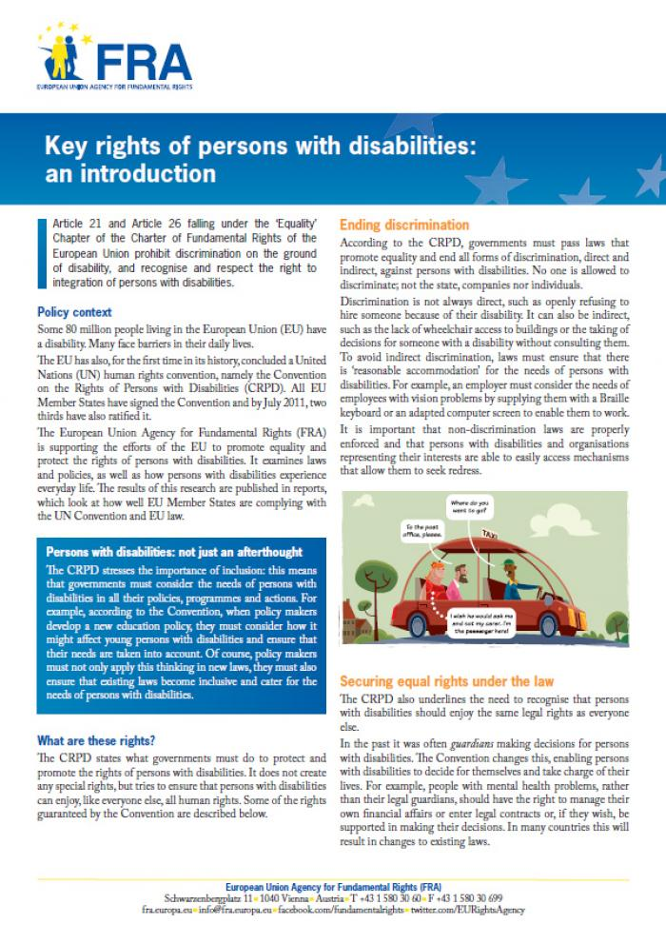 | Factsheet:  Key rights of persons with disabilities: an introduction  August 2011 | This factsheet describes some of the existing rights of people with disabilities, as set out under the UN Convention on the Rights of Persons with Disabilities (CRPD). The factsheet focuses in particular on ending discrimination, equal recognition by law, access to justice, the prevention of inhumane treatment, independent living and the right to political participation. | en - bg - de - el - fr - hu - lv - ro - sv
 | The right to political participation of persons with mental health problems and persons with intellectual disabilities  November 2010 | This report first recalls the international and European standards favouring the full participation of persons with intellectual disabilities and persons with mental health problems in the electoral process. The comparative law analysis then highlights the diverse approaches adopted in the EU Member States. In a majority of these, persons who have lost their legal capacity are automatically deprived of their right to political participation. | en  de - fr  non-verified language versions:  bg - cs - da - et - el - es - ga - hr- it - lv - lt - hu - mt - nl - pl - pt - ro - sk - sl - fi - sv
 | EASY READ  Violence against children with disabilities  December 2015 | This summary in easy read format looks at violence, where it happens, and why people are violent. It also looks at laws to protect children with disabilities from violence and what countries are doing to prevent this violence. | en
 | EASY READ  Laws about being able to make important decisions for yourself  October 2013 | This summary in easy read format provides information about FRA’s work on the right to equal recognition before the law. | en - de - fr
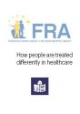 | EASY READ  How people are treated differently in healthcare  March 2013 | This summary in east read format provides information about FRA’s work on how people might be treated differently in healthcare and on multiple discrimination in healthcare. | en
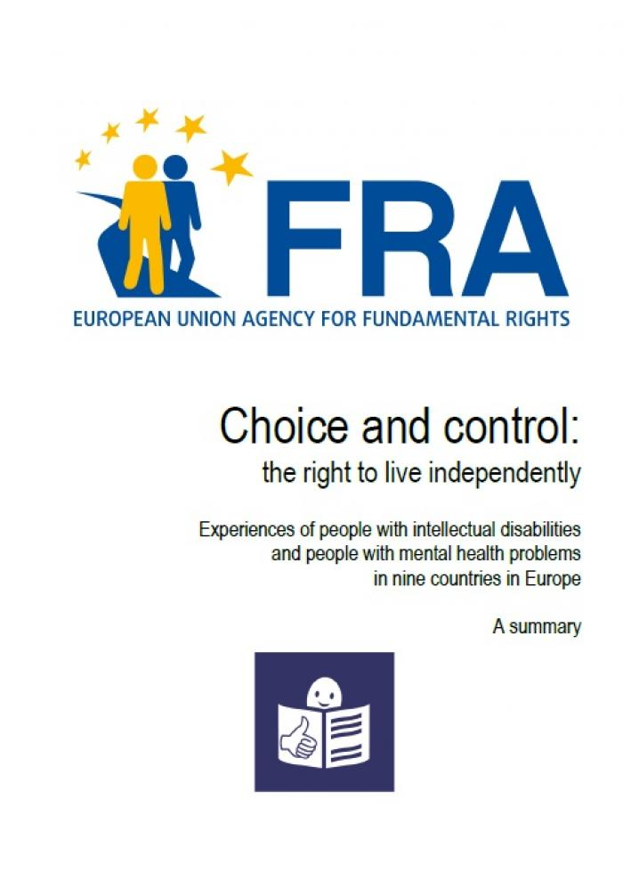 | EASY READ  Choice and control: the right to live independently - Experiences of people with intellectual disabilities  June 2012 | This summary in easy read format provides information about FRA’s work on the right to live independently. | en
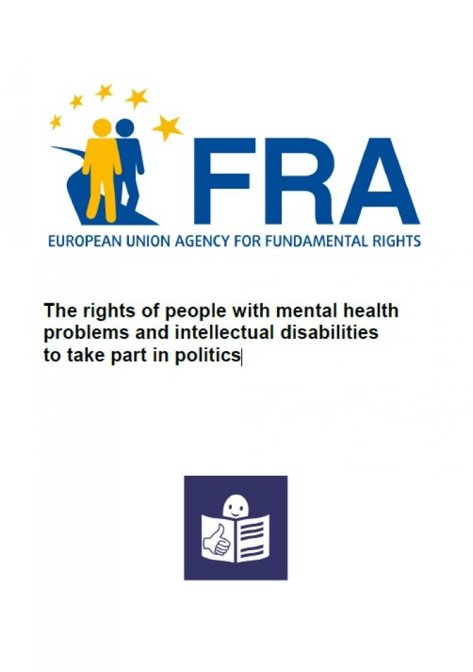 | EASY READ  The rights of people with mental health problems and intellectual disabilities to take part in politics  November 2010 | This summary in easy read format provides information about FRA’s work on the right to vote of persons with intellectual disabilities. | en

