Questions:

1- Please provide information on the legislative and policy framework in place in your country to ensure the realization of the rights of older persons with disabilities, including both persons with disabilities who are ageing and older persons who acquire a disability.
In accordance with Book IX of the Social Code - Rehabilitation and Participation of Persons with Disabilities (SGB IX) - persons with and at risk of disabilities are entitled to medical rehabilitation benefits and services, occupational integration assistance, educational participation assistance, social participation assistance and benefits to secure a livelihood and other complementary benefits. In general, access to these participation benefits and services does not depend on the person’s age. In particular benefits for children are an exception from that rule, as e.g. integration assistance for children and youth with psychological impairments and remedial education assistance and early intervention interdisciplinary measures for children, provided until they start to go to school. Especially persons in need of long-term care are entitled to medical and preventative rehabilitation benefits and services. This is beneficial for older persons with disabilities in particular.In general, access to participation benefits and services is not dependent on whether the impairment existed already at birth or occurred later in life. The cause of a disability may be relevant in order to determine which rehabilitation fund is responsible for the provision of benefits and services.
For people who are unable to work and for people beyond the retirement age Book XII of the Social Code offers two different minimum income benefit systems under the framework of Sozialhilfe (social assistance) for different situations to people who are not eligible for benefits under the Book II of the Social Code or otherwise exempted. Sozialhilfe includes two minimum income benefits systems: Hilfe zum Lebensunterhalt (minimum income benefits in the case of temporary reduced capacity to work) and Grundsicherung im Alter und bei Erwerbsminderung (minimum income benefits in the case of old age and permanent reduced capacity to work). Sozialhilfe is locally administered by the social welfare offices.
The Federal Government's National Action Plan for the Implementation of the Convention addresses a field of action to "older people with disabilities".

2- Please provide information on discrimination against older persons with disabilities in law and practice.
Article 3 of the Basic Law (Grundgesetz, GG) requires all people to be treated equally, prohibiting discrimination of any type, including against handicapped persons. Article 3 of the Basic Law does not contain an explicit ban on discrimination on the basis of age; cases of unequal treatment on the basis of age are assessed according to the principle of general equality contained in Article 3 Para. 1 of the Basic Law.
The Federal Government does not have any detailed information about discrimination against older people, it is only aware of isolated cases.

3- Please provide information and statistical data (including surveys, censuses, administrative data, literature, reports, and studies) related to the realization of the rights of older persons with disabilities in general, as well as with particular focus in the following areas:
- Exercise of legal capacity;
- Admission procedures to social or healthcare services, including involuntary admissions;
- Older persons with disabilities living in institutions;
- Access to support to live independently in the community;
- Access to free or affordable healthcare:
- Access to free or affordable rehabilitation goods and services;
- Access to social protection schemes; and
- End of life and palliative care.
The number of people with disabilities is increasing in Germany as well. On the one hand, people with congenital disabilities also get a lot older nowadays – thanks to medical progress. One the other hand, life expectancy as a whole is increasing. Since most people acquire a disability in the course of their life, consequently the number of people with disabilities is significantly increasing overall, especially from the age of 65.
The Federal Government of Germany compiles (lead responsibility: Federal Ministry of Labour and Social Affairs) a comprehensive report on the participation of people with disabilities every two years.
The first Federal Government Report on Participation with regard to the circumstances of persons with impairments from 2016 dedicated one chapter from page 358 to page 372 to the topic of older people with disabilities – to which reference is made here.

Female and male senior citizens with disabilities in Germany:
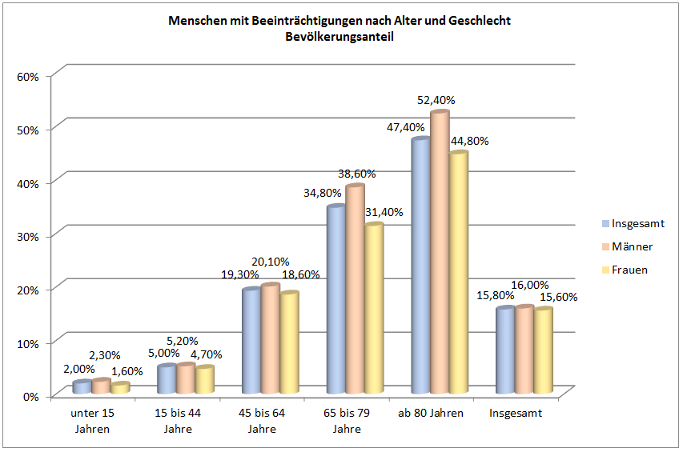
Source: Federal Government Report on Participation with regard to the circumstances of persons with impairments 2016; Federal Ministry for Family Affairs, Senior Citizens, Women and Youth

Female and male senior citizens in Germany: more than 20 million total.
The share of people older than 67 will increase to 23.8 per cent (about 18.7 per cent in 2013) by 2030. The percentage of the general population of people older than 80 will increase from 5.4 per cent (2013) to 7.7 per cent in 2030.
People with disabilities in Germany – about 7.6 million with a recognised severe disability (degree of disability higher than 50 per cent); 9.3 per cent of the entire German population are serverely disabled.
There are 12.77 million people with impairments in Germany. Of those, 6.43 million are women (which corresponds to 15.6 per cent of the female population), 6.34 million being men (from age 65 plus 3.396 million women and 3.003 million men)
More general information on the situation of elderly persons – including those in need of support – can as well be found at: https://www.dza.de/en/informationsdienste/fact-sheets.html
Palliative care is well developed in Germany, with the country ranked level 3b (advanced integration) in the WHO Atlas of Palliative Care (https://www.who.int/nmh/Global_Atlas_of_Palliative_Care.pdf​).
There is no specific regulation or legislation on palliative care for elderly persons with disabilities, but all the usual regulations apply to that group of patients as well. Elderly patients as well as patients with disabilities have access to the full range of palliative and hospice care if they suffer from a life-threatening disease. In particular, the German law on hospice and palliative care which came into effect in December 2015 included new regulations mandating sickness funds to provide information on hospice and palliative care for their clients, and nursing homes to provide care planning in advance for their residents, among other regulations.
Palliative home care is well developed in Germany, with approximately 300 specialist home care services and more than 1,400 volunteer services. More than 10,000 physicians - many of them GPs - have completed palliative care training, and palliative care is a mandatory subject for medical students.
Elderly patients with disabilities can access specialist palliative care services - inpatient, outpatient and at home - if they suffer from a life-threatening disease and have a life expectancy within the range of days, weeks or months. In many cases patients are receiving palliative care services even with longer life expectancies, for example for neurological diseases such as MND, Parkinson's disease or multiple sclerosis. Many of these patients are older and are severely disabled from their underlying disease.

Nursing home residents may also receive palliative care in their institutions. Basic palliative care may be delivered by their GP and by nursing home staff. Many nursing homes have initiated approaches to implement hospice culture.
As a major driver of the development of hospice and palliative care in Germany, the Charter for the Care of the Critically Ill and Dying has been developed in 2012 and is still being implemented. The Recommendations for Action (https://www.charta-zur-betreuung-sterbender.de/files/bilder/neu2%20RZ_161004_Handlungsempfehlungen_ONLINE.pdf​ for the second guiding principle (needs of affected persons) include detailed recommendations for palliative care for people with dementia and for people with mental disability.
In general (not only for palliative or end-of-life care) a personal assistant may accompany a patient during hospital treatment or rehabilitation if there is a medical or psychological reason (such as a disability). The physician on the ward has to confirm the medical / psychological reason. There is no payment for the assistant in that case. This regulation also applies to palliative care units as well as to any other part of the hospital.

People in Germany can rely on having access to high-quality medical care. The statutory health insurance (SHI), with which most people are insured, guarantees comprehensive social protection in the event of illness. Insured persons receive all of the medical benefits and services they need, regardless of their economic capacity, state of health or age. This includes all medical benefits and services such as the provision of remedies and remedial aids, rehabilitation and palliative care.
A person’s financial capacity determines their contribution to the statutory health insurance. Means or burden limits, according to which the individual co-payments may not exceed 2% per calendar year and, in the case of persons with chronic diseases, 1% of the annual gross income for subsistence, ensure that no one is financially overburdened while guaranteeing social balance. Section 2a of the Social Code Book V (SGB V), the legislation that governs the statutory health insurance, establishes the principle that the special concerns of disabled persons and the chronically ill must be taken into account. This principle applies to all of those who participate in the provision of healthcare, as well as to the health insurance funds.
Furthermore, there are various regulations that focus specifically on the concerns of disabled persons. Among them, for example, is the possibility of setting up medical treatment centres for mentally disabled adults or adults with multiple disabilities that cater specifically to the needs of those affected.

4- Please provide information on the existence of long-term care services in your country and describe to what extent they promote the autonomy and independence of older persons with disabilities.
At the end of 2017, there were some 14,100 outpatient long-term care facilities in Germany and approximately 14,500 residential long-term care facilities that assumed the provision of healthcare for older persons with disabilities, insofar as these persons were recognised as persons with long-term care needs within the meaning of the Social Code Book XI.

5- Please describe how is access to justice guaranteed for older persons with disabilities. Please provide information on jurisprudence, complaints or investigations in relation to violence, abuse and neglect against older persons with disabilities.
See the answer to the question 2 above.
To be able to work to prevent violence in care situations, carers must have the necessary knowledge and be able to access support. In a domestic care situation, it has been sufficiently proven that excessive stress on the carer is one of the strongest risk factors for problematic care relationships. The three Acts to Strengthen Long-Term Care therefore expand the assistance, support and advisory services provided by social insurance for long-term care (Eleventh Book of the Social Code – SGB XI) for people in need of care and their relatives. SGB XI creates a legal framework for good quality in care. The aim is to strengthen quality expertise and internal quality management and to create transparency of results. At the moment, against the background of the new definition of the need for long-term care which is based on the independence of those in need of care, a new scientifically based procedure for measuring and presenting the quality of care is being developed. Furthermore, there is in Germany (initially as part of a pilot) a contact person at the public prosecutor's office specialising in criminal offenses against older people. The Federal Ministry for Family Affairs, Senior Citizens, Women and Youth (BMFSFJ) has also, on the basis of the "Helpline Law", as it is called (2011), set up the "Violence Against Women" helpline which, since 2013, has been providing free, around the clock, anonymous, barrier-free qualified initial advice in a variety of languages with the option of onward referral to the local support system which also includes the target group of older women.
The results of the study "Violence against women in partner relationships" (2009) show that older women suffer physical and/or sexual violence from partners less frequently than the younger and middle age groups. Older women tend to be more affected by psychological violence without physical/sexual attacks. However, this does not mean that the group of women aged 60 and over would not be relevant for the monitoring and prevention of serious physical and sexual abuse in partner relationships. If the totality of current partner relationships involving serious physical and/or sexual violence is taken as a basis, women over the age of 60 represent a considerable proportion of the women suffering serious physical/sexual abuse from their current partners. For example, one in six or seven women (14-18%) were older than 60 – mostly under 75 years old. This indicates that older women, in comparison with their share of the overall population, were less frequently affected by serious physical/sexual abuse, but that they still represent a very relevant group of abused women because of the high proportion of older people within the population,
According to the findings from the Living Safely in Old Age project (Görgen 2002 and 2009), there are reports of violence against elderly people in domestic care settings and property offences committed against elderly people (especially confidence tricks, frauds and scams, embezzlement) even in care relationships.
In particular, people in care relationships and people of advanced age with or without cognitive impairment can be affected.

6- Please describe to what extent and how are older persons with disabilities involved in the design, planning, implementation and evaluation of policies related to ageing and/or disability.
We support to encourage the participation of older persons in general – including older persons with disabilities - by funding senior citizens’ organisations and pilot projects, construction and living programmes owing to the increasing ageing of our population. Germany regularly involves e.g. all multipliers from the arr. 110 NPOs which are members of the umbrella organization BAGSO. The international secretariat of the BAGSO organises 4-5 workshops per year in order to inform about policies on ageing in general and the actual debates at UN level. This includes developments with regard to the implementation of the Madrid International Plan of Action on Ageing (MIPAA) as well as the developments of the discussions in the New York UN Open ended working group on ageing (OEWG-A) with regard to how to best strengthen the rights of older persons. Beside this, the Federal Ministry for Family Affairs, Senior Citizens, Women and Youth supports that this umbrella organisation BAGSO be allowed to actively participate in the annual OEWG-A sessions in New York and thus pass on first hand experiences as well. Topics of 2018 for example have been “autonomy” and “long-term care and human rights”, both topics of specific interest for older persons in need of support.

7- Please provide information on any innovative initiatives that have been taken at the local, regional or national level to promote and ensure the rights of older persons with disabilities and identify lessons learned from these.

In Germany, there has been a constant effort to raise public awareness of contemporary images of ageing, including images of a happy and fulfilled life with a disability. Within the framework of the federal programme “New Images of Ageing” we sensitize people through the touring exhibition “What’s old anyway?” and also through a brochure with pictures showing how older persons with disabilities are perceived in society.
The German Alzheimer Society represents people with dementia and has taken the co-chairmanship of the Alliance for People with Dementia. Opinions and concerns of people with dementia could therefore be taken into account during the successful work process from 2012 to 2018. Practitioners from the Alzheimer society and one person suffering from dementia took part in one of the Alliance working groups.
Furthermore the German Alzheimer Society has taken up the co-chairmanship in the following development of the National Dementia Strategy and guarantees the participation of people with dementia.

Source: Reply of Germany to the Questionnaire OEWG-A, 2017
Source: 13. Koordinierte Bevölkerungsvorausberechnung (Results of the 13th coordinated population projection), Var.2 „Kontinuität bei stärkerer Zuwanderung“ (“Continuity during increased migration”) Federal Statistical Office (2015)
Source: Federal Government Report on Participation with regard to the circumstances of persons with impairments (Bundesteilhabebericht) 2016, page 25
Reply of Germany to the Quetionnaire OEWG-A, 2017
See www.whats-old-anyway.de

