_unlogo United Nations

**General Assembly - Human Rights Council**

**Office of the High Commissioner for Human Rights**

**The right of people with disabilities to live in the community**

**with everyone else**

**E:\images\To zip\services.wmf**

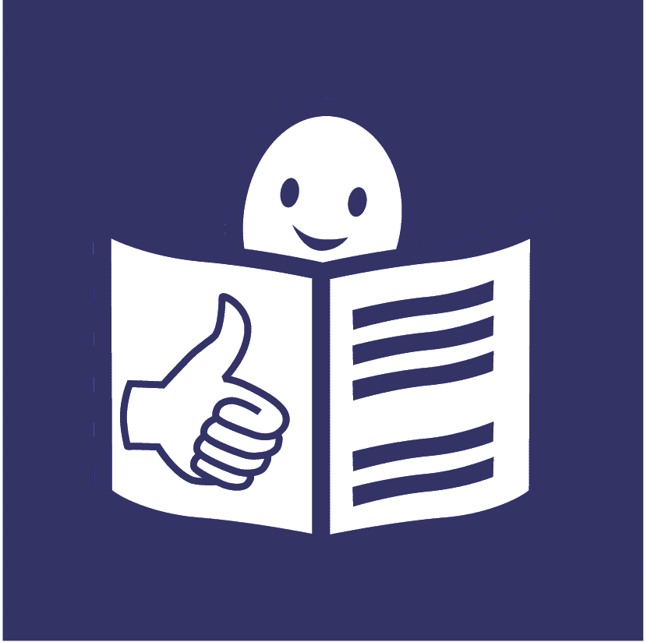

**Who are we?**

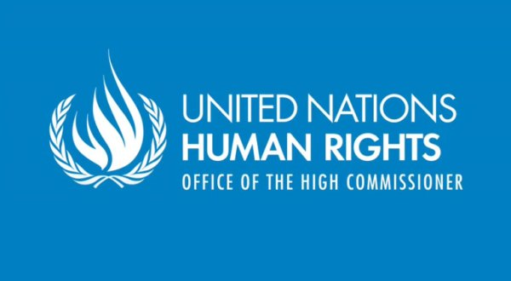

We are called the **Office of the High Commissioner for Human Rights**.

_unlogo

We are part of the United Nations (UN).

**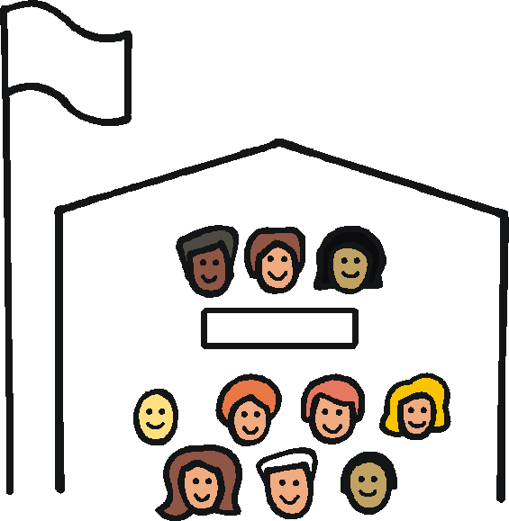**

The United Nations is a group of countries that work together to make the world a better and safer place.

**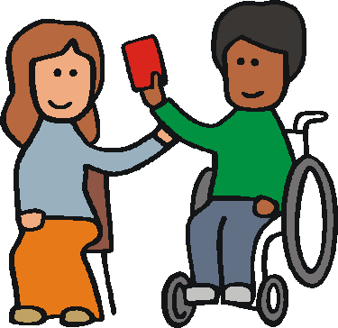**

Our job is to make sure everyone in the world is treated fairly and gets their human rights.

E:\images\To zip\staff.wmf

Human rights are rights that everyone should have, like the right to work and have a family.

**What is this report about?**

**E:\images\To zip\services.wmf**People with disabilities have the right

to live in the community with everyone else.

The community is your local area and the people near where you live.



Lots of countries agreed to make this happen.



We found out what is happening with this.

We asked lots of countries what they are doing.

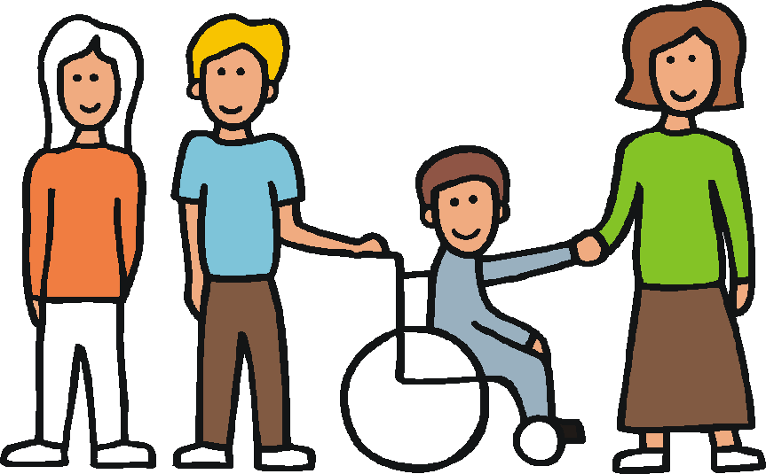

We asked people with disabilities and other groups as well.



This report is about:

* what countries should be doing
* some things that are already happening

**What is the right of people with disabilities to live in the community with everyone else?**



This right is about making sure people with disabilities can live in the way they want to.

It is about making sure people with disabilities can:



* choose things like where to live and who to live with
* do the same things as other people

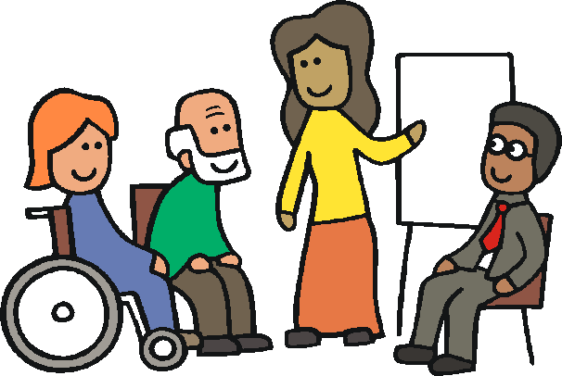

* have a say in laws, plans and decisions
* get the right support

Some people with disabilities live in homes far away from other people.

This is wrong.

They have the right to live near other people and do the same things as them.

**Making choices**

People with disabilities have the right to make their own choices.



For example, about:

* where to live and who to live with
* saying yes or no to medical treatment



Many people with disabilities in the world are not allowed to make their own choices.

The law says other people can make choices for them.

E:\images\To zip\learning disability.wmf

Some people may need a bit more support to make choices.

****

They should get support to make their own choices that are right for them.

Other people should not make choices for them.

**Living in homes far away from other people**

People with disabilities should not be forced to live in homes far away from other people.



But this is still happening in many parts of the world.



People in these homes are often not allowed to make their own choices.



They cannot choose things like:

* what to eat
* what to do in the day
* who to spend time with

This is wrong.

People should live in places where they can choose what happens.

**Moving out of these homes**



Countries should have good plans for moving people with disabilities out of these homes.

**E:\images\To zip\services.wmf**

There should be changes so that people with disabilities can live in the community like everyone else.

****

For example, people should get all the support they need.

And everything should be easy for people with disabilities to do.



This means countries may have to change their laws and the way they do things.

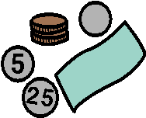

Countries should make sure they plan well and have the right money for this.

**Support**

Every person with a disability

should get support to live in the way they want to.



People should be able to choose their own support.

The support they get should be right for them.

The support should help them be part of the community like everyone else.

For example, people may need support to:

* live at home
* go out and about
* spend time with other people
* speak up and make choices

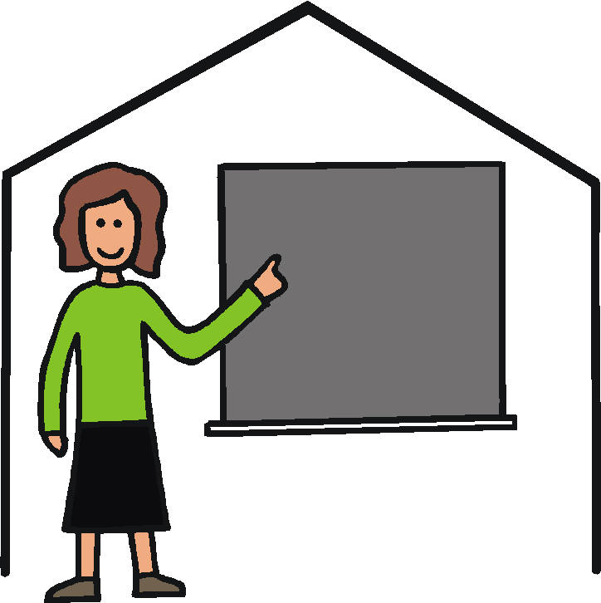

Staff may need training to support people in the right way.

Support from family and friends is really important.

But sometimes this can cause problems.



For example it may stop people in the family having a job or going to school.



Countries need to make sure:

* people get good support
* there is enough money for this support

**E:\images\To zip\staff.wmfDoing the same things as other people**

People with disabilities should be able to take part in the same things as everyone else.



For example, it should be easy for people with disabilities to:

* travel around
* get a job
* do things they enjoy
* have a say in decisions



This means everything should be easy for people with disabilities, like:

* buildings
* transport
* information
* voting



Making things easy for people with disabilities from the start can save money and stop problems later on.

**What some countries are doing**



Countries like Peru, Argentina and Ireland are changing their laws and rules about making decisions.



Finland is making sure people with intellectual disabilities move into the community by the year 2020.

E:\images\To zip\respect.wmf

In Croatia some people get support to get ready to move into their own place.



In Cuba, Sweden, Thailand and Korea some people get extra support to live at home or take part in things.

**What some countries are doing**



In some countries there are groups that help people with lots of things like:

* finding the right support
* making choices
* speaking up



In Trinidad and Tobago some people can get training to support people with disabilities in the right way.



In Germany and some other countries the money for people’s support

is paid to them.

E:\images\To zip\learning disability.wmf

This means people can choose and pay for their own support.

Australia is trying a new way to help people with this at the moment.

**What some countries are doing**



Many countries are working to make things easier

for people with disabilities.



For example, they are making transport and buildings easier.

E:\images\To zip\respect.wmf

In some countries like El Salvador and Nicaragua staff work closely with people with disabilities in their community.

For example, they may support a person to get a job or the right healthcare.



Groups from different countries work together on some projects to support people with disabilities.

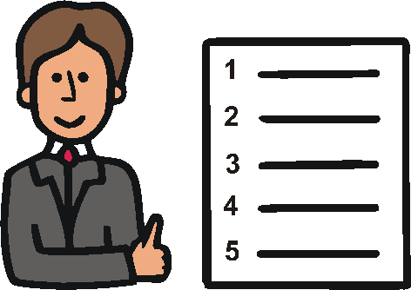

Some good work is happening.

But there is still a lot more to do.