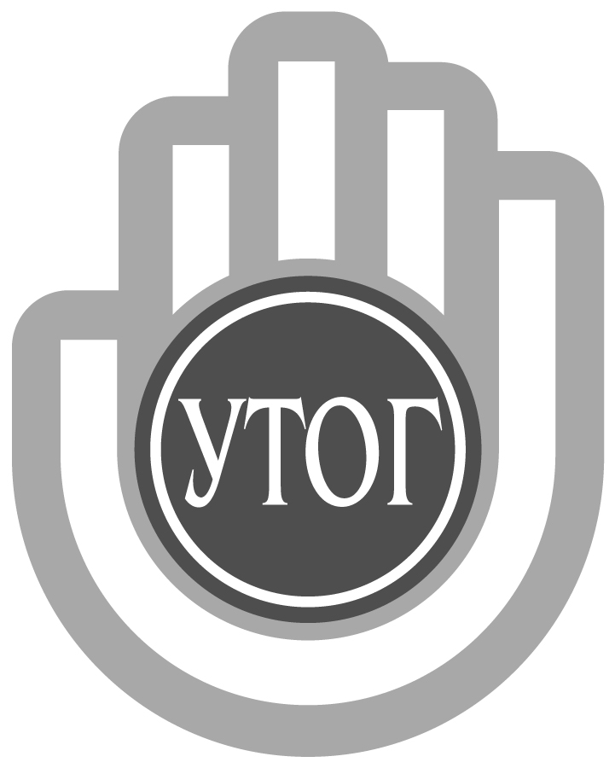
Ukrainian Nongovernmental Organization of Disabled “Ukrainian Society of the Deaf” (UNOD “USD”)
03150, Kyiv, Velyka Vasylkivska str., 74
tel./fax: +38 044 246-76-33, e-mail: cputog@ukr.net
Identification number 00021344 • MFO 322669
Bank account No. 26001300436978 PJSC “Oschadbank”

Ref. no. 03-28/388 from 22/07/2019 | Attention to:  Mr. Facundo Chavez Penillas,  Ms. Vicroria Lee Вікторії Лі  Copy — Officer on Human Rights World Federation of the Deaf  Mr. Alexandre Bloxs,  Administrative Secretary  World Federation of the Deaf  Philippi Sandholm

Dear Sir/Madam!

On your letter dated 13 June 2019 concerning the provision of information on issues related to Resolution 37/22 of the Human Rights Council on the rights of persons with disabilities, we are announcing the following:

1 (a). Does your country have laws, policies, plans, strategies or guidelines at any level of government relating to raising awareness about persons with disabilities, in particular initiatives to:
- foster respect for the rights and dignity of persons with disabilities;
- combat stereotypes, prejudices and harmful practices relating to persons with disabilities; or
- promote awareness of the contributions of persons with disabilities?

According to the Constitution of Ukraine, all people are free and equal in their dignity and rights. The protection of the rights and dignity of persons with disabilities is enshrined in the laws of Ukraine "On ratification of the Convention on the Rights of Persons with Disabilities and the Optional Protocol thereto", "On the Fundamentals of Social Protection of Persons with Disabilities in Ukraine", "On Rehabilitation of Persons with Disabilities in Ukraine", " On the Principles of Preventing and Combating Discrimination in Ukraine "," On Education "," On Television and Radio Broadcasting ", other laws of Ukraine, as well as international treaties, the consent of which was binding on the Verkhovna Rada of Ukraine.

In accordance with these laws, civil organizations that combine people with disabilities and protect the rights and interests of them, various measures and projects are implemented at both the state and local levels.

So, in the Ukrainian Society of the Deaf, the following projects were planned and carried out:
- in interaction with other non-governmental organizations, in particular with the National Assembly of Persons with Disabilities, in March 2019, the March of People with Disabilities "For Life" took place, during which more than a thousand deaf people march in the center of the capital and took part in speeches at the forum;
- every year there are events at the state and local levels on the International Day of People with Disabilities, the International Day of People with Disabilities, etc. (talks of talented deaf people and artistic groups at concerts for the general public, holding flash mobs in the streets, in parks, organizing exhibitions of deaf artists, performances the Theater of Mimics and Gesture "Rainbow" etc .;
- during the year such exhibitions and performances for the general public are organized to promote the creativity of persons with disabilities and hearing and in order to combat stereotypes and to formulate public opinion regarding the capabilities of deaf people.
- Television shows shows and films that cover the life and problems of people with hearing disabilities (there are quite a lot of such examples); There is a channel "Direct", where most of the programs are accompanied by a sign language; on many state and commercial TV channels there is a translation of news accompanied by an interpreter or subtitles;
- In the Ukrainian society of the deaf, published books (in particular, the collection "The Deaf is All"), the newspaper "Our Life" comes out; two sites and groups in social networks operate, which are widely informing about the contributions of people with disabilities to the state and world culture;
- in recent years, the number of those who want to learn sign language has increased significantly - they have such an opportunity at the School of Sign Language, where several groups are currently studying;
- the same work with the general population during the country's trips took place in order to implement the "I-Hromada" project, training the National Police officers on the joint project "Swallow" of the UTOG and the UN;
- Occasionally, the production of posts, booklets, games for children and calendars is practiced by various public organizations (UTOG, Association of Invincible Teachers and other non-governmental organizations);
- To facilitate communication with people with hearing impairments, various service applications such as online sign language translation are developed and widely implemented.

1 (b). What are the challenges to implementing the above?

- In the implementation of the projects described above, there are problems of financial nature due to the limited financial resources of their own. Greater engagement of foreign grants is hampered by the internal problem with personnel who would fluent English and have skills in working with grants.
- There is a problem associated with insufficient number of sign language translators. More on this further in the text, in paragraph 2 (b).
- At the personal level in deaf people, there are facts of restrictions on hiring, providing low-skilled work (deaf people with higher education find it hard to find work in the specialty that is indicated in the diploma because of the lack of confidence among employers in their opportunities and difficulties in communication). There are hopes that due to modern technologies and the introduction of online translation, it will be possible to partially solve the problem of communication between employers and deaf specialists.
- Since the Ukrainian Society of the Deaf has its own production base of more than 40 enterprises of different profiles, there is a problem of obtaining stable state orders for these enterprises. This leads to a lack of work, a reduction in employee wages and, ultimately, a reduction in overall profits on the Company, which could be aimed at its development and implementation of various social projects similar to those discussed above.
- There are certain barriers in ensuring the most complete access of deaf people to information due to inadequate implementation of decisions already taken by the state aimed at increasing the percentage of television programs submitted with the support of titles or sign language translation. In the conditions of commercialization and in order to reduce costs, some TV channel owners consider it inappropriate. If earlier from the side of TVs there were references to the fact that such support interferes with other viewers, in recent times society has become more tolerant and such claims sound less.

2 (a). What legislative and policy measures are taken to address hate crimes, hate speech and harmful practices against persons with disabilities?
Ukraine has a fairly powerful legislative protection of the rights of persons with disabilities (see paragraph 1 (a)), therefore, the facts of such crimes are not of a mass character, occur in veiled form and, if necessary, are solved by involving civil society organizations, assets, etc.

Preventive measures are all those measures referred to in paragraph 1 (a) above.

2 (b). In particular, are there legal remedies available for persons with disabilities seeking compensation and reparation? Are there legal provisions to sanction perpetrators, including through criminal law? Please provide information on their application in practice (e.g. cases of persons condemned for hate crimes against persons with disabilities).

There are 161 articles of the Criminal Code of Ukraine that provide for punishment (from fines to correctional labor for up to two years or imprisonment for up to five years) for violation of equal rights of citizens depending on their race, nationality, religious beliefs, disability and by other signs. But this article is rarely used.

As a rule, such crimes are classified as an offense related to the commission of criminal acts, without taking into account the violation of equality. In some cases, the police do not initiate criminal proceedings or incorrectly qualify actions based on the crime provided for in Article 161 of the Criminal Code (discrimination against hearing impaired persons), and in other cases, victims themselves do not apply to law enforcement agencies due to a number of legal awareness, financial inability to pay for services Sign language interpreter. The latter is due to the fact that some articles of the Criminal Procedure Code, the Civil Procedural Code, the Code of Administrative Procedure, the Code of Administrative Offenses, the Law on Enforcement Proceedings for the provision (attraction or provision) of sign language translation in Ukraine do not work due to a lack of funding (lack state regulation in the area of ​​remuneration for sign language interpreters) or the lack of a mechanism for the provision of translation services in this area. The reason is the lack of a single state or municipal service that would provide translation services to people with hearing disabilities for justice.

There is also a problem of insufficient number of sign language translators and low salaries of these specialists. Thus, due to the impossibility of high-quality communication and a range of legal culture of the hearing impaired, there is a blockage of appeals from people with hearing disabilities to justice (provision of primary and secondary legal aid), not to mention the actual absence of lawyers and other professionals who are free to speak with a sign. language. Thus, we have the actual absence of cases of violation of the equality of citizens with disabilities because of the lack of a mechanism for the provision of translation services.

At the same time, they were not discovered either by the courts during the criminal and civil cases, by the investigation authorities during the criminal proceedings, or by lawyers during the provision of legal aid to victims of hearing impairment in the event of their treatment. The problem on this issue in Ukraine is not resolved at this time.

3 (a). What steps have been taken to establish standards and/or good practices on the representation and portrayal of persons with disabilities in broadcast media, including codes, guidelines and other measures (legal, co-regulatory or self-regulatory)?

For a long time, the Ukrainian Society of the Deaf conducted and continues to carry out systematic informational work among mass media, in particular terrestrial, concerning the tolerant reflection of the facts of the life of people with hearing disabilities, their attitude towards them, and so on. This was discussed by submitting information in press releases, during speeches at press conferences and joint events. In particularly flagrant cases, letters were sent to the media leaders stating the facts of these violations, the requirements of correcting mistakes, apologizing, etc. Recently, the level of tolerance in the media and in society as a whole has increased significantly, although there are still cases of misuse of terms and the provision of biased estimates.

3 (b). In addition, what legal framework, measures or good practices exist to regulate social media in accordance with Article 8 and human rights standards on freedom of expression?

The Law of Ukraine "On the Fundamentals of Social Protection of Persons with Disabilities in Ukraine", adopted in 1991, states the following: "Manufacturers and customers of information (print media, broadcasting organizations, etc.), operators and telecommunication providers should provide services and product production taking into account the needs of persons with disabilities ".

The Ukrainian Society of the Deaf (UTOG) uses all opportunities during events with the participation of media representatives to bring their representatives information about tolerant information, use of terms, etc. In particular, during press conferences to important international and national events held in the UTOG or in conjunction with other public organizations to the International Day of People with Disabilities, the International Day of People with Disabilities, the celebration of the 85th anniversary of the UTOG, etc.

UTOG activists take part in thematic trainings, which are held with the participation of representatives of social media, but unfortunately, we do not receive an invitation to such events more often than not.

They also practiced the preparation of personal appeals and letters addressed to the leaders of the leading media with a proposal to assist in the preparation of materials on the protection of the rights of people with disabilities, informing about their opportunities and talents, but, unfortunately, they did not find wide support. At the same time, the Ukrainian Society of the Deaf takes the position of categorical rejection and condemnation of the facts of the promotion of only negative phenomena in the life of people with hearing disabilities and instead invites journalists to draw readers' attention to the achievements and problems of deaf people.

The facts of cooperation with those media workers, who are members of the families of the deaf, have a sign language, became more effective. Thanks to these contacts a number of topical programs and publications, including video clips for television, have been prepared.

4 (a). Please provide information on the existence and implementation of the programmes and activities, including successful examples of campaigns, related to raising awareness about persons with disabilities and their rights, and combating negative attitudes including through initiatives of:
- training, including human rights education;
- research, including studies on perception and attitudes;
- surveys and data collection.
- Specialists of UTOG use the interest of ordinary citizens in the study of sign language, providing trainees with courses on the study of sign language information about the culture of the deaf, their capabilities and achievements. As mentioned in paragraph 1 (a), similar events and lessons have already been mentioned, in particular the "Swallow" project, which is currently being carried out for police officers with financial support from PRO UN.
- Last year, in the framework of events for the International Day of the Deaf in the capital of Ukraine and regional centers, a number of events took place involving UTOG activists who went outdoors in their settlements with booklets and other printed matter, flash mobs and concert performances, telling residents of these cities about deaf and sign language
- The research and questionnaire on deaf children's education and the use of sign language during the training process was conducted in 2001 by the newspaper "Our Life", and later by the Association of Invincible Teachers. The collected information was brought to the attention of the Ministry of Education and Science of Ukraine and played a part in introducing into the program of special schools for children with hearing impairments a new subject - "Ukrainian Sign Language", which has the right to teach sign language speakers in 2009.
- Ukrainian Society of the Deaf initiated the questioning of the use of sign language in the questionnaire of the All-Ukrainian Population Census and hopes to receive new interesting facts after the census, which will be used in our further work.

4 (b). Please indicate their objective, scope, target audience, impact (including available data), partners and participants, particularly the participation of, and role of persons with disabilities and their representative organisations, and any key factors of success.

- The purpose of the "Swallow" project is to familiarize the National Police staff of Ukraine with the psychology of deaf people, to study the basics of the sign language and, ultimately, to improve the protection of the rights and freedoms of hearing impaired persons. The study covered 60 Police towns of Slovyansk, Severodonetsk and Kramatorsk, training was conducted by UTOG specialists, and trainings and other events - activists of our Company involved in the project were involved.

- In order to popularize the activities of the deaf community, the achievements of deaf people, the destruction of stereotypes in communication, etc., in the events of last year to the International Day of the Deaf was attended by about 100 innocent activists from Poltava, Zhytomyr, Dnipro and other cities of Ukraine who provided this information to the inhabitants of their cities, the exact number of which it is difficult to calculate.

- The census has yet to be postponed, but if the question on the sign language is included in the questionnaire, the data obtained will be used to resolve the issues of assisting abusers in obtaining sign language interpreter services, ensuring their rights to receive information in sign language, initiating new research, etc.

5. Please provide information on the role of persons with disabilities and their representative organisations, including children with disabilities, in the design, implementation, monitoring and evaluation of all measures relating to awareness raising. Please provide detail on concrete mechanisms and activities undertaken for consultation and active involvement (e.g. regular meetings, online consultations, etc.).

Acting on the principle "Nothing for us without us," UTOG representatives take the most active part in many activities, ranging from work meetings and meetings at higher levels of government to events in schools and work collectives.

In particular, to create a positive image in the environment for persons with disabilities, we use the following developments:
- During the organization and holding of meetings and events, as much as possible, we use the creative potential of deaf people, including concerts, performances, competitions, etc. that demonstrate unlimited personal, artistic and amateur talents of hearing impaired people;
- In the case of the awarding of any rewards (state, departmental, creative, sports, etc.) to the deaf, we do so with wide coverage in the media and in the presence of the widest possible audience with the participation of the whole public;
- in cases of publication in the media or on television, negative reports about people with hearing impairments are obliged to respond appropriately, providing objective and balanced information, we provide other facts that make it possible to approach the publication without bias and humiliation of the dignity of people with hearing impairments;
- on the same principle we operate in the event of such situations online;
- during the events we prepare as much information and handouts as possible, provide useful contacts and recommendations, alphabetic alphabet, information on "Deaf people can all", etc.

Acting chairman Tetiana Kryvko

