Response to the Call for Comments and Textual Suggestions on the Draft Convention on the Right to Development

August 2021, Geneva, Switzerland

Submission by:

ADF International
Rue Pré-de-la-Bichette 1
1202 Geneva, Switzerland

Web: www.ADFinternational.org
Email: UN@ADFinternational.org

ECOSOC Special Consultative Status (2010)

Introduction

- ADF International is a faith-based legal advocacy organization that protects fundamental freedoms and promotes the inherent dignity of all people before national and international institutions. As well as having ECOSOC consultative status with the United Nations (registered name “Alliance Defending Freedom”), ADF International has accreditation with the European Commission and Parliament, and the Organization of American States. ADF International is also a participant in the FRA Fun damental Rights Platform.

- In response to the call for comments and textual suggestions on the draft Convention on the right to development, ADF International wishes to comment on the concurrent use of the terms “sex” and “gender” in its Article 8.

- Under Article 8, paragraph 1, the draft states:
“States Parties undertake to respect, protect and fulfil the right to development for all, without discrimination of any kind on the basis of race, colour, sex, gender, language, religion, political or other opinion, national, ethnic or social origin, property, disability, birth, age or other status, in accordance with obligations set forth in the present Convention” (emphasis added).
- ADF International submits that the explicit listing of both “sex” and “gender” in this provision would result in an unprecedented conceptual separation of these two notions in a United Nations human rights treaty. Such an understanding is not grounded in international human rights law per relevant treaties as well as state practice. Furthermore, it would create a situation of legal uncertainty, in that it would prevent States from clearly identifying and fulfilling the obligations incumbent upon them under existing international law.

- This submission sets out why the listing of “sex” and “gender” as separate and distinct concepts erroneously recasts how these terms are understood under international law.

a) International Legal Definitions

- Under international law, the term “sex” refers to the two sexes, male and female. Indeed, the very origin of the word – derived from Middle French and Latin – relates to the division of something in two.

- Although containing no explicit definition, the so-called “International Bill of Rights,” consisting of the Universal Declaration of Human Rights, the International Covenant on Civil and Political Rights, and the International Covenant on Economic, Social and Cultural Rights, is unambiguously predicated on a view of human rights as belonging equally to the two sexes, male and female. It is the term “sex,” not “gender,” which appears in every subsequent core international human rights treaty adopted to date.
- It is worth noting that, while the Drafting Group’s commentary states that the term “gender” is referred to in two provisions of the Convention on the Rights of Persons with Disabilities, it appears evident that such a term was never employed to indicate a separate ground of discrimination, let alone a concept other than, or at minimum separate and distinct from “sex”.
- According to the 1998 Rome Statute of the International Criminal Court, the only international legal instrument providing an explicit definition of “gender,” it is understood that “the term refers to the two sexes, male and female, within the context of society. The term ‘gender’ does not indicate any meaning different from the above”. While some scholars have argued that the caveat “within the context of society” entails acceptance of gender as referring to the socially constructed characteristics of women and men, such arguments plainly contradict the clear language and only possible purpose of this definition, clearly grounded in the reality of the two sexes.
- While recent attempts to define gender as a separate concept have been made at various levels, this notion remains strongly contested within international fora. Such an ideological posture ignores the biological differences between men and women, and rests on the erroneous assumption that a human is born as a neutral being who can determine and/or change his or her gender during the course of life and under the influence of various factors, such as society, education, and self-determination. Where understood as separate and distinct from sex, as is the case of Article 8, paragraph 1, of the draft Convention, accepting the term “gender” entails accepting certain dogmas of gender anthropology that deny the existence of the natural differences between the two sexes.

b) Expressions of Political Will

- With regard to expressions of political will, the 1995 Fourth World Conference on Women resulted in a definitional resource for understanding the term “gender” that remains applicable to this day. The Beijing Declaration and Platform for Action was the result of heated debate throughout the negotiation process in which some Member States sought to safeguard state sovereignty with regard to the longstanding interpretation of “gender,” while others pushed for the recognition of alternative definitions.

- The President of the Conference issued a response noting that the contact group mandated with seeking clarity held that, “gender was intended to be interpreted and understood as it was in ordinary, generally accepted usage”. This was included in the Report of the Fourth World Conference on Women to signify that the Beijing Declaration and Platform for Action does not deviate from established international law on this matter. Furthermore, the governments of Guatemala, the Holy See, and Paraguay each issued an interpretative declaration on the term “gender” as referring to men and women.

- The 2001 Durban Declaration and Programme of Action (DDPA) recognized “universal respect for, and observance and protection of, all human rights, including the right to development,” as a fundamental factor in the prevention and elimination of racism, racial discrimination, xenophobia and related intolerance. It is worth noting that the DDPA adopted the ICC Rome Statute definition of “gender” as a reference, thereby applying the definition in a context related to the right to the development.

- The 2006 Declaration on the Right to Development likewise specifically references “sex,” not “gender,” when speaking about categories of non-discrimination. It states: “encouraging and strengthening universal respect for and observance of all human rights and fundamental freedoms for all without any distinction as to race, sex, language or religion”. From this it is evident that “sex” suffices to cover this category, and there exists no reason to list both “sex” and “gender” in the text of the present draft Convention.

Conclusion

- The absence of consensus within the international community around the definition and scope of the term “gender” justifies its deletion from the text of the proposed Convention. The inclusion of such a vague and ambiguous concept would indeed have significant detrimental effects on its foreseeability and predictability, blurring the exact content of the obligations of its eventual parties.

- Therefore, in order to improve clarity and facilitate the adoption, as well as the subsequent ratification and implementation of the proposed Convention by its States Parties, ADF International recommends that the term “gender” be deleted from its Article 8, paragraph 1.

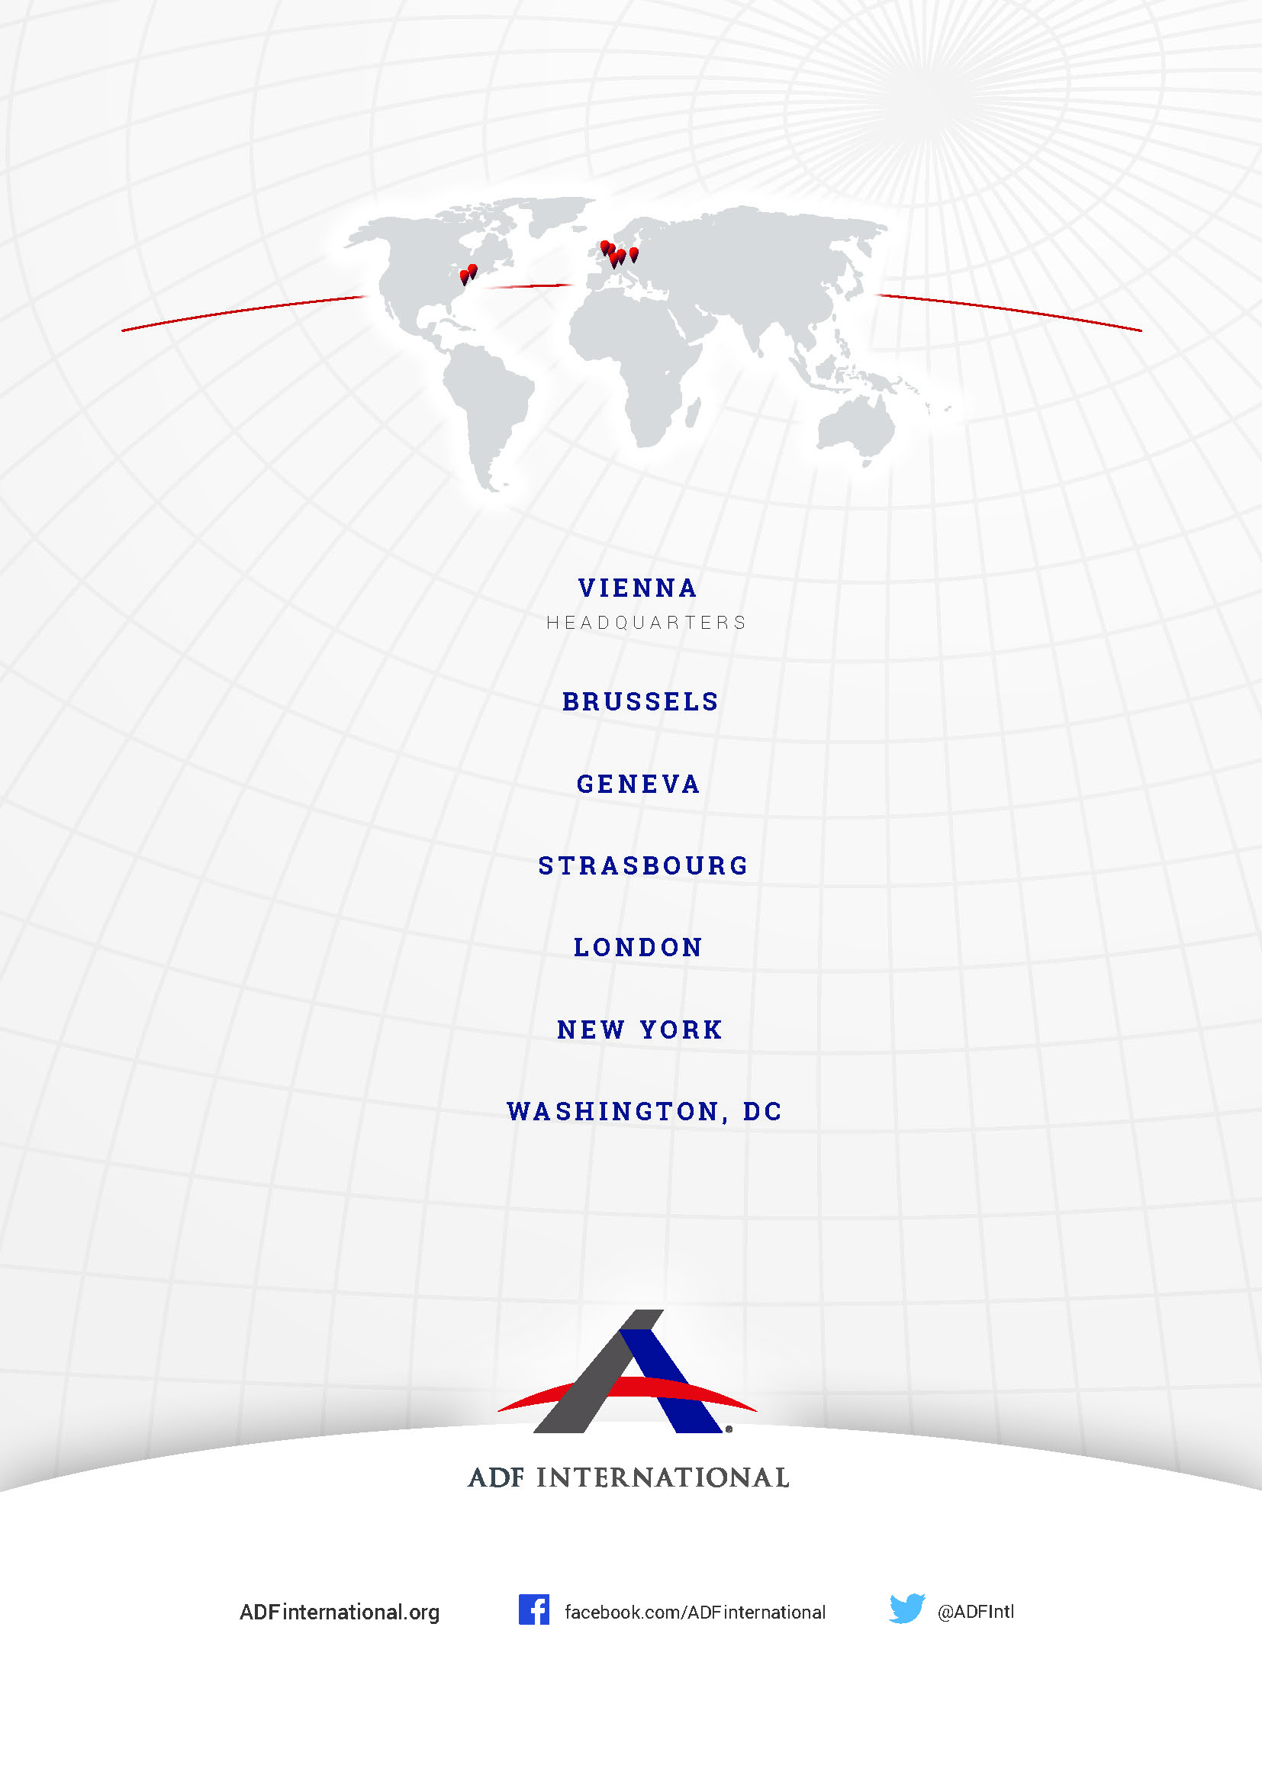
© 2021

Namely, the two biological sexes, male and female. See Oxford English Dictionary, available at <https://www.oed.com/view/Entry/176989?>.
UN Human Rights Council, Draft Convention on the Right to Development, with commentaries, paragraph 6, available at <https://undocs.org/A/HRC/WG.2/21/2/Add.1>.
Rome Statute of the International Criminal Court, Article 7.3, available at <https://www.icc-cpi.int/resource-library/documents/rs-eng.pdf>.
Report of the Fourth World Conference on Women, Annex IV, available at <https://www.un.org/womenwatch/daw/beijing/pdf/Beijing%20full%20report%20E.pdf>.
Ibid, Chapter V.
World Conference Against Racism, Racial Discrimination, Xenophobia and Related Intolerance Declaration and Programme of Action, Footnote i, available at <https://www.ohchr.org/Documents/Publications/Durban_text_en.pdf>.
Declaration on the Right to Development, Article 6.1, available at <https://www.ohchr.org/en/professionalinterest/pages/righttodevelopment.aspx>.

