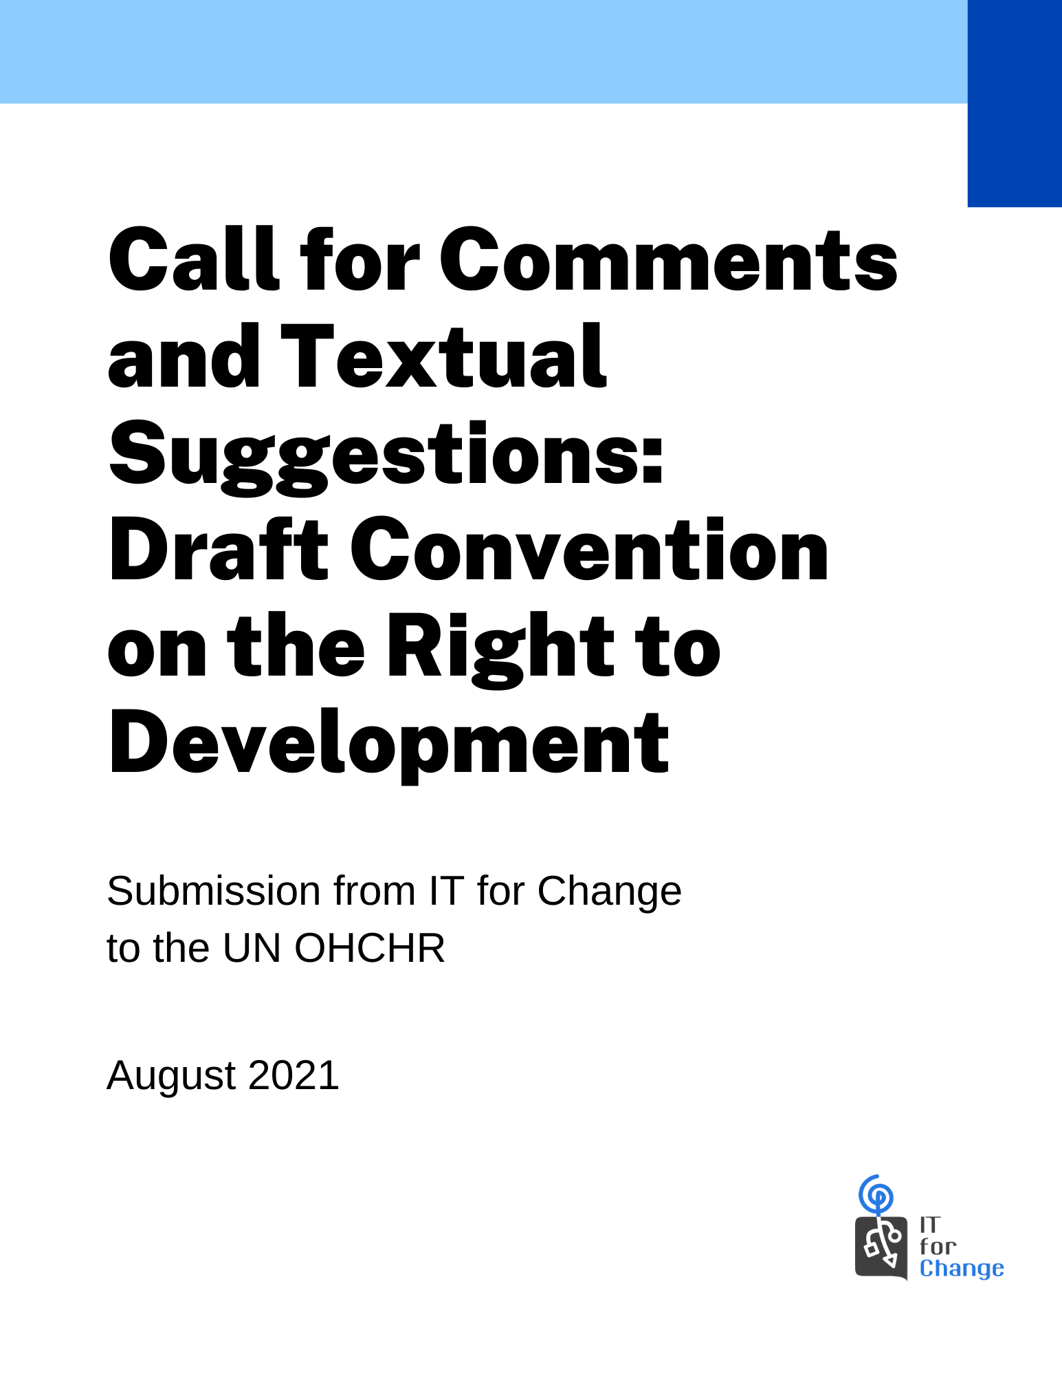

Office of the United Nations High Commissioner for Human Rights
Call for Comments and Textual Suggestions: Draft Convention on the Right to Development
Submission from IT for Change
August 2021
1. Introduction
The Draft Convention on the Right to Development comes at a point when the ravages of Covid-19 have thrown into sharp relief the entrenched inequalities of the global politico-economic order. The vaccine divide is not just a disturbing reminder of international cooperation being sacrificed at the altar of petty nationalisms but an early warning about the real risk of heightened global economic inequality in the post-pandemic world. As UNCTAD data indicates, there is an unmistakable fork in the road to global economic recovery. Developed countries are expected to experience a stronger rebound in GDP growth than developing ones, expanding the gap between rich and poor nations. The much-hyped Special Drawing Rights (SDR) package of the International Monetary Fund (IMF) in August 2021 has ended up as a lost opportunity to enhance unconditional development aid to developing countries, as rich countries have chosen to deploy their share of SDRs for concessional finance (soft loans) rather than grants.
Against this backdrop, the three levels of obligations placed by the Draft Convention on States Parties in relation to the realization of the Right to Development are an urgently needed measure in international law. As highlighted by Para 6 of the Commentaries on the Draft Convention (A/HRC/WG.2/21/2/Add 1), states have an obligation to respect, protect and fulfill the right to development. This obligation is not limited only to their individual capacities when formulating national development policies and programs affecting persons within their jurisdiction, but also applies to the adoption and implementation of policy measures that may impact persons outside their jurisdiction and in the collective actions they undertake as part of global and regional partnerships. This three-pronged schema brings into focus the reality of international political economy – where developing countries find their “right to regulate to achieve sustainable development” (Article 3(e), Draft Convention on the Right to Development) compromised by the policy positions adopted by powerful countries in the international arena.
The current text of the Draft Convention provides heft and body to this promise for preserving the sovereign prerogative of developing countries to chart their course for self-determined development through instituting the following safeguards:
- placing a duty on all States Parties to take action against legal persons domiciled on their soil (read: transnational corporations) for violations of the right to development on other territories (Article 11);
- requiring all States Parties to conduct themselves in trade, investment, aid and development cooperation arenas in a manner that does not impair the policy space of other States Parties to determine their own development priorities (Article 14); and
- imposing a ‘duty to cooperate’ on all States Parties in relation to creating an equitable international order conducive to the realization of the right to development of all peoples (Article 13).
This progressive vision of the Draft Convention would be much strengthened if the obligations on States Parties are made more specific in relation to addressing the development challenges of the digital moment.
The accelerated digitalization of the global economy during the pandemic further heightens the risk of developing countries being locked in perpetuity into the low value segments of data value chains controlled by transnational platform companies from advanced AI economies. Ongoing plurilateral negotiations on digital trade at the WTO — with their push for unrestricted cross-border data flows, hyperliberalization of e-commerce marketplaces, and a permanent moratorium on customs duties on electronic transmissions — are a new battlefront that threaten to take away from developing countries’ right to regulate. The near-total lack of Official Development Assistance for the development of platform, data, and AI infrastructure in developing countries is set to bring in a new 21st century digital age colonialism where developing countries become dependent on platform firms from advanced economies for essential infrastructural needs in core economic, social, and governance sectors.
Clearly, the vision of development and prosperity for all needs a compass that places the inter-dependency of all nations and peoples front and center. Development cannot be reduced to an instrumental relationship between countries seen to be developed and others cast as less developed. The right to development must move the bar towards an equitable and just international order in which the necessary duties and actions of states are guided by the differentiated ability and responsibility in building a sustainable and shared future for planetary well-being.
From the starting point of addressing these concerns, our submission makes a number of inputs to the current text, with respect to:
- Protecting and preserving the regulatory space of developing countries to self-determine their digital development trajectories and safeguard their data sovereignty.
- Emphasizing that the duty to cooperate necessitates structural changes through which everyone can gain equitably from the advancements in digital technologies.
- Enshrining commitments to decent work and gender justice as integral to the state obligation to fulfill the right to development.

2. Additions to text
Suggested text is in red.
Text to be deleted in strikethrough.
Addition 1
Preamble
[After the line]
Recognizing that development is a comprehensive economic, social, cultural, civil and political process that aims at the constant improvement of the well-being of the entire population and of all individuals on the basis of their active, free and meaningful participation in development and in the fair distribution of benefits resulting therefrom,
[please add]
Considering also that in a global economy increasingly redefined by digitalization, the realization of the right to development is inextricably linked to global digital justice.
Rationale: As accelerated digitalization transforms our economies and societies, the development destinies of peoples hinge on a global digital economy that is sustainable and equitable.

Addition 2
Preamble
Recalling the reaffirmation of the right to development in several international declarations, resolutions and agendas, including the Rio Declaration on Environment and Development of 1992, the Vienna Declaration and Programme of Action of 1993, the Cairo Programme of Action of the International Conference on Population and Development of 1994, the Copenhagen Declaration on Social Development and Programme of Action of the World Summit for Social Development of 1995, the Beijing Declaration and Platform for Action of 1995, the United Nations Millennium Declaration of 2000, the Monterrey Consensus of the International Conference on Financing for Development of 2002, the Geneva Declaration of Principles and Plan of Action of 2003, adopted at the World Summit on the Information Society and the Tunis Agenda for the Information Society of 2005, the World Summit Outcome of 2005, the United Nations Declaration on the Rights of Indigenous Peoples of 2007, the outcome document of the High-level Plenary Meeting of the General Assembly on the Millennium Development Goals of 2010, the Programme of Action for the Least Developed Countries for the Decade 2011–2020, the outcome documents of the thirteenth session of the United Nations Conference on Trade and Development of 2012, the outcome document of the United Nations Conference on Sustainable Development “The future we want” of 2012, the quadrennial comprehensive policy review of operational activities for development of the United Nations system of 2012, the SIDS Accelerated Modalities of Action (SAMOA) Pathway of 2014, the Addis Ababa Action Agenda of the Third International Conference on Financing for Development of 2015, ‘the 2030 Agenda for Sustainable Development and the Sustainable Development Goals of 2015, the Paris Agreement on Climate Change of 2015, the Sendai Framework for Disaster Risk Reduction 2015–2030 of 2015, the New Urban Agenda, adopted at the United Nations Conference on Housing and Sustainable Urban Development (Habitat III), of 2016
Rationale: During the Geneva phase of the World Summit on the Information Society (2003), States Parties declared their commitment to building a “people-centred, inclusive and development-oriented information society,” and acknowledged the challenge of harnessing information and communication technologies to promote the development goals as outlined in the Millennium Declaration. They also reaffirmed the right to development as an indivisible component of human rights. In the Tunis phase, States Parties re-affirmed their commitment to the Geneva Principles and Plan of Action, and built on them by focusing on financial mechanisms for bridging the digital divide, internet governance, and the follow-up of the Geneva and Tunis decisions.
In the current moment of accelerated digitalization and datafication, which has led to pervasive economic and social re-structuring, the inclusion of these instruments in the paragraph above reiterates the indispensable role of digital capacities and infrastructures in promoting the right to development for all.

Addition 3
Article 5 – Relationship with the Right to Self-Determination
- The right to development implies the full realization of the right of all peoples to self- determination.
- All peoples have the right to self-determination by virtue of which they freely determine their political status and freely pursue the realization of their right to development.
- All peoples may, in pursuing the realization of their right to development, freely dispose of their natural wealth and resources, as well as data and knowledge commons, based upon the principle of mutual benefit and international law. In no case may a people be deprived of its own means of subsistence, including of their right to access, control and benefit from such resources.
Rationale: The increasing datafication of traditional knowledge and practices, people’s bodies, and even of the natural world urgently requires that people are able to self-determine the terms on which their data resources are governed without external interference or constraints. Data is a social commons. Hence, the sovereign right of peoples to their own data resources needs to be seen as being in line with the General Assembly resolution 1803 (XVII) of 14 December 1962 on Permanent Sovereignty over Natural Resources.
Frontiers like Digital Sequence Information of genetic resources constituting the new raw material for corporatized innovation and profiteering deprive indigenous people and communities of their rightful share in the gains from science and technology. The sovereign claim of peoples and nations to govern their data resources is also impeded by trade policy regimes that attempt to entrench the status quo of unregulated cross-border data flows. This needs to be urgently countered. Without data sovereignty, diverse autonomous pathways to development are bound to be wiped out. Collective data rights are, therefore, an inseparable part of people’s right to economic self-determination.

Addition 4
Article 11 – Obligation to Protect
States Parties shall adopt and enforce all necessary and appropriate measures, including administrative, legislative, investigative, judicial, diplomatic or others, to ensure that human or legal persons, groups or any other State or its agents they are in a position to regulate do not nullify or impair the enjoyment and exercise of the right to development within or outside their territories when:
- (a) Such conduct originates from or occurs on the territory of the State Party;
- (b) The human or legal person has the nationality of the State Party;
- (c) The legal person conducting business activities, including those of a transnational character, and of a virtualized nature, is domiciled in the State Party, by virtue of having its place of incorporation, statutory seat, central administration or substantial business interests in that State Party.
Comment: The consolidation of Big Tech control in the global economy calls for urgent regulatory measures to enforce corporate accountability for human rights obligations, taxation, and cross-border conduct, including in virtualized business operations. We, therefore, welcome the inclusion of Article 11, which obligates States Parties to take measures to ensure that actors under their jurisdictions and/or control do not violate the right to development, in line with their extra-territorial obligations under the International Covenant on Economic, Social and Cultural Rights 1966 as elaborated in General Comment No. 24. In order to strengthen this duty, we urge that states adopt the Legally Binding Instrument to Regulate, in International Human Rights Law, the Activities of Transnational Corporations and other Business Enterprises at the earliest.
Addition 5
Article 13 (1) – Duty to Cooperate
1. States Parties reaffirm and undertake to implement their duty to cooperate with each other, through joint and separate action, in order to:
(a) Solve international problems of an economic, social, cultural, environmental, technological or humanitarian character;
(b) Promote higher standards of living, full employment and decent work, and conditions of economic, and social and technological progress and development:
Rationale: While employment and work are necessary pillars of the right to development, it is by no means sufficient to promote full employment at the cost of working conditions. The realization of the right to development includes access to “decent work”, which General Comment No. 18 has affirmed to be an integral component of the right work under Article 6 of the International Covenant on Economic, Social and Cultural Rights. The language of “decent work” also finds place in Sustainable Development Goal 8, which refers to promoting “sustained, inclusive and sustainable economic growth, full and productive employment and decent work for all.” Therefore, in Article 12(b), we recommend the inclusion of the phrase “decent work”. Additionally, in the current digital paradigm, progress is defined by technological advances.

Addition 6
Article 13 (2) – Duty to Cooperate
2. To this end, States Parties recognize their primary responsibility for the creation of international conditions favourable to the realization of the right to development for all, and undertake to take deliberate, concrete and targeted steps, separately and jointly, including through cooperation within international organizations, and as appropriate, in partnership with civil society:
(a) To ensure that human and legal persons, groups and States do not impair the enjoyment of the right to development;
(b) To ensure that obstacles to the full realization of the right to development are eliminated in all international legal instruments, policies and practices;
(c) To ensure that the formulation, adoption and implementation of all international legal instruments, policies and practices are consistent with the objective of fully realizing the right to development for all;
(d) To formulate, adopt and implement appropriate international legal instruments, policies and practices aimed at the progressive enhancement and full realization of the right to development for all;
(e) To mobilize appropriate technical, technological, financial, infrastructural and other necessary resources to enable States Parties, particularly those with limited availability of or access to these resources, to fulfil their obligations under the present Convention.
(f) To ensure that international trade and investment regimes preserve the right of States Parties to regulate, in order that they may autonomously determine their own development destinies.
(g) To reform the international taxation regime to check tax evasion by transnational business entities that thwarts the ability of States Parties to mobilize resources necessary for advancing development goals.
Rationale: As previously stated, in the 21st century, the right to development hinges on the ability of countries and people to benefit equally from the global digital economy. The democratic deficit in the global governance of the digital economy prevents fair distribution of its gains. Consequently, we recommend the inclusion of clauses (f) and (g) to Article 13, which would ensure the preservation of domestic regulatory capacities as well as the fair taxation of transnational companies who have virtual, rather than physical, presence.

Addition 7
Article 13 (4) – Duty to Cooperate
4. States Parties recognize their duty to cooperate to create a social and international order conducive to the realization of the right to development by, inter alia:
(a) Promoting a universal, rules-based, open, non-discriminatory and equitable multilateral trading system;
(b) Implementing the principle of special and differential treatment for developing countries, in particular least developed countries, in accordance with relevant trade agreements;
(c) Improving the regulation and monitoring of global financial markets and institutions, and strengthening the implementation of such regulations;
(d) Ensuring enhanced representation and voice for developing countries in decision-making in global international economic and financial institutions in order to deliver more effective, credible, accountable and legitimate institutions;
(e) Encouraging official development assistance and financial flows, including foreign direct investment, to States where the need for productive capacity and public digital infrastructure creation is greatest, in particular least developed countries, African countries, small island developing States and landlocked developing countries, in accordance with their national plans and programmes;
Rationale: In subsequent iterations of Article 13(4)(e), we recommend that due regard be paid to the documented failures of the market route for infrastructural creation and technology transfer. UNCTAD has observed that foreign direct investment (FDI) has a very limited contribution to the technology transfer which is integral for local productive capacity, especially in Least Developed Countries (LDCs).
In the current context, digital infrastructure is emerging as essential public infrastructure. It plays a central role in creating and catalyzing local productive capacity. Therefore, Official Development Assistance (ODA) and other instruments like FDI must advance the legitimate aspirations of developing countries for infrastructural capacity in the digital economy and society. Financial assistance and investment cannot become a route for corporate capture of domestic digital infrastructure. It cannot thwart the technological and data sovereignty of people, hollowing out local productive capacity.

Addition 8
Article 15 – Special or Remedial Measures
1. States Parties recognize that certain human persons, groups and peoples, owing to their age, disability, marginalization, vulnerability, indigeneity or minority status, may require special or remedial measures to accelerate or achieve de facto equality in their enjoyment of the right to development.
2. States Parties recognize that developing and vulnerable States, owing to historical injustices, conflicts, environmental hazards, climate change or other disadvantages, including of an economic, technical or infrastructural nature, may require special or remedial measures through mutually agreed international legal instruments, policies and practices for ensuring equal enjoyment of the right to development by all human persons and peoples. Such measures may, as appropriate, include:
(a) Recognition of common but differentiated responsibilities, taking into account different national circumstances;
(b) The provision of special and differential treatment;
(c) Preferential terms on trade, investment and finance;
(d) The creation of special funds or facilitation mechanisms;
(e) The facilitation and mobilization of financial, technical, technological, infrastructural, capacity-building or other assistance;
(f) The extension of the transition period for LDCs as well as ending non-violation complaints under the Agreement on Trade-Related Aspects of Intellectual Property Rights (TRIPS).
Rationale: The global intellectual property regime also requires reform to serve the development goals of people and countries everywhere. Corporations have succeeded in securing “TRIPS plus” provisions in international trade agreements that prevent developing countries from leveraging intellectual property exemptions they are legitimately allowed to exercise under the TRIPS Agreement. We, therefore, recommend the inclusion of clause (f) to Article 15 that would allow states to pursue their development aspirations unencumbered by the global intellectual property regime.

Addition 9
Article 16 – Gender Equality
(d) To mainstream gender perspectives in the formulation, adoption and implementation of all national laws, policies and practices and international legal instruments, policies and practices;
(e) To ensure equal and equitable access to resources, necessary for the full realization of the right to development by women and girls, and women’s collectives and cooperatives everywhere;
Rationale: It is important to think of access for individual women as well as for women’s collective enterprise models.

