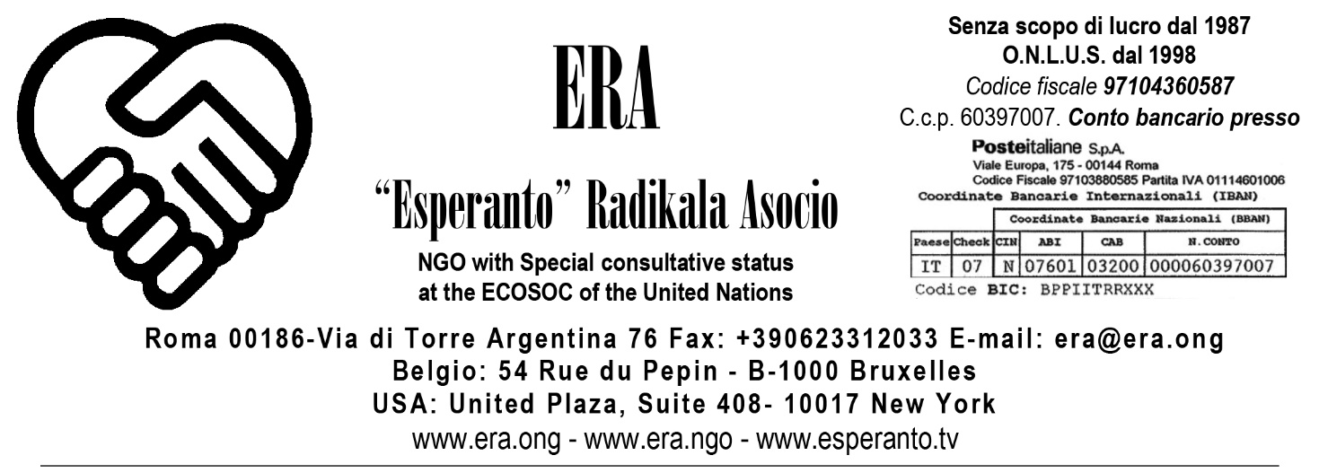

To the Office of the United Nations High Commissioner for Human Rights
Rome, 20.08.2021

Our comments and textual suggestions to the
Draft Convention on the Right to Development

In our opinion, the Draft Convention on the Right to Development, while containing important concepts relating to the conditions, or not, of development does not take into account how in the last century colonialism and imperialism have no longer been exercised only on the peoples but directly on the minds of the persons of other peoples through linguistic colonialism (cf. “The empires of the future are the Empires of the Mind” because “The power to control language offers far better prizes than taking away people’s provinces or lands or grinding them down in exploitation “Winston Churchill - in dialogue with Roosevelt - Harvard University, September 6, 1943 <https://youtu.be/OHs3Lo4Gq4A>.
This form of slavery, the linguistic one (See the book of the world’s leading expert on English linguistic imperialism, Robert Phillipson, “Linguistic Imperialism Continued“ Routledge Ed, published in Italian by our NGO under the title “L’imperialismo linguistico inglese continua“), does not distinguish by race, sex or religion but points straight to the people’s minds to assimilate and enslave them economically and to its own organizational and thought system.
It is so pervasive and totalitarian as a system of mental coercion that it goes as far as inside the United Nations where it should not only not take root but should be fought against. Instead, even the contributions to this Draft Convention on the Right to Development are requested to be:
- in English, the proprietary language of the English mother tongue speakers, to learn which all the others pay a cost which is economic, psychological, of enormous waste of time, unlike the former who thus benefit more and more in terms of development to the detriment of non-native English speaking persons and peoples (See the attached written statement at the Forty-fourth session of Human Rights Council titled “It is urgent that the poorest children in the world, like those from the Congo, and the richest children, like those from British or American societies, together, have a second common language, that Anglophones have a second language” N. A/HRC/44/NGO/119);
- in a “Microsoft Word” format, that too proprietary, owned by Microsoft Corporation.

To our knowledge, the first to speak of linguistic slavery was Gandhi, who in 1909 in Hind Swaraj’s chap. 18 explained: “To give millions a knowledge of English is to enslave them.” and also “It is worth noting that, by receiving English education, we have enslaved the nation. Hypocrisy, tyranny, etc. have increased; English-knowing Indians have not hesitated to cheat and strike terror into the people.” and also “It is we, the English-knowing Indians that have enslaved India. The curse of the nation will rest not upon the English but upon us.”

There is no right to development if it depends on the learning of the language of the most “developed” one and on the use of tools that are its own property: on the contrary, to our detriment, its further and ever greater development is assured, as well as our servility and dependence for life, until one’s mother tongue is turned into a dialect till its death, together with its own people reduced to a mere geographical entity.

For this reason we believe that within the Convention on the Right to Development there should be a place and the commitment by the States Parties the Principle that every human being has the Right to the International Auxiliary Language. It is the Right to the common language of the human species as identified, already in 1922, by the progenitor organization of the United Nations, the League of Nations, which unanimously approved the Report on Esperanto as International Auxiliary Language during its third General Assembly, with the convinced support of the British Lord Robert Cecil, later awarded the Nobel Prize for Peace.
If already in 1922 the International Language (called Esperanto) was deemed ready to be adopted as “International Auxiliary Language”, today it is more so than ever: it has almost a century of additional world linguistic experimentation; since 1993 it has been recognized by the PEN Club International as the 114th language of literature in the world; it is Google’s 64th translation language; it is the language of Nobel Laureates for Economics such as the German Reinhard Selten; it is the language of a transnational community present in over 120 countries around the world; is at least 12 times simpler than English; a great world-renowned scholar, Umberto Eco, defined Esperanto “a linguistic masterpiece” and, in his The Search for the Perfect Language , he devoted a lot of space to Esperanto, IAL, examining the “Theoretical Objections and Counter-objections “(p. 330) and the real “Political Possibilities of an IAL“(p. 332). Its most extraordinary aspect is that to learn it as a mother tongue one doesn’t have to go, as for English, to an English-speaking country but every country in the world is “Esperantia”, even the poorest country in the world, Burundi. And this will mean ensuring development for Burundi too!

We are not able to know how much the already linguistically colonized people are able to understand the importance and the historical dimension for humanity of this innovative and fundamental human right. Perhaps, the video of a former UN and WHO translator like Claude Piron, who was also a psychologist and lecturer at the Psychology Department of the University of Geneva, “The language challenge” <https://youtu.be/m1UFGTmCnuU> can help many to face the reality. It is certainly absurd that, in order to communicate, the defenders of Human rights, fair development and peace support the very language that most in the world destroys the other languages of the planet and the peoples who speak them.
Of course, we must also call upon the Anglo-Saxon peoples to face their responsibilities. We need to clarify that by continuing to support the Anglophone trade of the minds, they are continuing to operate in the nineteenth century’s colonialist and slave line, though switching, more astutely, from the material dimension of the bodies to the immaterial dimension of the persons’ minds. We are convinced that, faced with their own responsibilities in the destruction of the linguistic and cultural biodiversity of the planet, they too will become important supporters of the Human Right to the International Auxiliary Language, just as the British were against the slavery of the bodies with the Slave Trade Act in 1807 and the USA on 18.12.1865 when the thirteenth amendment to the Constitution came into effect, which officially abolished slavery.

The linguistic slavery of the minds is a crime against humanity and, even more so, against the Right to Development. Our NGO, with its international experts, is ready to give all the necessary support so that the definitive “Convention on the Right to Development” takes that into account, together with the possibility that such crime can no longer be perpetrated, thanks to the adoption of the IAL.

Best Regards,
Giorgio Kadmo Pagano
(General Secretary of ERA)

