Agenda 4.5 - Discussion to elaborate a draft legally binding instrument on the right to development through a collaborative process of engagement, including on the content and scope of the future instrument

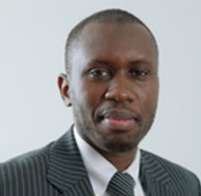
Professor Makane Moïse Mbengue
Prof. Mbengue is a Professor of International Law at the University of Geneva and Affiliate Professor at Sciences Po Paris (School of Law). He has acted and acts as expert for the African Union, the United Nations Economic Commission for Africa, the United Nations Environment Programme, the World Bank, the International Labour Organization, the United Nations Conference on Trade and Development and the International Institute for Sustainable Development, among others. He was also the Lead Expert for the negotiations and drafting of the Pan-African Investment Code in the context of the African Union and is involved in investment negotiations in different African republics and economic organizations. He also teaches international law in courses organized by the United Nations Office of Legal Affairs and by the United Nations Institute for Training and Research. Professor Mbengue holds a PhD in Public International Law from the University of Geneva, a Master’s in Public Law and an LL.M. in economic and commercial law from the University of Saint-Louis (Senegal).

Professor Koen De Feyter
Prof. De Feyter is Professor of International Law, Spokesperson of the Research Group on Law and Development and Academic Coordinator of the Master of Laws program at the University of Antwerp (Belgium). He chairs the Executive Committee of the global Law and Development Research Network (LDRn), is a Board Member of Picture People (UK), and a regular contributor to the European Master of Human Rights and Democratization (Venice). His main research areas are international law and sustainable development, and human rights in non-Western contexts. He has taught on these issues at universities in Africa, Asia and Latin America.

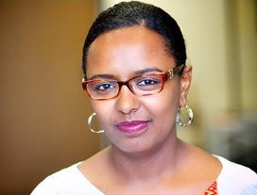
Ms. Meskerem Geset Techane
Ms. Techane is a human rights lawyer with over 15 years of experience at the national and international level. She previously held the position of High Court Judge in Ethiopia and Deputy Director of the Institute for Human Rights and Development in Africa (IHRDA). She has worked closely with African human rights mechanisms, served as an expert member in different Working Groups of the African Commission on Human and Peoples’ Rights, and collaborated with the various Special Rapporteurs of the Commission and was extensively commissioned as an expert by various UN institutions. . Her dedicated service to women and girls has earned her an award for outstanding pro bono legal aid, and the Ethiopian Women Lawyers Association prize for remarkable contribution. Ms. Techane holds a Bachelor of Laws (LL.B) from the Addis Ababa University and a Master of Laws (LL.M) from the University of Pretoria. She is currently a Doctoral Fellow at the Human Rights Center of University of Padova and a Member of the Working Group on the issue of discrimination against women in law and in practice. She has published on issues of women’s rights and human rights in Africa, and authored training manuals for lawyers, judges and law enforcement officers on women’s rights and gender justice.

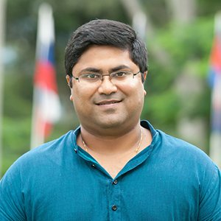
Dr. Mihir Kanade
Dr. Kanade is the Academic Director of the University for Peace (Established by the UN General Assembly), the Head of its Department of International Law and Human Rights and the Director of the UPEACE Human Rights Centre. He holds a LL.B from Nagpur University (India) and a Master degree and Doctorate from UPEACE. He is also an adjunct faculty at Universidad Alfonso X El Sabio (Spain), Cheikh Anta Diop University (Senegal), and Long Island University (United States). His principal area of academic research and study is International Law, Human Rights and Globalization, covering several themes within that interface including trade and investment, sustainable development, forced migration, indigenous peoples’ rights, public health, amongst others. He conducts several trainings for staff of inter-governmental, governmental and non-governmental organizations, as well as professionals, in the field of international law and human rights. He serves on the International Advisory Board of the International Bar Association on the topic of Business and Human Rights. He also co-leads an e-learning project in partnership with the OHCHR and UNU-IIGH on operationalizing the Right to Development in Implementation of the SDGs. Prior to academia, Mihir practiced for several years as a lawyer at the Bombay High Court and at the Supreme Court of India.

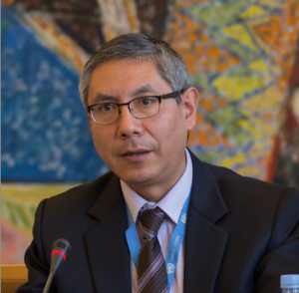
Dr. Carlos Lopez
Dr. Lopez is the Senior Legal Adviser on Business and Human Rights for the International Commission of Jurists since January 2008. Before taking up this post, Dr Lopez worked for the Office of the High Commissioner for Human Rights and the Food and Agriculture Organisation of the UN, on issues such as the right to food, economic and social rights and the right to development, human rights and extreme poverty, Rule of Law and democracy. He has also worked for the Graduate Institute of International Studies in Geneva and for several international human rights organizations as well as national human rights NGOs in his country, Peru. Mr. Lopez holds a PhD and Master’s degrees from the Graduate Institute of International Studies / University of Geneva. He has written extensively on human rights and business, private security companies and human rights, international trade and investment frameworks and human rights.

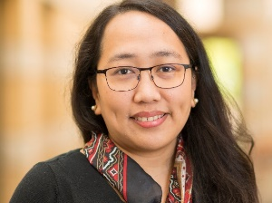
Prof. Dr. Diane Desierto
Prof. Dr. Desierto is tenured Associate Professor of Human Rights Law and Global Affairs, Keough School of Global Affairs, University of Notre Dame (USA), Fellow (Klau Center for Civil and Human Rights, Kellogg Institute for International Studies, Liu Institute for Asia and Asian Studies); Professor of International Law and Human Rights, Philippine Supreme Court Judicial Academy; and External Faculty Fellow, Stanford University’s Handa Center for Human Rights and International Justice. Alongside her academic appointments and work as international counsel, listed arbitrator, and resource expert in the areas of public international law and dispute settlement, international economic law and development, international human rights and humanitarian law, maritime security, and evolving regional ASEAN Law, Prof. Dr. Desierto authored over 100 law review articles, book chapters, essays, reviews, and several books, including Public Policy in International Economic Law: The ICESCR in Trade, Finance, and Development (OUP, 2015). She holds JSD and LLM degrees from Yale Law School, JD cum laude and BSc Economics degrees from the University of the Philippines.

