

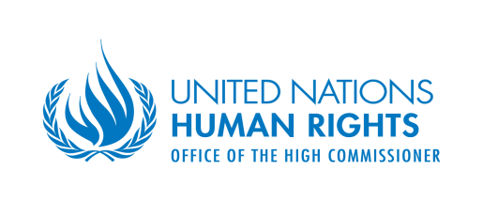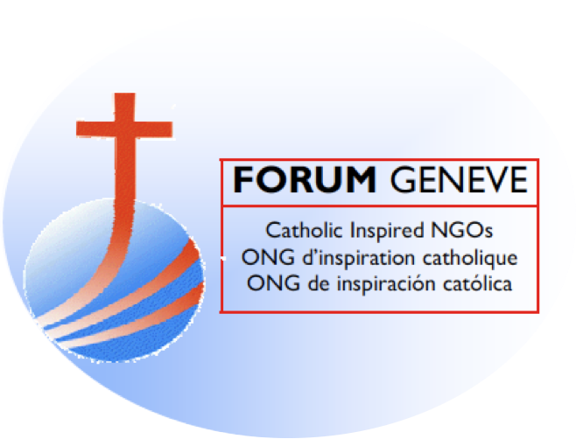

**PANEL EVENT:**

**‘Leaving No One Behind’: A Right to Development Perspective**

**13:00-15:00 hours, Wednesday 1 May, Room V, Palais des Nations**

**Background**

The right to development (RTD) marks ‘an epistemic break’ in development discourse. The Declaration on the Right to Development (DRTD) enshrines the inalienable human right of all individuals and peoples everywhere, to participate in, contribute to, and enjoy economic, social, cultural and political development. Its transformative vision calls for a holistic paradigm to improve the human condition, through an enabling environment for inclusive, equitable and sustainable development free of all obstacles, while advancing all human rights - civil, cultural, economic, political and social. Its human rights-based conception of development requires free, active and meaningful participation, and fair distribution of the benefits of development.

In an interdependent, globalized world, faced with multiple global crises including climate change, human rights and development challenges affect many people, and often transcend national borders. Over 700 million people live in extreme poverty. Reflecting a trajectory of inequality within and between nations, 26 individuals own the same wealth as 3.6 billion others. Illicit financial flows threaten domestic resource mobilization, which can in turn, deny people’s access to basic needs - food and water, health, education and livelihoods; and climate change threatens the very survival of entire communities, peoples and nations. Locally, vulnerable and marginalized groups including the poor, women and children, minorities and indigenous peoples, are often left behind. Globally, countries in Africa, Least Developed Countries, Landlocked Developing Countries and Small Island Developing States also tend to lag behind.

The RTD can enhance the human rights response to support transformative possibilities in people’s daily lives – As among other things, it mandates people-centred development policies for the constant improvement of human well-being, and national and international policies which are conducive to realizing the RTD. It makes international cooperation a duty of States.

By putting people at its centre, the 2030 Agenda, which aims to leave no one behind, helps to generate political momentum to realize the RTD – while the RTD can provide a vital enabling environment to ensure that the Sustainable Development Goals (SDGs) will be achieved, and that development processes integrate all indivisible and interdependent human rights. The DRTD must guide the implementation of the 2030 Agenda, the Addis Ababa Action Agenda and the Paris Agreement, to strengthen global partnership and the Means of Implementation. SDG 17 and the a, b, c Targets are key to bridging the divides and realizing alternative futures through RTD and SDGs.

The RTD is essential to "empowering people and ensuring inclusiveness and equality", the theme of the 2019 high-level political forum. It is key to **Goal 4 -** Ensure inclusive and equitable quality educationand promote lifelong learning opportunities for all; [**Goal 8**](https://sustainabledevelopment.un.org/sdg8) **-** Promote sustained, inclusive and sustainable economic growth, full and productive employment and decent work for all; [**Goal 10**](https://sustainabledevelopment.un.org/sdg10) **-** Reduce inequality within and among countries; [**Goal 13**](https://sustainabledevelopment.un.org/sdg13) **-** Take urgent action to combat climate change and its impacts; [**Goal 16**](https://sustainabledevelopment.un.org/sdg16) **-** Promote peaceful and inclusive societies for sustainable development, provide access to justice for all and build effective, accountable and inclusive institutions at all levels; and [**Goal 17**](https://sustainabledevelopment.un.org/sdg17) **-** Strengthen the means of implementation and revitalize the global partnership for sustainable development.

The RTD could be invoked to advocate the case for addressing shortfalls in SDG outcomes and Financing for Development (FFD). Lack of finance is closely linked with lack of basic economic rights including food and water, health and education. Closing gaps in technology and energy and addressing digital divides will help to reduce inequality. The interplay of underlying root causes for denials include lack of RTD/human rights-based economic decision-making, policy space and policy coherence; corruption and poor governance; tax havens, tax avoidance and tax evasion. The RTD can support a strengthened multilateral framework for fairness in global, regional and national governance and development, to leave no one behind.

The Office of the High Commissioner for Human Rights will convene a panel to lead an interactive discussion on the RTD and the SDGs, in particular, with a view to operationalizing the RTD in implementing the SDGs. This event will be organized in collaboration with the UN-mandated University for Peace (UPEACE), the Forum of Catholic – Inspired NGOs in Geneva and the International Youth and Student Movement for the United Nations (ISMUN).

**Objectives**

* To reflect on ‘Leaving No One Behind’ through the lens of the DRTD including by listening to the voices of those left behind through CSOs working closely with them
* To discuss the mutually reinforcing RTD and SDGs with a view to realizing both through bridging the gaps and ‘empowering people and ensuring inclusiveness and equality’
* To consider how the DRTD can be implemented at different levels while contributing to SDG implementation, including through developing policy and practical guidance

**Format**

This panel will draw on the structure, contents and approach of the ‘Interactive E-Learning Module on Operationalizing the Right to Development in Implementing the Sustainable Development Goals’ *-* a capacity-building project of OHCHR, in collaboration with the UN - mandated University for Peace (UPEACE), Costa Rica, and the UN University’s International Institute for Global Health, Malaysia, with contributions from academic experts worldwide.

The panel will commence with the screening of the video ***‘Development is a Human Right’.***

This interactive discussion will be co-moderated, with interventions from experts and activists on several issues which cut across the RTD and the SDGs.

**Panel:**

**Chair: Bat-Erdene Ayush, Chief, Right to Development Section, OHCHR, Geneva**

**Moderators:** **Shyami Puvimanasinghe,** Human Rights Officer, Right to Development Section, OHCHR, Geneva; **Mihir Kanade,** Head, Department of International Law and Director, Human Rights Centre, UN-mandated University for Peace (UPEACE), Costa Rica

**Speakers**:

**Gaynel Curry,** Human Rights Officer, Sustainable Development Section, OHCHR, Geneva

**Diane Desierto,** Associate Professor of Human Rights Law & Global Affairs, Keough School of Global Affairs, University of Notre Dame, Indiana, USA

**Bhumika Muchhala** Independent Consultant on Global Economic Governance and Sustainable Development and PhD Student, The New School, New York, USA (video presentation)

**Koen de Feyter,** Professor of International Law, Research Group on Law and Development, University of Antwerp, Belgium

**Maria Mercedes Rossi,** Main representative, A*ssociazione Comunità Papa Giovanni XXIII* (APG23) to the United Nations in Geneva and Representative of the Forum of Catholic – Inspired NGOs

**Hachem El Hani,** International Youth and Student Movement for the United Nations (ISMUN), and President, International Youth Future Founders Association

**Participants**

Member States, UN agencies, international organizations, academia, civil society, human rights advocates, development practitioners and other relevant stakeholders

For attendees without UN badges please send a request for registration by e-mail to [R2D@ohchr.org](mailto:R2D@ohchr.org)

************