HRC Intersessional Seminar

The role of good governance in the promotion and protection of human rights and best practices for implementing the Sustainable Development Goals, including Goal 16

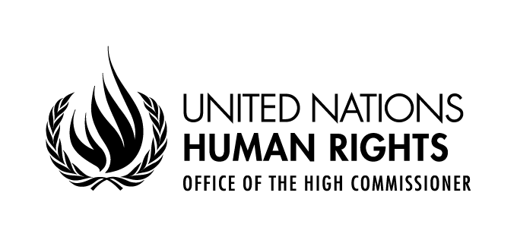

Opening statement by
Mr. Bat-Erdene Ayush
Chief, Right to Development Section

Geneva, 14 June 2019
Palais des Nations, Conference Room V

Excellencies,
Distinguished delegates,
Ladies and gentlemen,
It gives me great pleasure to welcome you to this seminar on the role of good governance in the promotion and protection of human rights and best practices for implementing the Sustainable Development Goals, including goal 16.
The importance of SDG 16 cannot be overemphasized. Progress on this goal will be an enabler and accelerator for the entire 2030 Agenda. Not delivering on this goal will mean falling further behind, for people affected by poor governance, for States, and for the international community in their efforts for the full realization of the 2030 Agenda for Sustainable Development.
But, good governance requires bold leadership, a commitment to do the right thing and to do things right. This demands the right experience, and the right resources.
Of course, good governance is required at all levels. The United Nations system and the Office of the High Commission for Human Rights must to be ready to do our part to fulfil the SDGs. Helpfully, the Secretary-General has embarked on an ambitious reform process of the United Nations Development System. The reform will see a new generation of United Nations country teams, with roles and profiles tailored to the context, set up to deliver shared results, with clearer and more robust lines of accountability and with empowered resident coordinators.
But what do human rights have to do with all this? Good governance and human rights are mutually reinforcing. International human rights law provides a set of standards to guide governing processes and to assess performance outcomes. Good governance is, in turn, an indispensable condition for the full realization of human rights. And both human rights and good governance are necessary to build peaceful, just and inclusive societies and to realize sustainable development.
Good governance and human rights play an important role in achieving social cohesion and political stability. Gross inequalities and pervasive discrimination are among the greatest threats to human rights across the world. Good governance, grounded in human rights norms, can mediate claims on resources in a way that reduces inequalities, defends against elite capture, remedies discrimination, and combats corruption.
The world we live in today is increasingly unequal, unstable and unsustainable. Wealth is increasingly concentrated in the hands of the few, as are opportunities and power. When basic human rights, access to resources and opportunities are systematically denied or unfairly distributed, feelings of resentment thrive. In this way, inequality, poverty, discrimination, oppression, and poor governance drive instability and conflict.
The 2030 Agenda puts people first. By addressing inequalities of power, income, access to resources, justice, and opportunities, the 2030 Agenda recognises the indivisible and interdependent nature of all human rights – economic, social, cultural, civil and political rights, as well as the right to development. It is a promise by Member States to ensure a more equitable, stable and sustainable world – a world where no one is left behind. However, it is about more than lifting people out of extreme poverty; the principle of leaving no one behind is also about ensuring that people have the freedom and opportunities to live the dignified lives they deserve. Human rights are essential to a sustainable and inclusive development because they create conditions for people to reach their full potential.
Under international human rights law, States have undertaken the obligation to take steps to the maximum of their available resources, with a view to achieving progressively the full realization of economic, social and cultural rights. Corruption clearly undermines this obligation. Moreover, it leads to discriminatory access to public services in favour of those able to influence authorities, including by offering bribes or resorting to political pressure. Corruption makes social services at worst unavailable, at best more expensive or of inferior quality. The negative impacts are harshest for those who are already disadvantaged and in a position of vulnerability. They are often more reliant on public goods and services and have limited means to seek alternatives. They have fewer opportunities to participate in the design and implementation of public policies and programmes and lack the resources to defend themselves and seek reparations. Those who least can afford it suffer most. Corruption creates a societal rift premised on unfair conditions. Money and resources lost to corruption is, at its core, development denied to those left behind.
Corruption undermines the rule of law, trust in public institutions and ultimately the State itself.
People must know their rights and there must be an environment where they can voice their grievances without fear. This requires an independent and impartial judiciary, a free press, access to information, free civic space and protection of anti-corruption actors. It also requires an accountable private sector that undertakes human rights due diligence. And it requires a responsible public service. This is all good governance.
Today’s seminar provides us with the opportunity to identify governance challenges, exchange experience and good practices in our work to support good governance institutions and processes that are based upon and respectful of international human rights standards .
I wish you the best of success in your deliberations and look forward to the outcome of this important and timely meeting, which will be presented to the Human Rights Council at its forty-third session in March 2020.
I thank you for your attention.

