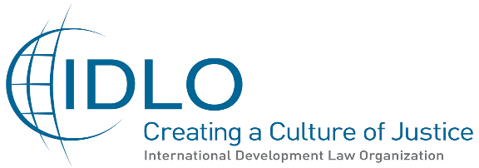

July 2021

Contribution of the International Development Law Organization (IDLO) to OHCHR in preparation for the
Third session of the Forum on Human Rights, Democracy, and the Rule of law:
"Equal access to justice for all: a necessary element of democracy, rule of law and human rights protection"
16-17 November 2021

The International Development Law Organization (IDLO) welcomes the upcoming third session of the United Nations Human Rights Council Forum on Human Rights, Democracy and the Rule of Law, scheduled for 16-17 November 2021, and the selected theme “Equal access to justice for all: a necessary element of democracy, rule of law and human rights protection”.
This marks the first time that the Forum - a platform for promoting dialogue and cooperation on the relationship between human rights, democracy and the rule of law - will focus directly and specifically on justice and the rule of law, providing opportunities for identifying and analysing best practises to guide States in their efforts to secure access to justice for all and effective judicial services.
As the only global intergovernmental organization exclusively devoted to promoting the rule of law and access to justice to advance sustainable development and help build more peaceful, inclusive and resilient societies, IDLO has done substantial work on this subject and could contribute to plenary session discussions and side events during the Forum.
In the context of COVID-19, this theme is as important as ever to inform responses to the pandemic and, more broadly, to promote good governance and protection of human rights (see IDLO’s Roadmap for a Rule of Law-based Recovery at https://www.idlo.int/roadmap-for-a-rule-of-law-based-recovery).
Access to justice is a human right in itself and, together with the rule of law, offers a concrete pathway to peace, good governance, human rights, democracy, and sustainable development. Thus, Sustainable Development Goal 16 - on access to justice and accountable institutions - is not only an end itself but is an essential enabler of human rights and the entire Agenda 2030 for Sustainable Development.
IDLO thanks the Office of the High Commissioner for Human Rights (OHCHR) for the invitation to offer suggestions for topics to be discussed during the third session of the Forum and appreciates this opportunity for engagement. For this purpose, below is a summary of Key Messages from the 25th March 2021 virtual high-level event entitled “Access to justice for all”, which IDLO organized in preparation of the Forum in cooperation with OHCHR and with the co-sponsorship of the Council’s Core Group on the Forum - Morocco, Norway, Peru, Republic of Korea, Romania, and Tunisia.
Based on the March 25 event, IDLO offers the following highlights from the event and, in the Annex, content suggestions for this year’s Forum.
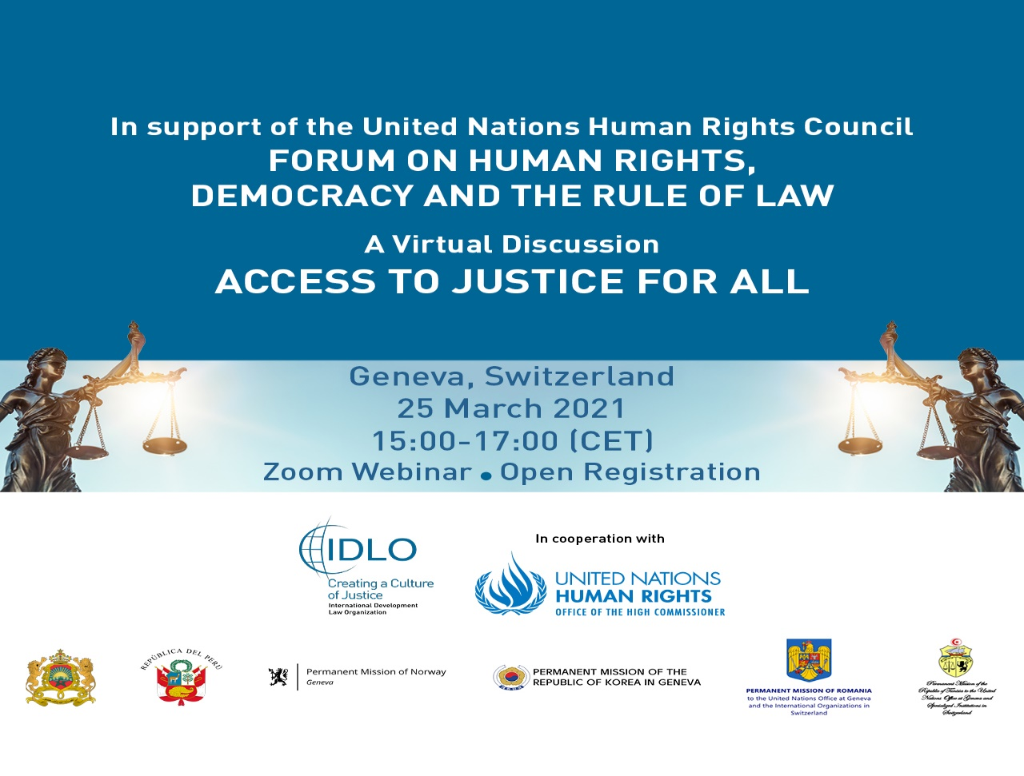

Discussion Highlights and Recommended Topics for the Forum

The event identified and analyzed best practices, challenges, and opportunities through an open and wide participation of actors from different sectors and levels, showcasing examples of concrete rule of law and justice programmes in countries and communities. It was also an opportunity for participants to suggest topics under the theme “Access to Justice” to be included in the agenda of the Forum.
The event developed ideas and proposals for the content and organization of the third session of the Forum on the theme of access to justice for all, highlighting the link between justice and the rule of law, good governance and accountable, effective public institutions.
The event was opened and moderated by Jan Beagle, Director-General of IDLO. A Keynote Address was provided by Hon. Michael Kirby, President of International Bar Association Human Rights Institute (IBAHRI) and formerly Justice of the High Court Justice of Australia. Panelists included: Mona Rishmawi, Chief of the Rule of Law, Equality and Non-Discrimination Branch, OHCHR; Åsa Regnér, Deputy Executive Director, UN Women; Diahann Gordon Harrison, Attorney-at-Law and Children’s Advocate of Jamaica; Gerald Abila, Founder of Barefoot Law, Uganda; and Diego García Sayán, Special Rapporteur on the independence of judges and lawyers. During the discussion also intervened: Her Excellency Silvia Elena Alfaro Espinosa, Ambassador and Permanent Representative of Peru to the United Nations in Geneva; Ms. Francesca Restifo, Senior Human Rights Advisor - UN Programme, International Bar Association Human Rights Institute (IBAHRI); and Ms Martina Caterina, DIP/IDP Section, chair of the Global Protection Cluster Task Team on Law and Policy, OHCHR. Almost 300 people attended the event out of a total of more of 500 registrations.

Specific areas of focus suggested for the Forum include:
- Consider how to increase trust in public institutions and how to help meaningful participation with a view to making “access to justice” a lived reality for all;
- study how to reduce the digital divide and leverage new and emerging technologies, through creative thinking, to achieve access to justice for all and particularly, those who are the most vulnerable and the most marginalised, including by linking international policy dialogues with grassroots discussions and grassroots action;
- identify opportunities and challenges to ensure the independence and impartiality of the judiciary, the integrity of the judicial system, and an independent legal profession;
- highlight best practices in building people-centred justice, adapting justice systems (including customary systems and alternative dispute resolution) to the needs of specific populations, including women, children and young people, and other key populations such as trafficked persons, persons with disabilities, refugees and migrants, indigenous peoples, minorities, the poor, among others, empower individuals and communities to develop and exercise justice solutions;
- study institutional responses to combat gender-based violence and increase women’s participation in justice systems; ensure a strong gender perspective in the upcoming session of the Forum;
- explore multi-stakeholder strategies and the role of civil society in supporting access to justice for all; highlighting examples of measures to increase legal awareness, legal empowerment, open justice, and access to legal remedies for people affected by public health emergencies such as COVID-19, including e-justice mechanisms;
- explore avenues to promote awareness in the perceptions and commitment of policymakers, thought leaders and the public to prioritize equal access to justice.
See the Annex for more detailed suggestions of panels and topics for the Forum. IDLO thanks OHCHR in advance for the consideration that it will give to this input. IDLO looks forward to its continued cooperation with the OHCHR and a successful event.

Annex
Proposed topics for discussion at the Forum on Human Rights, Democracy, and the Rule of Law
- Ensure equality before the law and end discrimination under the law by strengthening institutions, independence, transparency, integrity, anti-corruption, and trust. Working with governments, the United Nations system, and civil society partners (multi-stakeholder approach), strengthen States’ ability to fulfil obligations to guarantee access to justice. Reform of constitutional, legal, and regulatory frameworks. Encourage the consideration of the justice system as an essential service, with attention to actual delivery of the rule of law and of human rights. Strengthen the independence, transparency and integrity of the judiciary in the fight against corruption. Restore trust in governments and public institutions - especially for women (structural inequality, discrimination, gender power dynamics and exclusion from decision making spaces) and children - demonstrate respect for people’s human dignity, and be inclusive, responsive, effective, and accountable to all members of society.
Best practice highlighted at March 25 event: Task team on law and policy (UNHCR), a platform that brings together mainly humanitarian partners but also human rights organisations and environmental organisations to support governments in the implementation of legal and policy frameworks for the protection of people in displacement in humanitarian crisis.
- Make “access to justice” a lived reality for all. Importance of accountability in ensuring that the rule of law is respected and particularly with regards to the rights of vulnerable people, especially economically marginalised individuals, women and girls, children (intergenerational justice and impact of climate change), persons with disabilities, minorities, indigenous peoples, LGBTQI people, and sexual minorities. Racial justice: overcome lengthy processes and delays, little or no legal aid or financial or psychological support, harassment and intimidation. Educate society about the rule of law and human rights, strengthen mechanisms that advance ethics standards, and promote ethical conduct. Increase meaningful participation through public consultations, access to legal information and rights awareness. Empower individuals and communities to develop and exercise justice solutions. Build people-centred justice, engage with communities and civil society organisations. Make access to justice systems innovative, relatable, adaptive and flexible to positively impact those who are most affected (e.g. mobile units in high risk areas). This also includes addressing the gender gap in the judiciary and working with governments in the design of affirmative action policies to promote women's participation in justice delivery. Ensure special institutional responses and allocation of systematic resources to combat gender-based violence and gender orientation-based violence, impunity and lack of access to justice for the victims. Support women’s access to legal aid services, working with women lawyer associations and women judges associations. Combat intersectional discrimination faced by women and girls, including young women, women and girls with disabilities as well as indigenous women and girls. Ensure the gender perspective in all our work and in the third session of the Forum. Use alternative dispute resolution and informal justice systems consistently with United Nations principles, partnering with indigenous and minority people, ensuring accountability for crimes committed and clear preventive measures for women at risk of violence, supporting women access to transitional justice in conflict affected countries.

Best practices highlighted in March 25 event:
- IDLO partnership with UN Women on a joint initiative to identify and repeal the hundreds of laws discriminating against women and girls and to work with survivors of violations.
- Partnership between UN Women, OHCHR and Justice Rapid Response to ensure that women's rights violations are documented in line with international standards so that victims and survivors can ultimately access to justice.

- Leverage new and emerging technologies to eliminate barriers to access to justice (to guarantee due process, discreet access to a lawyer and combat exclusion) and achieve access to justice for all (SDG16) and particularly those who are the most vulnerable and the most marginalised and to reduce the gap between the North and the South, the poor and the rich. Strengthen States’ ability to provide equal access to technology (including access to adequate Internet); public and private investments to fill the technological gap and training on new technologies, even among the judges and lawyers. Use new and emerging technologies in dispute resolution processes and improve the quality of justice services: design technological means for judicial procedures, simplifying procedures and adopting a clear policy. Transmit information on new procedures to society with efficient ways of communication (radio, mobiles or new mechanisms) to establish contacts with authorities to prevent or react to injustices. Application of machine learning and Artificial Intelligence (AI). Explore the use innovative means to reach specific populations - as women, children, young people, migrants, persons with disabilities, refugees, indigenous peoples - adapting justice systems to their needs. To what extent technical innovation will have an effective impact on improving and accelerating access to justice for vulnerable populations and the application of e-justice mechanisms, and how must these be adapted to the needs of specific vulnerable populations? Ensure that women can affectively access modernised justice systems through appropriate technology and services. Create and disseminate e-learning tools aimed at increasing the capacity of stakeholders to identify and rescue victims of trafficking and to disrupt human trafficking situations.

Best practices:
- Office of the National Rapporteur on Trafficking in persons of Jamaica: victim survivors Handbook that educates victims of trafficking about their rights, avenues through which to seek redress, and access to support services.
- Barefoot Law: Broadcasting the law to their beneficiaries through multiple channels, from SMS and FM radio to community engagement programmes; people can send an SMS with law specific questions, it goes to a group of trained advocates providers. AI system for women.
- Ministry of Justice and human rights of Peru: in the occasion of international Women's Day, 8 March 2021, launched a campaign to provide legal assistance to women using virtual means. It managed to answer over 14,000 legal consultations across the whole country and held virtual sessions addressing legal awareness of women's rights.
- IDLO program in Kyrgyzstan supporting the development of an open, inclusive, and secure digital ecosystem within the Kyrgyz Judiciary as a means of (i) increasing recognition of the benefits of Audio-Visual Transcription (AVT) by legal/judicial professionals; (2) improving independent capacity to support and maintain AVT systems across the Judiciary; (3) enhancing the legal environment for the use of AVT and parties' rights; (4) strengthening integration of AVT with e-justice initiatives across the justice sector; and (5) improving justice sector capacities across selected key areas.

- Discuss concrete ways to overcome exacerbations consequent to the social-economic impact of COVID-19. The pandemic has negatively affected vulnerable populations disproportionately in such fundamental issues as healthcare, economic, and social welfare as well as their access to justice. Discuss measures that should be taken to prevent or to address the lack of independence of the justice systems due to financial restrictions and to ensure that groups such as refugees, internally displaced persons, undocumented migrants, asylum seekers, women, children, the poor, and persons with disabilities can access legal services. Combat the social areas in which the impact of the pandemic has been worst, such as gender-based violence and racial discrimination. Discuss empowerment of independent judiciaries to address legal issues related to the pandemic, such as lockdowns and over restrictive measures by executive or legislative branches, investment in legal aid.

