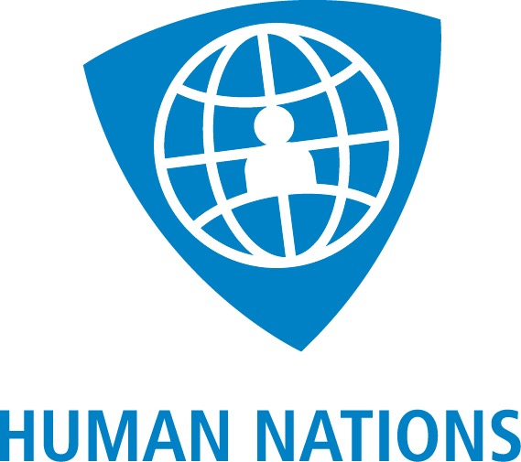

STATEMENT

First Session of the Forum on Human Rights, Democracy and the Rule of Law
21-22 November 2016
Item 5: Moving the global youth agenda forward: the role of youth in shaping the agenda of the United Nations and regional organisations (Tuesday 22 November 3pm-6pm)
Thank you Mr. Alhendawi,
Distinguished delegates and panelists,
Human Nations aims to protect and promote rights of migrants around the world.
Today we have been discussing the participation of youth in SDGs and their role in shaping the agenda of the United Nations and regional organisations.

Allow me please to make a reference to Goal 13 of SDGs which calls on States to work together to help mitigate and adapt to Climate Change and its impacts. Currently there are 65.3 million people displaced globally. According to the Internal Displacement Monitoring Centre since 2008, 21.5 million people become forcibly displaced by weather-related hazards each year. It is projected that combined with other drivers, Climate Change will drastically increase the magnitude of displacement in the future. We really appreciated the intervention by the distinguished delegate of Argentina on the rights of refugees and internally displaced persons.

Displaced persons, whether IDPs, refugees or persons on the move are one of the most vulnerable people without access to basic rights. They are the ones who will bear the biggest impact of Climate Change as most of them are situated in developing countries. Many of them are young individuals who do not understand international mechanisms including those of the UN, a point also raised by Mr. Alhendawi in the context of Human Rights Council. In fact, many of the refugee and internally displaced youth view the UN and regional organisations with scepticism as the organisation struggles to cope with major challenges globally including protecting their rights.

We were very pleased with the appointment of Mr. António Guterres as the next Secretary General, someone who has a wealth of experience in the field of refugee protection and displacement. We do look forward to see the United Nations benefit immensely from his experience in tackling major challenges.
However, given the lack of information or access to it due to the dire situations of displaced persons, we would like encourage a debate around the role of young internally displaced persons and refugees in moving the global youth agenda forward. They possess the talents, they need opportunities.

I thank you.

