Questionnaire for Civil Society by the

UN Special Rapporteur on the situation of human rights defenders

Mary Lawlor, August 2020

The UN Special Rapporteur on the situation of human rights defenders, Ms. Mary Lawlorinvites you or your organizationto respond to the questionnaire below. Submissions receivedwill inform thethematic report of the Special Rapporteur on the issue of killings of human rights defenders, which will be presented to the UN Human Rights Council in March 2021.

The questionnaire and related concept cote on the report are available at OHCHR website in English (original language) as well as in French, Spanish, Russian and Arabic (unofficial translations): (https://www.ohchr.org/EN/Issues/SRHRDefenders/Pages/SRHRDefendersIndex.aspx).

All submissions received will be published in the aforementioned website, unless you/your organization clearly indicated that you did not wish to have your input be made publicly available when submitting your response.

There is a word limit of 2500 words per questionnaire.Please submit the completed questionnaire to defenders@ohchr.org

Deadline for submissions: 5 October 2020

Contact Details

Please provide your contact details in case we need to contact you in connection with this survey. Note that this is optional. (edited for public release)

Type of Stakeholder (please select one) | Civil Society Group or Organisation  Individual human rights defender  Academic/training or research institution  Other (please specify):
Name of Stakeholder/Organization (if applicable)  Name of Survey Respondent | IBON International Foundation, Inc.
Email

Telephone

Address

Can we attribute responses to this questionnaire to you or your organization publicly? | Yes No  Comments (if any):

Questions

Human rights defenders are persons, who individually or in association with others, work peacefully to promote and protect universally recognized human rights and fundamental freedoms, in accordance with the UN Declaration on Human Rights Defenders.

1) Have you, any of your colleagues or your organization received online/offline threats and attacks since 1 January 2019 up 30 June 2020?

Yes, we have received online and offline threats in the period concerned.

2) If yes, can you please detail and in the case of Facebook preferably provide screenshot with URL?

IBON International is a Southern-based capacity development organisation for people’s rights and democracy, with our central offices based in the Philippines. The Philippine government has been actively branding IBON, encompassing both ourselves and our mother organisation IBON Foundation, as a “front” of the Communist Party of the Philippines (CPP). The CPP and its rural-based armed movement the New People’s Army (NPA) are targets of “counter-insurgency” operations, and the state attempts to classify the said groups as “terrorists” under national law. Thus all organisations and individuals branded as “fronts” are rendered targets of state security forces—tantamount to death threats that endangering the lives of those working on issues of social, economic rights and state accountability.

A recent, major “tagging” case against IBON appears in an official government report (Image 1), “consolidated by the Department of Foreign Affairs based on the information provided by various Philippine government agencies concerned,” and submitted to the UN level. The official social media page of the recently institutionalised “National Task Force to End Local Communist Armed Conflict” (NTF-ELCAC) also classified IBON in the same manner (Image 2). These have been various articles on state media, public statements of the same officials on news platforms, and in March 2019 statements of a government delegation to European Union officials.

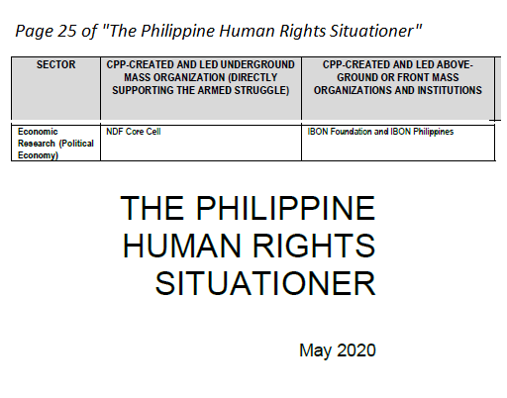

Top: Image 1 / Bottom: Image 2

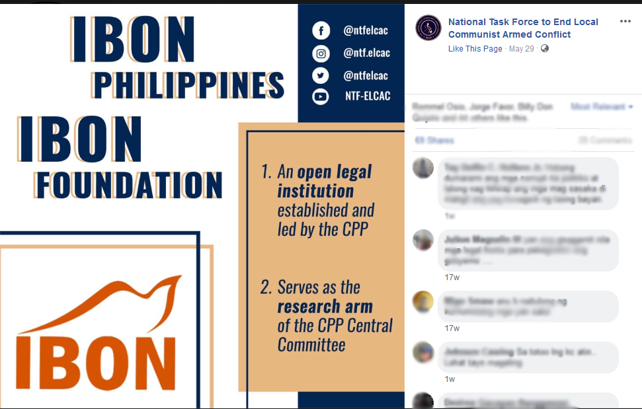

The recent report of the Office of the High Commissioner on Human Rights (OHCHR), also called the Bachelet report, acknowledges cases where “those who have been red-tagged were subsequently killed.” In this state logic, the report continues, “Human rights advocacy is routinely equated with insurgency,” with “’red-tagging’...pos[ing as] a serious threat to civil society and freedom of expression.”

While these threats against Philippine rights defenders and CSOs predate the Duterte administration, with the Bachelet report noting that it has been occurring “[f]or decades”, under the current administration has IBON witnessed firsthand explicit attacks and threats in this manner.

3) Did any of these threats/attacks escalate into killings - can you please chart the path as you see it?

Cases of red-tagging have shown that it can be accompanied by surveillance and direct death threats (e.g., anonymous messages, etc.), which could later lead to killings and other forms of rights violations such as harassment, criminalisation and arrests on false charges.

The threats to IBON have so far prevented at least two (2) of our senior officers’ return to the Philippines from fears of reprisal. A member of the IBON International Board of Trustees (BOT), with a long history in organisations for Indigenous rights in the Cordillera region, has been repeatedly “red-tagged” as well. The said member of our BOT was also included in a 2018 attempt of the Philippine Department of Justice (DOJ) to proscribe more than 600 individuals, including other rights defenders, as “terrorists”—with most of the names only dropped due to outcry from civil society.

While the threats have not yet resulted to killings against our staff, various cases of “red-tagged” Philippine organisations show clear evidence that these threats do escalate into killings. Some individuals in the abovementioned proscription list later became victims of extrajudicial killings themselves. We are writing now precisely to forward our urgent concern, towards preventing the existing threats against us from ever materialising into killings against our staff, and towards contributing to ending the killings of other rights defenders.

We stress that CSOs must able to perform their roles as independent development actors, unhampered from threats and state reprisals. Dissent and vibrant CSO working for people's rights and welfare are essential components of democracy—and claims to “democracy” are already challenged if the state specifically targets legal CSOs for touching upon rights issues and advocacy on systemic changes. It is state responsibility to ensure human rights-based approaches in development and governance processes, including to ensure accountability especially of the big private sector where their operations conflict with people’s rights.

4) Have any of your colleagues been killed since 1 January 2019 up to 30 June 2020?

As indicated above, fellow rights defenders in the Philippines have recently been killed.

By August 2020, seventy-one-year-old peasant advocate Randy Echanis was killed in his own rented apartment amid militarised police presence in Manila, with evidence of torture and prolonged suffering. Community health worker and woman rights defender Zara Alvarez was killed, amid the pandemic, in Negros province, central Philippines. In Cotabato, southern Philippines, Indigenous Lumad-Manobo leader Bae Merlin “Milda” Ansabu Celis, known for defending ancestral lands from corporate plunder of Dole Stanfilco, was brutally killed. Other cases, of false charges and even a disappearance of a red-tagged development worker, have been documented as well.

As the UNHRC held its recent 45th Regular Session this September, the European Parliament adopted a resolution condemning the extrajudicial killings, threats, harassment and intimidation of human rights and environmental activists including Zara Alvarez, Randall Echanis as well as activist Jory Porquia, trade unionists and journalists.

5) If so in what context did the killing(s) occur? Have there been any convictions for the killing(s)?
The killings occur in contexts of these organisations’ and individuals’ work on different rights concerns, from civil-political rights, social, economic and cultural rights, including peace advocacy based on socio-economic justice.

The following are recently established institutions pertinent to the current threats and killings: the inter-agency “National Task Force to End Local Communist Armed Conflict” (NTF-ELCAC) as per Executive Order No. 70 of the President, and the loose and overbroad definition of “terrorism” in the widely condemned Anti-Terrorism Act of 2020 further ossify the repressive state policy and practice against CSOs.

These occur in a broader national political climate in the Philippines, of state violence in purported campaigns against “drug-related” crime; the close ties of the current administration to the military as well as to the relatives of ousted and deceased dictator Ferdinand Marcos; the militarisation especially of national executive agencies; the militarised response to the pandemic amid gaps in necessary healthcare, housing, and other services; the deteriorating press freedom and the exposed links of the military and police to fake accounts and “inauthentic” social media behaviour that target activists; and armed conflict especially in the rural areas in context of long-running barriers to people’s democratic rights and welfare.

6) Do you normally report death threats? If so, where?
In the case of direct threats via “red-” and “terror-tagging” against IBON, major security institutions, including the abovementioned NTF-ELCAC, are responsible. The overall channels for grievances within domestic mechanisms are challenged by the abovementioned context and—as described in the Bachelet report—“impunity.” State “counterinsurgency” campaigns have precisely licensed political killings and other attacks.

We therefore reported our grievances to the country’s national rights institution, the Commission on Human Rights (CHR) in late-February 2019. The CHR, which received similar concerns from various CSOs as well, later made public statements calling to rescind the national Executive Order that created the NTF-ELCAC, and condemned such state practices against CSOs.

However, security officials and the NTF-ELCAC only responded with disdain, with high-ranking military official claiming that the CHR is just “continuously parrot[ing]” lies “in synch with the [calls for a] United Nations Commission on Human Rights investigation” on the rights situation. Outside the period being covered in the study, we also submitted a letter of concern to the Department of Justice, left unheeded.

Despite criticisms from the national CHR, the budget allocations for the NTF-ELCAC is bound to drastically increase, from PhP 622.3 million (USD 12.8 million) in 2020 to PhP 19.3 billion (USD 398.5 billion) in 2021—a proposed allocation three times higher than for COVID-19 response. Despite claims of the Philippine government panel on extra-judicial killings, this has neither led to conviction, prosecution, nor justice that matches the systematic nature of the killings.

7) What in your/Organization’s experience has worked well to respond to death threats? And to prevent them from escalating into the actual killing(s) of human rights defenders?
To defend our staff, we have continued internal capacity development on practical concerns on human rights, democracy, and have stressed the importance of vibrant civil society. The mandate of IBON International is the capacity development for people’s rights and democracy in the global South. We highlight community organising and empowerment of the grassroots as a first line of defence, as well as a basis for assertions, of rights vis-a-vis state repression and concerns on transnational firms.

In the particular case of the Philippines, campaigning for domestic and international solidarity of civil society and other relevant actors, towards driving the government to abide by its supposed rights commitments, have also acted as a concrete response to state-licensed threats. The efforts of peoples’ organisations and civil society, amid the Philippine government’s threats, have been essential in bringing attention on the Philippine rights situation to international concern, with their conscientious work in monitoring and reporting cases and trends.

We thus put importance to being active in national campaigns and in efforts for international solidarity towards accountability and justice. A network of Philippine development CSOs, the Council for People’s Development and Response, joined in submitting a Supreme Court petition against the Anti-Terrorism Act of 2020, asserting that the law will “seriously hinder its members from continuing their development work, for it will legitimize...red-tagging, abduction as well as incarceration on trumped-up charges, and even extra-judicial killings.”

We consider as essential the rescinding of national policies that enable continued rights violations, and the full use of all mechanisms—including at international level—to respond to threats and bring justice in cases of killings. In the case of the UN Human Rights Council and the Philippines, the challenge is to take off from Bachelet report whose concerns on state killings and the recommendations point to an immediate, impartial, transparent, independent and meaningful investigation on the Philippine rights situation.

