Questionnaire for Civil Society by the

UN Special Rapporteur on the situation of human rights defenders

Mary Lawlor, August 2020

The UN Special Rapporteur on the situation of human rights defenders, Ms. Mary Lawlor invites you or your organization to respond to the questionnaire below. Submissions received will inform the thematic report of the Special Rapporteur on the issue of killings of human rights defenders, which will be presented to the UN Human Rights Council in March 2021.

The questionnaire and related concept cote on the report are available at OHCHR website in English (original language) as well as in French, Spanish, Russian and Arabic (unofficial translations): (https://www.ohchr.org/EN/Issues/SRHRDefenders/Pages/SRHRDefendersIndex.aspx).

All submissions received will be published in the aforementioned website, unless you/your organization clearly indicated that you did not wish to have your input be made publicly available when submitting your response.

There is a word limit of 2500 words per questionnaire. Please submit the completed questionnaire to defenders@ohchr.org

Deadline for submissions: 5 October 2020

Contact Details

Please provide your contact details in case we need to contact you in connection with this survey. Note that this is optional. (edited for public release)

Type of Stakeholder (please select one) | Civil Society Group or Organisation  Individual human rights defender  Academic/training or research institution  Other (please specify):
Name of Stakeholder/Organization (if applicable)  Name of Survey Respondent | IRAQI ALAMAL ASSOCIATION &  Al-Namaa Center for Human Rights
Email

Telephone

Address

Can we attribute responses to this questionnaire to you or your organization publicly? | Yes No  Comments (if any):

Questions

Human rights defenders are persons, who individually or in association with others, work peacefully to promote and protect universally recognized human rights and fundamental freedoms, in accordance with the UN Declaration on Human Rights Defenders.

- Have you, any of your colleagues or your organization received online/offline threats and attacks since 1 January 2019 up 30 June 2020?

Yes, Human Rights Defenders working at Iraqi Al-amal Association and specialized in following up on human rights cases and issues , received and have been subjected to direct and indirect threats, the methods of threats varied from online to personal.
Iraqi human rights organizations, which are considered to be the point of access to information on violations and linkages to international comuinty and global public opinion ,all receiving increasing threats targeting their NGOs and individuals.

- If yes, can you please detail and in the case of Facebook preferably provide screenshot with URL?

Online death threats varied through using:
- Messages of death threats from fake accounts on social media.
- Comments on human rights defenders’ posts instigating killings and accusing them of treason.
- Using pictures of human rights activists and defenders, which were taken during meetings with foreign organizations or diplomatic missions, as tool for threatening and instigating killings by linking them to fabricated news reports.
- Militias use chat groups, Telegram channels and “troll armies”, paid blogger working towards specific agenda, to systematically defame human rights defenders in order to instigate killing them along with sending threats such as “Sabreen News Network” and “Zlem Al Shayb’.
- Targeting human rights defenders’ profiles for hacking and tracing, exploring network of advocates, and stealing steal data and photos of the defenders, using them later as threats.
- Reporting attacks targeting defenders and their work on human rights, carried out by militias’ troll armies.

Personal Attacks in Real Life:
- Text messages and direct threatening phone calls by anonymous number unregistered at communication companies.
- Verbal warning sent to defenders by militias through colleagues and relatives to leave civil work or be killed.
- TV channels affiliated to militias broadcasting programmes and TV interviews of some politicians who are affiliated to influential actors, accusing human right defenders of treason.
- Targeting human rights defenders homes with live ammo and sound grenades.
- Kidnapping human right defenders and blackmailing them by forcing them to sign written pledges.
- List of HRDs names circulated among social media and all been subjected to threats.
- Arbitrary detentions of human right defenders charging them with malicious accusations that amount life in prison and including them in terrorism related charges.

URL & screenshots:
https://t.me/sabreensecond?fbclid=IwAR04bI-ho6WTg8zgRVs0iMcmAwid_tMkHEgCYpCrxsgWYDrBCFuHAeFYwho

https://www.facebook.com/story.php?story_fbid=114099263285634&id=107700820592145&sfnsn=wa

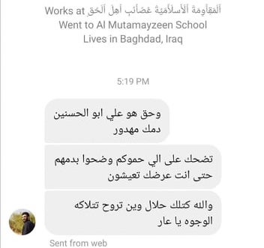
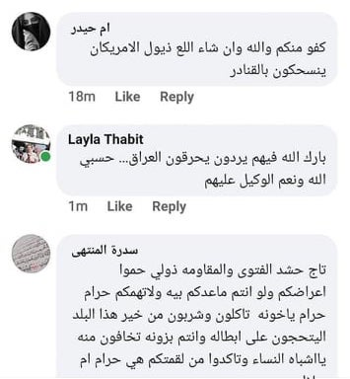
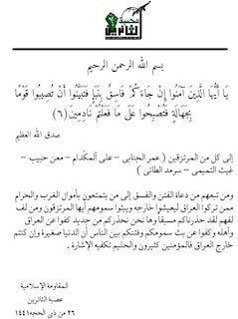

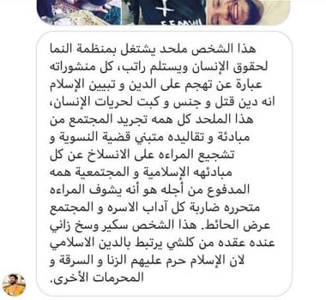
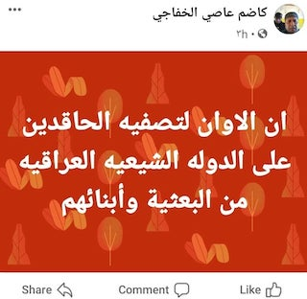
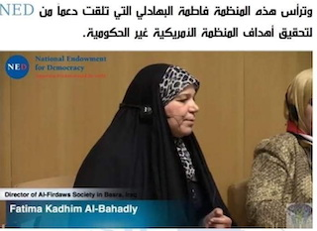
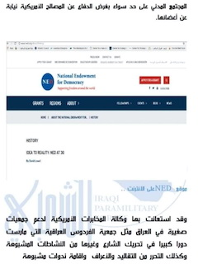
- Did any of these threats/attacks escalate into killings - can you please chart the path as you see it?

Most of the assassinated human rights defenders in Iraq were sent death threats via social media and SMS messages prior the assassination, this was preceded by systematic campaign included accusation of treason and defamation through using images and videos attached with fabricated news which led to their murder, and these operations coincided with increasing tensions of the popular protests demanding basic services, political system reform, and ending corruption.

- Have any of your colleagues been killed since 1 January 2019 up to 30 June 2020?
Attached below, a list of assassination cases of Iraqi Human Rights Defenders within the period mentioned above:

No. | Name | Governorate | Date
1 | Dr. Alaa Mashthoob | Kabala | 2/2/2019
2 | Sara Talib (pregnant & her husband Hussien Adel | Basra | 2/10/2019
3 | Muntasr Sa’di Ibrahim | Dhi Qar | 25/10/2019
4 | Haider Al Qbtan | Babel | 25/10/2019
5 | Safaa’ Al Sarai | Baghdad | 28/10/2019
6 | Amjed Al Dahamt | Maysan | 6/11/2019
7 | Ali Al lami | Baghdad | 10/11/2019
8 | Adnan Rustem | Baghdad | 16/11/2019
9 | Fares Hilal | Baghdad | 25/11/2019
10 | Ahmed Kareem Al Maliki | Basra | 28/11/2019
11 | Zahraa Ali Salman | Baghdad | 3/12/2019
12 | Fahem Al Ta’i | Karbala | 8/12/2019
13 | Haqi Ismail Al Azzawi | Baghdad | 15/12/2019
14 | Mohammad Jasem Al Dujaili | Baghdad | 15/12/2019
15 | Thair Kareem Al Taib | Deiwanya | Injured on 15/12/2019 and died on 24/12/2019
16 | Ahmed Al Mhena | Baghdad | 17/12/2019
17 | Ali Khaled Al Khafaji | Dhi Qar | 20/12/2019
18 | Ali Mohammad Al A’smi | Dhi Qar | 20/12/2019
19 | Ahmed Abdul Samad & Safaa Ghali (both TV team) | Basra | 10/1/2020
20 | Hassan Hadi | Dhi Qar | 13/1/2020
21 | Yousif Satar | Baghdad | 20/1/2020
22 | Jinan Mathi Shahmani (Um Jinat) | Basra | 21/1/2020
23 | Dr. Mohammad Hussien Al Quraishi | Baghdad | 28/1/2020
24 | Mohanad Wamidh Qais | Najaf | 5/2/2020
25 | Mohammad Harb | Baghdad | 14/2/2020
26 | Alaa Kamel Al Shemeri | Baghdad | 25/2/2020
27 | Mohammad Ali (Mokhtar) | Baghdad | 25/2/2020
28 | Ali Al Helfi | Basra | 3/3/2020
29 | Abdul Qedoos Al Helfi | Maysan | 10/3/2020
30 | Karar Adel | Maysan | 10/3/2020
31 | Anwar Jasim (Um Abbas) | Dhi Qar | 5/4/2020
32 | Azher Al Shemeri | Dhi Qar | 9/5/2020
33 | Ali Muzher Al Ghazi | Di Qar | 11/6/2020
34 | Hisham Al Hashemi | Baghdad | 6/7/2020
35 | Latif Osama Salman | Baghdad | 26/7/2020
36 | Mehdi Al Temimi | Baghdad | 26/7/2020
37 | Tahseen Osama | Basra | 14/8/2020
38 | Dr. Riham Yaqoob | Basra | 19/8/2020

Below a list of failed assassination attempts:
No. | Name | Governorate | Date
1 | Majeed Al Zubaidi | Maysan | 31/10/2019
2 | Bassam Mehdi | Maysan | 6/11/2019
3 | Mohammad Al Saadi | Maysan | 22/11/2019
4 | Jawad Al Hreshawi | Maysan | 22/11/2019
5 | Samad Al Shatri | Dhi Qar | 30/11/2019
6 | Mohanad Al Ka’bi | Karbala | 8/12/2019
7 | Ehab Al Wazni | Karbala | 8/12/2019
8 | Bassem Al Zubaidi | Maysan | 9/12/2019
9 | Ali Al Medni | Diwanya | 15/12/2019
10 | Hussien Naeem | Maysan | 22/12/2019
11 | Hassan Najem | Maysan | 21/12/2019
12 | Mohammad Abdul Adhim | Dhi Qar | 10/1/2020
13 | Munther Al Jboori | Babel | 15/1/2020
14 | Nahawand Turki | Dhi Qar | 19/1/2020
15 | Fatima Ali | Basra | 21/1/2020
16 | Ali Maarej | Dhi Qar | 12/1/2020
17 | Mohammad Al Kaabi | Karbala | 20/5/2020
18 | Weaam Al Sharawi | Maysan | 6/6/2020
19 | Tahseen Al Abadi (Abo Asaad) | Deiwanya | 20/6/2020
20 | Mohammad Abdul Ameer Al Helo | Maysan | 13/7/2020
21 | Khaled Al Samer | Basra | 17/7/2020
22 | Wesam Al Dhahabi | Dhi Qar | 14/8/2020
23 | Abbas Subhi | Basra | 17/8/2020
24 | Ludia Rimon | Basra | 17/8/2020
25 | Fahad Al Zubaidi | Basra | 17/8/2020
26 | Hashim Hamza Al Jeboori | Baghdad | 19/8/2020
27 | Entisar Nahi Fleih | Baghdad | 19/8/2020
28 | Zaydon Emad | Baghdad | 19/8/2020
29 | Dr. Mohammad Al Mansoori | Babel | 20/8/2020
30 | Adnan Al Khar | Babel | 20/8/2020
31 | Mohammad Jaber | Babel | 20/8/2020
32 | Haider Kadhem Abbas (Abo Shahema) | Dhi Qar | 23/8/2020

- If so in what context did the killing(s) occur? Have there been any convictions for the killing(s)?

- using motorcycles and four-wheel drive vehicles with tinted windows and no registrations plates in the assassinations via light firearms and firearms equipped with silencers.
- Planted IEDs in human rights activists and defenders cars and their houses.
- Stabbing with knives.
- Snipers, tear gas bombs, animal hunting guns and live bullets used by security forces in order to disperse the protests which occurred in the beginning of October 2019.
- Snipers and animal hunting guns .

Despite tens of HRDs killed and threated, all the condemnations regarding human rights defenders assassinations, issued by Amnesty, Human Rights watch and Golf center for Human Rights were very powerful and affective while condemnations from OHCHR, foreign embassies, UNAMI, international organizations, and the UN Special Rapporteur on the situation of human rights defenders, were very timid and did not include all the assassinated defenders, they were limited and issued as a blanket statement, we did not notice any mentioned coordination or cooperation among the bodies above to pressure the government in conducting transparent investigations and stopping killings of human rights defenders.

- Do you normally report death threats? If so, where?

Iraqi human rights defenders report death threats to international human rights organizations, UNAMI, and diplomatic missions, in addition to local organizations working in the field of protection of human rights defenders.
While the human rights defenders do not resort to submitting official reports to relevant government authorities- law enforcement- regarding the threats they receive, since they do not trust security facilities and their investigation measures to unveil perpetrators of sending death threats and weakening the rule of law, especially in some areas dominated by militias where they control sensitive security position, moreover, reporting to specialized courts will escalate killings of human rights defenders and their protectors.
Al-Namaa Center for Human Rights documented cases of security actors’ request of human rights defenders to leave their territories and flee to other safe areas, indicating government’s inability to provide safety and protection measures, deterrence, and mitigating militias’ authority in the cases of death threats.

- What in your/Organization’s experience has worked well to respond to death threats? And to prevent them from escalating into the actual killing(s) of human rights defenders?

Field experiences have proven that active coordination between CSOs and issue continues joint statements helped to release abducted HRDs and save them from been killed, in addition
responding to death threats by moving away from armed groups’ sight, leaving civil work and human rights advocacy, and shutting social media pages are one of the easiest and most effective ways to prevent escalation to actual killings.
Still, the perfect way to preserve the life of defenders is vacating them for relocation in safe areas where they are unrecognized, but this choice is very limited due to lack of funding in this area, and lack of financial allocations by the donors considering the increasing number of defenders at risk of threats and danger.

