Response to the Questionnaire from the UN Special Rapporteur on the situation of human rights defenders

 | Question | Answer
1 | 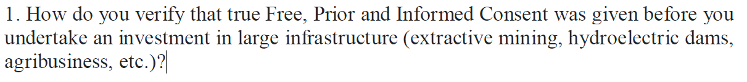 | Our environmental and social risk management framework requires that we require FPIC whenever indigenous people may be impacted by project activities. Our Environmental and Social due diligence (ESDD) requires us to verify that FPIC was given, in all such cases where it is applicable. In our ESDD we analyse, and triangulate information provided by the client as well as third parties and public sources, and community consultations. This includes information about both, the prospective project, and the context. In addition, we often carry out field visits and utilize external specialist consultants to provide deeper analysis and insight.
2 | 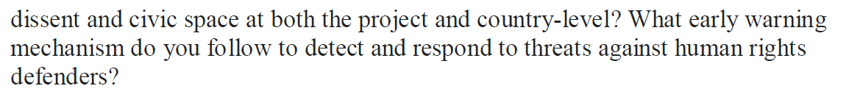 | At the beginning of our investment process, we assess the risks related both to the context and to the project. In addition, regarding our existing investments, we continuously monitor the human rights matters in the project and its context. One of the tools we use is a human rights context screening list, that has criteria regarding for example the fragility of the state, existing and pact conflicts, the level of democracy/civil freedom in the country, past statistics about deaths of human rights defenders, status of the civic space, corruption levels, known or expected opposition to the sectors, country human rights situations etc. We use different sources of information and tools, including for example:  - world bank list of fragile countries http://pubdocs.worldbank.org/en/179011582771134576/FCS-FY20.pdf  - global conflict tracker webpage https://www.cfr.org/interactive/global-conflict-tracker/?category=us  - civicus monitor index and watch list on situation of the civic space https://monitor.civicus.org/  - Transparency international index https://www.transparency.org/country  - annual reports and alerts/appeals by frontline defenders https://www.frontlinedefenders.org/  - https://freedomhouse.org/  - ITUC workers rights information  - business and human rights resource center  In addition, we monitor e.g. media outlets and social media platforms) as well as receive alerts and appeals from frontline defenders and NGOs, which are providing us with early warnings. For certain specific projects or situations we may also have specific conversations with Finnish NGOs having presence and/or partners in our countries of operation. All these tools help us assess the risks.
3 | 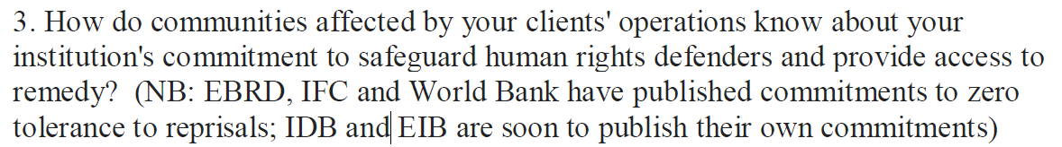 | Our human rights statement, including wording on human rights defenders is available in English and in Finnish on our homepage: https://www.finnfund.fi/wp-content/uploads/2019/01/Finnfund-Human-Rights-Statement_Final-ENG_230119.pdf  Our grievance mechanism is accessible to anyone on our webpage and allows for anonymous complaints. We have a specific team and procedure to address any complaint. The principle of confidentiality etc. is also explained on this “Complaints and whistleblowing” webpage.  Information on all our investments, based on our Disclosure Policy, is available on our homepage, after the investment agreement has been signed.
4 | 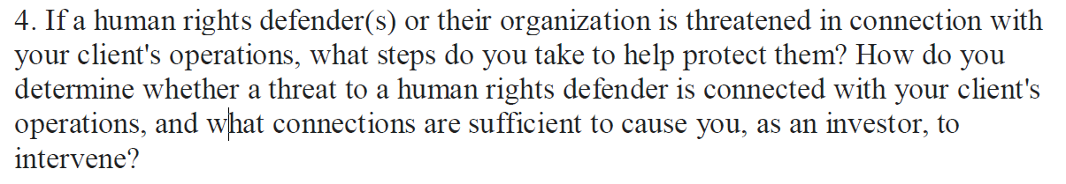 | In that case, we would seek further information from multiple sources, including public information (e.g. media), engaging with our client, engaging with civil society advocates in the project-affected area, in the country of operations, and/or in Finland – and wherever it is possible and would not put human rights defender(s) (HRDs) at further risk, with the human rights defenders themselves.  We would then seek to use our leverage to influence relevant actors to take appropriate steps to respect the rights of the HRD(s). Our leverage will often be greatest directly with the client, and we would seek to influence the client to take steps to ensure respect for HRD’s rights. In other situations, it may be that we need to seek to influence the host government. In either case, we may need to build additional leverage, though engagement with the Finnish government and its local embassy, with other financiers, and perhaps with other project partners We are also prepared organizationally to speak out publicly in support of the rights of any stakeholder to raise concerns or objections connected to projects we finance. We are currently planning to develop a clear organizational framework for leverage and remedy, which would further build out the tools we might use to build our leverage in such cases.  In principle, we would always intervene anytime there is credible information about a threat to human rights defenders; first by gathering information and through that, engaging with clients about the risks we are concerned about, and then by steadily escalating our leverage efforts as needed.
5 | 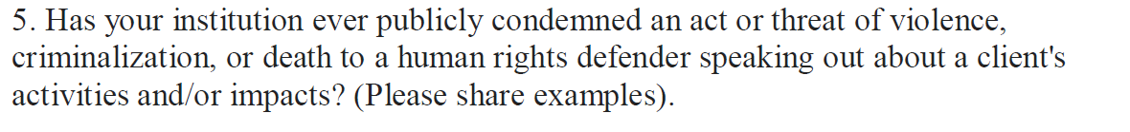 | Yes, we publicly and repeatedly condemned the murder of Berta Cáceres which took place in March 2016 in Honduras and was linked to the Agua Zarca project, which was our investee. Due to this tragic event, we suspended all financing and finally exited the project.
6 | 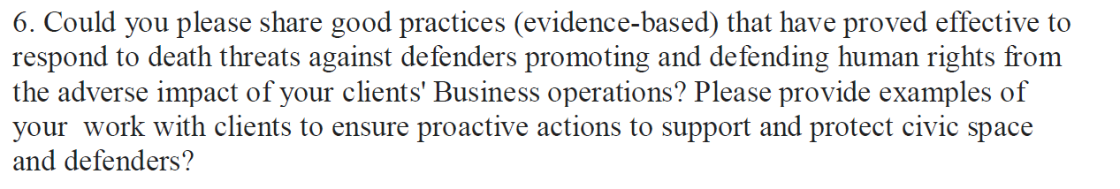 | We continuously work with our clients on the quality of their stakeholder engagement, the quality of their environmental and social impact and risk assessment as well as on the adequacy of their grievance mechanisms. We have also good experiences of promoting Human Rights sensitive approach and understanding within our investees on all levels of their operations, incl. management. In practice, this can include e.g. creation and developing of channels and platforms to develop dialogue with HRDs, local communities, civil society etc. as well as with various actors dedicated to protecting HRDs, such as EU embassies.

