Confined in a shanty: extreme poverty and surviving COVID-19

Cristóbal Ruiz Román, Jesús Juárez Pérez-Cea,
Lorena Molina Cuesta, José Manuel de Oña Cots and David Herrera Pastor
(University of Málaga)

I. Introduction
With the COVID-19 pandemic stalking the world and destabilising everyone's way of life, in this report we focus on how the pandemic has been experienced in a suburb of the city of Malaga (Andalusia, Spain). A neighborhood of social exclusion where the situation of Covid-19 has only led to the extreme, the survival of all families living here. Los Asperones was created in 1987 with the aim of eradicating slums in different urban areas of the city. With this main objective of dignifying the situation of many families living in subhuman conditions, a slum was built on the outskirts of the city for a five-year transition period. For this purpose, they provided prefabricated housing for this temporary period, at the expense of offering this population decent housing in the city during this period. Today, in the year 2020 and 33 years later, Los Asperones is still standing with a population of approximately 295 families. The houses, which were built for five years, have today become substandard housing, isolated from any public services, has meant a significant element of exclusion for the families who live there. Today, Los Asperones neighbourhood continues to live in a very serious situation of extreme poverty which, over the years, has only increased, damaging the life stories of its neighbours, on a personal, family and community level: problems such as overcrowding, school drop-out, extreme poverty, generalised unemployment, illiteracy, etc. Thus, during the COVID-19 pandemic, the social emergency has only grown. The objective of this report is to inform from the testimonies of the people who have lived confined in the substandard housing and shanties of Los Asperones during the COVID-19 pandemic.

II. Contextualization of the shanty town
Since 2005, the Andalusian Ombudsman has identified Los Asperones neighbourhood as one of the greater shanty towns of Andalusia (Spain). Los Asperones neighbourhood is located on the outskirts of the city of Malaga (Andalusia, Spain) and is in a situation of geographical and social isolation. Physically it is surrounded by different borders. To the north there is a clay extraction quarry and a headquarters for the city's cleaning and waste collection vehicles. To the south, there is a road and underground tracks, next to which is the main extension of the University Campus. To the east, there is a car dealership and a junkyard. And to the west are the city's subway depots and the Municipal Cemetery. Many of these bodies manage different types of waste: material (cars), organic (rubbish), and even human (cemetery) as shown in Image 1. That context has been used to process the city's waste, so however well planned the objectives to eradicate shantytown were 33 years ago, it was not and is not the best place for families to live with their children. After more than thirty years since the creation of this ghetto, the problems have worsened, as shown by the study that we carried out in 2017 from the University of Malaga in collaboration with the neighbourhood technical committee. This study shows the serious social conditions in which the 295 families of Asperones are living, comparable to under-developed countries: high unemployment rate (around 74% before COVID-19), substandard housing and shanty towns, major health problems, very low life expectancy and educational difficulties (Bernedo, Ruiz, Lino and Juárez, 2019).
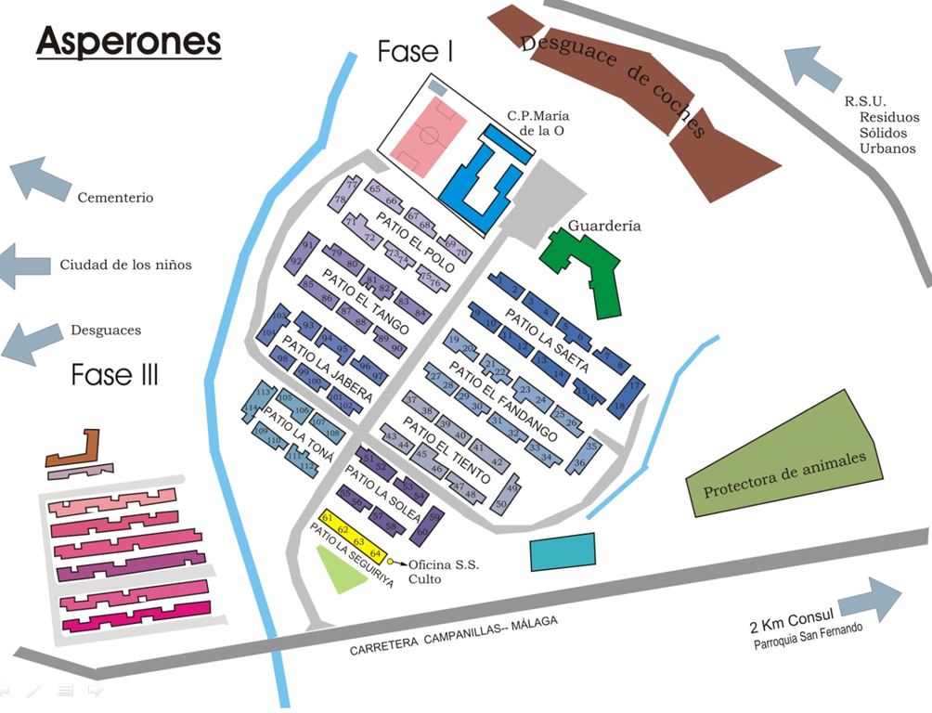
Image 1. Geographical location of Asperones.

This inadequacy of the place where Los Asperones was located is corroborated by the distance that still exists today, despite the growth of the city and the new district of Teatinos created in 2014, between Asperones and some places and services of interest to the population. Line 23 of the city's public buses is the only link between Los Asperones and the city center, since no metro stop has been located near the neighbourhood, despite the fact that the tracks and the depots pass through the neighbourhood. As for public services, the neighborhood has a day care center that serves children from 0 to 3 years, and a primary school. The Compulsory Secondary Education centres that serve the neighbourhood's students are located between 2.5 and 5 km away, the Health Centre is 3 km away, the Community Social Services are 3.5 km away and the nearest pharmacy is 1.5 km away.

III. Information gathering and results
For this brief report, a total of 14 interviews were carried out with different people from the Asperones neighbourhood, mainly residents of the neighbourhood, although some professionals working in the neighbourhood were also interviewed (school teachers and social educators from NGOs). This is a qualitative report without aiming statistical generalization, but with the determination to recognize and make visible the people who have lived confined in a shack during the COVID-19 pandemic. The interviews have been carried out between June 8 and 15, 2020, once Spain and the city of Malaga are in Phase 3 of the de-escalation of the confinement that has occurred by the State of Alarm (BOE, Royal Decree 463/2020, March 14). Also included are photographs and other evidence of the extreme situation of the neighborhood during the pandemic that have appeared in various national and local media (El País, Agencia EFE, Diario Sur and Málaga Hoy)
The results obtained are presented according to the main questions that have been put on the table by people who have lived in this confinement within a shack or an infra-housing.

1. Confined in a shack: overcrowding and lack of habitable conditions

During the confinement decreed by the Spanish Government on March 13, 2020, and until April 27, 2020, children were not been allowed to go out on the streets in Spain. During these 46 days, the families and children of the Asperones neighborhood were confined in substandard housing and shacks. According to the neighbors themselves, these have been the main difficulties they had in their homes.

"The difficulty is in the way of living (...) my house is a ruin, when it rains it leaks, or when it is hot it looks like an oven and there are many bugs. A lot of rats come in" (Neighbor 1 of the Asperones neighborhood).

As explained by the residents and shown in images 2, 3 and 4, the substandard housing and shacks in the Asperones neighbourhood do not guarantee minimum living conditions. The fact that in 1987 the neighborhood was built with the idea of being a transition neighborhood while a solution of habitability for these families was being sought made the public administration provide the neighborhood with prefabricated housing with an estimated expiration of 5 years. 33 Years later these prefabricated homes are very deteriorated: problems with insulation against inclement weather and rodent infestation (due to their proximity to the municipal dump) mean that the homes in this neighbourhood put the health of those who live there at risk. This exposure to unhealthy conditions is made even more pressing by the health risks generated by the pandemic.
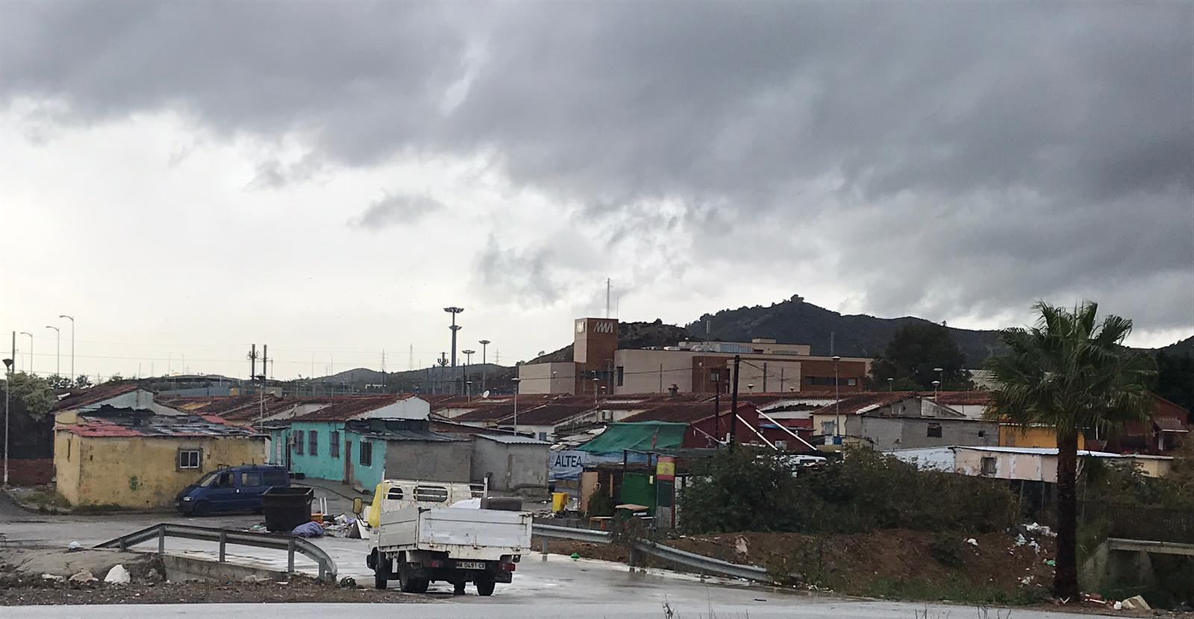
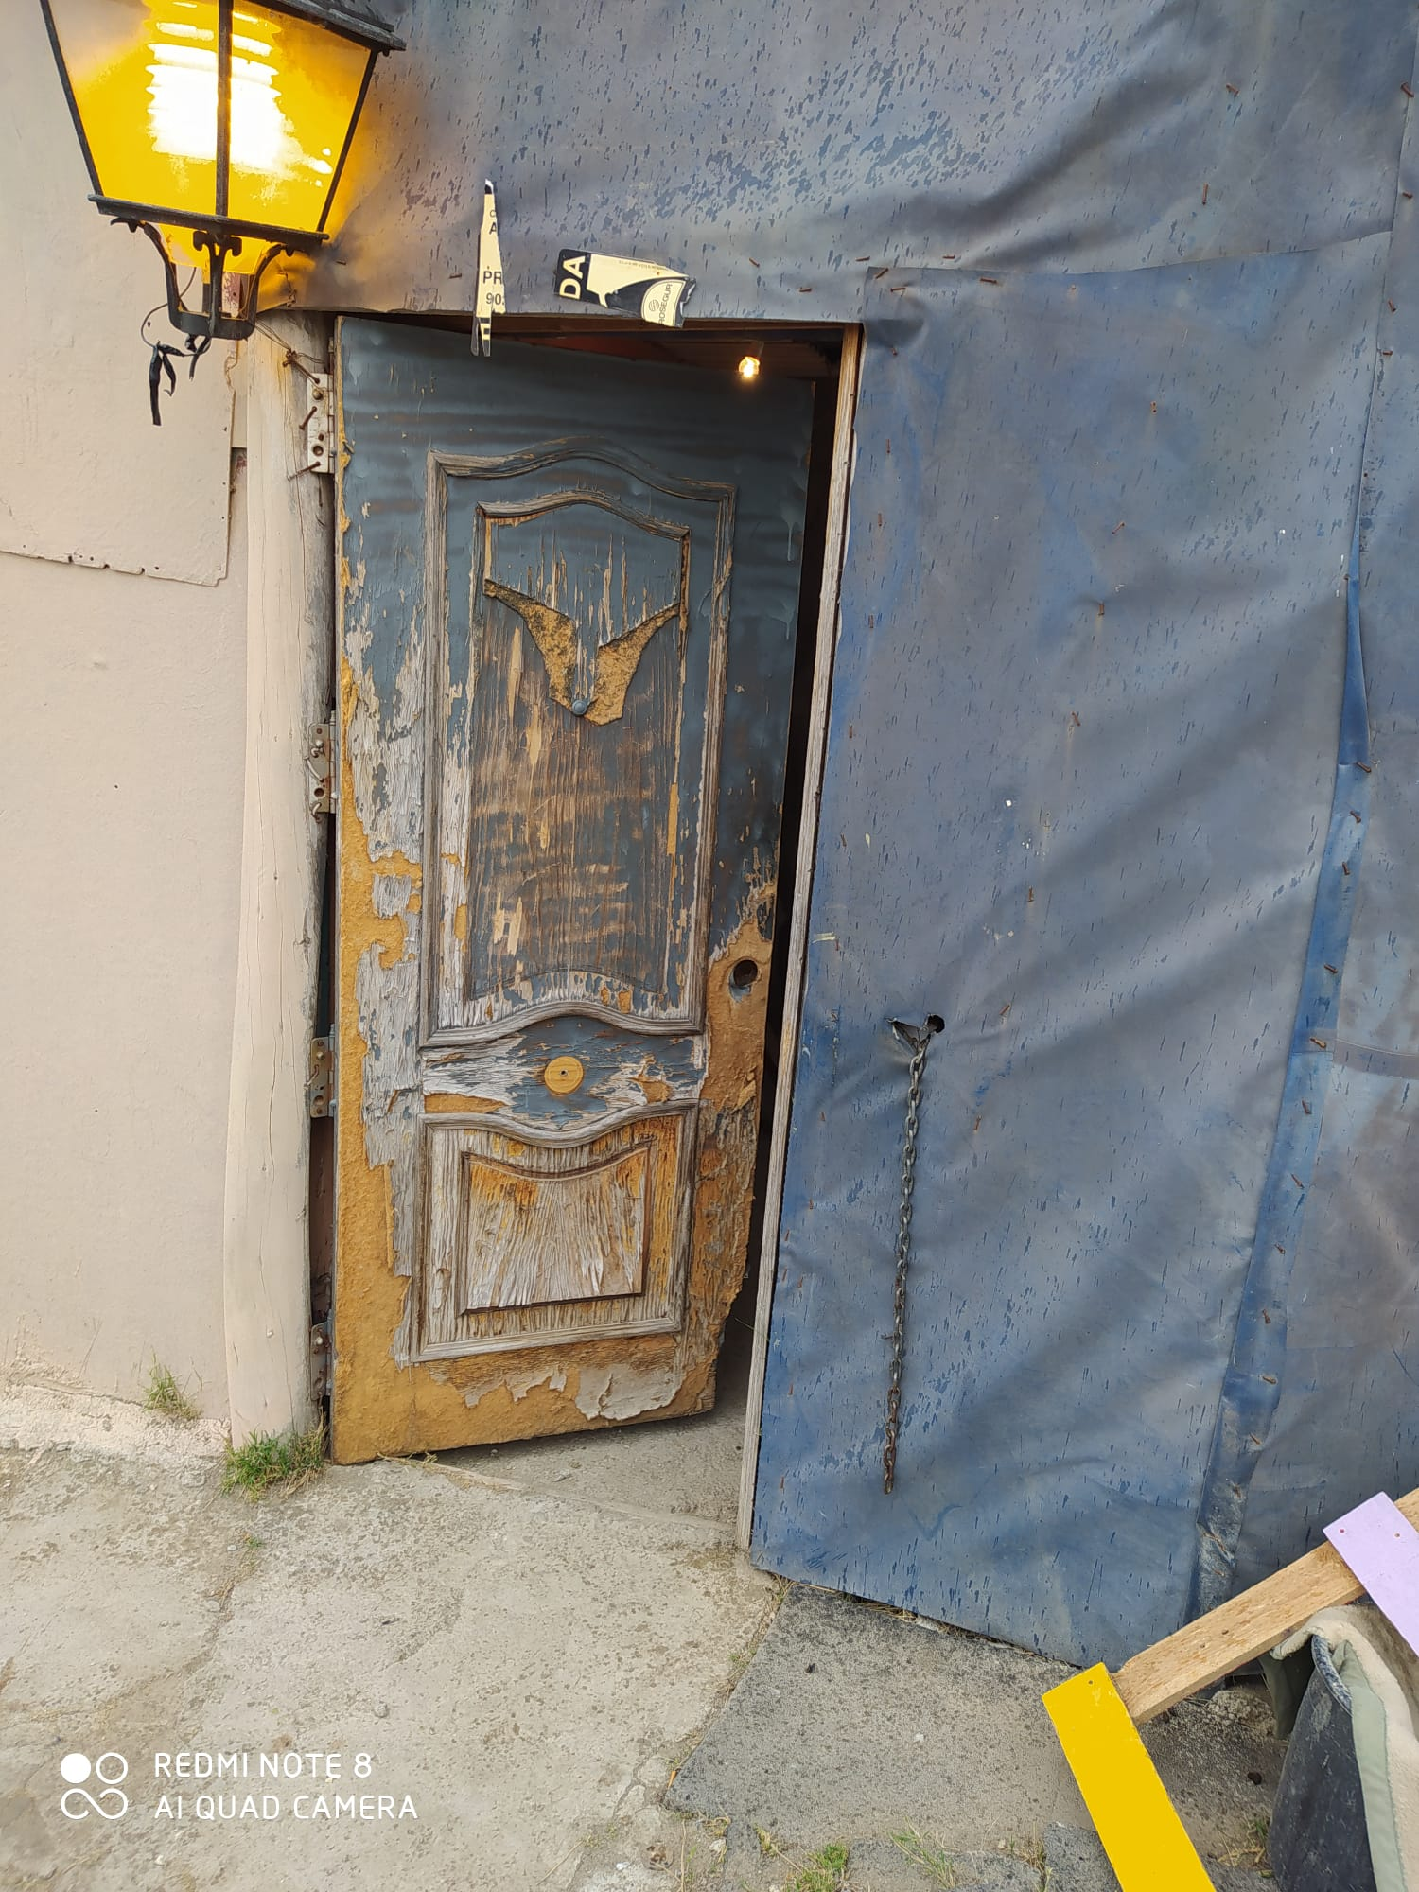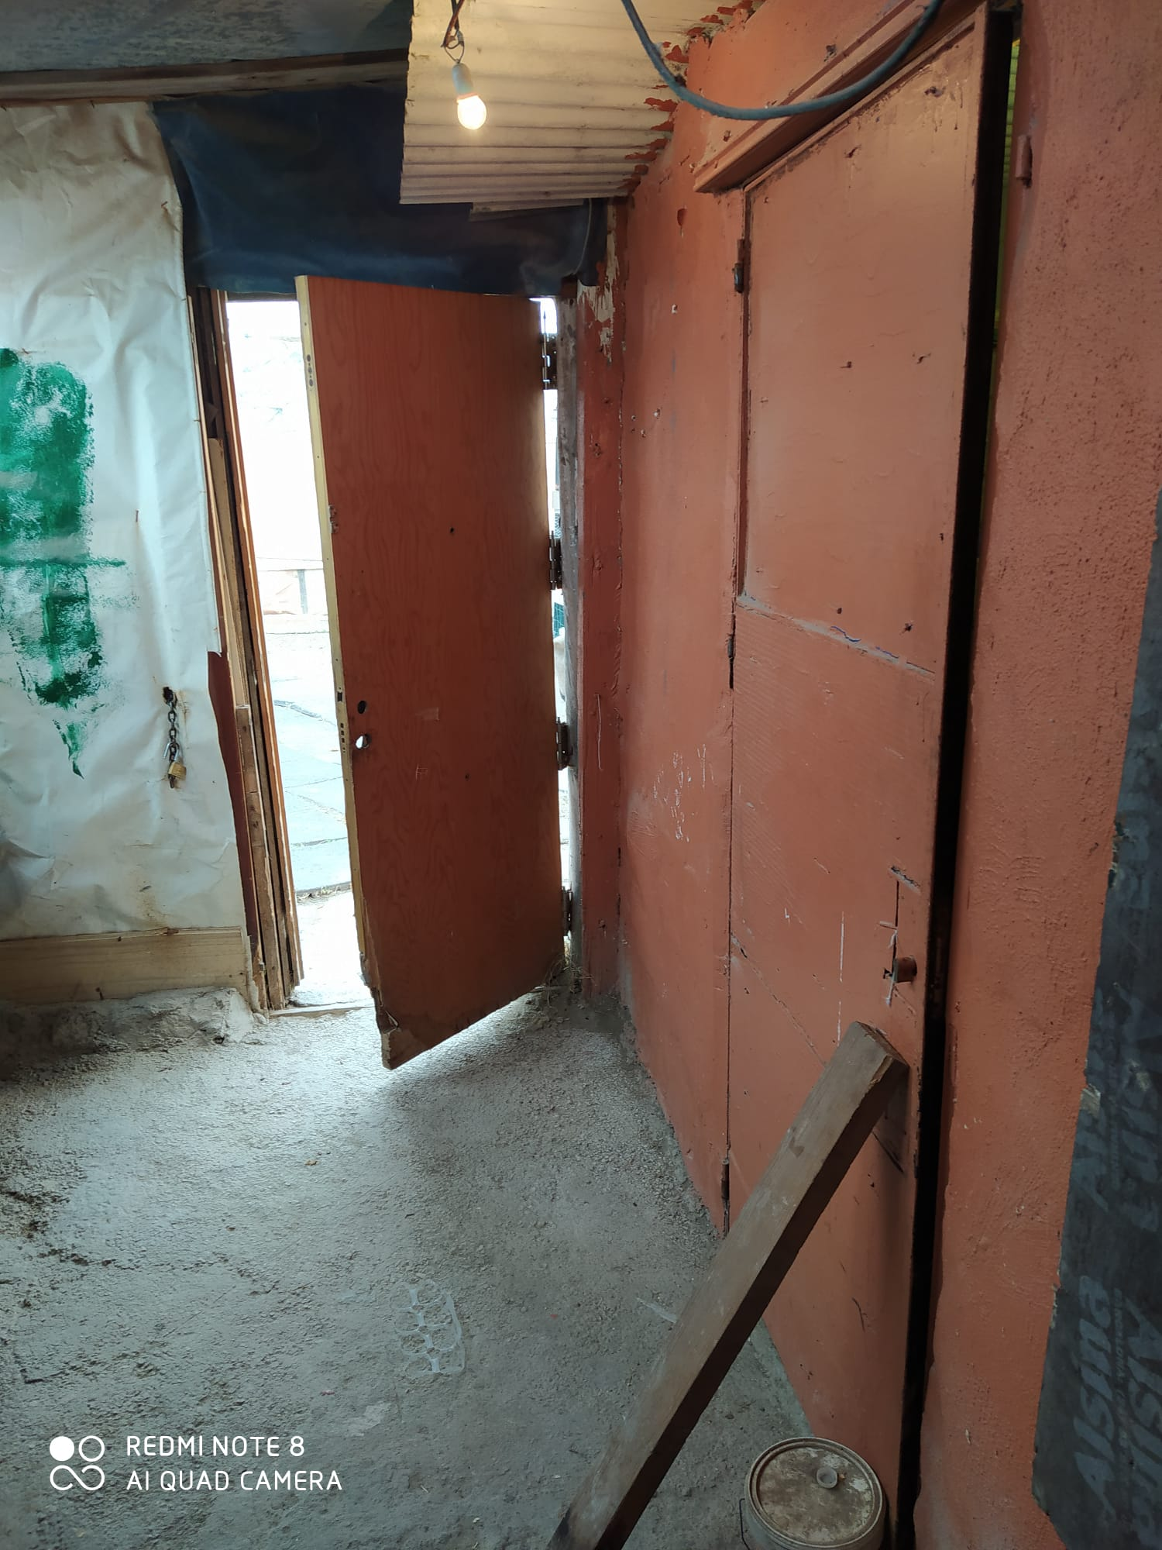
Pictures 3, 4 and 5. Los Asperones' substandard homes and shacks

Within these health conditions we must also report the size of some of these shacks. Homes in some cases no larger than 20 square meters. Where families with children have had to be locked up during confinement in Spain.

"My house is very small. A hovel Wow. And there we've been locked up. With a lot of sacrifice, but well, there we have been..." (Neighbor 8 of the Barrio de los Asperones).

"The atmosphere in the house has been terrible,... a lot of hunger, a lot of fights,... My house is 6 meters long and 4 meters wide. It's a small house and then the kids are in there all day fighting" (Neighbor 4 from Barrio de los Asperones).

"The children have had a hard time because they were locked up all day and they wanted to get out" (Neighbor 7 from the Asperones neighborhood).

"The kids were very nervous because they wanted to go out and we wouldn't let them and my house is very small. We explained it to the children" (Neighbor 5 of the Barrio de los Asperones).

"My kids awful, unable to get out, because they don't understand. All day long, crying, all day long, screaming. And that you don't see. I'm terrible." (Neighbor 12 of the Barrio de los Asperones).

The first studies on the psychological effects of the pandemic on people and children are currently being carried out, but there is no doubt that overcrowding as extreme as that experienced by some children in the Asperones makes us think that it does not guarantee their psychological and emotional well-being and that of their parents. The overcrowding and lack of living conditions in these substandard homes are compounded by the lack of furniture and household items. A lack caused by the situation of extreme poverty in which most of the neighbours of the neighbourhood live.
"There are families of 5 members who are spending the quarantine in a room with a bathroom, a couch, two mattresses, a light bulb, a small TV, a shaking refrigerator and a leaking boiler" (Social Educator 1 from the Asperones Neighborhood)

What is certain is that when we talk about housing, we must not only report the physical conditions of the house, but also the social conditions of those who live there. This social vulnerability means that the residents of these homes cannot have household goods and utensils for minimum daily life. These are things that provide comfort to any dwelling and that these people have been deprived of during their confinement.
2. Confined and without means to live

"We have been very hungry. We've had a very bad time. Because I make my living by scraping. And these days I couldn't look for junk, because you couldn't get out and everything was closed. I have been able to go ahead thanks to the school and its headmaster who has brought us food here" (Neighbor 1 of the Barrio de los Asperones).

"I've been hungry. But a lot! And it's no longer me, but my offspring. And I've lived through it badly. I've been like never before. Taking the bread from the garbage and freezing it.

As neighbours report, many homes had to face difficulties because they could not find a means to survive. In this neighbourhood, teleworking or working from home is not a possibility. And not only because of the difficulty of access to the Internet, but also because the neighbours have historically had many difficulties in being able to train and access employment (Ruiz-Román, Molina and Alcaide, 2019). Thus, deprived of their precarious jobs or of their ways of earning through the search for scrap metal or through street vending, these families are suffering from a lack of means of earning incomes.

"I work in a hotel for a living, and with the Coronavirus there's nothing left, no social benefits,... I had nothing and had to come here to the Maria de la O School to get aid" (Neighbor 2 of the Asperones neighborhood).

"I work in the junkyard. That's how I make my living. But with the Coronavirus we couldn't and we didn't have the means. So my father-in-law and my mother helped me.

"My husband made a living by scraping and couldn't get out. He couldn't get out and the junkyards were closed. And the same thing happened to my family, it has happened to many families in the neighbourhood because many of us are scrap dealers, and we couldn't make a living" (Neighbour 9 from Los Asperones).

3. Resisting extreme poverty in times of pandemic

Given the difficulties that families in this shanty town have experienced in surviving, they were asked about what their livelihoods have been once their usual means of subsistence declined. Alternative measures for survival included the following:

"We have been very hungry. I've been begging to the neighbours. People were giving me a plate of food." (Neighbour 7 of the Los Asperones).

"And the Town Hall missing. They haven't given me any help. I phoned them many times? And they took my data, but no sign. But they didn't help me. The only one who has helped me has been here in the school and the headmaster" (Neighbour 11 of Los Asperones).

"I've called them many times. And when I called, it always was busy”.

"Almost everyone has been helped by the school, because they give food out”. (Neighbor 1 of Los Asperones).

"The town council has provide me some help. But just to me. The rest has been helped by the school" (Neighbor 5 of the Los Asperones).

As can be seen, it has been the family networks, together with the NGOs and the Maria de la O school, which have fundamentally helped the most vulnerable families during the pandemic in the Asperones shanty town.

4. Beyond the precariousness of individual housing: the pandemic in a neighbourhood without resources

On the other hand, we find the difficulty of access to supermarkets and pharmacy. As we have pointed out previously, this shanty town does not have accessible means to communicate with the city, since there is only one bus stop, while the metro stop is far away from the neighbourhood, despite having the metro garage and the roads adjacent to it.
"In Asperones families usually can't get to any nearby supermarkets, the nearest one is quite far away. (Fernando, teacher at María de la O school)

"I had to walk to the supermarket. It took me 35 or 40 minutes to get there" (Neighbour 11 of Los Asperones).

In this sense we observe the particularity of not having easy access to the services that are in any neighbourhood of the city. Situations such as these contribute to increasing the situation of isolation and marginality in Los Asperones. The lack of these economic resources together with the lack of infrastructure in this settlement have made it difficult for the settlement to be self-sufficient in basic necessities (food, pharmacy and hygiene) during the confinement.

5. The health situation during the pandemic in a shantytown

This Covid19 situation has meant a situation of alarm in terms of health in many places in the world, and in this line we observe how the health situation in marginal areas such as Los Asperones has been aggravated. Evidence found helps us to understand the added difficulty of living with a pandemic in a marginal neighbourhood.

"I never had any gloves or masks until I got it from the school." (Neighbour 11 from Los Asperones)

"The social workers gave us gel for the hands, a pack of masks, disinfectants." (Neighbour 12 from Los Asperones)

"In fact, let me tell you that part of the quarantine was at my girlfriend's house (in Fuengirola [another town) and there, however, if they provided gloves, they also provided a type of gel to disinfect the hands and masks, but here in Asperones I have not received anything, neither my brother (...) In the news we heard about some help in that sense, but 'I do not know what help of I do not know how much’. Eventually the school contributed more than the government" (Neighbour 13 of Los Asperones).

"Fuengirola is taken into account, Asperones not. As they probably don't consider it worthwhile that the people who live in Asperones are infected or not (...) We are not people or what? the masks are not to dogs nor stones, they should be given to people, and if they don't give us masks, then…” (Neighbour 13 of Los Asperones).

We observe the despair and discontent of the neighbours in the face of COVID-19, which has meant a situation of emergency in many places in the world, and in this line we see how the health and sanitation gap in marginalized areas is increasing even more. The impossibility of having protection measures against COVID19 further enhances the neighbourhood community feeling of abandonment, as the United Nations rapporteur for extreme poverty, Philip Alston, stated in his recent visit to Spain: "What they have told me most is that they feel abandoned." (El País, 07-02-2020)

There is a feeling of disappointment at not being treated with dignity. On the other hand, we observe that although there has been a widespread situation of fear of COVID19 in many parts of the world, in Asperones this situation has also been aggravated, not only by the situation of abandonment, but also by illness, death or fear of contagion.

"I haven't been given any masks or others to fight this disease either, and the president saying there's help... (Neighbour 14 from Los Asperones).

"The truth in those moments the neighbourhood has been afraid (...) when someone get infected you are more afraid, (...) COVID arrived here, that here it was difficult to arrive. It is very difficult for the virus to get here, but by taking it one gets infected all because we are separated from the city (...) here the old people who have got it have died the truth" (Neighbour 12 of Los Asperones).

We find, therefore, a situation of inequality to combat COVID19 in the people of Los Asperones. We observe how the neighbours demand equal and dignified treatment as citizens, as well as respond with fear by stating that they feel abandoned in terms of health and citizen protection.

6. Access to education from a shack: virtual education?

The situation of confinement brought about by the COVID-19 has meant that students have had to access the Internet in order to continue their studies. This situation, far from bringing Asperones children closer to school, makes them move away from it, since most of the substandard housing and shacks in the neighbourhood do not have access to the Internet. Thus, except for the school's Wi-Fi or some public services located in the neighbourhood that were left open access so that neighbours with homes adjacent to the center could access them freely, most families do not have WI-FI access from their homes.

"Most houses don't have the Internet. When I needed to talk to someone on the internet I went to the side of the school where they have WIFI" (Neighbour 6 of Los Asperones).

"Here the internet will be had by one or two. Here to get internet you have to leave the house and go next to the school, to get the school WiFi" (Neighbour 12 of Los Asperones).

"I'm studying adult education (distance learning). And I couldn't take the exams because I didn't have internet at home. So I would come here to school and here they let me go into a computer so I could take the exams. And I passed!" (Neighbour 7 of Los Asperones).

Therefore, we find how families are affected by the school performance of their children and teachers in confinement have not been able to rely on the internet as a means to continue with educational work:

"My child was very affected by this since he was already behind (on an academic level) and now with this he has forgotten everything.” (Neighbour 7 from Los Asperones).

"On the other hand, the young people who were immersed in training courses, as well as studying for their own degree, have seen how their whole world has suddenly come to a standstill until further notice." (Neighbourhood Social Educator)

With families who have had access to the internet, even if it is precarious (through the limited data network of mobile phones) teachers have tried to send some educational support material together with social educators. But above all they have tried to keep in touch with their students to give them encouragement and support during the difficulties we are describing of living confined in a shack.

"I'm very grateful to Sara, Pili and Estefanía (teachers and educators at the center) because almost every day they talk to me, they ask me questions, they send me little things and I send them videos, photos and so on. (Neighbour 6 of Los Asperones).

"Manu (social educator) is the one who brought my homework to the house since we couldn't go to school" (Neighbour 3 of Los Asperones).

In this sense, we want to inform in this report the commitment and good socio-educational work of María de la O school and the educators of the NGOs working in the neighborhood. As it is reflected in the following news that we have been able to obtain from the local press, they are an important support for the neighbours of Los Asperones, since they have not only tried to attend educationally to their students during the confinement, but also have been the main way of support before the social-health emergency.

"There are no virtual classes in the Los Asperones district of Malaga. There, where 90 percent of the families live below the poverty line and there is hardly any Internet, teachers take advantage of the food distribution to hand out homework to their students. Instead of sending them by e-mail, they send them along with the bag of milk and bread. (EFE Agency, 21/05/2020)

"When I arrived at the school to pick up the food, there Montse would give me my homework" (Neighbour 1 of Los Asperones).

IV. Conclusions and proposals for the protection of vulnerable families and children in shanty towns during the pandemic
So far we have reported some of the difficulties that the Asperones' neighbours have had during the pandemic because they live in a substandard and shantytown. From this evidence, a series of emergency proposals are made to protect families living in such settlements:
- The first and foremost emergency that emerges from this report is a demand that has been reiterated by the residents for years to the responsible administrations: the dismantling of this shanty town. The unhealthy and overcrowded conditions of the substandard housing in Los Asperones violate the right to dignify housing recognized by the Spanish Constitution. But above all, this situation violates the convention on the rights of the child. The harsh conditions in which these children have lived confined in shacks and substandard housing in Los Asperones urges us to take measures to address the social and health emergency that these children are living in.
- Evidence suggests that mechanisms for the management of public administration social benefits need to be improved. Neighbours have reported the difficulty they have had in applying for or accessing certain emergency social assistance payments from the public administration. Some families have had to leave their homes, during confinement, and look for food in garbage containers to feed their children. The Welfare State in Spain cannot allow situations as harmful for children as these to happen. For this reason, and in light of the evidence gathered, it seems advisable to generate more agile and accessible processes on the part of the public administration so that no child in Spain goes hungry or has to eat from the waste.
- The approval from June 1, 2020 in Spain of the Minimum Vital Income will be a measure that will help many families and children who find themselves in a situation of extreme poverty. It is necessary to open different channels so that this social benefit becomes effective for all families regardless of whether they have access to the internet or not.
- In the light of the families' testimonies, it is necessary to facilitate access to the Internet as well as insurance and responsibility for it. In the coming months and in view of possible resurgence of COVID-19, it is necessary to guarantee access to a Wi-Fi signal so that all children and students can continue with their learning processes. In this sense, it is necessary to guarantee access to electronic devices and computers, as well as to educate and train children and their families in the use and responsible use of technological means. Otherwise, the digital divide will make the educational gap and social inequality even deeper.
- It is also necessary to facilitate access to the Internet to enable residents of slums and substandard housing such as these to access various procedures (unemployment, health, aid management, ...), as well as access to leisure and culture (series, music, readings, ...). In this sense, it is necessary not only to have access to technological means but also to insist on the figure of social educators who train and promote digital literacy for families living in shantytowns.
- In line with the previous paragraph, the social accompaniment that these families have had from some professionals of the neighbourhood has been vital in the face of fear, uncertainty and in many cases the desperation of many families. In this sense, it is necessary to support these professionals, guaranteeing their security and job stability.

Bibliographic References
EFE Agency (2020) The Asperones neighborhood: where homework is shared with food. (News 21/05/2020) https://www.efe.com/efe/andalucia/sociedad/la-barriada-de-los-asperones-donde-deberes-se-reparten-con-comida/50001109-4251814
Bernedo, I, Ruiz, C, Lino, R. M. and Juárez, J. (2019). Educational and socio-labour situation of socially excluded families in Malaga. In J. Marín, G. Gómez, M. Ramos and M. Campos (Coord.), Inclusion, technology and society: Research and innovation in education (pp. 1328-1340). Dykinson
BOE (2020) Royal Decree 463/2020, of 14 March, declaring the state of alarm for the management of the health crisis situation caused by COVID-19. https://www.boe.es/diario_boe/txt.php?id=BOE-A-2020-3692
Andalusian Ombudsman (2005). Shantytown in Andalusia. Special report to the Parliament of Andalusia. Seville: Andalusian Ombudsman.
Ruiz-Román, C; Molina, L, & Alcaide, R. (2019). We have a common goal: Support Networks for the educational and social development of Children in Disadvantaged Areas. British Journal of Social Work, 49 (6), 1658-1676.

Very small room

