Statement by Ms. Karima Bennoune
SPECIAL RAPPORTEUR IN THE FIELD OF CULTURAL RIGHTS

Countering Violent Extremism:
European Context and the Bangladeshi Diaspora

22 March 2018
Conference during the 37th session of the Human Rights Council
Geneva

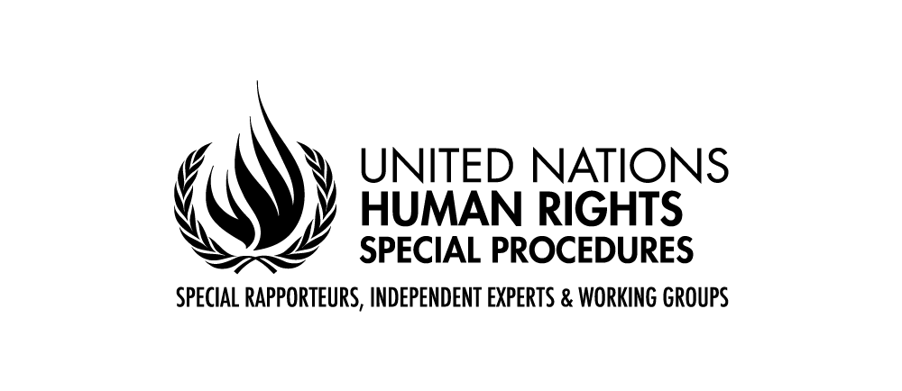
Ladies and Gentleman,
I send greetings from the meeting of the UN Commission on the Status of Women in New York. I am sorry that my schedule does not permit me to address you in person on the important topic of your conference today: violent extremism in Bangladesh and civil society responses thereto.
In my thematic work as Special Rapporteur in the field of cultural rights, I have repeatedly alerted the international community to the fact that rising tides of fundamentalism and extremism, in diverse forms, and whether espoused by State or non-State actors, today represent major threats to human rights, including cultural rights, worldwide. They are growing challenges that must be faced with urgency, using a human rights approach.
The impact of violent extremism in Bangladesh on secular writers and intellectuals was one of the first issues I took up when I became Special Rapporteur. I remain deeply concerned about this matter.
In my thematic report to the Human Rights Council on fundamentalism, extremism and cultural rights (A/HRC/34/56, paras. 71-72), I addressed the situation in Bangladesh, underscoring my grave concern about jihadist attacks on writers, publishers and freethinkers in Bangladesh and the placing of others on a death list. This has included the February 2015 murders of Washiqur Rahman Babu and Avijit Roy, secular bloggers and journalists, as well as the publisher of Mr. Roy’s work, Faisal Arefin Dipan, in October 2015 (see A/HRC/30/27, case BGD/2/2015 and A/HRC/31/79, State reply).
I also expressed regret that I did not receive a substantive reply from the Government of Bangladesh to my communication on the need to protect at-risk intellectuals. Moreover, I deplored subsequent government statements, which criticized the writers themselves. As Rafida Ahmed, widow of Mr. Roy, has written: “once a country silences and intimidates its intellectuals and freethinkers, a vicious cycle of … extremism becomes inevitable … it creates an intellectual vacuum, from which it could take many, many years to revert”.
Around the world, at the heart of the fundamentalist and extremist paradigms are rejections of equality and of the universality of human rights, making unwavering defence of these principles the touchstone of the human rights response. When States undermine universality, they aid and abet extremism.
In my work, I have framed fundamentalisms, to quote Algerian sociologist Marieme Helie-Lucas, as “political movements of the extreme right, which in a context of globalization … manipulate religion, culture or ethnicity, in order to achieve their political aims.” Fundamentalisms have emerged out of all of the world’s major religious traditions, including Buddhism, Christianity, Hinduism, Islam and Judaism, and others. Fundamentalists across all these categories abuse cultural rights. Given the religious claims of their proponents, religious fundamentalisms are especially difficult and dangerous to contest.
The links between fundamentalism and extremism on the one hand and violent extremism and terrorism on the other must be recognized, as must the inherently dangerous nature of the underlying ideologies themselves for human rights. Some fundamentalist and extremist forces may pass themselves off as “moderate”. Yet, they may have a deleterious impact on cultural rights, and/or provide the ground on which militant extremists stand by promoting the very discriminatory laws and practices that the Special Rapporteur on freedom of religion or belief finds to have a strong link to incitement to violence in the name of religion.
Extremist actors will not be truly disarmed unless their ideology is comprehensively challenged and repudiated, in accordance with international standards, and in particular through culture, expression and education in accordance with international standards. This connection between ideologies contrary to human rights norms and the practices that violate them explains why the United Nations did not simply focus on the abuses attendant on apartheid, but sought to dislodge the idea of racial superiority itself.
Fundamentalism and extremism are human rights issues. It is critical to take a human rights approach to addressing them. Cultural rights are a key component of the human rights approach, and the defence of these rights today requires tackling fundamentalism and extremism. Policies that combat discrimination in the right to take part in cultural life or promote freedom of artistic expression, scientific freedom and education in accordance with international human rights norms are core aspects of combating fundamentalism and extremism. When Governments imprison or censor the very voices of those who are standing up to extremists and are threatened by them, or fail to protect them, they facilitate the rise of extremism.
Arts, education, science and culture are among the best ways to fight fundamentalism and extremism. They are not luxuries, but critical to creating alternatives, making space for peaceful contestation, promoting inclusion and protecting youth from radicalization. Governments must ensure there is a counterweight to fundamentalist and extremist discourses by publicly challenging them and by guaranteeing education aimed at the objectives specified in relevant standards, including article 13 (1) of the International Covenant on Economic, Social and Cultural Rights.
States must respect, protect and fulfil human rights, in particular cultural rights, meaning that they must: (a) stop supporting directly or indirectly fundamentalist ideologies; (b) protect all persons from any act of fundamentalist or extremist groups aimed at coercing them into specific identities, beliefs or practices; and (c) design programmes aimed at creating conditions allowing all people to access, participate in and contribute to cultural life, without discrimination.
Both the basic obligation of States to respect human rights, and their obligation to exercise due diligence in ensuring rights from harm by non-State actors are relevant, as is finding creative ways to hold non-State actors directly accountable. Around the world, governments and non-governmental forces have been involved in promoting fundamentalism and extremism abroad, including through funding and education that is not compliant with international standards, and this has had significant consequences for cultural rights. Such contributing factors must be documented, condemned and combated.
It is also critical that the international community listen to the local opponents of fundamentalism and extremism, human rights defenders, including women human rights defenders, who have in some cases been battling them alone for decades. Despite unparalleled expertise, they are often not invited to international gatherings to discuss strategy. I am pleased that your meeting affords an opportunity for such voices to be heard at the United Nations.
Civil society plays a vital role in combating fundamentalism and extremism, and protecting cultural rights, using diverse strategies. However, civil society is often constrained in its ability to carry out these functions through limitations on freedom of association, arrest, harassment, and violence. This gravely undermines the much-needed struggle against fundamentalism and extremism.
Supporting women’s rights is also an essential component of the fight against all forms of extremism and fundamentalism. The gender component is not optional. As a woman from Niger said, “Every step forward in the fight for women’s rights is a piece of the struggle against fundamentalism.”
I honor the writers and artists and intellectuals and human rights defenders who have fallen to fundamentalists and extremists, and also those who face threats from fundamentalists and extremists and keep writing and singing and dancing and teaching and defending human rights. Despite this bleak picture, it is not a moment for despair but for hope based on concrete action. I see hope in those cultural rights defenders and other human rights defenders, as well as ordinary people, acting around the world, in countries like Bangladesh, and in diaspora populations, to challenge fundamentalism and extremism, sometimes at risk of their lives. The international community must stand with them. As Special Rapporteur in the field of cultural rights, I am committed to standing with those who continue cultural and intellectual and human rights endeavors in the face of threats from extremists.
I wish you a successful meeting as you seek to address these urgent concerns in the Bangladeshi context, and I look forward to hearing about your conclusions, which I hope will contribute to advancing the work on these critical issues.

Thank you.
-------------------------------------------

See General Assembly resolution 395 (V), preamble: “a policy of ‘racial segregation’ (Apartheid) is necessarily based on doctrines of racial discrimination”. The preamble to the International Convention on All Forms of Racial Discrimination commits to preventing and combating “racist doctrines”.

