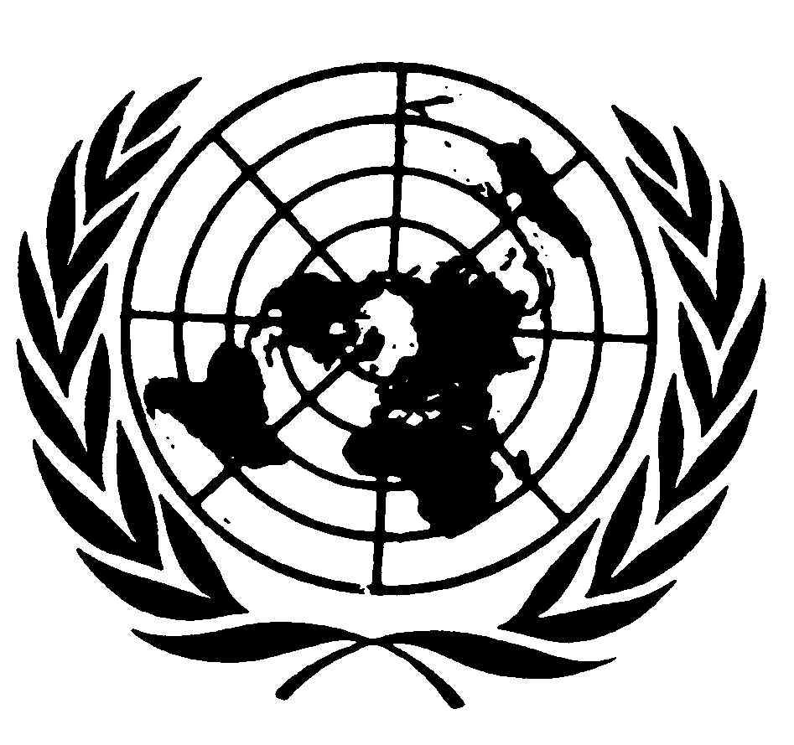

Statement by Ms. Karima Bennoune
UN SPECIAL RAPPORTEUR IN THE FIELD OF CULTURAL RIGHTS

Americas Cultural Summit

Theme: “Cultural citizenship”

9- 11 May 2018, Ottawa, Ontario, Canada

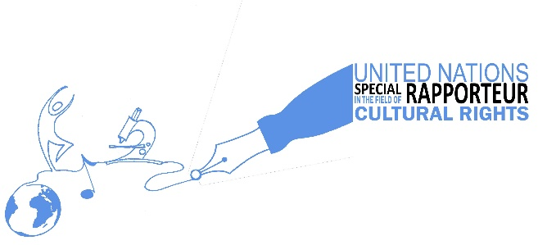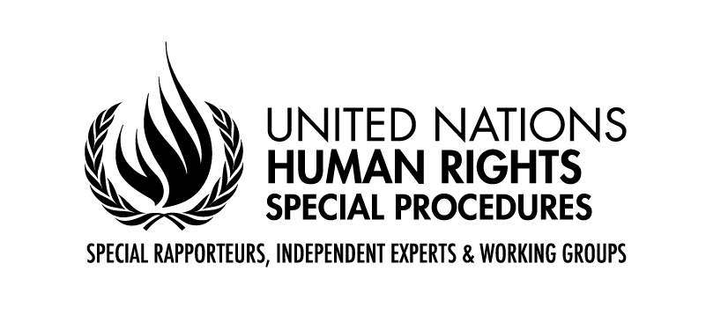
What cultural citizens can bring to our societies:
The Perspective of the UN Special Rapporteur in the field of cultural rights

Distinguished delegates, Ladies and Gentlemen,
Good morning. Bonjour. Buenos Dias.

- Introductory Remarks
It is a great privilege to be here with you in Ottawa at the opening of this historic first-ever Americas Cultural Summit. I am honored to be with all of you - cultural leaders from government and civil society, artists and activists, from across the Americas. I sincerely thank all the organizers, including the Ministry of Culture of Argentina and the International Federation of Arts Councils and Culture Agencies (IFACCA) and our most gracious hosts, the Canada Council for the Arts, for their work to convene this important meeting and for their kind invitation to me and the mandate I represent to take part.
I very much enjoyed the lovely reception last evening hosted by the Embassy of Argentina at the splendid National Gallery of Canada, though sadly I never managed to try one of the Argentinian-Canadian empanadas. One of the things I appreciated the most was the multilingualism, the very Canadian intermingling of languages. Alors je vais dire un mot en français avant de revenir vers l’anglais. Aujourd’hui, je vais présenter brièvement ce qu’est une Rapporteuse spéciale des Nations Unies et ce que sont les droits culturels, et je vais esquisser ma vision, en tant que Rapporteuse spéciale, du thème de ce sommet: la citoyenneté culturelle. Je vous remercie d’avoir choisi ce thème car il me semble que c’est une question très importante et une sur laquelle j’aimerai travailler davantage dans l’avenir.
J’estime que la précédente titulaire du mandat dans le domaine des droits culturels a pris la bonne décision lorsqu’elle a refusé de définir la culture et a adopté une approche globale et inclusive de cette notion. Elle a surtout fait valoir que la culture est créée, contestée et recréée dans l’interaction sociale, en d’autres termes, par l’être humain. Pour moi, cette participation est à la base de la citoyenneté culturelle. L’objet du mandat dans le domaine des droits culturels n’est pas de protéger la culture ou le patrimoine culturel en soi, mais plutôt les conditions permettant à chaque personne, sans discrimination, d’avoir accès, de participer et de contribuer à la vie culturelle d’une manière qui évolue en permanence. C’est une autre façon de souligner l’importance de la citoyenneté culturelle pour la mise-en-oeuvre des droits culturels.
By way of background, let me explain what exactly a UN Special Rapporteur does. It is a fancy title which is not widely understood. We are independent experts appointed by the UN Human Rights Council, the highest political body of the UN system focused on human rights, but we do not work for the UN, serving rather in our individual capacities and reporting (hence Rapporteurs) to the UN system. Every year, I prepare two thematic report on a topic of my choosing within the field of cultural rights, one for the Human Rights Council and one for the UN General Assembly. I also carry out two country missions a year and report on those. I am, moreover, able to send confidential communications to governments and also other relevant entities such as corporations with regard to allegations of violations of cultural rights. I hope you will consider submitting cases to the mandate for that purpose. Finally, I can make public statements on relevant issues. For more information, please visit the home page of the mandate and follow me on twitter @UNSRCulture. I am delighted that in 2019, the cultural rights mandate will be marking its 10th anniversary and I look forward to cooperating with many of you to mark this significant anniversary, to celebrate what we have achieved at the international level in the area of cultural rights and to identify the gaps that need to be filled in the next 10 years of the mandate.
This morning, as Special Rapporteur in the field of cultural rights, I want to think about the critical and complex question put to us by the organizers of this summit, namely: How can government, institutions, artists and citizens work together to help build more vibrant open and pluralist democracies which respect, promote and protect the right of everyone to take part in cultural life? I submit that this is one of the most pressing questions of our times, and in these times, it sometimes feels quite daunting to contemplate. Therefore, I am especially pleased that at this summit we have two days to work together to share and develop our answers to this question, but also to exchange and coordinate our strategies. As a Professor of International Law, I am always eager to discuss implementation, as it is only through la mise-en-oeuvre that standards take flight and have meaning in people’s lives. I hope that we all leave Ottawa with specific task lists that can contribute to this process and a strong call for action to be presented at the World Summit on Arts and Culture in Kuala Lumpur in 2019.
- Why the exercise of cultural rights matters
However, before we get to that, I would also like this morning to ask another related question to the one posed to us by the organizers, which is – before we come to the how question - why is it necessary for us as representatives of governments, of institutions, as artists and citizens, to work to protect and promote the right to take part in cultural life? Given all the challenges facing the world and the Americas in 2018, from economic problems to violence and environmental degradation, from repression to poor governance, from discrimination and exclusion in myriad forms to poverty and inequality, from inadequate access to health care and education in accordance with international standards, with all of these difficulties before us, why do our commitments to culture and cultural citizenship matter? Why do cultural rights matter? Why is this a most worthy area of endeavor? I will take a few moments to give you some of my answers, but I also know we will be contemplating this question in our deliberations. It is a case we must find new ways to make, in compelling and clear terms, at the political and popular levels, to advance our work.
The first answer that I give as a law professor, and one that is critical for governments and advocates to recall, is that the enjoyment of cultural rights is guaranteed by international law and the treaties to which so many governments are parties. As a legal matter, these treaty commitments must be fully complied with in good faith. The normative grounding of cultural rights is found in particular in Article 27 of the Universal Declaration of Human Rights, the 70th anniversary of which we are celebrating this year, and in article 15 of the Covenant on Economic, Social and Cultural Rights, which has 166 state parties, including most states in the Americas, with a few notable exceptions. Both of these norms basically guarantee the right to take part in cultural life, without discrimination.
Article 15 of the ICESCR states in paragraph 1 (a) the “right of everyone to take part in cultural life”. Clearly, this is shaped by the non-discrimination provision of article 2(2) of the Covenant. Paragraph 3of the same article affirms that the “States Parties to the present Covenant undertake to respect the freedom indispensable for scientific research and creative activity”, and paragraph 4, especially important to recall here at the summit, that they also “recognize the benefits to be derived from the encouragement and development of international contacts and co-operation in the scientific and cultural fields.”
Drawing on these standards, the UN Human Rights Council has regularly reiterated for the last ten years that “cultural rights are an integral part of human rights, which are universal, indivisible, interrelated and interdependent.” In recent years, cultural rights have gained in legitimacy. However, much remains to be done to fulfil the Council’s vision. In my work as Special Rapporteur, I hope to continue demonstrating that cultural rights are important in and of themselves, but also key to the overall implementation of all universal human rights and a crucial part of responses to many current challenges, from conflict to discrimination to poverty and extremism. Let me be clear as an aside here that cultural rights are not tantamount to cultural relativism. They are not an excuse for violations of human rights or for discrimination or violence. They are firmly embedded in the universal human rights framework.
So, the first part of the answer as to why cultural rights matter is that they are a core component of human rights, and states are legally required to respect and ensure them. However, that is only the beginning of the answer for the completion of which one must dig deeper. Humanity dignifies, restores and reimagines itself through creating, performing, preserving and revising its cultural and artistic life. Cultural and artistic expressions are tightly intertwined with our identities and values, they help us express and give form to our humanity and the future we want for ourselves and for generations to come. Freedoms and rights related to expression and participation in culture are not a luxury but are critical components of being human. I have always believed that culture is almost like oxygen in its importance to human beings and human life. Culture not only allows us to breathe metaphorically, it helps us grapple with our own understanding of why we do.
When faced with violence, oppression and hardship in various forms, every society searches for ways to make sense of the experience, to cultivate resilience, mourn losses and move forward. This is particularly true in the immediate aftermath of conflict. Artistic and cultural initiatives provide tools to understand suffering and means of expression for individuals, groups and entire societies, and hence can help to increase capacity to recover from human rights violations, acknowledge and address injustice and imagine and substantiate new and shared futures.
Not all cultural and artistic initiatives are explicitly pursuing the aim to transform society by tackling mindsets that create exclusion, helping to restore understanding between groups and trust in society, seeking to emphasize respect for cultural diversity or to contribute to reconciliation. Social engagement is a possibility for artists and cultural workers, not a requirement.
However, artists and cultural workers can and have in many different contexts played a leading role in responding to threats to human rights, acting as spokespersons, conveners and facilitators. In so doing, they give voice to others and act as human rights defenders and cultural rights defenders, but they also often face risks and their own human rights may need defense. Deciding to engage socially is a courageous choice many artists and cultural workers still make and one, which should be recognized and valued.
Active engagement in the cultural sphere offers crucial possibilities to contribute to social debates, challenge assumptions about accepted beliefs, revisit culturally inherited ideas and concepts, shape and reshape meanings. It also helps develop individual and collective capacities that are central traits of democratic citizenship, such as critical thinking, creativity, acceptance of differences, commitment to the universality of human rights and equality. It contributes to perceiving differences amongst human beings as a resource rather than as a problem, and in highlighting human beings’ all-too-often overlooked commonalities.
You will find such assertions in my reports and in those of my predecessor Farida Shaheed. However, this is not mere boilerplate language. This is lived reality, which I have seen firsthand in my travels as Special Rapporteur and in my own academic research. Just to give one set of examples, I think about the work of theatre companies I have encountered to tackle repression, conflict, extremism, discrimination and censorship often all while facing financial hardship. I have encountered arts promoters like the late great Faizan Peerzada whose events have been bombed and yet they have found the courage to continue those events the next day because as Faizan said at the time “otherwise we will just be sitting in a dark corner.” He inspired me to understand that our work in the cultural sphere is about keeping the light on in those corners and supporting all who do. Another striking example I highlighted in my most recent thematic report is the Belarus Free Theatre, an international theatre company operating underground in Belarus and led by artistic directors in exile in the United Kingdom who were forced to flee after repeated arrests, including, on one occasion, the arrest of the entire ensemble and its audience. They too continue their work.
I just had the great privilege of visiting the Detroit Repertory Theatre in the city of Detroit in the United States, a theatre which has kept going for some 60 years in a neighborhood faced with foreclosures, dwindling residents and economic blight. And yet, it still stands where so many other structures have fallen, committed to producing plays with diverse casts for diverse audiences and explicitly devoted to promoting cultural democracy. Or I think of another example I cited in my most recent thematic report: the cultural policies of the city Medellín, Colombia, whose distinguished former Mayor is with us at this meeting, and which offers an example of an inclusive, top-down and bottom-up approach to reclaiming a city afflicted with violence through culture, thanks to what one expert labelled “a public sector that has embodied and supported the public interest in culture with tremendous forethought, intentionality and caring; and results to match that intention”.
At the same time, the harm that is done to human beings when cultural rights are violated is all too real. I think about the real suffering caused to people when they are denied their cultural rights. I remember a woman weeping in front of me about limitations on access to churches in her country and also the outrage of a man reflecting on the vandalism of a mosque in his – these were in fact the same country. I have visited cultural sites guarded by tanks and seen how deep the connections are that populations living in situations of post-conflict have with them – to space, to place, to site, to practice in that particular site and have seen firsthand the human impact of the threats to those sites.
I have met those who have risked their lives and rights to preserve and engage in cultural practices, like dancer Sheema Kermani, whose response to the Daesh bombing on a Shia shrine in her country was to dance in the shrine amongst the mourners several days later. She explained: "The purpose of the performing arts is to 'uplift humanity' - to make us better human beings, to create an atmosphere of harmony and togetherness… [A]long with the sorrow for those who were killed, one has the hope that life will go on with beauty and love. This was my message and my dance!" The international community must show as much courage and commitment as artists and cultural workers like her do.
I have been honored to join with my colleague, the Special Rapporteur on the rights of indigenous peoples, in a public statement on the threats to Native American and in particular Sioux cultural sites in the United States of America due to the Dakota Access Pipeline and in support of the rights of those who stood peacefully against it and refused to stand back and watch cultural sites destroyed.
All of this reminds me every day why cultural rights are human rights, not because of rhetoric, but because of reality; why what we do goes to the core of who we are as human beings, of just how much is at stake if we do not succeed in our work and why we must therefore come together to find joint strategies that can help us shine light in all the dark corners and continue to uplift humanity.
To that end, I would like to recall some of the key elements of cultural rights that should be considered when shaping public policies and programs and what I believe are some current global threats and specific challenges one should be aware of when striving to develop cultural citizenship. I will also make a few suggestions for how to meet these challenges and flag a few items for discussion in your deliberations.
3) Key elements of cultural rights that should be considered when shaping public policies and programs
General Comment No. 21 (2009) of the Committee on Economic, Social and Cultural Rights on article 15 of the ICESR stresses that there are three interrelated main components of the right to participate or take part in cultural life: (a) participation in (b) access to, and (c) contribution to cultural life. A cultural rights approach emphasizes then access to places of culture and events and contact with artistic works and productions as a means to foster the development of cultural awareness, creativity and capacities for each person to participate in cultural life. Cultural agencies, institutions, policy makers and funders in the field of culture are key enablers in this process, as their work can greatly contribute to ensuring the conditions of exercise of cultural rights for all.
Cultural citizenship is threatened from many directions today, including due to the broader problem of the homogenization of culture and cultural experience due to a range of factors, including certain models of globalization and global media. Cultural rights are undermined by the prioritization of a narrow conception of economic concerns over human rights in general and cultural rights in particular, as well as by the diminishing and erosion of public space, and perhaps most of all by the sense that culture is optional, a luxury item. Further threats that I have concentrated on in my reports include the rise of diverse forms of fundamentalism and extremism in all regions of the world, including the Americas, and the intentional destruction of cultural heritage.

In the face of all these threats, governments have the responsibility to preserve existing spaces and institutions for the exercise of cultural rights as well as to create new ones, and to support the voices of tolerance, equality and diversity. They must adopt policies and measures that ensure the protection and promotion of cultural diversity, whilst facilitating access to and participation in a rich and diversified range of cultural expressions. But Governments cannot do this alone. Your role as enablers and facilitators in this process is crucial.
4) Priority Issues to create and sustain enabling conditions
So how can we support and invest in the arts and culture to create and sustain conditions for people to have the freedom to meaningfully choose, participate in and contribute to cultural life, free from discrimination?
What will make the difference in the answer to this very relevant question, is whether the approach chosen is based on cultural rights, grounded in universal human rights, including the principles of universality, equality and non-discrimination, whether it emphasizes the mandatory and binding nature of cultural commitments, and insists on the participatory and democratic components of discussions about culture. It is critical to recognize the autonomous initiative of citizens as the basis of cultural freedom and citizenship. There are many ways to achieve these goals, but let me point to a few substantives areas that should be prioritized from a cultural rights perspective.
A) Public Space
The first area is public space. I urge you all to not only protect but celebrate your public spaces and to carefully consider the designation and design of these spaces, and how they can be used as a tool for mutual exchange and interaction. Public and outdoor spaces have to be made or kept accessible so that a variety of artistic and cultural initiatives can become part of the ordinary flow of people’s lives. This contributes to artistic and cultural education and fosters the development of a range of capacities for expression and building bridges across divisive lines in society. States have a specific role in ensuring that both institutional and public spaces are made available for a plurality of cultural initiatives, including those that may express critical views, and that increased opportunities exist for people from a diversity of backgrounds to engage with each other through these spaces, and that women, minorities, persons with disabilities and all marginalized groups have access to such spaces in full equality.
B) Funding
The next priority area I wish to underline is that of funding. We cannot speak of cultural rights without consideration of the financial investment required to fulfill those rights. Due to various financial crises and austerity measures adopted in a number of States globally, programmes in the field of culture often suffer the most. This is a serious mistake. The UNESCO target of 1% of total expenditures being used for culture must be achieved universally and should be seen as a minimum.
Investments in the field of culture and in the conditions that allow people to fully participate in cultural life are necessary to create cultural democracies and foster civic engagement. Socially engaged artists and cultural workers, even when they manage to demonstrate their contribution in developing more tolerant, inclusive and right-respecting societies, still struggle to find the necessary material support for their work, especially the long-term engagement needed to build deeper trust and contribute to more sustainable social changes.
C) Gender Perspective
The final priority area I wish to emphasize is the full inclusion of women. UNESCO has noted that a “multifaceted gender gap persists in almost all cultural fields in most parts of the world”. This must be tackled so that women can be equal participants in cultural life. Required initiatives include the full recognition of and encouragement for women as creative persons, the removal of impediments in their paths towards fully participating in and enjoying arts and culture, the prevention of gendered attacks on artistic freedom and taking effective measures to respond to #MeToo and other related campaigns by effectively tackling sexual harassment in all cultural and artistic fields. We must recognize the work of women – as artists, as cultural heritage defenders and as people who wish to exercise their cultural rights just like anyone else. Equal cultural citizenship is essential.
5) Conclusion
The defense of cultural rights and cultural citizenship in the Americas is one of the most critical tasks before all who live in this region today. Let us make sure to build bridges with culture in this region, not walls. Perhaps most of all, let us reinvigorate ourselves with cultural optimism and share that optimism. There are many reasons for pessimism these days, including in this region. But I am deeply touched by the cultural optimists I meet. I think of the practitioners of Wayang Kulit, or shadow puppetry, which is formally banned in the state of Kelantan in Malaysia, who keep practicing their art and teaching it notwithstanding the ban, and even run a museum dedicated to it. Let us come together and send a shared message of cultural optimism and hope from Ottawa across this region and beyond to Kuala Lumpur.
This summit is an opportunity to exchange experiences, learn from each other and develop joint initiatives that will help integrate a cultural rights approach and perspective to reach for cultural citizenship and democracy. I wish you a most productive gathering. Fulfilling the role of Special Rapporteur in the field of cultural rights is, by its nature, intensely collaborative and I look forward to cooperating with all of you to implement this ambitious objective.

Thank you for your kind attention.
-----------------------------------------

“Everyone has the right freely to participate in the cultural life of the community, to enjoy the arts and to share in scientific advancement and its benefits.” Universal Declaration of Human Rights, art. 27(1), 1948.
“Sheema Kermani defies act of terrorism, performs at Lal Shahbaz Qalandar’s Shrine”, Dawn News, 21 February 2017.
A. Joseph, “Gender equality: missing in action”, in Re|Shaping Cultural Policies: Advancing Creativity for Development 2018 op. cit., p. 189.

