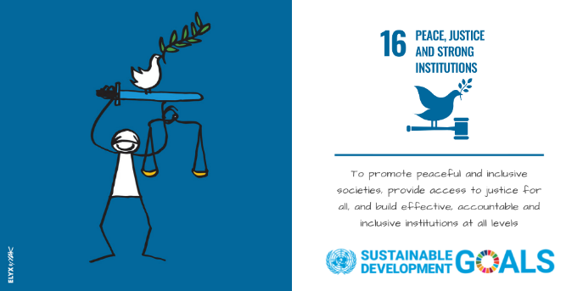
HUMAN RIGHTS, GENDER AND CORRUPTION - LINKAGES, GOOD PRACTICES, POTENTIAL AND LIMITATIONS
WEDNESDAY, 18 DECEMBER 2019, 13:00 - 14:00, CR1
BIOS OF SPEAKERS AND MODERATOR

Mr. Richard Lapper is a Human Rights Officer at the United Nations Office of the High Commissioner for Human Rights (OHCHR), where he has been working for the last 20 years in different positions and on different issues. He notably focused on the right to development, good governance, anti-corruption, indigenous peoples and HIV/AIDS. He also worked in the field operations department of OHCHR, primarily on human rights in Europe and Central Asia. Richard Lapper was also a Visiting Researcher at the Geneva Academy of International Humanitarian Law and Human Rights, where he focused on corruption as a violation of human rights. He holds master degrees in law and in philosophy.

H.E. Amb. Azzeddine Farhane has an outstanding career as diplomat in various functions and duty stations. He currently serves as Ambassador to Austria, Slovakia, Slovenia and Permanent Representative to the United Nations Office and International Organizations in Vienna. He was previously Ambassador to Vietnam and held numerous positions in the Ministry of Foreign Affairs and International Cooperation, notably Director of the United Nations and International Organizations Department.
During his diplomatic career, he participated in many international conferences, including as member of the Moroccan delegation to the United Nations General Assembly and the Human Rights Council and Sherpa of Morocco in the three Nuclear Security Summits (Seoul, The Hague and Washington).
He holds a PHD from the Hassan II University of Casablanca.

Ms. Jennifer Sarvary Bradford joined the United Office on Drugs and Crime (UNODC) in 2013, where she works as part of the secretariat to the Implementation Review Mechanism (IRM). Jennifer has led the efforts to quantify and analyse the technical assistance needs emerging from the review process and has worked on measuring the impact of the IRM on States parties to the Convention. During the negotiations of the Sustainable Development Goals, Jennifer was part of the UNODC inter-divisional team. Jennifer also spearheaded the work on gender and corruption.
Jennifer has worked for the United Nations since 1998. After working for the United Nations High Commissioner for Refugees and subsequently in the Department of Peacekeeping Operations at Headquarters and in the United Nations Mission in the Democratic Republic of the Congo (MONUC), she joined UNODC in Vienna in 2005. From 2010 to 2013, Jennifer established the UNODC national programme for Ethiopia.
Jennifer holds a Master's degree in Law from Lund University, Sweden, where she also attended the Master’s programme of the Raoul Wallenberg Institute for Human Rights and Humanitarian Law.

Mr. Charles Ayamdoo is a Chief Legal Officer and Director, Anti-Corruption at the Commission on Human Rights and Administrative Justice, Ghana, an independent constitutional institution, which combines the functions of a national human rights institution, Ombudsman and an Anti-Corruption Agency. As Director, Anti-Corruption, Ayamdoo has led investigations of high profile and complex cases of corruption, conflict of interest, abuse of power and human rights violations for close to 26 years. Mr. Ayamdoo is the immediate past President of the Africa Association of Anti-Corruption Authorities. He is also the focal point and Governmental Expert for the review of the implementation of the United Nations Convention against Corruption.

H.E. Amb. Mr. Stefan Estermann studied political science at the University of Lausanne and has a Master in Public Administration. In 1996, he joined the Swiss Federal Department of Foreign Affairs (FDFA) as a career diplomat. Among other postings, he served as chief of staff of the State Secretary and as the Swiss Ambassador to Croatia. Since 2018, he is heading the FDFA’s Sectoral Foreign Policies Division, cooperating with specialized Federal Offices in the Swiss administration to promote domestic and foreign policy coherence across a broad range of thematic issues, including anti-corruption. In this capacity, he chairs Switzerland’s Interdepartmental Working Group on Combating Corruption.

Ms. Làzarie Eeckeloo works as a Human Rights Officer at the Centre for Civil and Political Rights, an NGO based in Geneva. This NGO seeks to increase and support the participation of NGOs in the UN mechanisms, including the UN Human Rights Committee. The organization supports a holistic approach to the human rights system in order to achieve the greatest possible impact on the ground. In her work, Làzarie focuses on the link between corruption and human rights violations, and on projects in Central Asia. She conducted extensive research on how the Treaty Bodies have approached corruption between 2007 and 2017, and continues to monitor the changes in that approach. Làzarie studied law at the KU Leuven and also obtained an LL.M. in International Humanitarian Law and Human Rights at the Geneva Academy.

Mr. Juan Pablo Bohoslavsky is the current Independent Expert on the effects of foreign debt and other related international financial obligations of States on the full enjoyment of all human rights, particularly economic, social and cultural rights. The Independent Expert carries out analytical research and undertakes country missions, in an effort to work with Governments, the United Nations, non-governmental actors and other stakeholders on issues falling under his mandate. Mr. Bohoslavsky holds a law degree, an LL.M. in Corporate Law and a European Doctorate in Law. He was Hauser Global Fellow and postdoctoral researcher at the Max Planck for Comparative Public Law and International Law. Mr. Bohoslavsky worked as a law firm partner, as a legal consultant for the Argentinean state to arbitration cases related to international investments, and for the United Nations Economic Commission for Latin America and the Caribbean. In 2009 he was appointed as a Professor at the University of Rio Negro (Patagonia, Argentina). From February 2011 to April 2014 he worked as a Sovereign Debt Expert for the United Nations Conference on Trade and Development (UNCTAD) coordinating the Expert Group on Responsible Sovereign Lending and Borrowing. He has published books and articles on sovereign financing, foreign investment, transitional justice and human rights.

