Questionnaire in relation to Human Rights Council Resolution A/HRC/RES/38/4 on human rights and climate change

- Please describe the impacts of the adverse effects of climate change on the full and effective enjoyment of the human rights of women and girls. Where possible, please share specific examples and stories.
Across societies the impacts of climate change affect women and men differently. Women are often responsible for gathering and producing food, collecting water and sourcing fuel for heating and cooking. With climate change, these tasks are becoming more difficult. Extreme weather events such as droughts and floods have a greater impact on the poor and most vulnerable – 70% of the world’s poor are women. (IUCN, 2017). This means that not only climate change impacts more on women (and if so, also on children) but also means that if this is not addressed, more gender inequality will come because of climate change.
Therefore, there is an urgent need to address the climate change including women as an agent of change that should be part of the decisions making processes (from local, ONGs to UNFCC). Data speaks by itself, see below some examples.

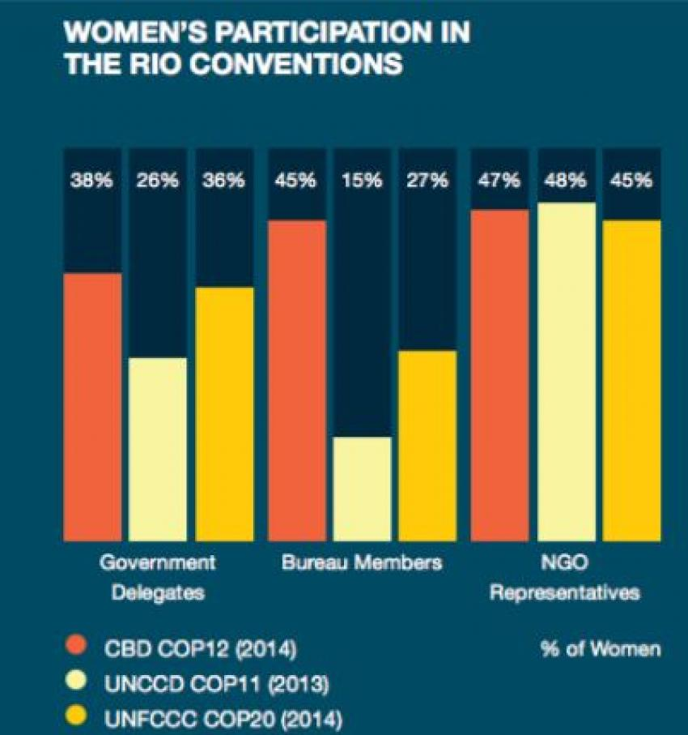
More data: 20 million out of the 26 million of climate refugees is women. Therefore, we have to address environmental and climate problems from gender equality perspective and also include, environmental and climate issues on the gender equality work. They go by hand.
IPCC 2014 report : only 20% researchers were female and no gender perspective is included. This of course impacts on no female vision included on the solutions.

An UK study (University of Exeter) establishes “ gender imbalance at energy firms and industry events is slowing transition to greener power, claims expert”
In Spain, at least in the first experts committee in charge of drafting the law, no women were included, what has been the consequences: An example if we take transport in the cities, it is proven that women move in a different patterns than men. Women usually move in the cities for “care purposes” : Short distances but busy hands (children, food, family things and usually public transport) while men go to work on their own by car. The mobility solutions now on the table have not mentioned solutions for women, but just for men’s /working mobility.
Women are miss represented or non-represented on climate change negotiations, including those related to UNFCC. See an example:

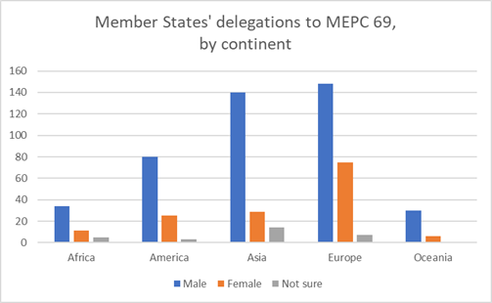

- Please describe any relevant commitments, legislation and other measures that you have taken to promote a gender-responsive approach to climate change mitigation and adaptation at the local, national, regional and international level and to ensure the full and effective enjoyment of the human rights of women and girls impacted by the adverse effects of climate change. Please include relevant mechanisms used to promote accountability and/or implementation.

.

- Please share a summary of any relevant data that captures how the adverse effects of climate change have affected women'and girls, taking into account multiple and intersecting forms of discrimination.

In the abovementioned linked study it has been concluded:

Because of their increased likelihood of living in poverty, and their gendered social roles, women are more likely than men to: • die in climate change-related disasters, and suffer from increased workload, loss of income, health problems, and violence and harassment in the aftermath of such events; • be displaced, or encounter problems when other (usually male) family members migrate for economic reasons; • experience increased burden of water and fuel collection, and resulting health problems, due to increased incidence of drought or other changes in climate; • feel the effects of rising food prices most acutely, and be the first to suffer during food shortages; • suffer exacerbated health inequalities; • suffer from violence, including sexual violence, in resource conflicts; • be expected to, and need to, adapt to the effects of climate change, increasing their workload; • suffer as a result of intended solutions to the problem of climate change, such as forestry projects and biofuel production.

Other data form same study: Global Humanitarian Forum’s recent Human Impact Report estimates that 300,000 people are already dying each year as a result of climate change, of which 14,500 deaths are directly caused by weather-related disasters attributable to climate change5 , and it is highly likely that the majority of these victims are female.
Ex: Experience from recent disasters supports this: in the 1991 cyclone in Bangladesh, the mortality rate for women aged 20-44 was 71 per thousand, compared to 15 per thousand men of the same age6 - almost five times higher for women. Reasons for the disparity include women not having been taught to swim, clothing restricting mobility and cultural norms regarding the preservation of female honour causing many women to leave their homes too late because they waited for a male escort. In addition, men were able to warn each other of the danger as they met in public spaces, but only conveyed the information back to their families sporadically.7 Similarly, one factor in the higher female mortality rates following the 2004 tsunami (although not caused by climatic factors) was women being unable to climb trees8 .

An analysis of disasters in 141 countries found that, where women had equal rights, there was little or no difference in the number of women or men that died, but where women’s rights were compromised, female mortality was higher than that for males14. The authors also report accounts of rescue efforts in which male survivors were prioritised over female

https://library.fes.de/pdf-files/bueros/quito/09023.pdf

https://www.newsecuritybeat.org/2018/02/women-front-lines-change-empowerment-face-climate-displacement/

https://www.bbc.com/news/science-environment-43294221

https://sutp.org/files/contents/documents/News/2018%20May/TUMI_SUTP_GIZ_Module%20Gender%20and%20Transport%202018.pdf

- Please describe mechanisms and tools, which can be used to measure and monitor the impacts of climate change on the full and effective enjoyment of the human rights of women and girls.

Analysis should be done on how women are represented on decision making processes including UNFCC ones and also, identification of the reasons why women are missrepresented. Gender expertise and training are required for decision makers (women and men), this is key.

In SP language, here’s a manual on how to include gender perspective on social policy.
https://www.juntadeandalucia.es/export/drupaljda/publicacion/17/01/Gui%CC%81a%20Genero%20CIPS_v4.pdf

English gender and climate toolkit: https://www.greens-efa.eu/files/doc/docs/94b0953df275d8f83b8dad341dcb841a.pdf
- Please identify and share examples of good practices and challenges in the promotion, protection, and 'fulfilment of the human rights of women and girls in the context of the adverse effects of climate change. Please include examples that highlight multilateral cooperation, gender mainstreaming, gender responsive approaches, and the full, meaningful and effective participation of women and girls in relevant decision-making processes.
http://www.ifpri.org/blog/how-gender-shapes-responses-climate-change-new-tools-measuring-rural-womens-empowerment
In the above mentioned gender and climate toolkit you will finf (page 10):
Malmö transport plan: For the city of Malmö in Sweden,“Gender equality leads to accessibility for a greater number of people” (City of Malmö’s transport plan, 2016 [31]). “Traffic /…/ produces visible and invisible barriers, giving persons of different gender, physical and mental capability, income and age different chances to access their city. /…/ In order to increase knowledge about travel conditions in society, and to create a more equal transport system, it is important to incorporate a perspective grounded in equality in the work with transport.” Malmö’s objective for 2010 is to design a transport system that gives everyone easy access to their city, regardless of people’s background and belonging. This involves the democratic division of urban space, meaning the reorganisation of the city’s streets and cityscapes in order to allow a greater Communication Toolkit on Gender and Climate Change 11 number of people to move on foot, by bicycle and with public transport. Moreover, according to the city’s plan, prioritising certain transport modes is an important factor for increased equality. Currently, as men own and drive cars to a greater extent than women, their accessibility to the city and the region is generally higher than women’s. The proximity to high standard public transport and possibilities to move on foot and by bicycle can compensate for this. Planning greater accessibility in a city makes travelling on foot, by bicycle and with public transport more rational but also the city more equal. As a first step, the city has raised awareness and spread knowledge on the connection between gender equality and transport, as a next step they will develop a Gender Equality Indicator. ► Climate protection plan North Rhine Westphalia: An impact assessment was undertaken for the climate protection plan of the German federal state of NorthRhine-Westphalia in 2014. It included a Gender Impact Assessment which focussed on housing, transport and employment. Gender differences were found in all of these issues, e. g. regarding older female pensioners who disproportionately often live in buildings in need for retrofitting, and in the different mobility patterns and ownership of cars. Furthermore, in the field of employment it was found that men benefit more from job creation by mitigation policies than women. Although it has been demonstrated that ensuring gender equality is needed for climate protection to be effective the conclusions of this plan were insufficient. Because of a lack of data and consistency, eventually gender was not addressed in the sectoral policies of the climate action plan. However, the positive aspect is that it sensitised experts and practitioners, who might consider gender when developing their policies, for instance at local levels. ► Public management in Austria: In the year 2000, an inter-ministerial working group on gender mainstreaming and gender budgeting has been set up. Within the public management system of the Austrian government that looks at results, actual gender equality is a dimension that has to be considered by all departments, based on the constitution and federal budget law from 2013 (http://www.imaggmb.at/cms/imag/content.htm?channel=CH0599&doc=CMS1395908132505)
- Please provide any additional information you believe would be useful to support efforts to integrate a gender-responsive approach into climate action at the local, national, regional and international levels for the full and effective enjoyment of the rights of women and girls.

