Human Rights Council – 41st session
Panel discussion on women’s rights and climate change:
climate action, good practices and lessons learned
28 June 2019

Biographies of speakers and panellists

Ms. Michelle Bachelet
United Nations High Commissioner for Human Rights (opening statement)

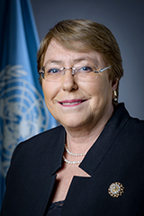
Michelle Bachelet assumed her functions as the United Nations High Commissioner for Human Rights in September 2018. Ms. Bachelet served as the President of Chile on two occasions (2006–2010 and 2014–2018). Since the early 1990s, Ms. Bachelet has worked closely with several international organizations. In 2010, she chaired the Social Protection Floor Advisory Group, a joint International Labour Organization (ILO) and World Health Organization (WHO) initiative, which sought to promote social policies to stimulate economic growth and social cohesion. In 2011, she was named the first Director of UN-Women, an organization dedicated to fighting for the rights of women and girls internationally. Economic empowerment and ending violence against women were two of her priorities during her tenure. She has recently pledged to be a Gender Champion, committing to advance gender equality within OHCHR and in international fora. High Commissioner Bachelet has a Medical Degree in Surgery, with a specialization in Paediatrics and Public Health. She also studied military strategy at Chile's National Academy of Strategy and Policy and at the Inter-American Defence College in the United States.

Her Excellency Ms. Hilda C. Heine
President of the Marshall Islands (opening statement, by video message)

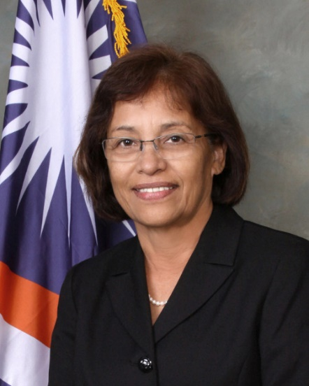
President Hilda C. Heine became the first woman to lead an independent Pacific Island nation when she was elected President of the Marshall Islands in January 2016. By shattering this long-standing glass ceiling, President Heine has paved the way for more women leaders at all echelons of Pacific society, including its highest offices. President Heine is a long-standing educator who, early in her career, worked as a classroom teacher, counsellor, and Secretary of Education. She later went on to become Minister of Education for the Marshall Islands, a position she served in prior to being elected President. As President, she strongly appeals to and urges all countries to take action to mitigate climate change. The Marshall Islands comprises over a thousand low-lying islands and islets that are threatened by the effects of climate change such as rising sea levels and more frequent and extreme weather events such as droughts and floods. President Heine is the co-founder of the women’s rights group Women United Together Marshall Islands (WUTMI), an association advocating for the elimination of violence against women and providing counselling services for victims of domestic violence.
Panellists:
Ms. Mary Robinson
Adjunct Professor of Climate Justice at Trinity College Dublin, Chair of The Elders
and former President of Ireland
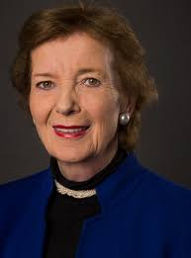
Mary Robinson served as Ireland’s first woman President from 1990 until 1997 and as United Nations High Commissioner for Human Rights from 1997 to 2002. Foremost a barrister, she has been advocating for human rights and women’s equality before Irish and European Courts. A prolific academic, she is Adjunct Professor of Climate Justice, Trinity College Dublin. Mary Robinson served as the Special Envoy of the Secretary-General for the Great Lakes Region of Africa from 2013-2014, stepping down in July 2014 to take up the post of Special Envoy of the Secretary-General on Climate Change. In 2016, she was appointed as the Special Envoy of the Secretary-General on El Niño and Climate. She is Chair of The Elders, an international non-governmental organization composed of prominent world leaders whose purpose is to work towards attaining global peace and human rights. Mary Robinson established her namesake organisation – The Mary Robinson Foundation – Climate Justice, whose goal was to secure global justice for those people vulnerable to the impacts of climate change who are usually forgotten – the poor, the disempowered and the marginalized across the world.

Her Excellency Ms. Nazhat Shameem Khan
Ambassador and Permanent Representative of Fiji to the United Nations Office and other international organizations in Geneva

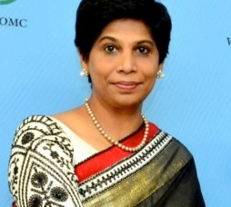
Ambassador Nazhat Shameem Khan is a lawyer by profession and a former judge of the High Court of Fiji. Ms. Khan studied law at Sussex University and obtained her LLM and a Master of Philosophy degree in Criminology from Cambridge University. Ambassador Khan has been engaged in training lawyers, judges, NGOs and the business community on litigation skills, governance, human rights law and practice and gender competence in the justice system. She was the Chief Negotiator for Fiji’s Presidency of COP 23. Ambassador Khan is a member of the Advisory Board for the Centre for Multilateral Negotiations and a member of the Board of Trustees for the United Nations Institute for Training and Research (UNITAR). She chairs the United Nations Office for Disaster Risk Reduction (UNDRR) Support Group, a group set up to further the goals of the Sendai Framework for Disaster Risk Reduction and of the UNDRR work. Ambassador Khan has been on the Advisory Council of the Women’s Initiatives for Gender Justice at the International Criminal Court since the inception of the Court.

Mr. Martin Oelz
Senior Specialist on Equality and Non-Discrimination at the International Labour Organization

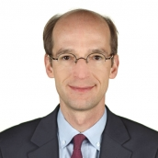
Martin Oelz currently serves as Senior Specialist on Equality and Non-Discrimination at the International Labour Organization, leading the Indigenous Peoples and Ethnic Minorities Team at the Gender Equality and Diversity Branch. A national of Austria, Mr Oelz obtained his LLM in International Human Rights Law from the University of Notre Dame and is a Doctor of Laws (International Public Law) from Leopold-Franzens University Innsbruck. Having previously served as human rights adviser at the Ministry of Foreign Affairs of Austria, he joined the ILO in 2001 and held various legal positions working on human and labour rights. He is the author of numerous articles, studies and working papers on the use of international labour law in domestic courts, working conditions, gender equality, indigenous and tribal peoples and domestic workers.

Ms. Nahla Haidar
Member of the Committee on the Elimination of Discrimination against Women

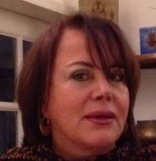
Nahla Haidar is a member of the Committee on the Elimination of Discrimination against Women (CEDAW). She has over 30 years of professional experience within the United Nations system ranging from social development, relief coordination, emergency management training, capacity-building, development cooperation and peace-building to human rights. Ms. Haidar holds an Advanced University Degree in Law and Sociology of Law from the University “Panthéon-Sorbonne” in Paris. Currently, she offers her expertise to various non-governmental organizations with regional involvement in the development field and inter alia oversees the program component related to human rights education for AMEL Association and AMEL International. She also acts as an advisor to NGOs on a pro-bono basis to streamline gender perspective into their policies and programs. Ms. Haidar was elected as a Commissioner of the International Commission of Jurists (ICJ) in March 2019.

