Date: 20th September 2019
Protocol No: Oi - K - SA - 133/19

E-mail address: srsaleofchildren@ohchr.org

Subject: Information for the Special Rapporteur on the sale and sexual exploitation of children including child prostitution, child pornography and other child sexual abuse material, Maud de Boer-Buquicchio

The Human Rights Ombudsman of Bosnia and Herzegovina is an independent institution set up in order to promote good governance and the rule of law and to protect the rights and liberties of natural and legal persons, as enshrined in particular in the Constitution of Bosnia and Herzegovina and the international treaties appended thereto. Based on the competences set out in the Law on the Ombudsman for Human Rights of Bosnia and Herzegovina, the Ombudsman of Bosnia and Herzegovina develops its strategic goals in order to achieve the mission and vision of the Ombudsman of Bosnia and Herzegovina, which include, inter alia, the more effective protection and promotion of human rights and cooperation with the authorities and institutions of Bosnia and Herzegovina, as well as cooperation with non-governmental organizations and citizens. In accordance with the Law on the Ombudsman for Human Rights of Bosnia and Herzegovina, the Ombudsman of Bosnia and Herzegovina, in addition to acting upon individual complaints and registered cases, undertakes a number of activities and measures aimed at protecting and promoting human rights, including, as the most important, the research on certain phenomena, training, drafting of special reports, participation in expert meetings discussing human rights in general, giving opinions and suggestions in the process of drafting laws, strategies and the like. The Human Rights Ombudsman of, since the establishment of its Department for the protection of the rights of the child (June 2009), have made additional efforts to protect and promote the rights of the children in Bosnia and Herzegovina.

In 2012, Bosnia and Herzegovina ratified the Council of Europe Convention on the Protection of Children against Sexual Exploitation and Sexual Abuse. By ratifying international human rights standards, Bosnia and Herzegovina has committed itself to protecting children from all forms of psychological or physical violence, as well as sexual abuse.

The United Nations Committee on the Rights of the Child, considering the combined second, third and fourth periodic reports of Bosnia and Herzegovina (CRC/C/BIH/2-4) at its 1730 and 1731sessions held on 19 September 2012, adopted, inter alia, the observation that the types and lengths of criminal sanctions for the sexual exploitation and sexual abuse of children in domestic criminal legislation are not commensurate with the consequences these acts leave on victims and, in this respect, requires the legislative bodies to provide within their jurisdiction adequate and proportionate penalties for perpetrators of sexual exploitation of children and offenses abuse.

Acting upon the recommendations of the UN Committee on the Rights of the Child, the Council of Ministers of Bosnia and Herzegovina at its 9th session held on 2 June 2015 made a Decision to adopt the Action Plan for Children in Bosnia and Herzegovina (2015-2018) whereby under „A.1 Enhancement of a legal framework“ it reads:

„The current legal system for the protection of children from sexual abuse and exploitation in Bosnia and Herzegovina is not at the required level, especially in the area of criminal justice, which is why it is necessary to harmonize it with the international standards, as well as their harmonization within the country.

Amendments to the criminal law should ensure the following:
- Align the definition of a child with the UN Convention on the Rights of the Child and the Convention on the Protection of Children against Sexual Exploitation and Sexual Abuse, as a person up to the age of 18.
- Increase the age limit for the child’s consent to sexual intercourse to 16 years.
- Elimination of a statute of limitation for criminal offences against the sexual freedom and morals committed against a child.
- Strengthen criminal policies for crimes against sexual freedom and morals, first of all, by raising the minimum sentences.
- Introduction of additional security measures that can be imposed on perpetrators of criminal offenses (especially those related to violence against children): compulsory treatment - psychosocial treatment of the perpetrator, restraint order prohibiting the approach and communication with a specific person, removal from a shared household, a ban on practicing a profession, activity or function related to children.
- Abolish all statutory restrictions for certain professions with regard to criminal liability for failure to report crimes against sexual freedom and morality committed against a child.
- Abolish the possibility of amnesty and pardon for finally convicted perpetrators of sexual abuse of children.
- Establish an obligation of maintaining the unified record of perpetrators of sexual violence against children and enable institutions and other legal entities whose activity is directly related to working with children to obtain/verify information on conviction of the incumbents to positions involving children.
- to align the definition of a criminal offence „trafficking in human beings” with the Palermo Protocol“.

The criminal area in Bosnia and Herzegovina is governed by four criminal laws: the Criminal Code of Bosnia and Herzegovina, the Criminal Code of the Federation of Bosnia and Herzegovina, the Criminal Code of the Republika Srpska, and the Criminal Code of the Brčko District of Bosnia and Herzegovina. The Criminal Code of the Federation of Bosnia and Herzegovina, the Criminal Code of the Republika Srpska and the Criminal Code of the Brčko District of Bosnia and Herzegovina prescribe criminal offenses against marriage and family, which include, among other things, the neglect and abuse of a child, abandonment of a child, violation of a child's privacy, avoidance of child maintenance etc.

In 2017 Republika Srpska adopted its new Criminal Code of Republika Srpska, introducing a new chapter (Chapter XV – Criminal acts of sexual abuse and sexual explotation of children) that comprises the following criminal offences: Sexual Intercourse with a Child under the Age of 15, Sexual Abuse of a Child over the Age of Fifteen, Soliciting a Child’s Presence During Sexual Acts, Exploitation of Children for Pornography, Exploitation of Children for Pornographic Performances, Introducing Pornography to Children, Use of a computer network or communications by other technical means for the commission of criminal offenses of sexual abuse or exploitation of children, Satisfying Sexual Lust in the Presence of a Child and Soliciting a Child to Prostitution.

In 2017 the process of amending the Criminal Code of the Federation of Bosnia and Herzegovina was initiated to fulfill the obligations of the Action Plan for Children of Bosnia and Herzegovina (2015-2018), but the competent authorities of the Federation of Bosnia and Herzegovina did not proceed with activities to amend the provisions of the Criminal Code of the Federation of Bosnia and Herzegovina. Ombudspersons of Bosnia and Herzegovina have made a recommendation to the Parliament of the Federation of Bosnia and Herzegovina to initiate procedural steps without delay in order to amend the Criminal Code of the Federation of Bosnia and Herzegovina. The Ombudsman follows up the implementation of this recommendation. According to information available to the Ombudsman, legal solutions in the Brčko District of Bosnia and Herzegovina are identical to those in the Federation of Bosnia and Herzegovina.

Article 37 of the Council of Europe Convention on the Protection of Children against Sexual Exploitation and Sexual Abuse prescribes the obligations of all member-states as follows: “For the purposes of prevention and prosecution of the offences established in accordance with this Convention, each Party shall take the necessary legislative or other measures to collect and store, in accordance with the relevant provisions on the protection of personal data and other appropriate rules and guarantees as prescribed by domestic law, data relating to the identity and to the genetic profile (DNA) of persons convicted of the offences established in accordance with this Convention“. Related to the above, in April 2019, Law on special register of persons convicted of criminal offences of sexual abuse and exploitation of children the Law on the Special Registry of Persons Convicted for the Offenses of Sexual Abuse and Exploitation of Children entered into force in Republika Srpska.

In their annual reports Ombudspersons turn the attention of the competent parliaments in Bosnia and Herzegovina that particular care should be taken of the violence on the Internet including the new trends of violence against children: sexting, grooming, false Facebook accounts etc. Competent police bodies need to keep abreast of trends and be aware of the many applications on the Internet. Ombudspersons are aware that the police are also facing a number of problems, such as the time-consuming process of data collection from large companies such as Facebook and/or Google, or difficulties in obtaining the valid evidence to initiate and conduct criminal proceedings.

Ombudspersons emphasize, based on citizens' complaints, in addition to their continuous monitoring of media coverage of current events in the country, especially when it comes to children, that media reporting on cases of violence against children still does not ensure the protection of their identity and rights. Ombudspersons are aware of the fact that technological globalization is facilitating the access to media and social networks. Sensationalistic approach to reporting on children only causes additional violations of and threats to the rights of the child, and traumatizes them additionally, especially victims of child sexual abuse and exploitation. Aware that media freedom is a key condition for the development of a democratic society that protects and respects fundamental human rights, Ombudspersons always take the opportunity to invite the media to always tackle a phenomenon instead of an individual case when reporting on children.

Ombudspersons would like to use this opportunity to inform the Special Rapporteur of their continuous interest in following the rights of children on the move. Children on the move are children moving for a variety of reasons, voluntarily or involuntarily, within or between countries, with or without their parents or other primary caregivers, and whose movement, while it may open up opportunities, might also place them at risk. Among the concerns expressed by Ombudspersons in their Special report on situation in the area of migrations in Bosnia and Herzegovina is the failure to provide care for children without parental care since a number of unaccompanied children is found in Bosnia and Herzegovina for whom no guardian is appointed to represent their best interest in the course of the asylum procedure. It happens that an interview for registration be conducted in the absence of a guardian, not even a guardian for a special case, which means that the whole procedure is sometimes done without the appointment of a child’s guardian.

Sincerely,

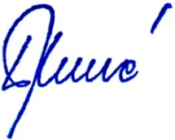
Ombudspersons of Bosnia and Herzegovina:

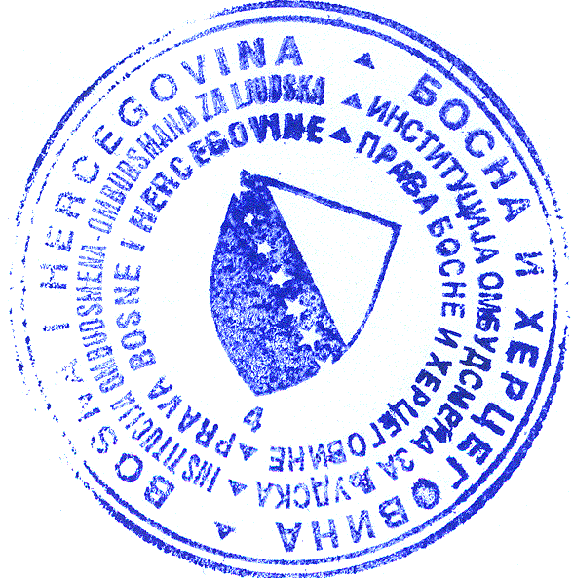
_______________________
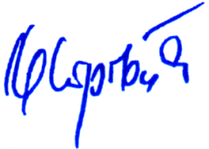
Nives Jukić

_______________________
Prof. Dr. Ljubinko Mitrović
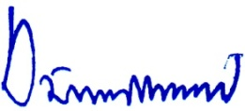

_______________________
Jasminka Džumhur, PhD

http://www.mhrr.gov.ba/PDF/djeca/Bosanska%20v%20FINAL%20prevod%20ISPRAVNE%20VERZIJE1.pdf
http://www.vijeceministara.gov.ba/saopstenja/sjednice/zakljucci_sa_sjednica/default.aspx?id=19519&langTag=bs-BA
http://www.mhrr.gov.ba/PDF/djeca/akcijski%20plan%20za%20djecu-BH-web.pdf
http://www.mhrr.gov.ba/PDF/djeca/akcijski%20plan%20za%20djecu-BH-web.pdf
Criminal Code of Republika Srpska “("Official Gazette of Republika Srpska” no.: 64/17 and 66/18
Recommendations no. P-117/19 of 19 April 2019 sent on 03 June 2019
the Parliamentary Assembly of Bosnia and Herzegovina, the National Assembly of Republika Srpska, the Parliament of the Federation of BIH, the Assembly of the BDBIH
through its work on individual complaints of the citizens
Ž-SA-01-73/17
Definition of Save the Children
from December 2018

