OFFICE OF THE HIGH COMMISSIONER FOR HUMAN RIGHTS

Submission by:

ADF International
Chemin du Petit-Saconnex 28
1209 Geneva, Switzerland

Web: www.ADFinternational.org
Email: un@ADFinternational.org

ECOSOC Special Consultative Status (2010)

Response to the Questionnaire of the Special Rapporteur on the sale and sexual exploitation of children, including child prostitution, child pornography and other child sexual abuse material

8 May 2019
Geneva, Switzerland

Introduction
- ADF International is a faith-based legal advocacy organization that protects fundamental freedoms and promotes the inherent dignity of all people before national and international institutions. As well as having ECOSOC consultative status with the United Nations (registered name “Alliance Defending Freedom”), ADF International has accreditation with the European Commission and Parliament, the Organization for Security and Co-operation in Europe, and the Organization of American States, and is a participant in the FRA Fundamental Rights Platform.
- With reference to the recent questionnaire on safeguards for the protection of the rights of children born from surrogacy arrangements (herein, “the questionnaire”), ADF International wishes to take the opportunity to provide input to the Special Rapporteur on the sale and sexual exploitation of children, including child prostitution, child pornography and other child sexual abuse material (herein, “the Special Rapporteur”) regarding her next thematic report to be presented to the General Assembly in October 2019 (herein, “the report”).
- This contribution argues that, given that surrogacy in all its forms results in the commodification of human life, no legal safeguards, however comprehensive, can appropriately respond to the need for protecting the human rights of children born following such arrangements.
- Based on a structured overview of international human rights law, this contribution firstly investigates the notion of the ‘best interest of the child’, one of the core principles guiding the work of the Special Rapporteur. ADF International submits that the Special Rapporteur should not pursue an over-individualised consideration of this principle; referring to the best interests of children rather than the interest of a particular child.
- Second, this written contribution addresses the topic of identity, origin and parentage rights as raised in the primary section of the questionnaire. ADF International submits that the web of legal uncertainty surrounding these three fundamental rights in surrogacy situations casts serious doubt as to the adequacy of any national safeguards whatsoever, to the detriment of the child’s personality and welfare.
- Third, by briefly analyzing the international legal definitions of the sale and trafficking of children, ADF International submits that these conducts are integral to the nature of surrogacy arrangements and cannot be avoided through the implementation of safeguarding measures. The response of European law to this embedded problem is presented as an illustrative tool.

Best Interest of the Child
- Article 3 (1) of the Convention on the Rights of the Child (herein, “CRC”) requires to take the “best interests of the child” as a primary consideration in all actions concerning children. Although several other provisions rely on this principle, the CRC does not define “the best interest of the child”. Therefore, the term has been open to interpretation by the Committee on the Rights of the Child (herein, “the Committee”), as well as by the international and national legislators and courts.
- In its General Comment No. 7 (2005) on implementing child rights in early childhood, the Committee outlines a dual-aproach to honouring this principle: individualistic (in “all decision-making concerning a child”), and collective (putting “young children as a group or constituency” at the center of “all law and policy development”).
- The imperative to consider the best interests of all children guided the European Court of Human Rights (ECtHR) to the following conclusion in Paradiso and Campanelli v. Italy:
“the legitimate aim of […] protecting children – not merely the child in the present case but also children more generally – having regard to the prerogative of the State to establish descent through adoption and through the prohibition of certain techniques of medically assisted reproduction.”
- Each surrogacy arrangement is unique, and some situations may appear more risk-prone than others. However, the fundamental premise of surrogacy is detrimental to children as a collective group; compromising their dignity and endangering human rights as enshrined in the CRC.

Rights to Identity, Parentage and Access to Origins
- The Special Rapporteur’s questionnaire queries approaches to balancing the fulfilment of surrogacy arrangements (including the detachment and anonymization of gamete donors and surrogate mothers) against the protection of the rights of the child to identity, a family environment and access to origins. However, even with the implementation of “legal safeguards” to this intent, significant and immoveable obstacles continue to put fundamental rights of the child at risk.
- At root, surrogacy deprives children of clear lines of filiation and ultimately commodifies their lives. Indeed, a child born following a surrogacy agreement is deliberately placed into a situation of planned abandonment from his/her gestational mother, as well as, potentially, both of his/her genetic parents. At one end of the spectrum of possibilities, all six adults vie for legal “possession” of the child. At the other end, the child is completely abandoned, unwanted, and left as a ward of the state. Moreover, in situations of cross-border surrogacy enabled by third-party agencies, it is unclear which state will ultimately take charge of the child in the event of dispute or the dissolution of the initial deal. The practice of surrogacy thus inevitably exposes children to unacceptable levels of legal uncertainty; undermining their right to know their origins, their right to develop a family identity, and any aspirations to family reunification. Whether abandoned or battled for, it is clear that in each situation the child is deprived of a stable and caring environment crucial for his or her development. It is erroneous to think that clear legal rules regarding parentage would suffice to limit interference with the human rights of children born through surrogacy agreements.
- Furthermore, a child born following a surrogacy agreement is disproportionally at risk of being prevented from accessing vital genetic information; thus not only interfering with the right to know one’s origins, but also with the enjoyment of the right to the highest attainable standard of health.

Surrogacy and the Sale of Children
- Several questions on the questionnaire refer to national safeguards against trafficking and the sale of children in surrogacy situations. However, regardless of attempted prevention, surrogacy is by nature integrated into both of these crimes. No amount of regulation would in fact cease the violation of rights that it inherently imbues.
- As defined by the Optional Protocol to the CRC on the Sale of Children, Child Prostitution and Child Pornography (OPSC), the ‘sale of children’ constitutes “any act or transaction whereby a child is transferred by any person or group of persons to another for remuneration or any other consideration.” Furthermore, Article 35 CRC states that “State Parties shall take all appropriate national, bilateral and multilateral measures to prevent the abduction of, the sale of or traffic in children for any purpose or in any form.” The purpose of the sale is clearly deemed irrelevant – even if, in the best case scenario, surrogacy can promise a child a loving home. Therefore, regardless of national legal safeguards aimed at post-transfer protection, the operation of surrogate transactions intrinsically invokes this crime.
- Some advocates of the practice insist that limiting the profits derived from surrogacy provides an adequate safeguard against the sale of children. However, research shows that in the United Kingdom, where only “altruistic” forms of surrogacy are permitted, the majority of commissioning couples still pay between £20,000-30,000 throughout the process in so-called “pregnancy expenses.” Even in situations where money is not transferred discretely, surrogacy falls within the Article 2 OPSC definition of the sale of children because of the reference to “remuneration or any other consideration.” Such considerations may include payments in-kind, such as accommodation, payment of household or grocery bills, medical care and medication bills, etc; and more still, such gestures are often coupled with significant emotional pressures placed on the surrogate mother to make a sacrifice for a sister or friend. All forms of surrogacy, then – and not just those without monetary safeguards and deemed to be “commercial” – constitute the sale of children by international legal standards.

Surrogacy and Human Trafficking
- The Protocol to Prevent, Suppress and Punish Trafficking in Persons, especially Women and Children (hereinafter, “the Palermo Protocol”) defines human trafficking as comprising of three central stages: (1) “...the recruitment, transportation, transfer, harbouring or receipt of persons”; (2) “by means of the threat or use of force or other forms of coercion, of abduction, of fraud, of deception, of the abuse of power or of a position of vulnerability or of the giving or receiving of payments or benefits to achieve the consent of a person having control over another person”; and (3) “for the purpose of exploitation. Exploitation shall include, at a minimum, the exploitation of the prostitution of others or other forms of sexual exploitation, forced labour or services, slavery or practices similar to slavery, servitude or the removal of organs.”
- Within the framework of surrogacy, the victimization not only of the surrogate woman, but also the child, is of primary concern. Often passed along a de facto production line, the child is certainly (1) “transported, harbored and received” from the surrogate mother, to the clinic “brokers” and finally to the commissioning party. Indeed, before the embryo is even created, sperm and egg samples - either from the commissioning couple or from donors - are often flown across the world. In many cases, after implantation, the child is moved in utero to wherever the mother is placed in order to navigate international legal loopholes. Finally upon birth, the child must be transported and transferred to the homes of the commissioning party – an unavoidable element of the deal, even under purely domestic circumstances.
- Although the Protocol does not require criterion (2) to be fulfilled in the case of a victim who is a minor; certainly, nonetheless, means of “abuse of power or a position of vulnerability” is employed given the inability of the child to make a choice regarding separation from their gestational mother, and furthermore, the “giving and receiving of payments or benefits to achieve the consent of a person having control over another person” takes place in every surrogate transaction, in one form of another, whether technically labelled “commercial” or not.
- Finally, the Protocol requires that the action is (3) for the purpose of exploitation. This term is not clearly defined in international law; however, drawing out the common denominator from the list of examples offered within the protocol, it is derived that the term means to use the life or being of one party, to their own detriment, to advantage another. It is abundantly clear that surrogacy arrangements are detrimental to children, whose rights to an identity, access to their origins and, in some cases, nationality, are at severe risk of neglect or abuse for the sake of fulfilling parental as well as profit-driven desires.
- Furthermore, the health and well-being of the child are unavoidably jeopardized due to the nature of surrogacy arrangements. Studies show that separation from the gestational mother has proven to lead to anxiety issues and behavioral problems for children both in infancy and later in adolescence. Development of the brain’s response to stimuli is also affected when the baby is deprived of the scent and smell of the mother that the baby learned to know in utero, which is also known to assist with soothing for newborns. Therefore, in no surrogacy situation can the best interests of the child ever be considered to be given priority over the desires of the parents and agencies.

Surrogacy in European Law
- Article 4 of the Council of Europe Convention on Action against Trafficking in Human Beings reiterates the definition of human trafficking from the Palermo Protocol.
- Recognizing the duty of the European Union to ensure respect for human rights, human dignity and equality between men and women, the European Parliament has repeatedly condemned surrogacy as human trafficking. In a 2016 resolution, the Parliament:
“Condemns the practice of trafficking in human beings for forced surrogacy as a violation of the woman’s rights and the rights of the child; notes that demand is driven by developed countries at the expense of vulnerable and poor people often in developing countries, and asks the Member States to consider the implications of their own restrictive reproductive policies;”
Also, in a 2015 resolution regarding the Annual Report on Human Rights and Democracy in the World, the Parliament:
“Condemns the practice of surrogacy, which undermines the human dignity of the woman since her body and its reproductive functions are used as a commodity; considers that the practice of gestational surrogacy which involves reproductive exploitation and use of the human body for financial or other gain, in particular in the case of vulnerable women in developing countries, shall be prohibited and treated as a matter of urgency in human rights instruments;”
- Condemnation of human trafficking is not enough, however, and States are obliged to take positive action. The European Parliament called for ‘clear principles and legal instruments addressing human rights abuses related to surrogacy’. Article 11 CRC mandates States to “take measures to combat illicit transfer and non-return of children abroad”, including through “the conclusion of bilateral agreements”. Surrogacy arrangements can often feature the cross-border transfer of a child, resulting in a violation of national legislation. Furthermore, almost all European states committed to criminalizing human trafficking as well as “acts constitutive of this great violation of human dignity” in the abovementioned Council of Europe Convention.
- While some isolated cases of cross-border surrogacy do not necessarily violate national law, the practice as a whole inevitably results in the trafficking and selling of children and the commodification of their livesTherefore, rather than attempting to regulate international surrogacy (through efforts such as those taken within the ‘parentage/surrogacy’ project of the Hague Conference), States should adopt a convention univocally prohibiting the practice.

Conclusion
- In accordance with all the information provided above, it is the strong recommendation of ADF International that the Special Rapporteur uses her upcoming report to condemn the practice of surrogacy for violating the human rights and dignity of children. The intrinsic structure of surrogacy compromises, by nature, the best interests of the child. No “safeguard” regulation can fully restore their rights to filiation, to identity and to know and be cared for by their parents; no less, can it restore the cost of their dignity, their lives having been bartered for as simple commodities.

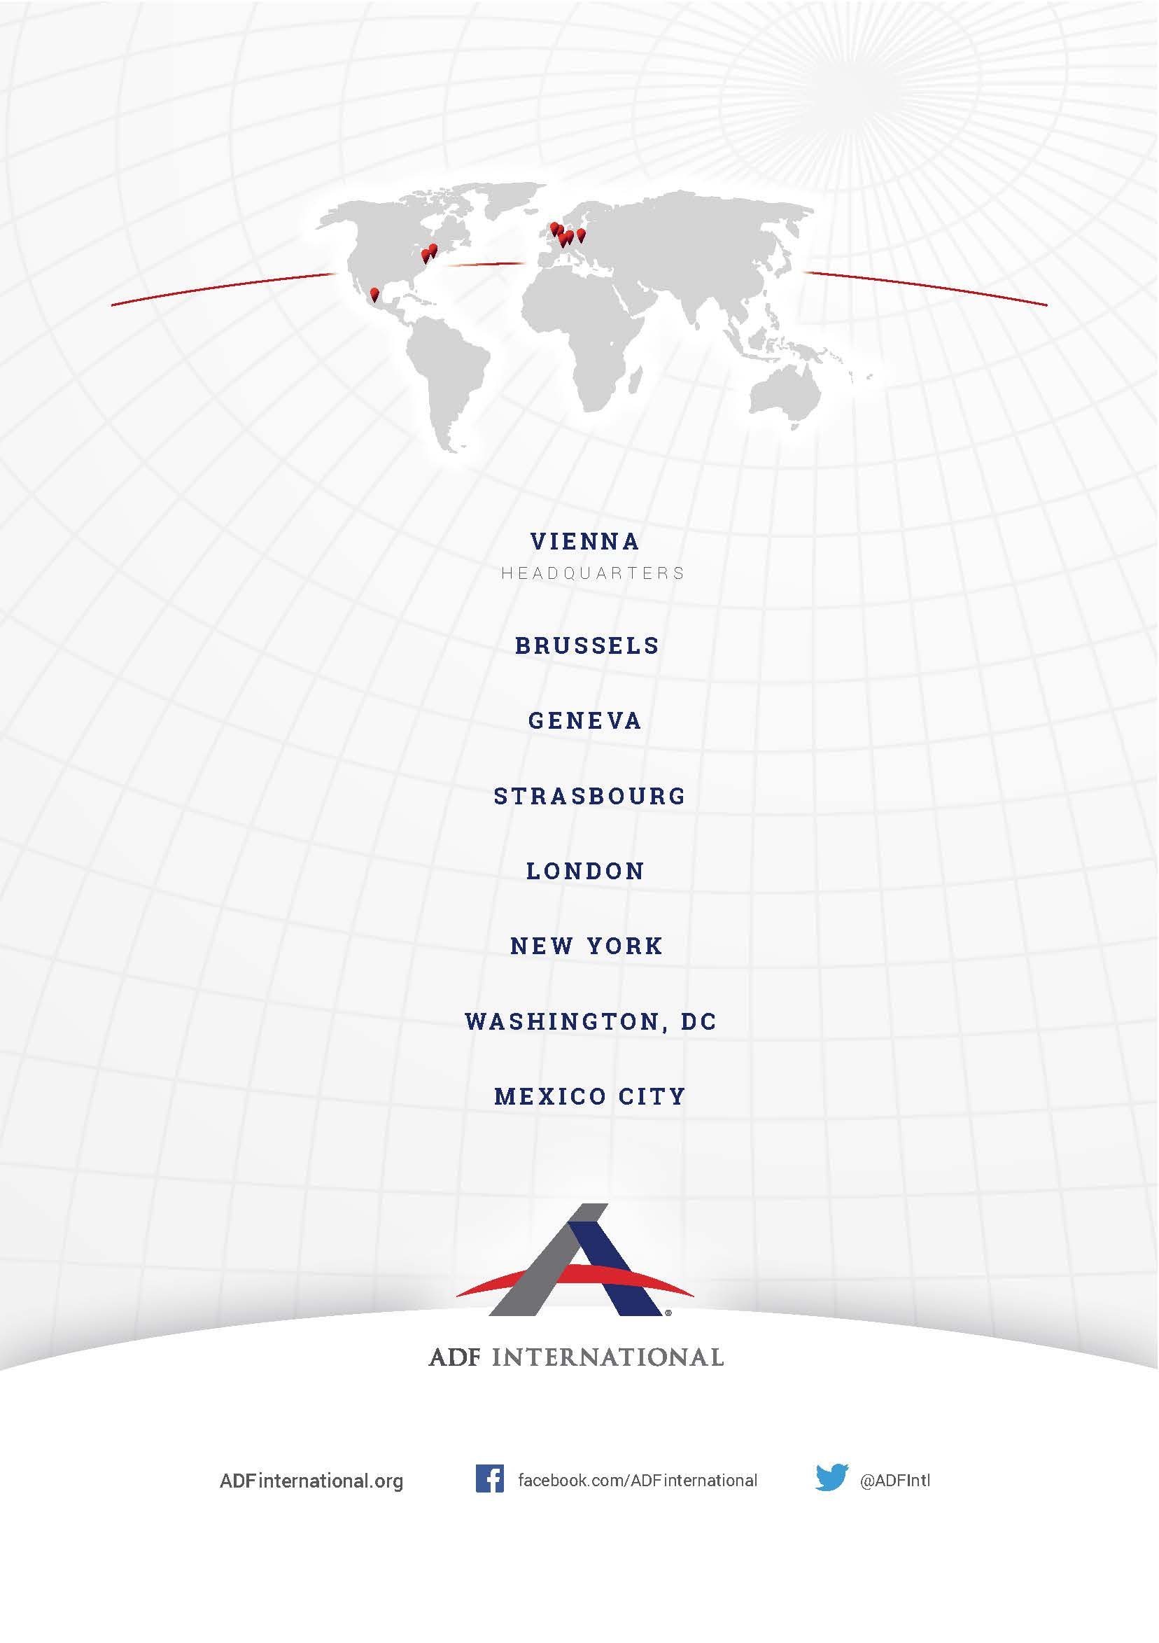
© 2019

UN Committee on the Rights of the Child, General comment No. 7 (2005): Implementing Child Rights in Early Childhood (20 September 2006) CRC/C/GC/7/Rev.1 ¶ 13.
Paradiso and Campanelli v. Italy no. 25358/12 (ECtHR 27 January 2017) ¶ 197; see also Costa and Pavan v. Italy no. 54270/10 (ECtHR 28 August 2012) ¶ 62.
Convention on the Rights of the Child (adopted 20 November 1989, entered into force 2 September 1990) 1577 UNTS 3 (CRC) Art 7,8,9,10,20.
See, for example, ‘Chinese baby born four years after parents' death’ BBC News (12 April 2018) <http://www.bbc.com/news/world-asia-china-43724395>; Amy Wang, ‘Surrogate mother forced to give away own child after surprise twin pregnancy’ The Independent (3 November 2017) <https://www.independent.co.uk/news/world/americas/surrogate-mother-pregnant-twins-own-baby-jessica-allen-omega-family-global-san-diego-a8034901.html>. See also Clotilde Brunetti-Pons, Le ‘Droit à l’Enfant’ et la filiation en France et dans le Monde (2017) 72, 223-244.
‘Australian couple abandon surrogate Down's Syndrome baby’ BBC News (2 August 2014) <https://www.bbc.com/news/world-asia-28617912>.
Sanoj Rajan, ‘International surrogacy arrangements and statelessness’ Institute on Statelessness and Inclusion (2017) <http://children.worldsstateless.org/3/safeguarding-against-childhood-statelessness/international-surrogacy-arrangements-and-statelessness.html>.
CRC (n3) Art 7, 8.
Kirsty Horsey, ‘Surrogacy in the UK: further evidence for reform: Second Report of the Surrogacy UK Working Group on Surrogacy Law Reform’ (Surrogacy UK, December 2018).
Susan Golombok et al. “Children born through reproductive donation: a longitudinal study of psychological adjustment” (2013) 54, 6 Journal of Child Psychology and Psychiatry, 653.
Id. See also Susan Golombok et al. “Children born through reproductive donation: a longitudinal study of psychological adjustment” (2013) 54, 6 Journal of Child Psychology and Psychiatry, 653.
Council of Europe (COE), Convention on Action against Trafficking in Human Beings (16 May 2005) 197 CETS.
joint reading of the Charter of Fundamental Rights of the European Union (26 October 2012) 2012/C 326/391 Art 1, 5(3), 23 & 51 and of the Consolidated Version of the Treaty on the Functioning of the European Union (13 December 2007) 2008/C 115/01 Art 8.
European Parliament, ‘Resolution of 5 July 2016 on the fight against trafficking in human beings in the EU’s external relations’ (5 July 2016) 2015/2340(INI) ¶ 31.
European Parliament, ‘Resolution of 17 December 2015 on the Annual Report on Human Rights and Democracy in the World 2014 and the European Union’s policy on the matter’ (17 December 2015) 2015/2229(INI) ¶ 115.
European Parliament, ‘Resolution of 12 December 2018 on the annual report on human rights and democracy in the world 2017 and the European Union’s policy on the matter’ (12 December 2018) 2018/2098(INI) ¶ 48.
COE (n13) Art 18-26.

