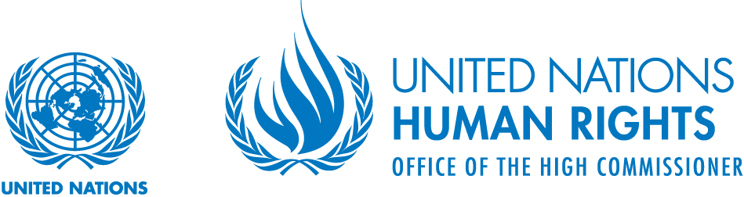
Working Group on the issue of human rights and
transnational corporations and other business enterprises

“The State as an economic actor: the role of economic diplomacy tools to promote business respect of human rights”
Open multi-stakeholder consultation convened by the UN Working Group on Business and Human Rights
Palais Wilson (first floor conference room), Geneva
15:00-18:00, 28 September 2017
Aims of the consultation
The UN Working Group on Business and Human Rights plans to focus its 2018 report to the Human Rights Council on UN Guiding Principle 4, which focuses on the state-business nexus. More specifically, the report will focus on the role States can play in strengthening business respect for human rights, through the agencies that provide benefits and services to business entities within their jurisdiction.
The commentary to Guiding Principle 4 states:
“A range of agencies linked formally or informally to the State may provide support and services to business activities. These include export credit agencies, political investment insurance or guarantee agencies, development agencies and development finance institutions. Where these agencies do not explicitly consider the actual and potential adverse impacts on human rights of beneficiary enterprises, they put themselves at risk – in reputational, financial, political and potentially legal terms – for supporting any such harm, and they may add to the human rights challenges faced by the recipient State.
Given these risks, States should encourage and, where appropriate, require human rights due diligence by the agencies themselves and by those business enterprises or projects receiving their support. A requirement for human rights due diligence is most likely to be appropriate where the nature of business operations or operating contexts pose significant risk to human rights.”
With this commentary in mind, the Working Group will hold an open multi-stakeholder consultation focused on how states are creating requirements or incentives for business respect for human rights, through the various government mechanisms that provide support or tangible benefits for business.
Key questions for discussion
The consultation will seek to address questions and examples of practical experience related to the following:
- Requirements by relevant trade, foreign affairs and other business ministries and agencies for businesses to demonstrate commitments to human rights or the UN Guiding Principles as a condition of receiving government support, such as export promotion, export credit, trade advocacy service, participation in trade missions, investment guarantees or political risk instance.
- Requirements for companies who receive support as outlined above to engage in human rights impact assessment/human rights due diligence (including how such policies are made clear to the business community and steps taken by relevant government agencies/ministries to monitor or evaluate a company’s commitments and actions).
- Steps by relevant agencies/ministries taking steps to withdraw trade and investment support for a company/business that is the subject of a credible complaint by victims relating to adverse human rights impacts (including complaints presented through OECD National Contact Points).
- Requirements for companies who are seeking government assistance within domestic markets to demonstrate respect for human rights and/or a commitment to the UN Guiding Principles (e.g. requirements to make commitments relating to human rights in order to receive subsisted government loans or tax concessions, participation in government advisory bodies and councils, etc.)
- Requirements for companies seeking government contracts through a procurement process to demonstrate corporate respect for human rights (including the consequences if a complaint is lodged against a company that has been awarded a government contract, with respect to its causing, contributing or being directly linked to negative human rights impacts)
Agenda and practical information
An agenda for the consultation will be posted on the Working Group’s web page closer to the date of the meeting. A number of key questions for discussion at the consultation can be found in the below annex. To register, please contact registrationwgbusiness@ohchr.org.
Further background
With a mandate to promote worldwide implementation of the UN Guiding Principles on Business and Human Rights and to identify and scale up good practice, the UN Working Group on Business and Human Rights has decided to give specific attention to issues related to the “state-business nexus” during 2017-18.
It has identified activities to complement and support efforts by others, including to (i) identify good practice models of integrating human rights in the operation of “economic diplomacy tools”, such as export credit, investment guarantees, export promotion and trade missions; (ii) develop practical recommendations for States and international and regional organizations relating to these policy areas; (iii) identify good practice models of integrating human rights in public procurement; (iv) engage key actors and stakeholders to support dialogue and drive convergence in these areas.
The aim is to develop concrete recommendations to be presented in its report to the Human Rights Council in June 2018. To gather information about good practice models and inform recommendations, the Working Group intends to consult with experts and a range of relevant stakeholders through both written processes and in-person meetings. It will seek to get inputs from States from all regions as well as from other stakeholders, including business organizations, civil society, international and regional organizations and other UN experts.
In addressing the “State-business nexus”, the UN Guiding Principles on Business and Human Rights clarify that all States are expected to ensure protection of and respect human rights in their role as economic actors. This aspect of the State duty to protect human rights covers policy areas such as management of State-owned enterprises, export credit, official investment insurance, and public procurement, and emphasizes that States should both integrate human rights due diligence in the entities in charge of these areas as well as incentivize due diligence by business with which the State conducts commercial transactions. The Guiding Principles also highlight that States should ensure policy coherence between government departments and agencies that “shape business practice” and the States’ international human rights obligations.
While the Guiding Principles clarify normative and policy implications of States’ existing human rights obligations, further work to unpack good practice models and practical implications is necessary in order to support and scale up implementation efforts. A key issue is to support convergence and coordination among the various international, regional and state actors that play a role in shaping practice in relation to the “State-business” nexus.
During 2015-16 the Working Group undertook the first part of this project, which had an overall aim of encouraging States to “lead by example” in their role as economic actors to a much larger extent than today. The first stage focused on the duty of States to protect against human rights abuses involving those business enterprises that they own or control, generally referred to as State-owned enterprises (SOEs). In this regard, the Working Group set out special recommendation in its 2016 report to the Human Rights Council “Leading by example - The State, State-owned enterprises, and Human Rights” (A/HRC/32/45). In the second part of its project exploring the “state-business nexus”, the Working Group will focus on the operation of “economic diplomacy tools”, such as export credit, investment guarantees, export promotion and trade missions, as well as public procurement.
The policy areas covered by the project relate closely to a range of the Sustainable Development Goals and their implementation both at home and abroad as well as in multi-lateral settings. Good practice by States – individually and collectively – in these policy areas has tremendous potential to contribute positively to advancing human rights and sustainable development, but this potential might not be realized unless current efforts are backed up by strengthened alignment with and practical implementation of the UN Guiding Principles.
* * *

Guiding Principle 4 reads: “States should take additional steps to protect against human rights abuses by business enterprises that are owned or controlled by the State, or that receive substantial support and services from State agencies such as export credit agencies and of political/ investment insurance or guarantee agencies, including, where appropriate, by requiring human rights due diligence”.

