Submission by the Geneva Academy of International Humanitarian Law and Human Rights
to the Questionnaire in Relation to General Assembly Resolution 68/268 Circulated by OHCHR

academic input into the 2020 review

The Geneva Academy of International Humanitarian Law and Human Rights (Geneva Academy), a joint centre of the University of Geneva and the Graduate Institute of International and Development Studies, welcomes this opportunity to submit input to the United Nations (UN) Secretary-General Report on the status of the human rights treaty body system and wishes to provide comments especially on further action to strengthen and enhance the effective functioning of the human rights treaty body system.
In particular, we would like to draw your attention to the recommendations regarding the interaction of states, non-governmental organizations (NGOs) and National Human Rights Institutions (NHRIs) with the Committees overseeing the implementation of the treaties and conventions, reforming the system of reporting and dialog as highlighted in our report Optimizing the UN Treaty Bodies.
The main recommendations entailed in this report are to introduce a streamlined reporting and dialog procedure, based on the Simplified Reporting Procedure currently introduced by most treaty bodies (TBs). In two variations, practical possibilities are presented to move towards with a Single State Report, based on a consolidated list of questions, and a combined State Review every eight years, or a Semi-consolidated State Report and two clustered reviews every four years (see excerpt of the reports’ executive summary below).
Following the adoption of GA Resolution 68/268, the Geneva Academy has been coordinating academic input to the 2020 review of UN treaty bodies by the UN General-Assembly via the creation of an Academic Platform of independent researchers, a call for papers, a series of regional consultations, annual conferences in Geneva, as well as ongoing interaction with key stakeholders. Based on a shared understanding of the shortcomings of the current system, which effectively was never organized as a system in the first place, the recommendations aim at strengthening visibility, predictability, sustainability, user-friendliness and, as a result, impact of the treaty body system.
Key parameters of the research and resulting recommendations were 1) the respect for the current legal framework, i.e. not put forward recommendations which would require changes in the treaties and 2) ensure that the recommendations would be realizable roughly within the currently existing resources.
MAIN RECOMMENDATIONS

The proposals developed through the Academic Platform and presented in the above-mentioned publication consider a wide range of issues. They are grouped under: (1) TB functions, states’ reporting and dialogues with TB experts; (2) synergies, in and beyond the system; (3) the accessibility of the system; and (4) its structure. At the end, the report comments on (5) the transitional period that will be required to establish any significant changes to the TB system. The main recommendations relate to the consolidation of reports and state reviews.

Combine state reviews in a consolidated state report and a single review or a semi-consolidated state report and two clustered reviews

The review of state party reports is challenged both by under- and over-reporting.
A change in the review process would have a significant impact on TBs’ work and could create conditions in which TBs could provide a universal and fair review of all state parties at reasonable intervals while increasing compliance. Both the options described would bring specific benefits: for instance, dialogues and conclusions would be more visible, duplication of reports and recommendations would fall, and states and other actors would be required to make fewer visits to Geneva, reducing costs and the burden of reporting.
The following models are proposed

a. A single state report combined with a consolidated state review
Under this model, states parties would be reviewed by all relevant TBs during the same week every seven to eight years on the basis of a single state report (SSR). The SSR would contain a general section that covered all the treaties a state has ratified, followed by sections that are treaty-specific. The adoption of this model would not entail a radical shift in current practice, because the first general section would be the equivalent of what is now called the Common Core Document. The SSR would replace the various periodic reports that states parties are currently asked to submit to the relevant committees. In a similar manner, the model foresees preparation of a single consolidated list of issues that the Committees would send to a state before its review. Its written replies on those would constitute its periodic report. However, the outcome of the review would include distinct concluding observations from the Committee of each treaty that the state had ratified.

In practical terms, this option would require all but one (SPT) of the ten Committees to sit simultaneously in Geneva in different meeting rooms for a week. States under review would meet each relevant Committee in turn.

b. A semi-consolidated state report combined with a clustered state review
The second option would also consolidate state reviews but would not require all committees to sit at the same time. Under this proposal, instead of appearing before all Committees in the same short period every seven to eight years, states would be reviewed twice, by different Committees, at four year intervals. They would therefore still be reviewed by all relevant committees over an 8-year cycle, but in two clustered reviews. Clustering the reviews by Committees of the two general Covenants, and Committees of the treaties that address specific groups and themes, could strengthen follow-up and reinforcement while avoiding unnecessary and unintended overlaps.
FURTHER REFINEMENT / PRACTICAL CONSIDERATIONS
Building on the recommendations developed by the Academic Platform, the Geneva Academy has moved on proving the practical feasibility of implementing the recommendations. A scheduling program was developed which optimizes the TB sessions in the way it groups states according to their ratification scheme. The ‘Treaty Body Scheduler’ allows planning, in the context of a consolidated report and single or clustered dialogue, the best schedules for TBs sessions.
While the duration of TBs sessions would remain approximately the same, the schedules developed by this tool would allow delegations to reduce their travels to Geneva. This type of organization would also promote greater interactions between Committees’ members as they would be in session simultaneously.

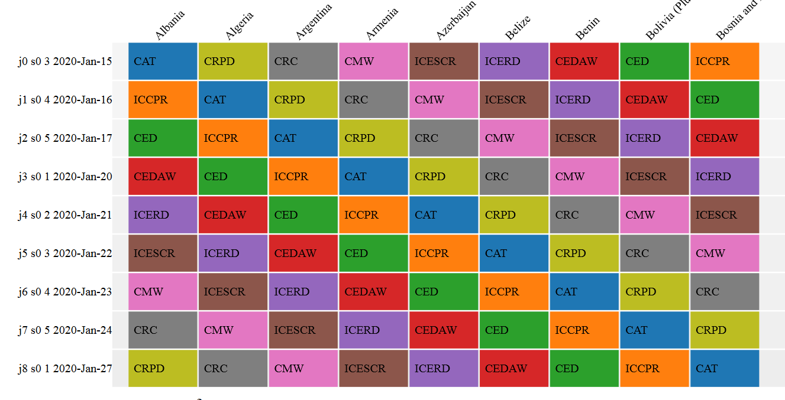
Screenshot of a potential schedule produced via the ‘Treaty Body Scheduler’. Any other parameters can by modelled.

