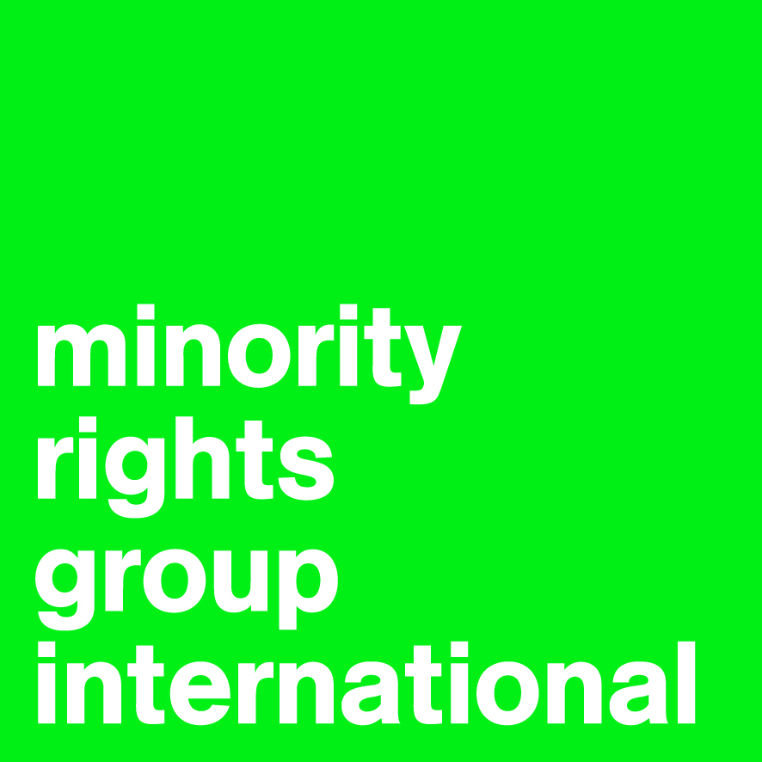

Open-ended intergovernmental working group on transnational corporations and other business enterprises with respect to human rights

Textual Suggestions on Revised Draft of 16 July 2019

By: Minority Rights Group International & Lex Justi

25 November 2019

Further to our recent submission dated 4 October 2019 to the open-ended intergovernmental working group, Minority Rights Group International (MRG) and Lex Justi would like to present the following short list of textual suggestions on the most recent draft of the Legally Binding Instrument to Regulate, in International Human Rights Law, the Activities of Transnational Corporations and Other Business Enterprises dated 16 July 2019.

We begin by suggesting the insertion ‘national or ethnic, religious and linguistic minorities’ where relevant, while at same time suggesting a few other changes to the list of groups at risk of disproportionate impact, primarily for consistency and comprehensiveness. Then we go on to suggest the crucial change to ‘free, prior and informed consent’ for indigenous peoples, to bring the proposed legally binding instrument into line with international norms. Finally, we suggest changes to paragraphs concerning victims, in order to reflect the particular impacts faced by minorities and indigenous peoples – both as individuals and as communities.

The textual suggestions are presented below in track changes:

I. Minorities

Preambular para. 14
Recognizing the distinctive and disproportionate impact of certain business-related human rights abuses on individuals from groups or populations that are at heightened risk of marginalization, disadvantage or exclusion, such as women and girls, children, persons with disabilities, national or ethnic, religious and linguistic minorities, indigenous peoples, , migrants, refugees, internally displaced persons and protected populations under occupation or in conflict areas, and the need for a perspective that takes into account their specific circumstances and needs.

Article 5.3.b
- Carrying out meaningful consultations with groups whose human rights can potentially be affected by the business activities, and with other relevant stakeholders, through appropriate procedures including through their representative institutions, while giving special attention to those facing heightened risks of violations of human rights within the context of business activities, such as women and girls, children, persons with disabilities, national or ethnic, religious and linguistic minorities, indigenous peoples, migrants, refugees, internally displaced persons and protected populations under occupation or in conflict areas. Consultations with indigenous peoples will be undertaken in accordance with the internationally agreed standards of free, prior and informed consultations, as applicable.

Article 14.4
In implementing this (Legally Binding Instrument), State Parties shall address the specific impacts of business activities on while giving special attention to those facing heightened risks of violations of human rights within the context of business activities, such as women and girls, children, persons with disabilities, national or ethnic, religious and linguistic minorities, indigenous peoples, migrants, refugees, internally displaced persons and protected populations under occupation or in conflict areas.

Comment:

Legal Support for inclusion of “national or ethnic, religious and linguistic minorities”
- International Covenant on Civil and Political Rights (ICCPR) and the International Covenant on Economic, Social and Cultural Rights, provide for respect for the rights of persons without distinction or discrimination “of any kind” as to, among other grounds, race, colour, language, religion, and national origin (see Articles 2.1 and 2.2, respectively);
- ICCPR, provides that “ethnic, religious or linguistic minorities” “in community with the other members of their group,” have the right “to enjoy their own culture, to profess and practice their own religion, or to use their own language” (see Article 27);
- UN Guiding Principles on Business and Human Rights (2011) include “national or ethnic, religious and linguistic minorities” as one of the groups of persons that require special attention (see commentary to Guiding Principles 3 and 12); and
- Committee on Economic, Social and Cultural Rights, General Comment No. 24 on State obligations under the International Covenant on Economic, Social and Cultural Rights in the context of business activities, U.N. Doc. E/C.12/GC/24 (10 Aug. 2017) para. 8.
Comment:

Legal Support for the right of minorities to be consulted
- U.N. Declaration on the Rights of Minorities (see Article 2.2);
- U.N. Human Rights Committee, Ángela Poma Poma v. Peru, U.N. Doc. CCPR/C/95/D/1457/2006 (24 April 2009) para. 7.6; and
- Inter-American Court of Human Rights, Case of the Saramaka People v. Suriname, Preliminary Objections, Merits, Reparations and Costs, Judgment (ser. C) No. 172, (28 Nov. 2007) paras. 129, 133.

II. Free, Prior and Informed Consent

Article 5.3.b
- Carrying out meaningful consultations with groups whose human rights can potentially be affected by the business activities, and with other relevant stakeholders, through appropriate procedures including through their representative institutions, while giving special attention to those facing heightened risks of violations of human rights within the context of business activities, such as women, children, persons with disabilities, indigenous peoples, migrants, refugees, internally displaced persons and protected populations under occupation or conflict areas. Consultations with indigenous peoples will be undertaken in accordance with the internationally agreed standards of free, prior and informed consent.
Comment:

Legal support for Free, Prior and Informed Consent
- U.N. Declaration of the Rights of Indigenous Peoples (see Article 19);
- U.N. General Assembly, Outcome document of the high-level plenary meeting of the General Assembly known as the World Conference on Indigenous Peoples, U.N. A/RES/69/2 (2014) para. 20;
- UN Global Compact, The Business Reference Guide to the UN Declaration on the Rights of Indigenous Peoples (2013) 45;
- U.N. Human Rights Council, Report of the Special Rapporteur on the rights of Indigenous Peoples U.N. A/HCR/21/47 (2012) para. 85;
- U.N. Committee on Economic, Social and Cultural Rights, General Comment No. 21, Right of eight of everyone to take part in cultural life (2009) 9 (para. 37);
- U.N. Committee on the Elimination of Racial Discrimination, General Recommendation 23 on the rights of indigenous peoples (1997) 1 (para. 4d);
- UN REDD Programme, Legal Companion to the UN-REDD Programme Guidelines on Free, Prior and Informed Consent (FPIC): International Law and Jurisprudence Affirming the Requirement of FPIC (Jan. 2013);
- Inter-American Court of Human Rights, Saramaka People v. Suriname, Interpretation of the Judgment on Preliminary Objections, Merits, Reparations and Costs (12 Aug. 2008) 6 (para.17); and
- African Commission on Human and Peoples Rights Case 276 / 2003 – Centre for Minority Rights Development (Kenya) and Minority Rights Group International on behalf of Endorois Welfare Council v Kenya (2009) para. 291.

III. Definitions

Article 1.1
“victims” shall mean any persons or group of persons who individually or collectively have suffered or have alleged to have suffered human rights violation or abuse as defined in Article 1 paragraph 2 below. Where appropriate, and in accordance with domestic law, the term “victim” also includes the immediate family or dependents of the direct victim and may include the minority or indigenous community of the victim.

Comment:

Legal Support for impacts on minority or indigenous community “victims” as affecting the minority or indigenous community of the victim, with specific reference to land rights
- U.N. Declaration on the Rights of Indigenous Peoples (see Articles 8.b, 10, 25, 26, 27 and 28)
- U.N. Human Rights Committee, General Comment No. 23: The rights of minorities (Art. 27), U.N. Doc. CCPR/C/21Rev.1/Add.5, 4 August 1994, paras. 1 and 3.2;
- Inter-American Court of Human Rights, Case of the Saramaka People v. Suriname, Preliminary Objections, Merits, Reparations and Costs, Judgment (ser. C) No. 172, (28 Nov. 2007) para. 95;
- African Court on Human and Peoples’ Rights, African Commission on Human and Peoples’ Rights v. Republic of Kenya, App. No. 006/2012, Judgment (26 May 2017) paras. 122-124, 131, 200-201; and
- MRG has received numerous reports from indigenous land rights activists being threatened and harassed by security guards retained by businesses. The intention in these cases is very clearly to undermine the will of the individual and the community, and often, targeted violations and broader harassment and threats are used in combination as a deliberate strategy.

Article 1.2
“Human rights violation or abuse” shall mean any harm committed by a State or a business enterprise, through acts or omissions in the context of business activities, that violates the human rights of any person or group of persons, individually or collectively, including physical or mental injury, emotional suffering, or economic loss or environmental rights.

IV. Rights of Victims and Prevention

Article 4.2
Victims shall be guaranteed the right to life, personal integrity, freedom of opinion and expression, peaceful assembly and association, and free movement and the communities of victims shall be protected from unlawful interference of their right to practice their livelihoods, their culture and religion.

Article 4.3
Victims, their representatives, families and witnesses, as well as other members of the minority or indigenous community of the victim, shall be protected by the State Party from any unlawful interference against their privacy and from intimidation, and retaliation, before, during and after any proceedings have been instituted.

