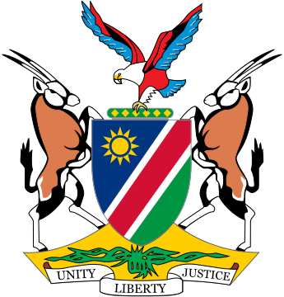

Statement by ***Gladice Pickering – Ministry of Justice and Office of the Attorney-General,*** 5th session of the WG on Transnational Corporations and Human Rights, Geneva, 16 October 2019

Thank you Mr Chair and thank you to the panellist for their insights.

Namibia welcomes the improvements to Article 6 on legal liability and comments as follows:

As indicated yesterday, there is a close connection between the human rights due diligence requirement contained in Article 5 and the legal liability of TNCs and OBEs. In this regard, we propose that administrative penalties be imposed when companies fail to comply with human rights due diligence requirements in all instances, as established.

It is worthwhile to look at some effective practices already employed by States in this regard and we recommend that more emphasis should be placed on the supply and value chains and how these can be used to ensure compliance with due diligence requirements.

We advise that Article 6(2) be clarified to specify in what circumstances the legal persona and the natural persona will become liable for violations and abuses. In some legal systems, the laws are clear on the circumstances in which the personas become liable.

We further submit that compliance with due diligence requirements cannot exonerate businesses from legal liability in the case of abuse of rights and damages caused. The due diligence compliance is but a preventative measure in minimizing the risk of abuse and damages and aiding the foreseeability aspect. That is why on going behaviour-based due diligence is the preferred option. Suitable remedial measures, including psychosocial and rehabilitative therapy, should still be available to the victims where rights are abused and damages caused. In this regard, particular attention should be paid to the rights of children who might have suffered abuse during early childhood, but are only able to articulate their claims later in life. We particularly welcome Article 6(5) on the requirement for insurance and financial guarantees.

Mr. Chair,

On Article 6(6), we believe the text can benefit from additional wording that depicts the ability of parent or holding companies to exercise control or influence over subsidiary companies with which it has business relations. We also reiterate the calls for liability of business entities to not be limited to “contractual relationships” but to the “business relationship”.

The insights shared by Ms. Aparac and Mr. Meeran are particularly insightful on this point.

We reserve our comments regarding the list of criminal offences in Article 6(7), pending further consultations, but we want to know if the list in this Article is open to further additions or is it a closed list and we would like to see the addition of environmental crimes as this is of critical importance to States who are particularly at risk of destruction and contamination of their ecosystems.

I thank you.