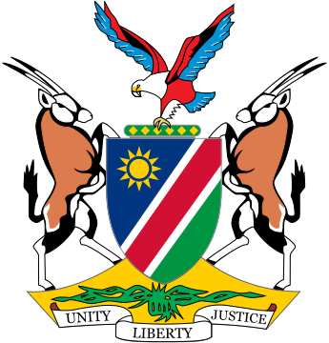

Statement by ***Gladice Pickering – Ministry of Justice and Office of the Attorney-General,*** 4th session of the WG on Transnational Corporations and Human Rights, Geneva, 16 October 2018

Item 4 interventions: Articles 2 and 8

Thank you Mr. Chair,

On Article 2: It is our position that States already have a duty to regulate the operations of national businesses and that the focus of this treaty is on the ETO’s of businesses, thus relate to TNC’s primarily and involving both host and home States. Therefore, the focus should be on the responsibilities of TNC’s. However, in the interest of consensus, it might be wise to consider for the treaty to throughout refer to all types of business entities.

We concur with Ms. Molly Scott Cato that it is time to come up with a legal framework to govern the global responsibility and not retreat to nationalism. Decisions taken in one State has the potential of having an impact beyond its borders, which impact might be on the enjoyment of the human rights in another country. We are jointly shaping the political landscape within which international human rights law has to be enforced.

Article 8: Namibia welcomes the establishment of a fund for victims. Such a fund can be instrumental in facilitating access to justice for victims and can also serve to provide funding when witness protection is needed. Other instruments in ICL (UNTOC) make provision for similar funds, which has proven to be very effective.

There might be some repetition in Article 8 and some uncertainty regarding the wording of Article 8 (12), but this is the purpose of the exercise…to polish the draft. We will make proposals to the drafters in this regard.

I thank you.